DMPTool for SMHS Data Management and Sharing Plans
Are you applying for a federal grant? To maximize the sharing of scientific data, current best practices for research data now include a data management and sharing plan.
DMPTool can help you create a plan that aligns with University of North Dakota (UND) School of Medicine & Health Sciences (SMHS) guidance and funder expectations.
Follow these steps to create a data management and sharing plan using SMHS best practices:
Use this guide to get started and ensure your plan is clear, complete, and ready for review.
- Access the DMPTool.
- Use the SSO option.
- Sign in with your UND email address.

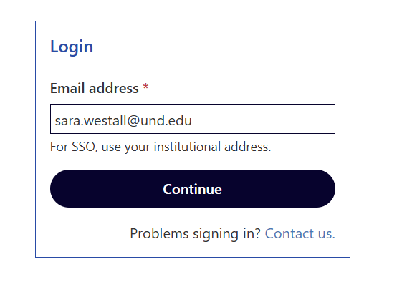

- Make sure to click on “sign in with institution (SS0)

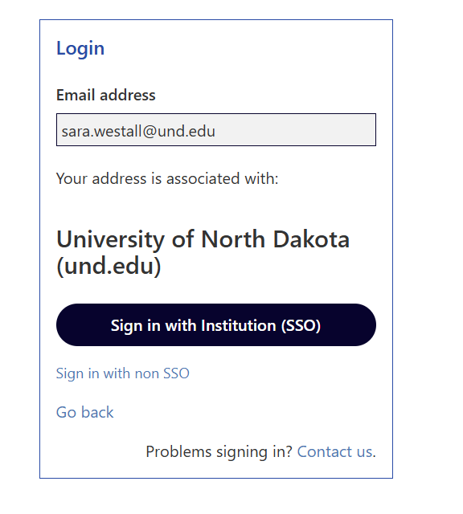

- This will prompt you to sign in using your @UND credentials.

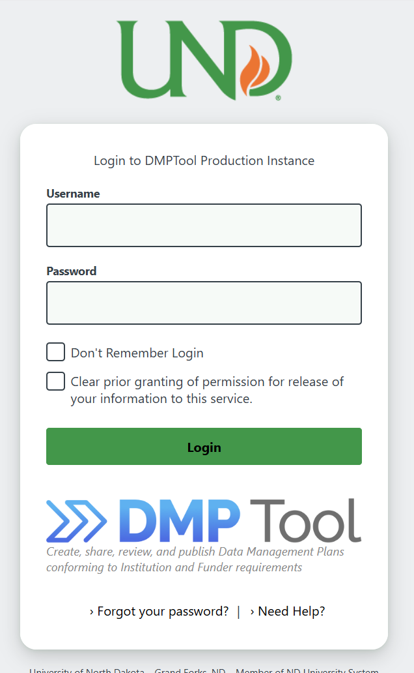

To use the DMPTool
- Click on “create plan” tab at the top of the page.

- On the next screen, provide the basic information requested. Depending on the Funder you select, a list of templates may appear (e.g. NIH Default DMSP). Additional template options will be available on the next screen if your funder doesn’t provide templates.
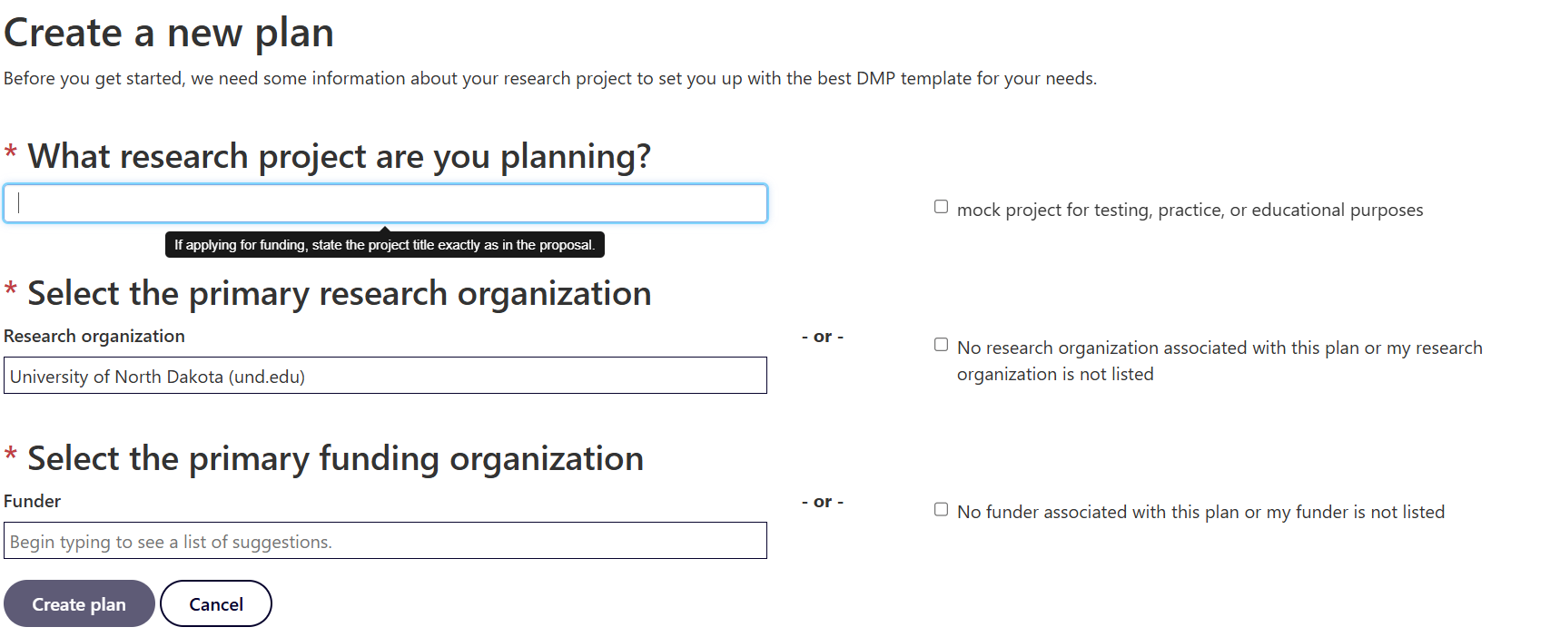

- Click on “create plan”
Note: If you are working with a federal funding agency, i.e. NSF or NIH, please add Sara Westall as a collaborator: sara.westall@und.edu
- Now you will see a screen with a horizontal menu. Complete the Project Details and select guidance options on the right side of the screen.

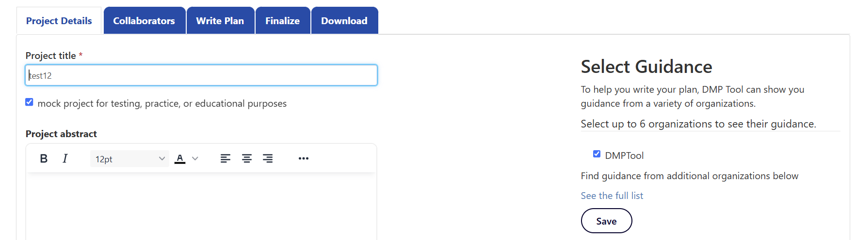

- From the drop-down list, select DMPTool and click on save
- Fill out information as required
- Under the “write plan” answer the questions and pay attention to the guidance tab
  - Make sure to click “save” under each question

- Once the write plan is completed, move onto the “finalize plan tab
  - Set visibility to “Organization”

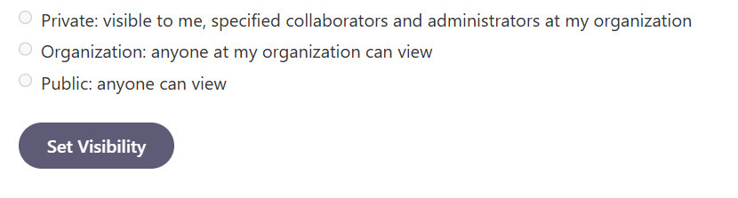

- Register your plan for a DMP Identifier

*FYI you must have your ORCID or access to your ORCID- this is mandatory for NIH grants.
10. download plan and save
11.Upload the PDF of your finalized DMSP to submission platform (i.e. ASSIST, research.gov, grants.gov, etc.).

