

Policy and Procedure Manual

November 2006
Revised June 2011
Revised October 2012
Revised January 2017
Revised February 2019

This publication was supported by Cooperative Agreement Grant Number U158/DP17-1701 from the Centers for Disease Control and Prevention (CDC). Its contents are solely the responsibility of the authors and do not necessarily represent the office view of CDC.

Table of Contents

Policy and Procedure Manual Maintenance

Section 1: Legal Issues 1
  - North Dakota Law or Century Code 2
  - Administrative Rule 6
  - Confidentiality 12
  - HIPAA 13
  - Federal Law 13
Additional Information-
North Dakota Department of Health Release of Health Information Policy 16
North Dakota Department of Health Data Use Agreement 23
U.S. Public Law 102-515 27
Benign Brain Tumor Cancer Registries Amendment Act 38
Section 2: North Dakota Statewide Cancer Registry General Information 40
  - Mission Statement 41
  - Purpose 41
  - Contacts 42
  - Registry Information 43
  - Compliance 44
  - Reporting Sources 45
  - Advisory Board 45
Section 3: Hardware and Software: Registry Operating and Data Management 46
  - Software 47
  - Hardware 50
  - Data Security 53
Section 4: Cancer Data Reporting Guidelines 57
  - Reporting Guidelines 58
  - Reporting Requirement Clarification 58
  - Required Cases 59
  - NDSCR Data Set 62
  - Reportable ICD-10 Codes 132
  - Multiple Primaries 134
  - Manual Implementation Datelines 134
  - Non-registry Hospital Submission Rules and Guidelines 138
  - Multi-Facility Reporting 139
Section 5: Data Processing 140
  - Reporting Requirements 141
  - Case Ascertainment 141
  - Data Exchange Agreements 141
  - Abstracting 142
  - Data Entry 144
  - Internal Matching, Linking and Consolidation 145
CRSPlus Data Flow chart 148
  - Training/Trainer 154
Section 6: Death Clearance 155
  - Introduction 156
  - Procedures 157
  - Death Certificate Only Cases 157
  - Cause of Death 157
Section 7: Quality Control 158
  - Quality Control / Continuous Quality Improvement 159
  - EDITS, Visual Review and Data Processing 160
  - Quality Assurance Activities 162
Additional Information-
Guidelines for Visual Editing 164
Section 8: Audits: Case-findings and Re-abstracting 165
  - Introduction 166
  - Case-finding Audits 166
NDSCR Case-finding Audits Guidelines and Letters 168
  - Re-abstracting Audit 172
NDSCR reporting facility letter 173

Section 1 Legal Issues

North Dakota Law or Century Code

Administrative Rule

Confidentiality

HIPAA

Federal Law

North Dakota Century Code Excerpts

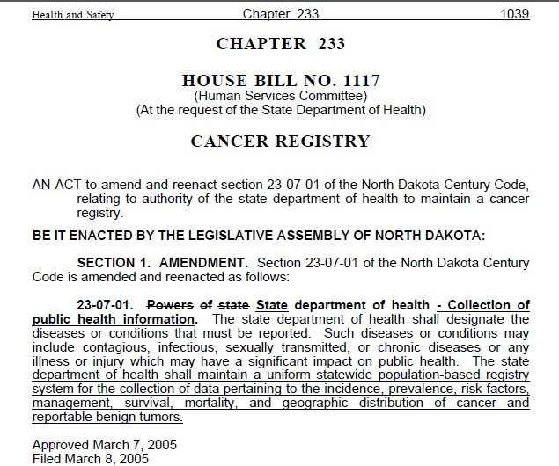

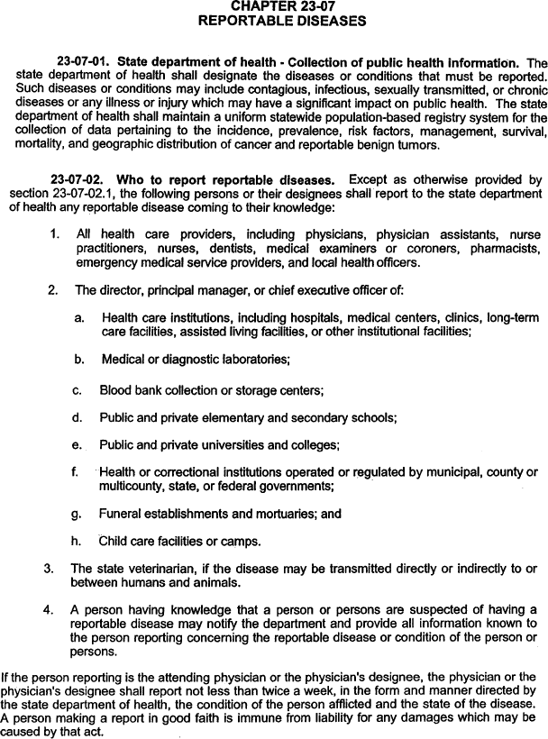

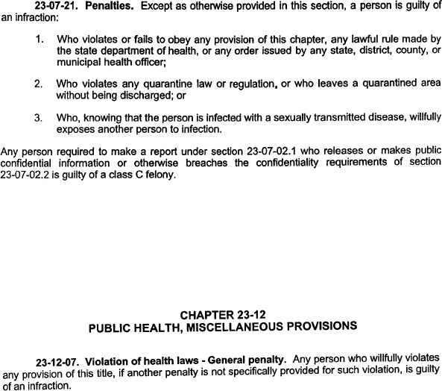

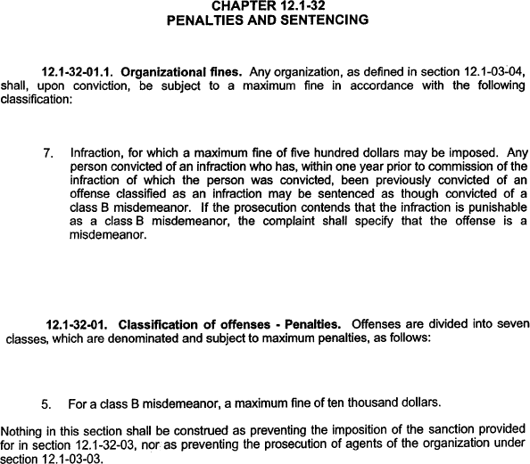

  - Administrative Rule

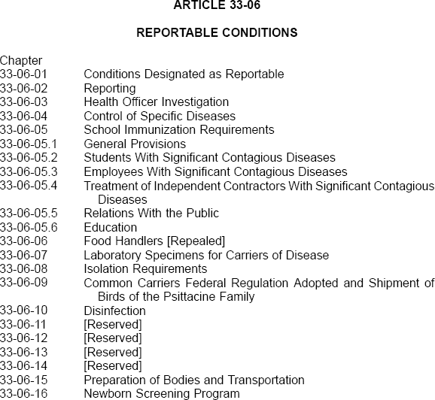

CHAPTER 33-06-01 CONDITIONS DESIGNATED AS REPORTABLE

Section
33-06-01-01 Reportable Conditions

33-06-01-01. Reportable conditions. All reports and information concerning reportable conditions are confidential and not open to inspection. The following designated reportable conditions must be reported to the state Department of Health by the persons designated in chapter 33-06-02. If any
reportable condition is designated by an asterisk, an appropriate sample or isolate must be submitted to the division of microbiology (public health laboratory) in addition to the required report.

    - Anthrax*.
    - Arboviral infection.
    - Botulism*.
    - Brucellosis*.
    - Campylobacter enteritis*.
    - Cancer, all malignant and in situ carcinomas; in addition, all benign cancers of the central nervous system, pituitary gland, pineal gland, and craniopharyngeal duct. Carcinoma in situ of the cervix is not collected. Basal or squamous cell carcinoma is not collected unless diagnosed in the labia, clitoris, vulva, prepuce, penis, or scrotum.

    - All CD4 test results.
    - Chickenpox (varicella).
    - Chlamydial infections.
    - Cholera*.
    - Clostridium perfringens intoxication*.
    - Coccidioidomycosis*.
    - Creutzfeldt-Jakob disease.
    - Cryptosporidiosis.
    - Diphtheria*.
    - E. coli, shiga toxin-producing*.
    - Enterococcus, vancomycin resistant (VRE)*.
    - Foodborne or waterborne outbreaks.
    - Giardiasis.
    - Glanders*.

    - Gonorrhea.
    - Hantavirus*.
    - Haemophilus influenzae infection (invasive infection with haemophilus influenzae isolated from blood, cerebral spinal fluid, or other normal sterile site)*.
    - Hemolytic uremic syndrome.
    - Hepatitis (specify type).
    - Human immunodeficiency virus (HIV) infection, including acquired immunodeficiency syndrome (AIDS)*. (Any positive HIV test result.)
    - Human immunodeficiency virus (HIV) nucleic acid test result (detectable or nondetectable).

    - Human immunodeficiency virus (HIV) rapid screens (positive only).
    - Influenza.
    - Laboratory incidences involving the possible release of category A bioterrorism agents or novel influenza viruses into the laboratory environment.
    - Lead blood level greater than or equal to 10 ug/dl.
    - Legionellosis.
    - Listeriosis*.
    - Lyme disease.
    - Malaria*.
    - Measles (rubeola)*.
    - Melioidosis*.
    - Meningitis, bacterial (all bacterial species isolated from cerebrospinal fluid)*.
    - Meningococcal disease (invasive infection with neisseria meningitidis isolated from blood, cerebral spinal fluid, or other normal sterile site)*.
    - Mumps.
    - Nipah viral infections*.
    - Nosocomial outbreaks in institutions.
    - Organisms with reduced susceptibility to carbapenem*. (ex. klebsiella pneumonia carbapenemase [KPC], carbapenem-resistant enterobacteriaceae [GRE], etc.).
    - Pertussis*.
    - Plague*.
    - Poliomyelitis

    - Pregnancy in a person infected with hepatitis B or HIV.
    - Psittacosis.
    - Q fever*.
    - Rabies (animal or human*).
    - Rocky Mountain spotted fever.
    - Rubella*.
    - Salmonellosis*.
    - Scabies outbreaks in institutions.
    - Severe acute respiratory syndrome (SARS)*.
    - Shigellosis*.
    - Smallpox*.
    - Staphylococcus aureus, methicillin resistant (MRSA), invasive sites only - excluding urine*.
    - Staphylococcus aureus, vancomycin resistant and intermediate resistant (VRSA and VISA)*.
    - Staphylococcus enterotoxin B intoxication*.
    - Streptococcal infections (invasive infection of streptococcus group A or B or streptococcus pneumoniae isolated from blood, cerebral spinal fluid, or other normal sterile site)*.
    - Syphilis.
    - Tetanus.
    - Tickborne diseases*.
    - Vibriosis*.

History: Amended effective May 1, 1984; December 1, 1986; January 1, 1988;
January 1, 1989; October 1, 1990; January 1, 1991; February 1, 1992; May 1,
1994; January 1, 1995; July 1, 1996; February 1, 2000; August 1, 2002; March 1,
2003; July 1, 2004; April 1, 2007; January 1, 2011.
General Authority: NDCC 23-07-01
Law Implemented: NDCC 23-07-01

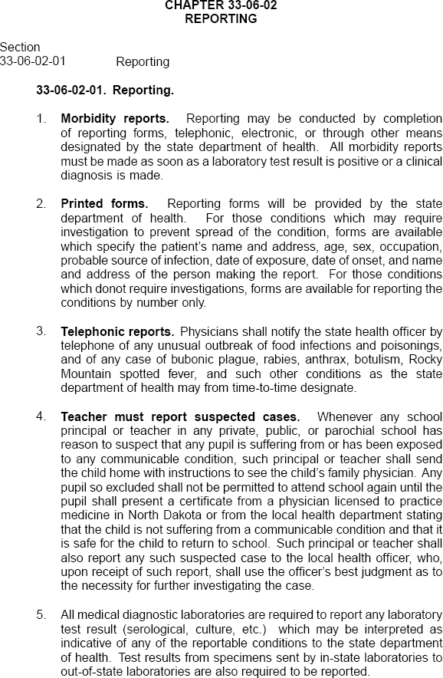

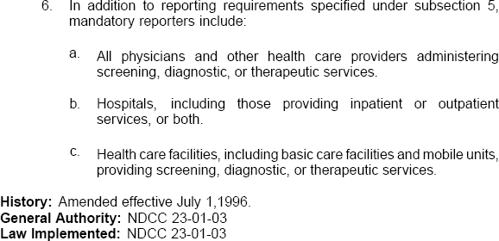

Confidentiality

The North Dakota Statewide Cancer Registry (NDSCR), through the amendment of the Administrative Rule in July 1996, collects cancer incidence data, and as such, acts as custodian of this data to ensure that these records are held in confidence and that the privacy of the individual patients, reporting facilities and physicians are protected.

Federal law or Public Law 102-515 provides a means for the state registry to access records of hospitals, outpatient clinics, physicians, surgeons, and all other facilities or individuals providing such services to patients that would identify cases of cancer or establish characteristics of cancer or the treatment of cancer.

NDSCR is concerned that data collection, maintenance and release be performed with attention given to data security requirements. This policy outlines the rules that govern the collection, maintenance and release of data gathered as a result of the registry’s operations and applies to all cancer data that falls within the activity of NDSCR, regardless of format or physical location. Although a state of confidentiality does not guarantee appropriate conduct, it shows the intent to hold the NDSCR staff and other designated users of the data accountable for information security.

The following information on cancer patients is considered to be confidential: Name
Street address
Social Security number Telephone number Physician name Reporting facility

Additionally, the following will be considered confidential if requested in a combination with other items that could identify a patient or facility:
Sex Race
Date of birth or age City address County address
Zip code
Census tract/Block group

No information that identifies or by its nature can be used to identify individuals upon whom data has been collected may be included in any summary report of data or other compilation of data for public distribution.

All employees or contractors working with or for NDSCR are required to remove all papers, forms, notes, computer files or other materials containing patient identifier information from desk tops and lock all such materials in desks or file cabinets at the end of each day. All documents are to be turned face down when staff are away from their desk during the day. Employees performing data collection in the field, when asking

contact people for information, shall make sure forms containing other data are not shown, shall transport forms and medical records so that private information is not visible and will not comment on any information seen in the medical records reviewed.

The NDSCR coordinator has the responsibility for data security, and the registry staff is responsible for their own actions in regard to data security policies and procedures.

Confidential data must not be transmitted electronically in any means without authority from the registry coordinator or a staff member to whom such authority has been delegated. Data transmitted shall be encrypted and password protected. Paper partial abstracts, paper pathology reports and computer disks containing confidential information must be kept in a locked drawer.

In completing requests for statistical information on North Dakota residents, many of the cell sizes relating to cancer, age, gender and numbers are very small due to the population size of our state. To help in the protection of the confidentiality of the state’s residents, the North Dakota Health Information Disclosure Act took effect August 1999.

Any researcher or individual requesting the use of raw data from central registry must complete a Data Use Agreement, page 23, which ensures compliance with the requirements of the Health Information Disclosure Act and the Federal Health Insurance Portability and Accountability Act (HIPAA).

HIPAA (Health Insurance Portability and Accountability Act)
The NDSCR, within the Department of Pathology, University of North Dakota School of Medicine & Health Sciences acting as the bona fide agent for the North Dakota Department of Health (NDDoH), is authorized by law to collect cancer information for the purpose of preventing or controlling disease and to conduct public health surveillance, public health investigations and interventions. HIPAA permits covered entities to disclose protected health information without individual authorization to public health authorities such as state health departments.

The NDDoH has developed policies that address the many facets of HIPAA regulations. HIPAA Policy Number P-028, page 15, relates to release of health information and the associated Data Use Agreement for Disclosure of Protected Health Information is included at the end of this section.

Federal Law

Established by Congress through the Cancer Registries amendment Act in 1992, and administered by the U.S. Centers for Disease Control and Prevention (CDC), the National Program of Cancer Registries (NPCR) collects data on the occurrence of cancer; the type,

extent, and location of the cancer; and the type of initial treatment. In 2004, Congress passed another law mandating the collection of all benign central nervous system tumors. These two laws are included at the end of this section.

North Dakota was one of several states that did not have a cancer registry due to lack of resources and legislative support to gather complete cancer data. Funding for a statewide cancer registry was initially received in 1994. Data collection of newly diagnosed or incidence cancer began in 1997. Today, funding for the state central cancer registry is received through NPCR, state general fund dollars and in-kind support from various sources.

(This page left blank intentionally)


North Dakota Department of Health

HIPAA Policy

Policy Title: | Release of Health Information
Policy Number: | P-028 | Version: 1.2 Reviewed June 8, 2015
Reference: | 45 CFR 164.502(d); 45 CFR 164.514 (d) 45 CFR 164.514(e); 45 CFR  164.512(i), 45 CFR 164.512(b)
Applicability: | Department of Health
Approved By: | Dr. Terry Dwelle, State Health Officer Arvy Smith, Deputy State Health Officer  Dirk Wilke, HIPAA Coordinator, Privacy Officer
Effective Date: | February 1, 2004
Policy:
The NDDoH may release health information data as outlined in the following procedure.

Exceptions:
None

Procedure:
The NDDoH may disclose:
- Protected health information with the individual’s specific written authorization. Such authorization must meet all the requirements described in the Authorizations Policy (P-004); or
- De-identified health information; or
- A limited data set with a data use agreement; or
- Health information for research if the information is not de-identified or is not a limited data set, with or without the individual’s authorization, if the NDDoH uses a data use agreement and obtains documentation that an alteration to, or waiver of, the individual’s authorization has been approved by:
  - The NDDoH privacy board, or
  - The NDDoH Institutional Review Board (IRB) if the research is in part conducted by an NDDoH employee for the Department of Health.
- Decedents’ information with a data use agreement. No IRB or privacy board review is needed. Consistent with the Minimum Necessary policy (P-012), the minimum necessary information will be disclosed. In addition, for research on decedents’ information, the NDDoH will obtain:
  - Representation from the researcher that the information sought is solely for research on the PHI of decedents, and
  - Assurance that there will be no attempt to contact family members, and
  - Representation that the PHI requested is necessary for the research purpose, and

  - Documentation of the death of such individuals, (if applicable).
- PHI when the NDDoH is operating as a public health authority. NDDoH is authorized to disclose individual information without authorization for the purpose of preventing or controlling disease, injury or disability and for the conduct of public health surveillance, investigation and intervention; or
- Information to a known public health authority. If the public health authority status of an organization is not known, the NDDoH will require a Business Associate Agreement or Data Use Agreement to be completed. Dependent upon the reason for the request from a public health authority, the NDDoH may require a Business Associate Agreement or Data Use Agreement be completed prior to disclosure of PHI to another public health authority; or
- Information without individual authorization to the extent that such disclosure is required or permitted by law.

Any disclosures not consistent with this policy are a violation of NDDoH policies and procedures and federal HIPAA regulations. Sanctions may be imposed consistent with the Workforce Sanctions policy (P-027).

De-identified Health Information:
- The NDDoH may disclose de-identified health information without the written authorization of the individual when the health information does not identify an individual and there is no reasonable basis to believe that the information can be used to identify an individual. The NDDoH will use reasonable discretion when disclosing de-identified health information.

- The NDDoH may use protected health information to create information that is not individually identifiable health information or disclose protected health information only to a business associate to create the de-identified information.

- The NDDoH may determine that health information is not individually identifiable health information (de-identified) if the following identifiers of the individual or of relatives, employers, or household members of the individual, are removed and if the NDDoH does not have knowledge that the information could be used alone or in combination with other information to identify the individual:
  - Names
  - All geographic subdivisions smaller than a State, including street address, city, county, precinct, zip code, and their equivalent geocodes, except for the initial three digits of a zip code if, according to the current publicly available data from the Bureau of the Census:
    - The geographic unit formed by combining all zip codes with the same three initial digits contains more than 20,000 people, and
    - The initial three digits of a zip code for all such geographic units containing 20,000 or fewer people is changed to 000.
  - All elements of dates (except year) for dates directly related to an individual, including birth date, admission date, discharge date, date of death, and all ages over 89 and all elements of dates (including year) indicative of such age, except that such ages and elements may be aggregated into a single category of age 90 or older
  - Telephone numbers

  - Fax numbers
  - Electronic mail addresses
  - Social security numbers
  - Medical record numbers
  - Health plan beneficiary numbers
  - Account numbers
  - Certificate/license numbers
  - Vehicle identifiers and serial numbers, including license plate numbers
  - Device identifiers and serial numbers
  - Web Universal Resource Locators (URLs)
  - Internet Protocol (IP) address numbers
  - Biometric identifiers, including finger and voice prints
  - Full face photographic images and any comparable images
  - Any other unique identifying number, characteristic or code

- The NDDoH may also determine that health information is not individually identifiable health information (de-identified) if:
  - A person within the NDDoH who has appropriate knowledge and experience with statistical and scientific principles and methods for rendering information not individually identifiable:
    - Determines that the risk is very small that the information could be used, alone or in combination with other reasonably available information, by an anticipated recipient to identify an individual who is a subject of the information; and
    - Documents the methods and results of the analysis that justify such determination.

- The NDDoH may assign a code or other means of record identification to allow information de-identified to be re-identified if:
  - The code or other means of record identification is not derived from or related to information about the individual and is not capable of being translated in order to identify the individual;
  - The code or other means is not used for any other purpose and does not disclose the mechanism for re-identification.

- De-identified information disclosed via internet access will be accompanied by a statement notifying the user that:
  - Linking the data to other data for the purpose of identifying individuals is prohibited, and
  - The user must report to the NDDoH any inadvertent discovery of the identity of any person, and
  - The user must make no use of the discovery, and
  - By using this data, the user signifies agreement to comply with the above statements.

Limited Data Sets:
- The NDDoH may disclose protected health information (PHI) for research, public health or health care operations without the written authorization of the individual if the information is a limited data set and the NDDoH enters into a data use agreement with the limited data set recipient.

- A limited data set is PHI that excludes the following direct identifiers of the individual or of relatives, employers or household members of the individual:
  - Names
  - Postal address information, other than town or city, county, State and zip code
  - Telephone numbers
  - Fax numbers
  - Electronic mail addresses
  - Social security numbers
  - Medical record numbers
  - Health plan beneficiary numbers
  - Account numbers
  - Certificate/license numbers
  - Vehicle identifiers and serial numbers, including license plate numbers
  - Device identifiers and serial numbers
  - Web Universal Resource Locators (URLs)
  - Internet Protocol (IP) address numbers
  - Biometric identifiers, including finger and voice prints
  - Full face photographic images and any comparable images

- The NDDoH may disclose a limited data set only if the NDDoH obtains satisfactory assurance, in the form of a data use agreement, that the limited data set recipient will only use or disclose the PHI for limited purposes.

Data Use Agreements:
- All requests for data which require a Data Use Agreement are to be sent to the North Dakota Statewide Cancer Registry (NDSCR) epidemiologist at cristina.oancea@med.und.edu, along with a completed NDSCR Data Request Form, a completed NDDoH IRB Request Form and IRB approval from your institution. The epidemiologist will then forward the required documentation to Tracy Miller, the North Dakota Department of Health (ND DoH) HIPAA Privacy Office. Once ND DoH IRB approval is received, the ND DoH HIPAA Privacy Office will send the requestor a Data Use Agreement.

- A data use agreement between the NDDoH and the limited data set recipient must:

  - Establish the permitted uses and disclosures of the information by the limited data set recipient. The data use agreement may not authorize the limited data set recipient to use or further disclose the information in a manner that would violate these requirements;
  - Establish who is permitted to use or receive the limited data set;
  - Provide that the limited data set recipient will:
    - Not use or further disclose the information other than as permitted by the data use agreement or as otherwise required by law;
    - Use appropriate safeguards to prevent use or disclosure of the information other than as provided for by the data use agreement;
    - Report to the NDDoH any use or disclosure of which it becomes aware not provided for by its data use agreement;

    - Ensure that any agents to whom it provides the limited data set agrees to the same restrictions and conditions that apply to the limited data set recipient with respect to this information;
    - Not identify the information or contact the individuals.
  - Be signed and dated by the Requestor, the appropriate NDDoH Division Director, and the NDDoH Privacy Officer.

- The proposed Data Use Agreement will be sent to the requestor for review. The requestor must sign and date the Agreement and return to the NDDoH HIPAA Coordinator.

- The appropriate NDDoH Division Director will be requested to review the Data Use Agreement, sign and date.

- The NDDoH HIPAA Coordinator will review the completed Data Use Agreement, sign and date.

- A Data Use Agreement number will be assigned to the Data Use Agreement when the Agreement has been finalized and all appropriate signatures have been obtained.

- A copy of the signed Data Use Agreement will be given to the requestor and the appropriate NDDoH Division. A copy will also be maintained by the HIPAA Coordinator. The signed original will be forwarded by the HIPAA Coordinator to the NDDoH Administrative Services Section. The original will be maintained by the NDDoH Administrative Services Section in a secure file.

- Documentation of the information released (actual copies and/or database fields, etc.) is to be retained by the appropriate NDDoH Division.

- If NDDoH knows of a pattern of activity or practice of the limited data set recipient that constitutes a breach or violation of the data use agreement, NDDoH will take reasonable steps to end the breach or violation or the NDDoH will discontinue disclosure of protected health information to the recipient and report the problem to the Secretary of the Department of Health and Human Services (DHHS).

- A Data Use Agreement may also be used in other situations as deemed necessary by the NDDoH HIPAA Coordinator.

Privacy Board:
(In relation to this section of the procedure, any reference to an IRB is to be considered an IRB from an organization outside of the NDDoH. The NDDoH IRB policies and procedures are not included in the NDDoH HIPAA policies.)
- The NDDoH privacy board must:
  - Have NDDoH staff members with varying backgrounds and appropriate professional competency as necessary to review the effect of the research protocol on the individual’s privacy rights and related interests;

  - Include at least one member who is not affiliated with the NDDoH or with any entity conducting or sponsoring the research and not related to any person who is affiliated with any such entities;
  - Not have any member participating in a review of any project in which the member has a conflict of interest.

- The chair of the NDDoH Privacy Board is the HIPAA Coordinator.

- Prior to the research, the NDDoH obtains representations from the researcher that:
  - The use or disclosure of PHI is necessary to prepare a research protocol or preparatory purpose;
  - No PHI is to be removed from the NDDoH by the researcher until approval is granted;
  - The PHI requested is necessary for the research purposes.

- For a disclosure permitted based on documentation of approval of an alteration or waiver, the documentation from the researcher if an IRB or the NDDoH if a privacy board must include:
  - Identification of the IRB or privacy board and the date on which the alteration or waiver of authorization was approved;
  - A statement that the IRB or privacy board has determined that the alteration or waiver of authorization satisfies the following criteria:
    - The use or disclosure of PHI involves no more than a minimal risk to the privacy of individuals based on;
      - An adequate plan to protect the identifiers from improper use and disclosure.
      - An adequate plan to destroy the identifiers at the earliest opportunity consistent with conduct of the research, unless there is health or research justification for retaining the identifiers or retention is required by law;
      - Adequate written assurances that PHI will not be reused or disclosed to any other person or entity except as required by law, for authorized oversight of the research study or for other research for which the use or disclosure of PHI would be permitted;
    - The research could not be conducted without the waiver or alteration.
    - The research could not be conducted without access to and use of the PHI.
  - A brief description of the PHI for which use or access has been determined to be necessary by the IRB and/or privacy board;
  - A statement that the alteration or waiver of authorization has been reviewed and approved under either normal or expedited review procedures as follows:
    - An IRB must follow the Common Rule as defined in the Federal Register.
    - A privacy board must review the proposed research at meetings at which a majority of the privacy board members are present, including one member
who is not affiliated with the NDDoH or with any entity conducting or sponsoring the research and not related to any person who is affiliated
with any of those entities. The alteration or waiver of authorization must be approved by the majority of the privacy board members present at the meeting unless the privacy board elects to use an expedited review procedure;
    - An expedited review procedure may be used if the research involves no more than minimal risk to the privacy of the individuals who are the subject of the PHI for which use or disclosure is being sought. The review and approval of the

alteration or waiver of authorization may be carried out by the chair of the privacy board or by one or more members of the privacy board as designated by the chair.
  - The documentation of the alteration or waiver of authorization must be signed by the chair or other member as designated by the chair of the IRB or the privacy board.

Related Forms:
Data Release Checklist
DOH Data Use Agreement for Disclosure of Protected [Individually Identifiable] Health Information

Definitions:
NDDoH – North Dakota Department of Health

Protected Health Information – Individually identifiable health information that is transmitted or maintained by electronic media or transmitted or maintained in any other form or medium

Individually Identifiable Health Information – Health information which includes demographic information that relates to the past, present or future physical or mental health or condition of an individual; the provision of health care to an individual; or the past, present or future payment for the provision of health care to an individual and that identifies the individual or there is a reasonable basis to believe the information can be used to identify the individual

Electronic Media – Electronic storage media including memory devices in computers and any removable/transportable digital memory medium such as magnetic tape or skid, optical disk or digital memory card; or transmission media used to exchange information already in electronic storage media. Transmission media includes the internet, extranet, leased lines, dial-up lines, private networks and the physical movement of removable/transportable electronic storage media

Research – Systematic investigation, including research development, testing and evaluation, designed to develop or contribute to generalizable knowledge

Public Health Authority – An agency or authority of the United States, a State, a territory, a political subdivision of a State or territory, or an Indian tribe, or a person or entity acting under a grant of authority from or contract with such public agency, including the employees or agents of such public agency or its contractors or persons or entities to whom it has granted authority, that is responsible for public health matters as part of its official mandate

DOH Data Use Agreement for Disclosure of Protected [Individually Identifiable] Health Information
In order to ensure the confidence of the public regarding the confidentiality of information collected and maintained by the North Dakota Department of Health [DOH], and to comply with federal and state laws, these requirements apply to the use or disclosure of the file(s) containing “protected [individually identifiable] health information” or any data derived from that (those) file(s).

- Any term used in this Agreement that appears in bold type has the meaning set forth in the federal privacy rule, 45 C.F.R. § 160.103.

- This Agreement applies to the disclosure of the following DOH data:

Please specify the data files and/or information (including the “fields of health information” and demographic information) that are the subject of the request.
- Requestor Identification Information: Name:
Title: Company/Organization: Street Address:
City, State and ZIP code: Phone Number:
Fax: Email:

- Requestor represents and warrants that the protected health information described in 2 above and disclosed under this Agreement may be used only for (1) the project and (2) the purposes described below:

(Describe briefly, but concretely, (1) the nature and (2) the purpose of the project. An additional description of the project may be incorporated by reference if it is attached to the DUA)

- Requestor may use protected health information (including the information in a limited data set) only for research or public health purposes.

- Requestor may not use or disclose information disclosed under this Agreement in a manner that would violate the requirements of the HIPAA privacy rule if done by a covered entity.

- The protected health information disclosed under this Agreement may be used only by the following individuals:
Name:
Title:
Organization:

(Describe briefly and concretely by name, title, or position, and by organization, the persons authorized to have access to information disclosed under this Agreement)

- Requestor may not: (1) use or further disclose the information disclosed under this Agreement, except as specified in this Agreement or otherwise required by law; (2) disclose any protected health information or aggregation of data from the file(s) covered by this Agreement, unless the data is de-identified; or, (3) make any attempt to identify any individual or link records included in the file(s) to any other individually identifiable information without the express written authorization of DOH.

- Requestor agrees not to contact any individual whose protected health information is disclosed to the Requestor under this Agreement without the express written authorization of DOH.

- Requestor will use appropriate safeguards to prevent any use or disclosure of information except as provided in this Agreement.

- Requestor will report to the Department of Health any use or disclosure of protected health information provided under this Agreement (of which the Requestor becomes aware) that is not authorized by the Agreement. Any such report must be made within three working days of the date it is discovered, except that in the case of a catastrophic breach involving (a) 25 percent or more of the records disclosed under the Agreement, or
(b) the records of more than 100 individuals, a report must be made within 24 hours of the time the catastrophic breach is discovered.

- Requestor will ensure that any agents, including a subcontractor to whom the Requestor provides any of the information disclosed under this Agreement, agrees to the same restrictions and conditions that apply to the Requestor with respect to the protected health information disclosed under this Agreement.

- If Requestor is in material breach of any requirement of this Agreement, and fails to promptly correct the breach, the Requestor must, at the request of DOH, return to DOH all information disclosed to the Requestor under this Agreement, and destroy any copies of protected health information (including information contained in a limited data set) contained in, or created or derived from, health information provided under this Agreement.
- Unless authorized by the next sentence, only one disclosure of the DOH data described in 2 of this Agreement is authorized. The Department of Health hereby authorizes periodic (or as requested) disclosures through the retention date. [Initials of DOH HIPAA Coordinator/Privacy Officer for DOH]

- Requestor may not amend the fields of protected health information (including the fields of health information in a limited data set or demographic variables) subject to periodic (or as requested) disclosure if authorized under 14 of this Agreement without the express prior written authorization of the Department of Health.

- For each file, Requestor shall pay the standard fee, if any, established by DOH.

- In the event Requestor makes an unauthorized disclosure of any data, or is otherwise in material breach of this Agreement, DOH may impose any or all of the following measures:
  - Request a formal response to an allegation of an unauthorized disclosure;
  - Require the submission of a corrective action plan formulated to implement steps to be taken to alleviate the possibility of any future unauthorized disclosure;
  - Require the return of the data; and/or
  - Impose further restrictions on disclosure of DOH data to the organization/Requestor in question.

- The parties mutually agree that the data file(s) identified in 2 above (and/or any derivative file(s)) may be retained and used by the Requestor until , 200_, (“retention date”). Requestor agrees that on , 200_, the retention date, Requestor must (1) return all protected health information disclosed under this Agreement to the Department of Health, or
(2) destroy any protected health information disclosed to the Requestor and any derivative files containing protected health information and will certify to the Department of Health that Requestor has accomplished these actions.

- If protected health information is disclosed in violation of this data use Agreement it may result in CIVIL OR CRIMINAL PENALTIES OR BOTH. For example –
  - If the information was received from the health care data committee a person may be subject to a civil penalty not to exceed $500 per day. N.D.C.C. § 23-01.1-07.
  - If the information is a vital birth or death record, and the information is disclosed in violation of this Agreement, the person is guilty of an infraction. N.D.C.C. § 23-02.1- 32(2) (c).
  - If a public servant discloses protected health information in violation of the Agreement, the public servant may be guilty of a class C felony. N.D.C.C.
  - § 12.1-13-01.
  - If the person disclosing information is a covered entity under the HIPAA privacy regulations, and the person knowingly and in violation of the regulations discloses individually identifiable health information to another person, they may be guilty of a criminal offense under 42 U.S.C. § 1320d-6. They also may be subject to civil money penalties of $100 per violation, up to $25,000 per person, per year for each requirement or prohibition of the privacy rule that is violated.

- Warranty. Requestor represents and warrants that the facts and statements made in this Agreement and any research project plan or other document submitted to DOH in support of this Data Use Agreement is complete and accurate.

Name and title of Requestor

Signature Date

Name and title of DOH Division Director

Signature Date

Dirk Wilke, DOH HIPAA Coordinator and Privacy Officer

Signature Date

(DOH Data Use Short Form; Revise d 8/2003; 2/2004)

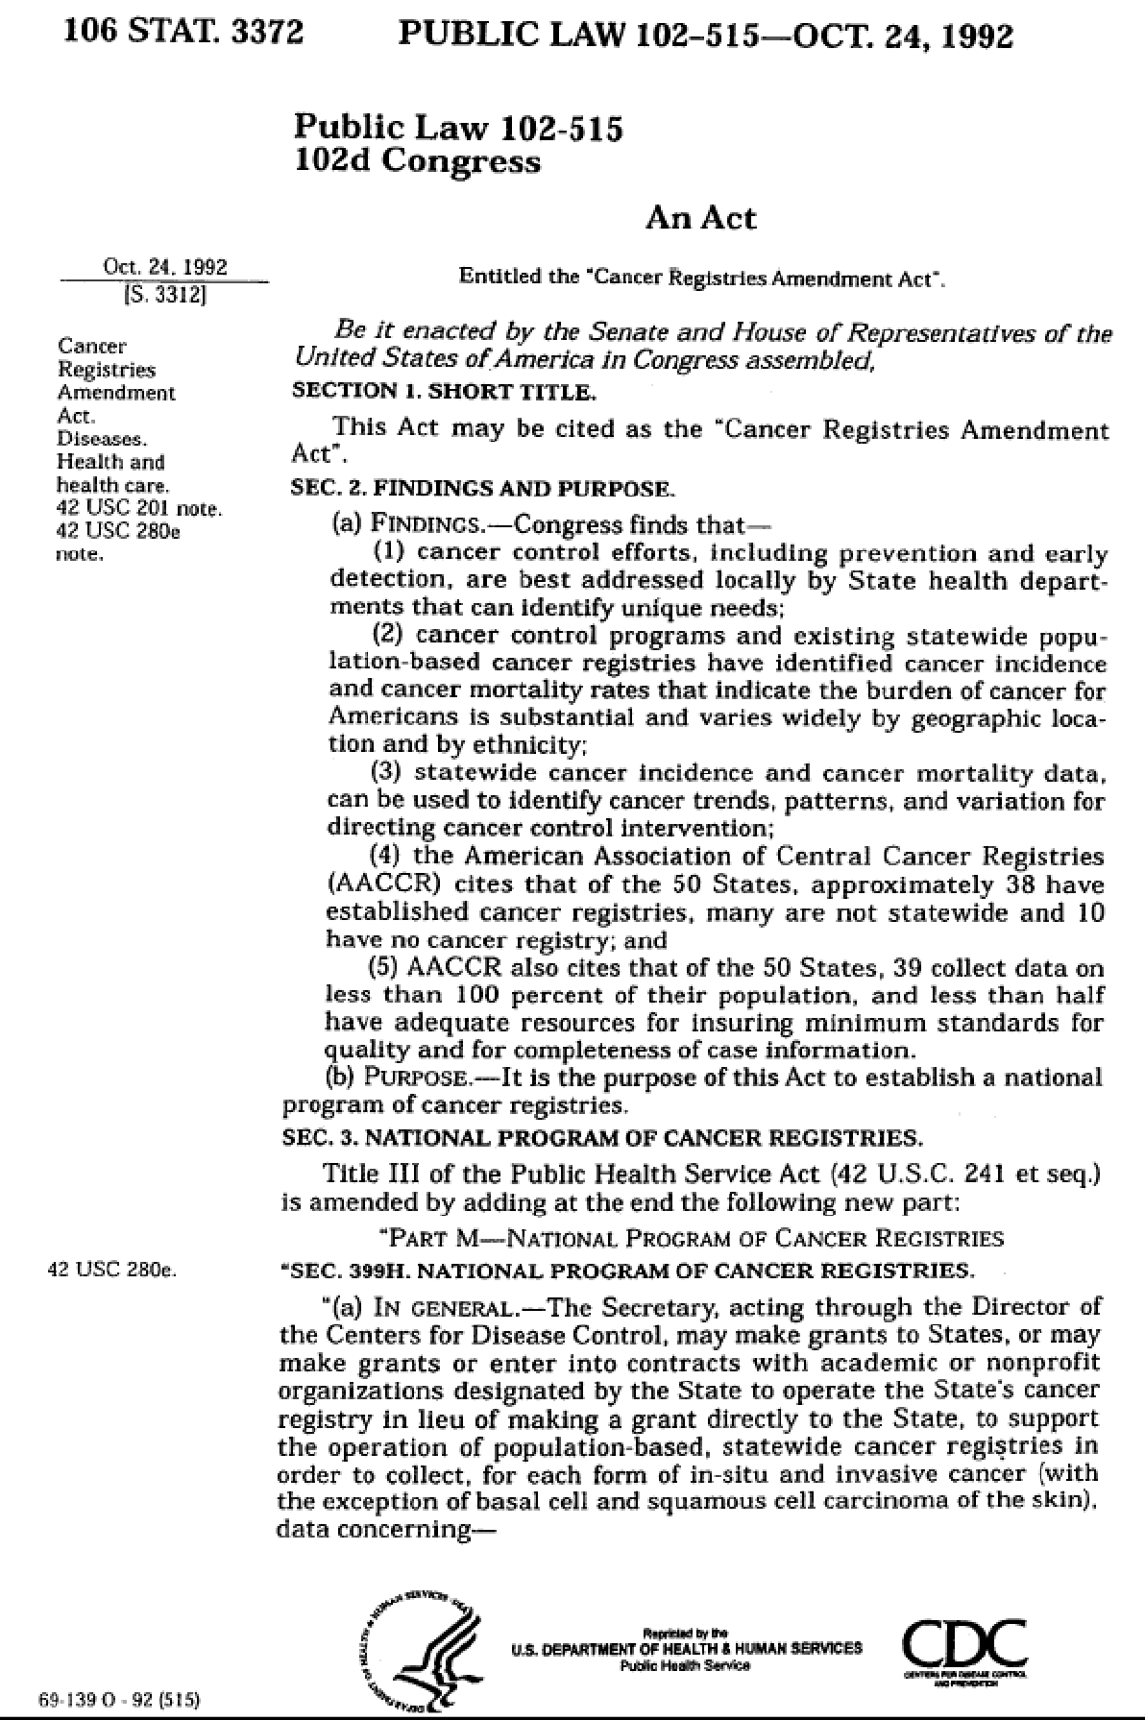

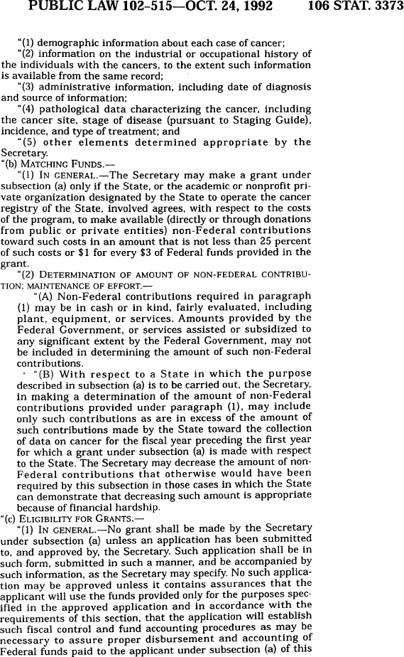

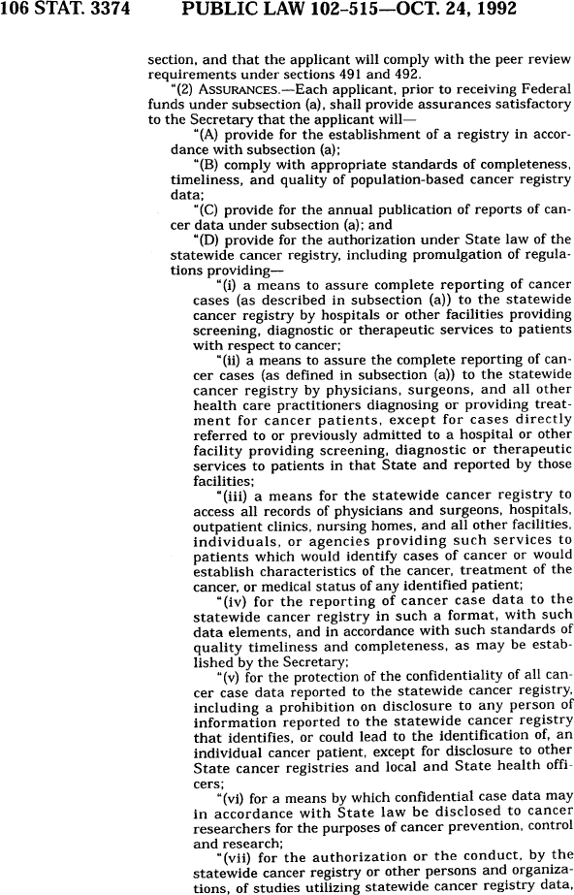

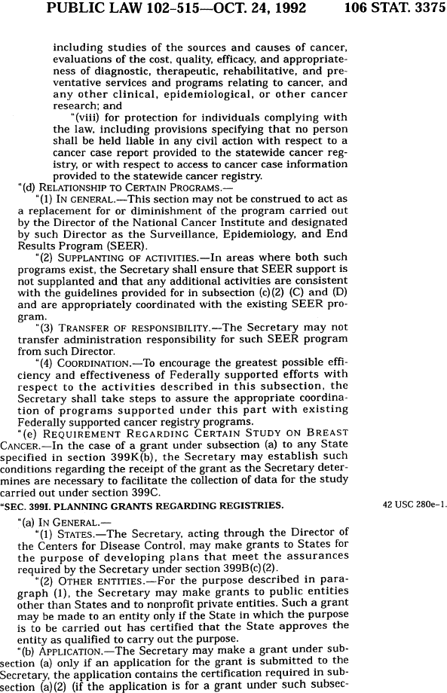

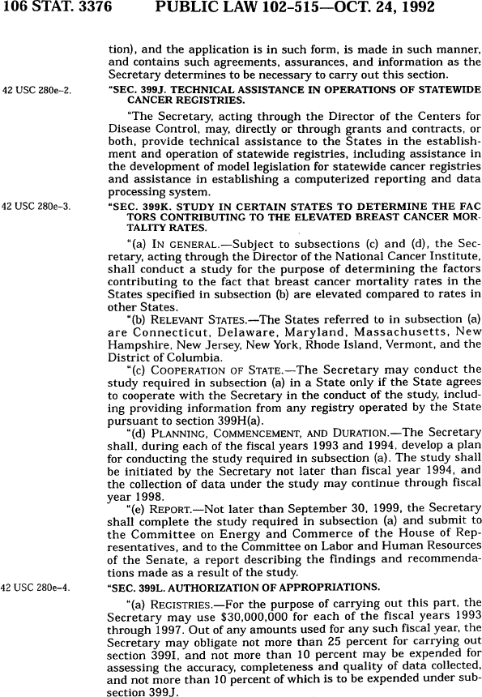

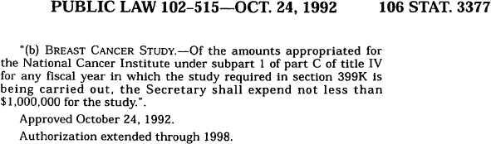

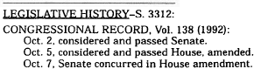

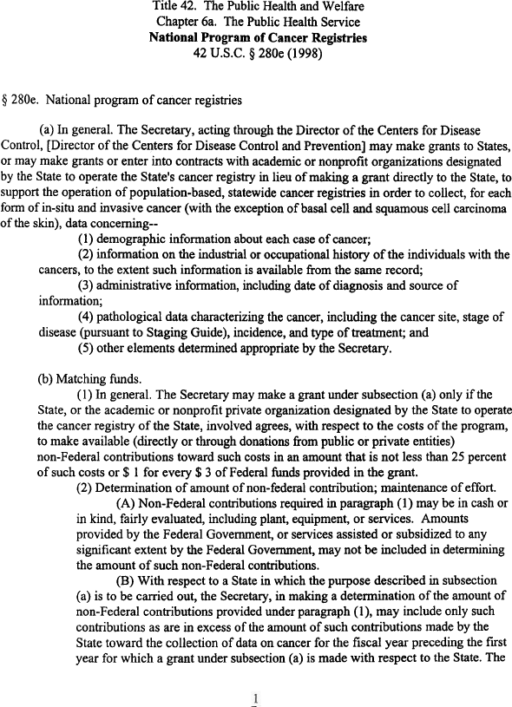

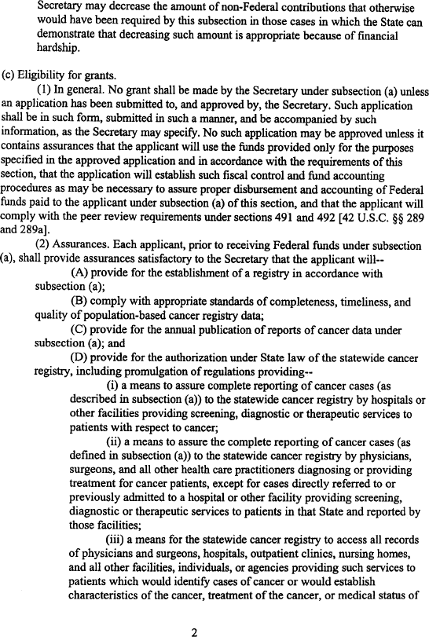

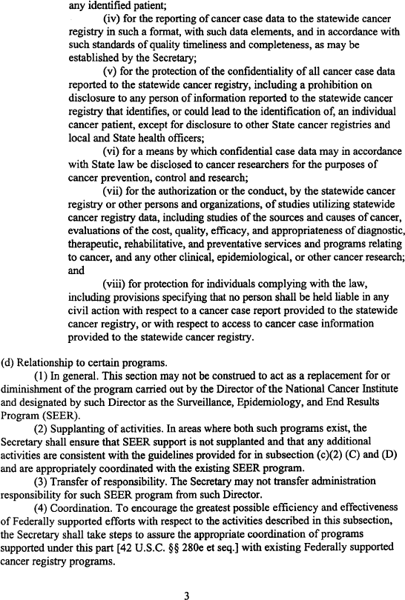

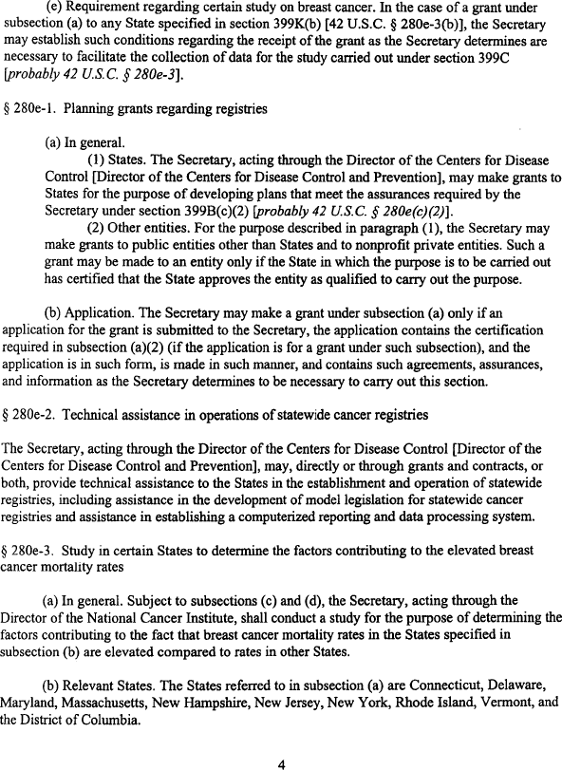

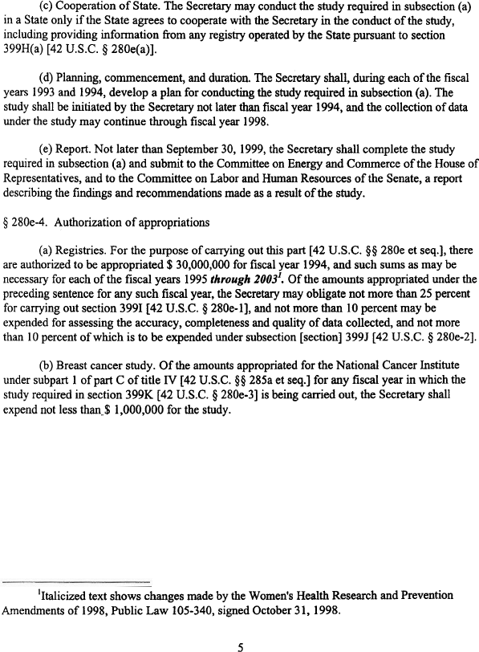

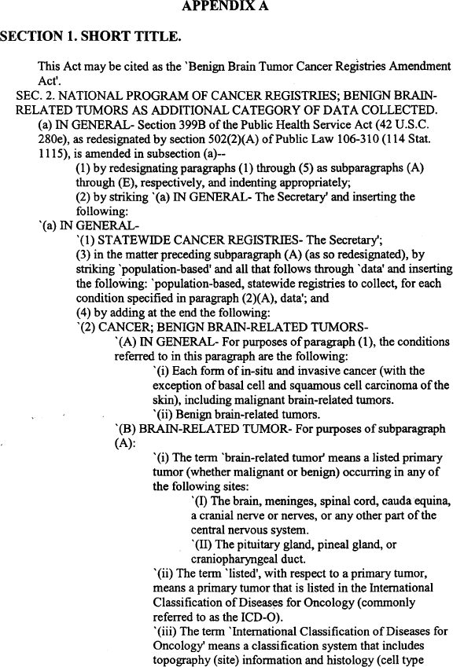

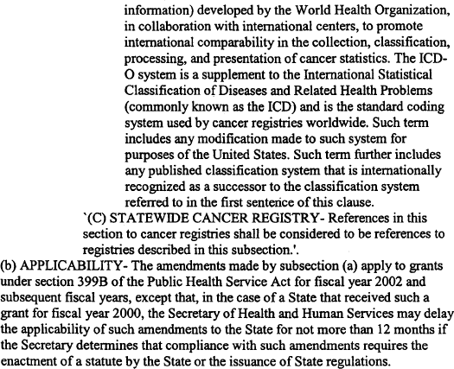

Section 2
North Dakota Statewide Cancer Registry General Information

Mission Statement

Purpose
  - Registry Information
  - Contacts
  - Compliance
  - Reporting Sources
  - Advisory Board

Mission Statement
Support cancer control by providing data to target, monitor and evaluate programs promoting prevention, early detection, diagnosis and treatment to reduce the burden of cancer in North Dakota.

Purpose
The primary purpose of the North Dakota Statewide Cancer Registry (NDSCR) is to support cancer control by targeting, monitoring and evaluating programs promoting prevention, early detection, diagnosis and treatment of cancer. The NDSCR supports efforts by community hospitals, health systems, and treatment centers with respect to the evaluation of their cancer patient care.

The NDSCR supports state and local health-care agencies and providers by:

    - Providing summary statistics on the distribution of cancer cases by type.
    - Monitoring cancer incidence and treatment trends throughout the state over time.
    - Facilitating rapid reporting of cancer, thereby allowing state or local health officials to assess suspected cancer clusters or suspected cancer hazards in their local communities.
    - Providing accurate cancer data for cancer-related reports and research activities.
    - Providing data to determine various population cancer patterns.
    - Helping to set priorities for allocating health resources.
    - Providing cancer data for national cancer incidence databases.

Contacts

Registry Administration
    - Mary Ann Sens, MD PhD, Chair, Department of Pathology, University of North Dakota School of Medicine and Health Sciences
    - Yun [Lucy] Zheng, MB CTR, Co-Program Director Main Contact, yun.zheng@med.und.edu, 701.777.0791
    - Xudong Zhou, MB CTR, Co-Program Director, Xudong.zhou@med.und.edu, 701.777.2868

Quality Control
    - Xudong Zhou, MB CTR, Co-Program Director, Xudong.zhou@med.und.edu, 701.777.2868

Education Training Coordinator
    - Xudong Zhou, MB CTR, Co-Program Director, Xudong.zhou@med.und.edu, 701.777.2868

Research Analyst
    - Cristina Oancea, MS, MS, PhD, Cristina.oancea@med.und.edu, 701.777.6696

Database Administrator/Technology Support
    - Austin Theisen, Database Administrator, austin.theisen@med.und.edu, 701.777.6848

Contact Information
North Dakota Statewide Cancer Registry Department of Pathology
School of Medicine and Health Sciences University of North Dakota
1301 N Columbia Rd Stop 9037 Grand Forks, N.D. 58203-9037
Telephone: 701.777.0791 or 701.777.2868
Fax: 701.777.3108

Registry Information

Cancer registries play an important role in the efforts to reduce the burden of cancer by identifying and quantifying the cancer problem. The North Dakota Statewide Cancer Registry (NDSCR) is a population-based surveillance system located in the University of North Dakota School of Medicine and Health Sciences Department of Pathology which acts as the registry operating bona fide agent for the North Dakota Department of Health. The registry is designed to collect, manage, analyze and disseminate information on the incidence of cancer among North Dakota residents. The NDSCR is the central repository of information and is a valuable and essential tool in the identification of populations at risk for cancer, monitoring of cancer incidence trends and mortality, facilitation of studies related to cancer prevention, evaluation of cancer control initiatives, planning of health-care delivery systems, and development of educational awareness programs.

One goal of the NDSCR is to reduce death and illness due to cancer by providing data about cancer incidence. Population-based cancer registries are essential for evaluating the cancer burden in a specific geographic area.

The NDSCR was established in 1994. The amendment of the Administrative Rules Article 33-06-01-01 in 1996 mandated the reporting of all invasive and in situ carcinomas (ND CC 23-07-01). Data collection on newly diagnosed cases began in 1997. The Administrative Rule amendment requires the reporting of newly diagnosed cancers to the central cancer registry for all medical diagnostic laboratories, physicians and other health-care providers who administer screening, diagnostic or therapeutic services. Also required to report are hospitals and other health-care faculties that provide inpatient and/or outpatient services and mobile units that provide screening, diagnostic or therapeutic services.

All in situ and malignant cancers are reportable with several exceptions (See Chapter 4 for details). In addition, beginning with cases diagnosed in 2004, nonmalignant primary intracranial and central nervous system (CNS) tumors are reportable to the NDSCR. This includes benign and borderline tumors in the following sites: meninges, brain, spinal cord, cranial nerves, and other parts of central nervous system: pituitary gland, craniopharygeal duct, and pineal gland.
Malignant primary neoplasms of skin (C44._) with ICD-O-3 histology codes 8000-8110 are not reportable unless they originate in the following sites – vagina, clitoris, vulva, prepuce, penis or scrotum.

Carcinoma in situ of the cervix uteri is not reportable following the recommendations of the Commission on Cancer and the North American Association of Central Cancer Registries (NAACCR).

Incidence statistics are published when 95 percent completeness rate for a specific year is reached.

Mortality data is received through the Division of Vital Records, North Dakota Department of Health.

NDSCR uses the SEER (Surveillance Epidemiology and End Results) average population figures for performing data analysis.

Seventy-five percent of NDSCR’s funding is from the U.S. Centers for Disease Control and Prevention’s (CDC) National Program of Cancer Registries (NPCR), with the remaining 25 percent shared between the state of North Dakota and in-kind support is received from various central cancer registry supporters.

The NDSCR participates in the NPCR and NAACCR groups. The program standards for NPCR and NAACCR are adhered to for completeness and timeliness of data and registry certification.

The NDSCR, under the Administrative Rule, acts as the custodian of the data. Strict state and federal policies are followed to ensure that the information received is held in confidence and that the privacy of the individual patients, reporting facilities and physicians are protected.

The guidelines and standards for cancer reporting that are contained in this manual have been established by the Centers for Disease Control and Prevention, American College of Surgeons and North American Association of Central Cancer Registries.

Compliance
All records must be submitted within six months or 180 days following diagnosis. A registry facility 12-month Data Submission Calendar helps the facilities keep in compliance with monthly data reporting. A Monthly Data Tracking form monitors receipt of the facility and out-of state central cancer registry data submissions and the number of records whether newly diagnosed or updated that are included in the data file.

The following submission schedules are designed to ensure continuous data flow to the NDSCR, thereby facilitating timely cancer reporting to the NDSCR.
Registry Hospitals: Registry hospitals must submit monthly data files and completed case abstracts monthly.

Non-registry Hospitals: Non-registry hospitals have the opportunity to have their cases abstracted on-site by an NDSCR registrar, or they may mail pertinent sections of the cancer patient's medical records to the NDSCR for case abstracting. Non-registry hospitals participating in the mail-in option are to submit medical record documents quarterly. Non-registry hospitals electing to have on-site case abstracting completed by NDSCR staff will establish a visitation schedule with the NDSCR that is mutually agreeable.

Reporting Sources
Cancer became a reportable disease in 1996 with the amendment of the North Dakota Administrative Rule Article 33-06-01-01. This amendment requires the reporting of newly diagnosed cancers to the central cancer registry for all health-care facilities that offer inpatient and/or outpatient services and that provide screening, diagnostic or therapeutic services.

The NDSCR expects between 3500 and 3800 new incident cases annually. Data is submitted electronically to the NDSCR’s secure web-based cancer reporting system (Web Plus, part of CDC’s Registry Plus software for central cancer registry’s) in the current NAACCR Record Layout version.

The state’s six major medical facilities and the Veteran’s Administration Medical Hospital have American College of Surgeon Commission on Cancer (CoC) accredited cancer programs. These registry facilities provide approximately 90 percent to 95 percent of the annual incident cases. These facilities are required to submit monthly data files to the registry’s secure web-based cancer reporting system.

Additional reporting sources include all medical diagnostic laboratories, independent physicians, outpatient surgical centers, free-standing radiation centers, clinics and other health-care facilities that provide screening, diagnostic and therapeutic services.
Presently, data sharing agreements are in effect with numerous states for exchange of cancer data. Efforts are continually being undertaken to receive data from all states.
In addition to receiving cases from the major medical facilities and non-registry facilities including physician offices, the NDSCR collects pathology report data. The pathology report data is matched against the complete abstract information in the central registry database as a case-finding mechanism. Cases identified through the pathology report data processing procedure along with medical charts received from Non-registry facilities are abstracted by the NDSCR staff.

Advisory Board
The advisory board shall consist of members of the North Dakota Cancer Coalition’s Data and Evaluation Committee, University of North Dakota’s School of Medicine and Health Sciences, Centers for Rural Health, NDSCR staff and others as deemed necessary.

Section 3
Hardware and Software: Registry Operating and Data Management

Software

Hardware
  - Security

Software
The NDSCR uses the Centers for Disease Control and Prevention’s (CDC) Registry Plus software programs. Registry Plus is a suite of publicly available, free-of-charge Windows-based software programs that can be used for collecting and processing cancer registry data. Registry Plus currently includes eight applications (Table 1).
These software programs are made available by the CDC to facilitate the implementation of the National Program of Cancer Registries. All of the programs are compliant with national standards and can be used separately or together for both routine and special data collection. In addition, the applications are fully customizable for NDSCR-specific needs.

Table 1. Registry Plus Suite of Software Programs

Product | Function and Use
Abstract Plus | - Used to abstract and code cancer cases using standard data items and codes  - Customized by central registries for distribution to and use by hospitals and other reporting sources to abstract reports of cancer  - Also used for special projects and start-up registries
Web Plus | - Used to abstract, code, and collect cancer data securely over the Internet  - Customized by central registries for abstracting and reporting of cancer by physician’s offices, low-volume facilities, and for interstate data exchange and follow-back efforts aimed at increased cancer reporting  - Supports upload of files of abstracts in NAACCR format; used by hospitals and non-hospital reporting sources for submission of files of cancer reports to central registries  - Eliminates need to distribute and maintain software at reporting facilities
eMaRC Plus | - Used currently to view and work with HL7 files and messages  - Imports HL7 files manually/directly from PHIN MS queue, and tests messages for existence of required data items  - Parses HL7 messages and maps HL7 data elements to NAACCR data elements (also used for abstracting additional information)  - Supports mapping of pipe-delimited format described in NAACCR Standards for Cancer Registries, Volume V  - Searches cancer terms to mark potential cancer case  - Builds a pathology lab database (MS Access, SQL Server, Oracle, or Sybase)
Data File Mapper Plus | - Used to map data elements from any fixed width or delimited file to the NAACCR data elements in a NAACCR formatted file  - Will assist registries with:  - Death clearance linkage efforts  - Follow-back file generation for follow-back efforts in Web Plus  - Mapping of NBCCEDP data for linkage with cancer registry data  - Files received in formats other than NAACCR-formatted files

Product | Function and Use
Prep Plus | - Used to receive and apply data quality and completeness edits to batches of abstracts  - Customized by central registries for processing, reviewing and editing reported abstracts
CRS Plus (including TLC Plus)* | - Used to link and consolidate edited abstracts in the central registry  - Creates consolidated patient and tumor tables for the same person and tumor with the best values from multiple sources  - Provides for automatic determination of multiple primary tumors and consolidation of data items from multiple case reports into incidence records  - Produces extracts for NPCR and NAACCR call-for-data submission  - Provides standard management reports
Link Plus | - Uses probabilistic methods to link records  - Configured by central registries for:  - Detecting duplicates within the registry to reduce over-counting of cancers  - Linking cancer registry files to external files for follow-back and research purposes
Registry Plus Online Help | - Used to look-up abstraction and coding information  - Contains current versions of all standard abstracting and coding manuals (NAACCR, FORDS, CS, ICD-O-3, SEER & ROADS)  - Facilitates abstraction by centralizing information into one easy-to-use resource  - Eliminates need to purchase and maintain manuals in hardcopy form
*CRS: Central Registry System, TLC: Tumor Linkage and Consolidation

The NPCR Registry Plus suite of applications offers the NDSCR reporting solutions for all levels of data reporting sources. The online abstracting capability of Web Plus is suitable for reporting from physicians’ offices and other low-volume reporting sources, while the file upload feature can be used for electronic submission of data from all other reporting sources (often along with the offline abstraction capability of Abstract Plus). Web Plus also supports death certificate and pathology lab follow- back efforts. The file mapping functions of the eMaRC Plus and Data File Mapper Plus Tools can be used to generate follow-back files for loading into Web Plus, as well as to map files received by central registries in formats other than NAACCR- formatted files. Once received, the data may be cleaned and edited with Prep Plus, and then consolidated and maintained using CRS Plus. In addition, Link Plus provides the capability to detect duplicates within a cancer registry or to link files of cancer registry data to external files.

Benefits to NDSCR of Using Registry Plus Products
    - All software and user support, including user training, provided free-of-charge by NPCR
    - Certified Tumor Registrar (CTR) support also provided free-of-charge by NPCR
    - All applications are customizable for state- and project-specific needs

      - Customizable user interfaces
      - Support state-specific data items and edit sets
      - Databases are not proprietary; central registry can develop their own queries and reports
    - Central Registry System (CRS Plus) provides for automation of central registry patient record linkage and consolidation, as well as for tumor and data item consolidation tasks
      - Potential central registry savings in processing time and cost
    - Software updates and enhancements developed with input from users, and upon request
    - Monthly Registry Plus Users Group (RPUG) teleconference meeting
      - Used to communicate Registry Plus software updates, discuss development plans with users of the applications, and gather feedback from users
      - Promotes exchange of software issues, successes, and ideas for implementation among users
    - Updates to database are timely and user friendly
      - Provided via a secure FTP site
      - IT support for updates provided by NPCR free-of-charge
      - All applications kept up-to-date with national standards and requirements
Using the Centers for Disease Control and Prevention’s Registry Plus suite of software programs for collecting and processing cancer registry data allows NDSCR to meet the functional requirements of a central cancer registry as specified in NAACCR Standards for Cancer Registries, (Vol. III) Data Standards for Completeness, Quality, Analysis, Management, Security, and Confidentiality of Data.

The Registry Plus suite handles the various functional requirements specified in NAACCR Standard Volume III, as they pertain to the NDSCR's data collection system. These include:
    - Submission of new cancer reports from hospital cancer registries via secure web submission. Hospital registries upload their NAACCR flat-files directly into Web Plus.
    - At the discretion of the NDSCR, abstracted and uploaded data are validated by the CDC EDITS Engine running on the web server. Hospital registries can validate their data submission upon file upload to the system. This helps ensure that the quality of data being submitted from the hospital registry meets the state registry’s validation requirements.
    - Complete death clearance follow-up and follow-back processing.
    - Seamless system upgrades to reflect national cancer registry standards.
    - Reconciliation of duplicate records through deterministic and probabilistic methods; provision of patient and cancer-report record merging.
    - Provision online new cancer report data entry (abstracting). New cancer reports can be entered directly into the registry’s database via a web browser and Web Plus program, thus providing the ability for rapid reporting of incidence data from other non- registry facilities (i.e., clinics, labs, physician offices).
    - The ability to download records in various file formats, including the NAACCR

data exchange record layout.
    - Tighter integration of EDITS into the single-record-interface (data entry) component.
    - Custom query capability via access database query module.

The NDSCR also utilizes existing third-party software. The SEER Prep/Stat programs are used to prepare various epidemiological statistics for the annual report. Microsoft Access and Excel are used for simple statistical analysis. SAS will be used when conducting more sophisticated analysis.

Data Edits
EDITS is a set of CDC-developed software tools that can be used to improve data quality and standardize the way data items are checked for validity.

Data quality edits are written and maintained using the EditWriter software, and are applied to cancer data using GenEDITS Plus. The NDSCR uses standardized data edits developed by the NAACCR EDITS Committee, distributed on the NAACCR website in the form of the NAACCR metafile. These individual data edits are grouped into separate edit sets to differentially edit incoming data in Web Plus and Prep Plus, as well as abstract-level data and consolidated data in the CRS Plus database.
Currently, the NDSCR uses comprehensive state-specific edit sets developed by NDSCR Certified Tumor Registrars (CTRs) that include demographic, diagnosis, staging and treatment edits.

The EDITS are supported and maintained by the NDSCR Data Administrator with updates to the EDITS metafile and edit-sets as new versions are released by the NAACCR EDITS Committee.

Hardware

Server Hardware Used:
    - 3 hard drives:
      - Hard Drive: 250GB SATA, HDD RPM: 7200, GB Hard Drive: 250
      - Hard Drive: 250GB SATA, HDD RPM: 7200, GB Hard Drive: 250
      - Hard Drive: 250GB SATA, HDD RPM: 7200, GB Hard Drive: 250
    - IP Allocation: 2 IPs, # IPs: 2
    - Included Bandwidth: Included Bandwidth, GB Bandwidth: 1000
    - License: Windows 2003 (x64) Standard Edition
    - Memory: 2GB DDR RAM, GB Memory: 2
    - OS: Windows 2003 Standard - 64 bit
    - Processor: Single Socket Dual Core AMD Opteron 2214HE, #Cores per Proc: 2, #Processors: 1
    - RAID: SATA RAID Controller (RAID 5)
    - Whitebox Tower: Whitebox Tower

Antivirus Protection: The antivirus utilized is Sophos:
    - Provides proactive, sustained protection against viruses, worms, Trojans, spyware, PUAs, malicious behavior and root kits
    - Uses Behavioral Genotype Protection to identify programs that will behave maliciously before they execute. Behavioral Genotype Protection identifies malicious code at the gateway or on file servers and deletes it before it ever reaches endpoint computers
    - Provides automatic updates with the latest protection. The smallest, most rapidly issued protection is automatically updated as frequently as every 10 minutes, at pre-set times or on demand.
    - End-user quarantine manager for deleting or disinfecting infected files
    - Developed by Sophos, a world leader of IT security and control that protects over 100 million users in more than 150 countries
    - Anti-Virus and Regulatory Compliance:
      - HIPAA requires entities to implement “procedures for guarding against, detecting and reporting malicious software.” The managed Anti-Virus solution implemented by NDSCR meets this important requirement.

Other Server Services:
Monitoring: Daily basic monitoring User Support: Daily, on call support
Terminal Services: Terminal Services 10 users
WIN2K3 (x64) Standard Required: WIN2K3 (x64) Standard Required Database Support: MS SQL basic support, Access data base support
The NDSCR uses the Centers for Disease Control and Prevention’s Registry Plus™ suite of programs (described above). These programs work with 32- and 64- bit Microsoft® Windows® operating systems on x86-compatible processors. The minimum hardware requirements are the same as those of the Microsoft Windows operating system. The programs are written in Microsoft Visual Basic and .NET Framework. Many of the programs incorporate Dynamic Link Libraries (DLLs) written in C.

Hardware Description for CRS Plus
CRS Plus is a client-server application which has the registry database on a server computer and the client application running on individual workstations. In order to be fully functional, the registry database must reside on an MS SQL Server.

Database Server for CRS Plus
The table below lists the minimum specifications for the database server computer which is installed within an existing, larger IT infrastructure with connectivity, security, and operational features established by local policy. The above-described NDSCR server meets these minimum requirements:

System Component | Database Server Computer
RAM | 2 GB, more memory will result in better performance
Hard Disk | RAID-5 for data, RAID-1 for log files
Size of data file | (3 * 7000 * estimated_number_of_cases) /  1048576 MB
Size of transaction log file | 25% of the data file size
System drive for caching | At least 2GB of free space
CPU | Dual processor with latest processor speed
OS | Windows Sever 2K/2003/2008 (Server 2008 Enterprise will meet the NIST FIPS 140-2 standard)
Database server | SQL 2000/2005/2008/2013

Client PC for CRS Plus
The table below lists CRS Plus specifications for the Client computer, which are all met by the computers used by NDSCR staff.

System Component | Client Computer
RAM | 500 MB or more
Hard Disk | 200 MB of free space
OS | Windows 2K/Windows XP/Vista/Windows 7
Applications | MS Access 2000 or above, make sure scripts are permitted to execute

Hardware Description for Prep Plus
Prep Plus is in client-server mode, and has a database to store tracking information. A database server is required to host the tracking database. Note that this database is hosted on the same database server that has the CRS Plus database, as no dedicated server is required.

Database Server for Prep Plus
The database server used for CRS Plus database is also being used for Prep Plus. There are some local temporary databases (MS Access databases) that are located on the shared network drive.

Client PC for Prep Plus
The table below lists Prep Plus specifications for the Client computer, which are all met by the computers used by NDSCR staff.

System Component | Client Computer
RAM | 500 MB or more
Hard Disk | 200 MB of free space
OS | Windows 2K/Windows XP/Vista/Windows 7
Applications | MS Access 2000 or above

Data Security

Web Plus Security Features
Web Plus has been designed as a highly secure application that can be used to transmit confidential patient data between reporting locations and a central registry safely over the public internet. Security is achieved by a combination of software features and network infrastructure.

Web Plus is a form-authenticated, ASP.NET application that is hosted on Internet Information Services (IIS) running on Windows 2000 or later server operating systems. In the NDSCR system, the web server sits in the demilitarized zone between the external and internal firewalls while SQL Server, where the Web Plus database is stored, resides inside the internal firewall as part of the trusted network.

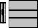
Web Plus User
Internet
External Firewall
Internet Information Services hosting Web Plus
Web Plus database
Internal Firewall
SQL Server
Demilitarized zone

The security of Web Plus is based on the security of the client computer, the communication channel between the client and the web server, the web server, the base operating system, and the configurations of firewalls on either side of the web server. Use of strong logon passwords for logging in to Web Plus is utilized and the sharing of user accounts by users is prohibited.

Security Features of the Web Plus Application Form-Based Authentication
Web Plus uses form-based authentication where users are required to enter their user IDs and passwords to be authenticated by the application.

Role-Based Access
Web Plus also implements a role-based access where users are granted different levels of access depending on their roles. There are currently five roles defined in Web Plus:

Users | Description
Facility Abstractor | Works in a local facility or doctor’s office and handles patients’ medical records and paperwork. When a patient is diagnosed with cancer, the facility abstractor reports the case to the state’s central cancer registry.
Central Registry Abstractor/Reviewer | Reviews abstracts submitted to the central registry for completeness and accuracy and may abstract additional data items from submitted text; also abstracts new cases.
Central Registry Administrator | Sets up the local facilities with access to the Web Plus software to report their data, manages facility accounts and users at both central registry and facilities, configures display types, edit sets and system preferences, manages assignment of abstracts to central registry staff, exports data and views reports.
Local Administrator | Manages local users of a facility
File Uploader | Uploads files of abstracts in the appropriate NAACCR format that were not abstracted using Web Plus, views EDITS error report and cleans, or works with abstractors to clean, errors on rejected files prior to re- uploading.

Other Application Security Features

Other security features of the application include:
- Facilities and offices have access only to those abstracts entered at their facility or office.
- Web Plus keeps an extensive log of user logins, data accesses, and updates for auditing purposes.
- User accounts can be locked out if invalid login attempts exceed a threshold value, configurable by the Central Administrator.
- Current user activities are visible to the Central Administrator through the Current User Activities page.
- Display types and edit set configurations are centrally controlled.
- User passwords are stored in the database using a one-way hash encryption method.
- The Web Plus configuration file can store the connection string to the SQL Server database in encrypted format.

Security Features of the Operating Infrastructure Security on the Client Computer
The client computer is protected from any kind of Trojan horse or spyware attacks via UND anti-virus and anti-spyware software, and ensuring that these programs are up- to-date.

Secure Communication Channel and Server Certificate
Web Plus relies on the existence of a Secure Sockets Layer (SSL) channel between the web server and client browser for the protection of data exchanged over the Internet. In order to set up an SSL channel, the web server has a server certificate installed and the website containing the application and has SSL encryption turned on. The certificate for the server is purchased from a commonly trusted third party commercial organization called a Certificate Authority (CA). The employed certificate of 128-bit cyber strength is the industry standard for secure communication over the Internet.

Secure Connection to the Database
Windows authentication is used for secure connection to the database, so the user’s credentials are not included in the connection string; the connection string is encrypted hiding the database server’s IP address, port number, etc.
Windows authentication is the preferred method from security point of view because this mode does not transmit the user’s credentials over the network. In order for

Windows authentication to work, a mirrored ASPNET process account has been created as a local Windows account with the same name and password on the database server. ASPNET is a least privileged account created at the time of installing
.NET Framework on the web server. By default, all ASP.NET applications run under the security context of this account.
The SQL Server listens on a port number different from the default port, 1433. This port is opened in the internal firewall to allow web server to access the database.

Firewall Protection
The NDSCR system utilizes a custom-configured Cisco PIX 501 firewall to provide added security. The PIX 501 delivers enterprise-class security in a reliable, plug-and- play security appliance. Ideal for securing high-speed, broadband environments, the PIX 501 provides robust security capabilities, networking features, and powerful remote management capabilities:
- Stateful inspection security based on state-of-the-art Adaptive Security Algorithm (ASA).
- Supports over 100 predefined applications, services, and protocols for flexible access control.
- Virtual Private Networking (VPN) for secure remote network access using IKE/IPSec standards.
- Intrusion protection from over 55 different network-based attacks
- URL filtering of outbound web traffic via industry-leading, third-party URL filtering products.
- Integrated switch allows multiple users to share a single broadband connection.

A firewall is a mechanism that enforces a boundary between two points on a network, for example a web server and the Internet. The NDSCR uses a custom-configured firewall setup, where one firewall protects the web server and a second, internal firewall resides between the web server and the database server; through this, an encrypted channel is used for database connections. In this way, as described above, the Web server sits between the external and internal firewalls while the SQL Server, where the Web Plus database is stored, resides inside the internal firewall as part of the trusted network.

IP Lock Down and Daily Monitoring
Access to the NDSCR server is locked down to only the IP addresses of authorized users, preventing professional hacker attacks on the system. Firewall rules are updated on a regular basis to accommodate any changes in IP address of NDSCR staff computers. In addition, the NDSCR Data and System Manager monitors the system daily for any break-in attempts.

Section 4
Cancer Data Reporting Guidelines

Reporting Guidelines
  - Reporting Requirements

Required Cases
  - NDSCR Data Set[NAACCR v18]
  - Reportable ICD-10 Codes
  - Multiple Primaries
  - Manual Implementation Datelines
  - Non-registry Hospital Reporting
  - Multi-facility Reporting

Reporting Guidelines

Reference Date
All cases diagnosed on or after January 1, 1997, are reportable to NDSCR.

Residence Requirements
    - Patient’s residency at the time of diagnosis should be recorded as the patient’s “usual” census and is as follows:
    - Patient’s “usual residence” is where the patient lives and sleeps most of the time.

    - For military personnel and their families living on a military base, the residency is that of the military base. For personnel living off base, the residency is the address where they live.

    - For institutionalized patients, including those who are confined in a nursing, convalescent or rest home, the residency is the address of the institution.
    - For college students, residency is the place of the current residence. For boarding school students, a parent’s residence is the place of residency.
    - For the homeless population with no usual address, code the address as unknown, code the city and the county where the diagnosing hospital is located, and code the state as North Dakota.
    - For persons with more than one residence (i.e., snowbirds), residency is the place they designate as their residence at the time of diagnosis if the usual residence cannot be determined.

Reporting Requirements Clarification

Text:
Text is a very important section of the abstract. Completion of the text fields is required by both the Commission on Cancer and the NDSCR. Documentation in the required text fields includes information used to verify the coding of numerous data items. Documentation must include treatment dates, justification of primary site, histology, and collaborative staging and AJCC staging coding selections.

Malignant Neoplasms:
An individual is considered to have a malignant neoplasm or tumor when indicated by a recognized medical practitioner. A positive pathology report takes precedence over all other

reports or statements. When a pathology report is unavailable, information contained in the record is used to determine if the case is reportable.

- Ambiguous Terminology at Diagnosis: (from STORE 2018)

Ambiguous Terms that Constitute a Diagnosis
Interpret the following terms as a diagnosis of cancer. The database must include patients who have a diagnosis using one or more of these terms:
Apparent(ly) Presumed
Appears Probable
Comparable with Suspect(ed)
Compatible with Suspicious (for)
Consistent with Tumor* (beginning with
Favors 2004 diagnoses and only for
Malignant appearing C70.0–C72.9, C75.1–75)
Most likely Typical of
Neoplasm* (beginning with 2004 diagnoses and only for C70.0–C72.9, C75.1–75.3)
* Additional terms for nonmalignant primary intracranial and central nervous system tumors only

EXCEPTION: If a cytology is identified only with an ambiguous term, do not interpret it as a diagnosis of cancer. Abstract the case only if a positive biopsy or a physician’s clinical impression of cancer supports the cytology findings.

- Ambiguous Terms That Do Not Constitute a Diagnosis without additional information
Cannot be ruled out Questionable
Equivocal Rule out
Possible Suggests
Potentially malignant Worrisome

Required Cases

Reportable Patients
All patients first seen at the reporting facility after January 1, 1997 [NDSCR’s reference date], whether as an inpatient or an outpatient in an ambulatory care setting, who meet one or more of the following criteria must be reported:

All patients with an active, malignant neoplasm, whether being treated or not. All patients with benign central nervous system neoplasm.
All clinically disease-free (NED) patients who are receiving prophylactic or adjuvant cancer- directed therapy.
All patients diagnosed at autopsy.
All patients with a previous diagnosis of a malignant and/or benign central nervous system neoplasm.
All patients with a non-analytic* Class of Case 30 and higher.

Outpatient Only Cases
Outpatient-only cases should be reported if there is sufficient documentation in the medical chart (positive pathology report, positive radiology report, physician documentation, etc.) that definitively establishes that the patient has been diagnosed or has active malignancy and/or is currently undergoing therapy for malignancy.

Non-Analytic Cases
Although the American College of Surgeons/Commission on Cancer does not require accredited facilities to abstract non-analytic cases, NDSCR does require the collection and reporting of all cases that meet the NDSCR reporting requirements regardless of class of case. All fields needs to be completed with the information available in the record being reviewed. Text is especially helpful in processing non-analytic cases.

The NDSCR is a population-based registry and is responsible for the recording of all cancer cases seen in the state of North Dakota, regardless of the place of diagnosis or class of case.
If a patient is seen at the reporting facility for a medical condition that is not related to active cancer but does have evidence of active cancer at any time during the hospital visit (inpatient or outpatient), the case is reportable to NDSCR.

Historical Cases
Patients diagnosed with any cancer during their lifetime are likely to develop new cancers. It is very important for NDSCR to know the number and types of any and all cancers each patient has during his/her lifetime in order to effectively research and evaluate cancer incidence.

If a patient had a reportable in situ or malignant primary diagnosed prior to
NDSCR reference date, the primary sequence number, date of diagnosis and primary site must be included in text field and submitted to NDSCR.

Reportable Neoplasms
Determination of whether or not a given primary malignant neoplasm or benign central nervous system (CNS) neoplasm is reportable is made by reference to the morphology and behavior codes of the International Classification of Disease for Oncology, Third Edition, 2001, (ICD-O-3), 2018 ICD-O-3 Update Table, and the most updated Hematopoietic and Lymphoid Database.

In-situ and Malignant Cancers – NDSCR collects primary malignancies that are either in- situ or malignant. Therefore, any cancer with an ICD-O-3 behavior code of /2 (in-situ) or /3 (malignant) is reportable to NDSCR with the exceptions listed below:
- Pilocytic/Juvenile astrocytoma, listed as 9421/1 in ICD-O-3, should be recorded as 9421/3
- Carcinoid, NOS of the appendix is reportable and must be coded to 8240/3, effective with 2015 diagnosed cases
- Mature teratoma of the testes in adults is malignant and reportable as 9080/3
- Malignant skin primary (C440-C449) with histology codes 8000-8005 (malignant neoplasm), 8010-8046 (epithelial carcinoma), 8050-8084 (squamous cell carcinoma) and 8090-8100 (basal cell carcinoma), are not required
- Carcinoma in situ of cervix, CIN III or SIN III (squamous intraepithelial neoplasia III) of cervix, and PIN III (prostatic intraepithelial neoplasia III) are not required
NDSCR follows the reportability rules of SEER program. In contrast to CoC’s STORE manual, the following diagnoses of intraepithelial neoplasia, grade III are reportable (not a complete list):
- Vulvar intraepithelial neoplasia III (VIN III, 8077/2)
- Vaginal intraepithelial neoplasia III (VaIN III, 8077/2)
- Anal intraepithelial neoplasia III (AIN III, 8077/2) of the anus or anal canal (C210- C211)
- Laryngeal intraepithelial neoplasia III (LIN III, 8077/2)
- High grade biliary intraepithelial neoplasia (BiIN III, 8148/2) of the gallbladder
- Pancreatic intraepithelial neoplasia III (PanIN III, 8148/2)
- Mucinous cystic neoplasm of the pancreas with high grade dysplasia (8470/2), previously known as non-invasive mucinous cystadenocarcinoma
- Penile intraepithelial neoplasia III (PeIN III, 8077/2)

Benign and Borderline CNS Neoplasms Beginning with cases diagnosed in 2004, non- malignant primary intracranial and central nervous system (CNS) tumors with ICD-O-3 behavior code of 0 or 1 are reportable for the following sites: meninges (C70._), brain (C71._), Spinal cord, cranial nerves, and other parts of central nervous system (C72._), pituitary gland (C75.1), craniopharyngeal duct (C75.2) and pineal gland (C75.3).

Gastrointestinal stromal tumors (GIST) and thymomas are reportable when there is evidence of multiple foci, lymph node involvement or metastasis. A behavior code of 3 should be assigned to these cases.

All cases meet the above reportable criteria are required to be submitted to NDSCR, including non-analytic cases.

NDSCR Data Set

The NDSCR collects clinical and demographic data on the state’s residents diagnosed with cancer. To ensure that data items and their corresponding codes and definitions are consistent across statewide cancer registries and national databases, the NDSCR recognizes the importance of the national standard and adopts the current NAACCR data record layout for use. See the following pages for current required data elements.

NAACCR Record Layout Version 18
The table below is adapted from the NAACCR website (http://datadictionary.naaccr.org/?c=7), which presents Version 18 of the NAACCR record layout. The NDSCR follows the standard of record layout developed by the NAACCR.

Column# | Length | Item# | Item Name | XML NAACCR ID | PARENT XML ELEMENT | Section | Note
1 - 1 | 1 | 10 | Record Type | recordType | NaaccrData | Record ID | Revised
2 - 2 | 1 | 30 | Registry Type | registryType | NaaccrData | Record ID | Revised
3 - 16 | 14 | 37 | Reserved 00 | reserved00 | Tumor | Record ID | Revised
17 - 19 | 3 | 50 | NAACCR Record Version | naaccrRecordVersion | NaaccrData | Record ID | Revised

Column# | Length | Item# | Item Name | XML NAACCR ID | PARENT XML ELEMENT | Section | Note
20 - 29 | 10 | 45 | NPI--Registry ID | npiRegistryId | NaaccrData | Record ID | Revised
30 - 39 | 10 | 40 | Registry ID | registryId | NaaccrData | Record ID | Revised
40 - 41 | 2 | 60 | Tumor Record Number | tumorRecordNumber | Tumor | Record ID | Revised
42 - 49 | 8 | 20 | Patient ID Number | patientIdNumber | Patient | Record ID | Revised
50 - 57 | 8 | 21 | Patient System ID- Hosp | patientSystemIdHosp | Tumor | Record ID | Revised
58 - 73 | 16 | 370 | Reserved 01 | reserved01 | Tumor | Record ID | Revised
74 -  123 | 50 | 70 | Addr at DX--City | addrAtDxCity | Tumor | Demographic | Revised
124 -  125 | 2 | 80 | Addr at DX--State | addrAtDxState | Tumor | Demographic | Revised
126 -  134 | 9 | 100 | Addr at DX--Postal Code | addrAtDxPostalCode | Tumor | Demographic | Revised
135 -  137 | 3 | 90 | County at DX Reported | countyAtDx | Tumor | Demographic | Revised
138 -  149 | 12 | 2450 | Reserved 16 | reserved16 | Tumor | Demographic | Revised
150 -  152 | 3 | 89 | County at DX Analysis | countyAtDxAnalysis | Tumor | Demographic | New
153 -  164 | 12 | 351 | GeoLocationID - 1970/80/90 | geolocationid19708090 | Tumor | Demographic | New
153 -  154 | 2 | 81 | State at DX Geocode 1970/80/90 | stateAtDxGeocode19708090 | Tumor | Demographic | New

Column# | Length | Item# | Item Name | XML NAACCR ID | PARENT XML ELEMENT | Section | Note
155 -  157 | 3 | 94 | County at DX Geocode 1970/80/90 | countyAtDxGeocode1990 | Tumor | Demographic | Revised
158 -  163 | 6 | 110 | Census Tract 1970/80/90 | censusTract19708090 | Tumor | Demographic | Revised
164 -  164 | 1 | 368 | Census Block Grp 1970/80/90 | censusBlockGrp197090 | Tumor | Demographic | Revised
165 -  165 | 1 | 120 | Census Cod Sys 1970/80/90 | censusCodSys19708090 | Tumor | Demographic | Revised
166 -  166 | 1 | 364 | Census Tr Cert 1970/80/90 | censusTrCert19708090 | Tumor | Demographic | Revised
167 -  168 | 2 | 82 | State at DX Geocode 2000 | stateAtDxGeocode2000 | Tumor | Demographic | New
167 -  178 | 12 | 352 | GeoLocationID - 2000 | geolocationid2000 | Tumor | Demographic | New
169 -  171 | 3 | 95 | County at DX Geocode2000 | countyAtDxGeocode2000 | Tumor | Demographic | Revised
172 -  177 | 6 | 130 | Census Tract 2000 | censusTract2000 | Tumor | Demographic | Revised
178 -  178 | 1 | 362 | Census Block Group 2000 | censusBlockGroup2000 | Tumor | Demographic | Revised
179 -  179 | 1 | 365 | Census Tr Certainty 2000 | censusTrCertainty2000 | Tumor | Demographic | Revised
180 -  181 | 2 | 83 | State at DX Geocode 2010 | stateAtDxGeocode2010 | Tumor | Demographic | New
180 -  191 | 12 | 353 | GeoLocationID - 2010 | geolocationid2010 | Tumor | Demographic | New

Column# | Length | Item# | Item Name | XML NAACCR ID | PARENT XML ELEMENT | Section | Note
182 -  184 | 3 | 96 | County at DX Geocode2010 | countyAtDxGeocode2010 | Tumor | Demographic | Revised
185 -  190 | 6 | 135 | Census Tract 2010 | censusTract2010 | Tumor | Demographic | Revised
191 -  191 | 1 | 363 | Census Block Group 2010 | censusBlockGroup2010 | Tumor | Demographic | Revised
192 -  192 | 1 | 367 | Census Tr Certainty 2010 | censusTrCertainty2010 | Tumor | Demographic | Revised
193 -  194 | 2 | 84 | State at DX Geocode 2020 | stateAtDxGeocode2020 | Tumor | Demographic | New
193 -  204 | 12 | 354 | GeoLocationID - 2020 | geolocationid2020 | Tumor | Demographic | New
195 -  197 | 3 | 97 | County at DX Geocode2020 | countyAtDxGeocode2020 | Tumor | Demographic | Revised
198 -  203 | 6 | 125 | Census Tract 2020 | censusTract2020 | Tumor | Demographic | New
204 -  204 | 1 | 361 | Census Block Group 2020 | censusBlockGroup2020 | Tumor | Demographic | New
205 -  205 | 1 | 369 | Census Tract Certainty 2020 | censusTractCertainty2020 | Tumor | Demographic | New
206 -  206 | 1 | 150 | Marital Status at DX | maritalStatusAtDx | Tumor | Demographic | Revised
207 -  208 | 2 | 160 | Race 1 | race1 | Patient | Demographic | Revised
209 -  210 | 2 | 161 | Race 2 | race2 | Patient | Demographic | Revised

Column# | Length | Item# | Item Name | XML NAACCR ID | PARENT XML ELEMENT | Section | Note
211 -  212 | 2 | 162 | Race 3 | race3 | Patient | Demographic | Revised
213 -  214 | 2 | 163 | Race 4 | race4 | Patient | Demographic | Revised
215 -  216 | 2 | 164 | Race 5 | race5 | Patient | Demographic | Revised
217 -  217 | 1 | 170 | Race Coding Sys-- Current | raceCodingSysCurrent | Patient | Demographic | Revised
218 -  218 | 1 | 180 | Race Coding Sys-- Original | raceCodingSysOriginal | Patient | Demographic | Revised
219 -  219 | 1 | 190 | Spanish/Hispanic Origin | spanishHispanicOrigin | Patient | Demographic | Revised
220 -  220 | 1 | 200 | Computed Ethnicity | computedEthnicity | Patient | Demographic | Revised
221 -  221 | 1 | 210 | Computed Ethnicity Source | computedEthnicitySource | Patient | Demographic | Revised
222 -  222 | 1 | 220 | Sex | sex | Patient | Demographic | Revised
223 -  225 | 3 | 230 | Age at Diagnosis | ageAtDiagnosis | Tumor | Demographic | Revised
226 -  233 | 8 | 240 | Date of Birth | dateOfBirth | Patient | Demographic | Revised
234 -  235 | 2 | 241 | Date of Birth Flag | dateOfBirthFlag | Patient | Demographic | Revised
236 -  238 | 3 | 250 | Birthplace | birthplace | Patient | Demographic | Revised

Column# | Length | Item# | Item Name | XML NAACCR ID | PARENT XML ELEMENT | Section | Note
239 -  241 | 3 | 270 | Census Occ Code 1970-2000 | censusOccCode19702000 | Tumor | Demographic | Revised
242 -  244 | 3 | 280 | Census Ind Code 1970-2000 | censusIndCode19702000 | Tumor | Demographic | Revised
245 -  245 | 1 | 290 | Occupation Source | occupationSource | Tumor | Demographic | Revised
246 -  246 | 1 | 300 | Industry Source | industrySource | Tumor | Demographic | Revised
247 -  346 | 100 | 310 | Text--Usual Occupation | textUsualOccupation | Tumor | Demographic | Revised
347 -  446 | 100 | 320 | Text--Usual Industry | textUsualIndustry | Tumor | Demographic | Revised
447 -  447 | 1 | 330 | Census Occ/Ind Sys 70-00 | censusOccIndSys7000 | Tumor | Demographic | Revised
448 -  448 | 1 | 191 | NHIA Derived Hisp Origin | nhiaDerivedHispOrigin | Patient | Demographic | Revised
449 -  450 | 2 | 193 | Race-- NAPIIA(derived API) | raceNapiia | Patient | Demographic | Revised
451 -  451 | 1 | 192 | IHS Link | ihsLink | Patient | Demographic | Revised
452 -  453 | 2 | 366 | GIS Coordinate Quality | gisCoordinateQuality | Tumor | Demographic | Revised
454 -  455 | 2 | 3300 | RuralUrban Continuum 1993 | ruralurbanContinuum1993 | Tumor | Demographic | Revised
456 -  457 | 2 | 3310 | RuralUrban Continuum 2003 | ruralurbanContinuum2003 | Tumor | Demographic | Revised

Column# | Length | Item# | Item Name | XML NAACCR ID | PARENT XML ELEMENT | Section | Note
458 -  459 | 2 | 3312 | RuralUrban Continuum 2013 | ruralurbanContinuum2013 | Tumor | Demographic | Revised
460 -  460 | 1 | 339 | RUCA 2000 | ruca2000 | Tumor | Demographic | New
461 -  461 | 1 | 341 | RUCA 2010 | ruca2010 | Tumor | Demographic | New
462 -  462 | 1 | 345 | URIC 2000 | uric2000 | Tumor | Demographic | New
463 -  463 | 1 | 346 | URIC 2010 | uric2010 | Tumor | Demographic | New
464 -  466 | 3 | 102 | Addr at DX--Country | addrAtDxCountry | Tumor | Demographic | Revised
467 -  469 | 3 | 1832 | Addr Current-- Country | addrCurrentCountry | Patient | Demographic | Revised
470 -  471 | 2 | 252 | Birthplace--State | birthplaceState | Patient | Demographic | Revised
472 -  474 | 3 | 254 | Birthplace--Country | birthplaceCountry | Patient | Demographic | Revised
475 -  477 | 3 | 1847 | FollowUp Contact-- Country | followupContactCountry | Tumor | Demographic | Revised
478 -  479 | 2 | 1942 | Place of Death--State | placeOfDeathState | Patient | Demographic | Revised
480 -  482 | 3 | 1944 | Place of Death-- Country | placeOfDeathCountry | Patient | Demographic | Revised
483 -  486 | 4 | 272 | Census Ind Code 2010 CDC | censusIndCode2010 | Tumor | Demographic | Revised

Column# | Length | Item# | Item Name | XML NAACCR ID | PARENT XML ELEMENT | Section | Note
487 -  490 | 4 | 282 | Census Occ Code 2010 CDC | censusOccCode2010 | Tumor | Demographic | Revised
491 -  491 | 1 | 145 | Census Tr Poverty Indictr | censusTrPovertyIndictr | Tumor | Demographic | Revised
492 -  541 | 50 | 530 | Reserved 02 | reserved02 | Tumor | Demographic | Revised
542 -  543 | 2 | 380 | Sequence Number-- Central | sequenceNumberCentral | Tumor | Cancer Identification | Revised
544 -  551 | 8 | 390 | Date of Diagnosis | dateOfDiagnosis | Tumor | Cancer Identification | Revised
552 -  553 | 2 | 391 | Date of Diagnosis Flag | dateOfDiagnosisFlag | Tumor | Cancer Identification | Revised
554 -  557 | 4 | 400 | Primary Site | primarySite | Tumor | Cancer Identification | Revised
558 -  558 | 1 | 410 | Laterality | laterality | Tumor | Cancer Identification | Revised
559 -  563 | 5 | 419 | Morph--Type&Behav ICD-O-2 | morphTypebehavIcdO2 | Tumor | Cancer Identification | Revised
559 -  562 | 4 | 420 | Histology (92-00) ICD-O-2 | histologyIcdO2 | Tumor | Cancer Identification | Revised
563 -  563 | 1 | 430 | Behavior (92-00) ICD-O-2 | behaviorIcdO2 | Tumor | Cancer Identification | Revised
564 -  568 | 5 | 521 | Morph--Type&Behav ICD-O-3 | morphTypebehavIcdO3 | Tumor | Cancer Identification | Revised
564 -  567 | 4 | 522 | Histologic Type ICD- O-3 | histologicTypeIcdO3 | Tumor | Cancer Identification | Revised

Column# | Length | Item# | Item Name | XML NAACCR ID | PARENT XML ELEMENT | Section | Note
568 -  568 | 1 | 523 | Behavior Code ICD- O-3 | behaviorCodeIcdO3 | Tumor | Cancer Identification | Revised
569 -  569 | 1 | 440 | Grade | grade | Tumor | Cancer Identification | Revised
570 -  570 | 1 | 441 | Grade Path Value | gradePathValue | Tumor | Cancer Identification | Revised
571 -  571 | 1 | 449 | Grade Path System | gradePathSystem | Tumor | Cancer Identification | Revised
572 -  572 | 1 | 450 | Site Coding Sys-- Current | siteCodingSysCurrent | Tumor | Cancer Identification | Revised
573 -  573 | 1 | 460 | Site Coding Sys-- Original | siteCodingSysOriginal | Tumor | Cancer Identification | Revised
574 -  574 | 1 | 470 | Morph Coding Sys-- Current | morphCodingSysCurrent | Tumor | Cancer Identification | Revised
575 -  575 | 1 | 480 | Morph Coding Sys-- Originl | morphCodingSysOriginl | Tumor | Cancer Identification | Revised
576 -  576 | 1 | 490 | Diagnostic Confirmation | diagnosticConfirmation | Tumor | Cancer Identification | Revised
577 -  577 | 1 | 500 | Type of Reporting Source | typeOfReportingSource | Tumor | Cancer Identification | Revised
578 -  579 | 2 | 501 | Casefinding Source | casefindingSource | Tumor | Cancer Identification | Revised
580 -  580 | 1 | 442 | Ambiguous Terminology DX | ambiguousTerminologyDx | Tumor | Cancer Identification | Revised
581 -  588 | 8 | 443 | Date Conclusive DX | dateConclusiveDx | Tumor | Cancer Identification | Revised

Column# | Length | Item# | Item Name | XML NAACCR ID | PARENT XML ELEMENT | Section | Note
589 -  590 | 2 | 448 | Date Conclusive DX Flag | dateConclusiveDxFlag | Tumor | Cancer Identification | Revised
591 -  592 | 2 | 444 | Mult Tum Rpt as One Prim | multTumRptAsOnePrim | Tumor | Cancer Identification | Revised
593 -  600 | 8 | 445 | Date of Mult Tumors | dateOfMultTumors | Tumor | Cancer Identification | Revised
601 -  602 | 2 | 439 | Date of Mult Tumors Flag | dateOfMultTumorsFlag | Tumor | Cancer Identification | Revised
603 -  604 | 2 | 446 | Multiplicity Counter | multiplicityCounter | Tumor | Cancer Identification | Revised
605 -  704 | 100 | 680 | Reserved 03 | reserved03 | Tumor | Cancer Identification | Revised
705 -  714 | 10 | 545 | NPI--Reporting Facility | npiReportingFacility | Tumor | Hospital- Specific | Revised
715 -  724 | 10 | 540 | Reporting Facility | reportingFacility | Tumor | Hospital- Specific | Revised
725 -  734 | 10 | 3105 | NPI--Archive FIN | npiArchiveFin | Tumor | Hospital- Specific | Revised
735 -  744 | 10 | 3100 | Archive FIN | archiveFin | Tumor | Hospital- Specific | Revised
745 -  753 | 9 | 550 | Accession Number-- Hosp | accessionNumberHosp | Tumor | Hospital- Specific | Revised
754 -  755 | 2 | 560 | Sequence Number-- Hospital | sequenceNumberHospital | Tumor | Hospital- Specific | Revised
756 -  758 | 3 | 570 | Abstracted By | abstractedBy | Tumor | Hospital- Specific | Revised

Column# | Length | Item# | Item Name | XML NAACCR ID | PARENT XML ELEMENT | Section | Note
759 -  766 | 8 | 580 | Date of 1st Contact | dateOf1stContact | Tumor | Hospital- Specific | Revised
767 -  768 | 2 | 581 | Date of 1st Contact Flag | dateOf1stContactFlag | Tumor | Hospital- Specific | Revised
769 -  776 | 8 | 590 | Date of Inpt Adm | dateOfInptAdm | Tumor | Hospital- Specific | Revised
777 -  778 | 2 | 591 | Date of Inpt Adm Flag | dateOfInptAdmFlag | Tumor | Hospital- Specific | Revised
779 -  786 | 8 | 600 | Date of Inpt Disch | dateOfInptDisch | Tumor | Hospital- Specific | Revised
787 -  788 | 2 | 601 | Date of Inpt Disch Flag | dateOfInptDischFlag | Tumor | Hospital- Specific | Revised
789 -  789 | 1 | 605 | Inpatient Status | inpatientStatus | Tumor | Hospital- Specific | Revised
790 -  791 | 2 | 610 | Class of Case | classOfCase | Tumor | Hospital- Specific | Revised
792 -  793 | 2 | 630 | Primary Payer at DX | primaryPayerAtDx | Tumor | Hospital- Specific | Revised
794 -  794 | 1 | 668 | RX Hosp--Surg App 2010 | rxHospSurgApp2010 | Tumor | Hospital- Specific | Revised
795 -  796 | 2 | 670 | RX Hosp--Surg Prim Site | rxHospSurgPrimSite | Tumor | Hospital- Specific | Revised
797 -  797 | 1 | 672 | RX Hosp--Scope Reg LN Sur | rxHospScopeRegLnSur | Tumor | Hospital- Specific | Revised
798 -  798 | 1 | 674 | RX Hosp--Surg Oth Reg/Dis | rxHospSurgOthRegDis | Tumor | Hospital- Specific | Revised

Column# | Length | Item# | Item Name | XML NAACCR ID | PARENT XML ELEMENT | Section | Note
799 -  800 | 2 | 676 | RX Hosp--Reg LN Removed | rxHospRegLnRemoved | Tumor | Hospital- Specific | Revised
801 -  801 | 1 | 690 | RX Hosp--Radiation | rxHospRadiation | Tumor | Hospital- Specific | Revised
802 -  803 | 2 | 700 | RX Hosp--Chemo | rxHospChemo | Tumor | Hospital- Specific | Revised
804 -  805 | 2 | 710 | RX Hosp--Hormone | rxHospHormone | Tumor | Hospital- Specific | Revised
806 -  807 | 2 | 720 | RX Hosp--BRM | rxHospBrm | Tumor | Hospital- Specific | Revised
808 -  808 | 1 | 730 | RX Hosp--Other | rxHospOther | Tumor | Hospital- Specific | Revised
809 -  810 | 2 | 740 | RX Hosp--DX/Stg Proc | rxHospDxStgProc | Tumor | Hospital- Specific | Revised
811 -  811 | 1 | 3280 | RX Hosp--Palliative Proc | rxHospPalliativeProc | Tumor | Hospital- Specific | Revised
812 -  813 | 2 | 746 | RX Hosp--Surg Site 98-02 | rxHospSurgSite9802 | Tumor | Hospital- Specific | Revised
814 -  814 | 1 | 747 | RX Hosp--Scope Reg 98-02 | rxHospScopeReg9802 | Tumor | Hospital- Specific | Revised
815 -  815 | 1 | 748 | RX Hosp--Surg Oth 98-02 | rxHospSurgOth9802 | Tumor | Hospital- Specific | Revised
816 -  865 | 50 | 750 | Reserved 04 | reserved04 | Tumor | Hospital- Specific | Revised
866 -  867 | 2 | 930 | TNM Path Staged By | tnmPathStagedBy | Tumor | Stage/Prognostic Factors | Revised

Column# | Length | Item# | Item Name | XML NAACCR ID | PARENT XML ELEMENT | Section | Note
868 -  869 | 2 | 990 | TNM Clin Staged By | tnmClinStagedBy | Tumor | Stage/Prognostic Factors | Revised
870 -  870 | 1 | 1112 | Mets at DX-Bone | metsAtDxBone | Tumor | Stage/Prognostic Factors | Revised
871 -  871 | 1 | 1113 | Mets at DX-Brain | metsAtDxBrain | Tumor | Stage/Prognostic Factors | Revised
872 -  872 | 1 | 1114 | Mets at Dx-Distant LN | metsAtDxDistantLn | Tumor | Stage/Prognostic Factors | Revised
873 -  873 | 1 | 1115 | Mets at DX-Liver | metsAtDxLiver | Tumor | Stage/Prognostic Factors | Revised
874 -  874 | 1 | 1116 | Mets at DX-Lung | metsAtDxLung | Tumor | Stage/Prognostic Factors | Revised
875 -  875 | 1 | 1117 | Mets at DX-Other | metsAtDxOther | Tumor | Stage/Prognostic Factors | Revised
876 -  878 | 3 | 752 | Tumor Size Clinical | tumorSizeClinical | Tumor | Stage/Prognostic Factors | Revised
879 -  881 | 3 | 754 | Tumor Size Pathologic | tumorSizePathologic | Tumor | Stage/Prognostic Factors | Revised
882 -  884 | 3 | 756 | Tumor Size Summary | tumorSizeSummary | Tumor | Stage/Prognostic Factors | Revised
885 -  889 | 5 | 3605 | Derived SEER Path Stg Grp | derivedSeerPathStgGrp | Tumor | Stage/Prognostic Factors | Revised
890 -  894 | 5 | 3610 | Derived SEER Clin Stg Grp | derivedSeerClinStgGrp | Tumor | Stage/Prognostic Factors | Revised
895 -  899 | 5 | 3614 | Derived SEER Cmb Stg Grp | derivedSeerCmbStgGrp | Tumor | Stage/Prognostic Factors | Revised

Column# | Length | Item# | Item Name | XML NAACCR ID | PARENT XML ELEMENT | Section | Note
900 -  904 | 5 | 3616 | Derived SEER Combined T | derivedSeerCombinedT | Tumor | Stage/Prognostic Factors | Revised
905 -  909 | 5 | 3618 | Derived SEER Combined N | derivedSeerCombinedN | Tumor | Stage/Prognostic Factors | Revised
910 -  914 | 5 | 3620 | Derived SEER Combined M | derivedSeerCombinedM | Tumor | Stage/Prognostic Factors | Revised
915 -  915 | 1 | 3622 | Derived SEER Cmb T Src | derivedSeerCmbTSrc | Tumor | Stage/Prognostic Factors | Revised
916 -  916 | 1 | 3624 | Derived SEER Cmb N Src | derivedSeerCmbNSrc | Tumor | Stage/Prognostic Factors | Revised
917 -  917 | 1 | 3626 | Derived SEER Cmb M Src | derivedSeerCmbMSrc | Tumor | Stage/Prognostic Factors | Revised
918 -  920 | 3 | 772 | EOD Primary Tumor | eodPrimaryTumor | Tumor | Stage/Prognostic Factors | Revised
921 -  923 | 3 | 774 | EOD Regional Nodes | eodRegionalNodes | Tumor | Stage/Prognostic Factors | Revised
924 -  925 | 2 | 776 | EOD Mets | eodMets | Tumor | Stage/Prognostic Factors | Revised
926 -  940 | 15 | 785 | Derived EOD 2018 T | derivedEod2018T | Tumor | Stage/Prognostic Factors | New
941 -  955 | 15 | 815 | Derived EOD 2018 N | derivedEod2018N | Tumor | Stage/Prognostic Factors | New
956 -  970 | 15 | 795 | Derived EOD 2018 M | derivedEod2018M | Tumor | Stage/Prognostic Factors | New
971 -  985 | 15 | 818 | Derived EOD 2018 Stage Group | derivedEod2018StageGroup | Tumor | Stage/Prognostic Factors | New

Column# | Length | Item# | Item Name | XML NAACCR ID | PARENT XML ELEMENT | Section | Note
986 -  986 | 1 | 762 | Derived Summary Stage 2018 | derivedSummaryStage2018 | Tumor | Stage/Prognostic Factors | Revised
987 -  987 | 1 | 764 | Summary Stage 2018 | summaryStage2018 | Tumor | Stage/Prognostic Factors | Revised
988 -  988 | 1 | 759 | SEER Summary Stage 2000 | seerSummaryStage2000 | Tumor | Stage/Prognostic Factors | Revised
989 -  989 | 1 | 760 | SEER Summary Stage 1977 | seerSummaryStage1977 | Tumor | Stage/Prognostic Factors | Revised
990 -  1001 | 12 | 779 | Extent of Disease 10- Dig | extentOfDisease10Dig | Tumor | Stage/Prognostic Factors | Revised
990 -  992 | 3 | 780 | EOD--Tumor Size | eodTumorSize | Tumor | Stage/Prognostic Factors | Revised
993 -  994 | 2 | 790 | EOD--Extension | eodExtension | Tumor | Stage/Prognostic Factors | Revised
995 -  996 | 2 | 800 | EOD--Extension Prost Path | eodExtensionProstPath | Tumor | Stage/Prognostic Factors | Revised
997 -  997 | 1 | 810 | EOD--Lymph Node Involv | eodLymphNodeInvolv | Tumor | Stage/Prognostic Factors | Revised
998 -  999 | 2 | 820 | Regional Nodes Positive | regionalNodesPositive | Tumor | Stage/Prognostic Factors | Revised
1000 -  1001 | 2 | 830 | Regional Nodes Examined | regionalNodesExamined | Tumor | Stage/Prognostic Factors | Revised
1002 -  1009 | 8 | 682 | Date Regional Lymph Node Dissection | dateRegionalLymphNodeDisse ction | Tumor | Stage/Prognostic Factors | New
1010 -  1011 | 2 | 683 | Date Regional Lymph Node Dissection Flag | dateRegionalLymphNodeDisse ctionFlag | Tumor | Stage/Prognostic Factors | New

Column# | Length | Item# | Item Name | XML NAACCR ID | PARENT XML ELEMENT | Section | Note
1012 -  1013 | 2 | 835 | Sentinel Lymph Nodes Positive | sentinelLymphNodesPositive | Tumor | Stage/Prognostic Factors | New
1014 -  1015 | 2 | 834 | Sentinel Lymph Nodes Examined | sentinelLymphNodesExamined | Tumor | Stage/Prognostic Factors | New
1016 -  1023 | 8 | 832 | Date of Sentinel Lymph Node Biopsy | dateOfSentinelLymphNodeBio psy | Tumor | Stage/Prognostic Factors | New
1024 -  1025 | 2 | 833 | Date of Sentinel Lymph Node Biopsy Flag | dateSentinelLymphNodeBiops yFlag | Tumor | Stage/Prognostic Factors | New
1026 -  1038 | 13 | 840 | EOD--Old 13 Digit | eodOld13Digit | Tumor | Stage/Prognostic Factors | Revised
1039 -  1040 | 2 | 850 | EOD--Old 2 Digit | eodOld2Digit | Tumor | Stage/Prognostic Factors | Revised
1041 -  1044 | 4 | 860 | EOD--Old 4 Digit | eodOld4Digit | Tumor | Stage/Prognostic Factors | Revised
1045 -  1045 | 1 | 870 | Coding System for EOD | codingSystemForEod | Tumor | Stage/Prognostic Factors | Revised
1046 -  1047 | 2 | 1060 | TNM Edition Number | tnmEditionNumber | Tumor | Stage/Prognostic Factors | Revised
1048 -  1051 | 4 | 880 | TNM Path T | tnmPathT | Tumor | Stage/Prognostic Factors | Revised
1052 -  1055 | 4 | 890 | TNM Path N | tnmPathN | Tumor | Stage/Prognostic Factors | Revised
1056 -  1059 | 4 | 900 | TNM Path M | tnmPathM | Tumor | Stage/Prognostic Factors | Revised
1060 -  1063 | 4 | 910 | TNM Path Stage Group | tnmPathStageGroup | Tumor | Stage/Prognostic Factors | Revised

Column# | Length | Item# | Item Name | XML NAACCR ID | PARENT XML ELEMENT | Section | Note
1064 -  1064 | 1 | 920 | TNM Path Descriptor | tnmPathDescriptor | Tumor | Stage/Prognostic Factors | Revised
1065 -  1068 | 4 | 940 | TNM Clin T | tnmClinT | Tumor | Stage/Prognostic Factors | Revised
1069 -  1072 | 4 | 950 | TNM Clin N | tnmClinN | Tumor | Stage/Prognostic Factors | Revised
1073 -  1076 | 4 | 960 | TNM Clin M | tnmClinM | Tumor | Stage/Prognostic Factors | Revised
1077 -  1080 | 4 | 970 | TNM Clin Stage Group | tnmClinStageGroup | Tumor | Stage/Prognostic Factors | Revised
1081 -  1081 | 1 | 980 | TNM Clin Descriptor | tnmClinDescriptor | Tumor | Stage/Prognostic Factors | Revised
1082 -  1096 | 15 | 1001 | AJCC TNM Clin T | ajccTnmClinT | Tumor | Stage/Prognostic Factors | New
1097 -  1100 | 4 | 1031 | AJCC TNM Clin T  Suffix | ajccTnmClinTSuffix | Tumor | Stage/Prognostic Factors | New
1101 -  1115 | 15 | 1002 | AJCC TNM Clin N | ajccTnmClinN | Tumor | Stage/Prognostic Factors | New
1116 -  1119 | 4 | 1034 | AJCC TNM Clin N  Suffix | ajccTnmClinNSuffix | Tumor | Stage/Prognostic Factors | New
1120 -  1134 | 15 | 1003 | AJCC TNM Clin M | ajccTnmClinM | Tumor | Stage/Prognostic Factors | New
1135 -  1149 | 15 | 1004 | AJCC TNM Clin  Stage Group | ajccTnmClinStageGroup | Tumor | Stage/Prognostic Factors | New
1150 -  1164 | 15 | 1011 | AJCC TNM Path T | ajccTnmPathT | Tumor | Stage/Prognostic Factors | New

Column# | Length | Item# | Item Name | XML NAACCR ID | PARENT XML ELEMENT | Section | Note
1165 -  1168 | 4 | 1032 | AJCC TNM Path T  Suffix | ajccTnmPathTSuffix | Tumor | Stage/Prognostic Factors | New
1169 -  1183 | 15 | 1012 | AJCC TNM Path N | ajccTnmPathN | Tumor | Stage/Prognostic Factors | New
1184 -  1187 | 4 | 1035 | AJCC TNM Path N  Suffix | ajccTnmPathNSuffix | Tumor | Stage/Prognostic Factors | New
1188 -  1202 | 15 | 1013 | AJCC TNM Path M | ajccTnmPathM | Tumor | Stage/Prognostic Factors | New
1203 -  1217 | 15 | 1014 | AJCC TNM Path  Stage Group | ajccTnmPathStageGroup | Tumor | Stage/Prognostic Factors | New
1218 -  1232 | 15 | 1021 | AJCC TNM Post  Therapy T | ajccTnmPostTherapyT | Tumor | Stage/Prognostic Factors | New
1233 -  1236 | 4 | 1033 | AJCC TNM Post  Therapy T Suffix | ajccTnmPostTherapyTSuffix | Tumor | Stage/Prognostic Factors | New
1237 -  1251 | 15 | 1022 | AJCC TNM Post  Therapy N | ajccTnmPostTherapyN | Tumor | Stage/Prognostic Factors | New
1252 -  1255 | 4 | 1036 | AJCC TNM Post  Therapy N Suffix | ajccTnmPostTherapyNSuffix | Tumor | Stage/Prognostic Factors | New
1256 -  1270 | 15 | 1023 | AJCC TNM Post  Therapy M | ajccTnmPostTherapyM | Tumor | Stage/Prognostic Factors | New
1271 -  1285 | 15 | 1024 | AJCC TNM Post  Therapy Stage Group | ajccTnmPostTherapyStageGro up | Tumor | Stage/Prognostic Factors | New
1286 -  1286 | 1 | 3843 | Grade Clinical | gradeClinical | Tumor | Stage/Prognostic Factors | New
1287 -  1287 | 1 | 3844 | Grade Pathological | gradePathological | Tumor | Stage/Prognostic Factors | New

Column# | Length | Item# | Item Name | XML NAACCR ID | PARENT XML ELEMENT | Section | Note
1288 -  1288 | 1 | 3845 | Grade Post Therapy | gradePostTherapy | Tumor | Stage/Prognostic Factors | New
1289 -  1290 | 2 | 1120 | Pediatric Stage | pediatricStage | Tumor | Stage/Prognostic Factors | Revised
1291 -  1292 | 2 | 1130 | Pediatric Staging System | pediatricStagingSystem | Tumor | Stage/Prognostic Factors | Revised
1293 -  1293 | 1 | 1140 | Pediatric Staged By | pediatricStagedBy | Tumor | Stage/Prognostic Factors | Revised
1294 -  1294 | 1 | 1150 | Tumor Marker 1 | tumorMarker1 | Tumor | Stage/Prognostic Factors | Revised
1295 -  1295 | 1 | 1160 | Tumor Marker 2 | tumorMarker2 | Tumor | Stage/Prognostic Factors | Revised
1296 -  1296 | 1 | 1170 | Tumor Marker 3 | tumorMarker3 | Tumor | Stage/Prognostic Factors | Revised
1297 -  1297 | 1 | 1182 | Lymphovascular Invasion | lymphVascularInvasion | Tumor | Stage/Prognostic Factors | Revised
1298 -  1300 | 3 | 2800 | CS Tumor Size | csTumorSize | Tumor | Stage/Prognostic Factors | Revised
1301 -  1303 | 3 | 2810 | CS Extension | csExtension | Tumor | Stage/Prognostic Factors | Revised
1304 -  1304 | 1 | 2820 | CS Tumor Size/Ext Eval | csTumorSizeExtEval | Tumor | Stage/Prognostic Factors | Revised
1305 -  1307 | 3 | 2830 | CS Lymph Nodes | csLymphNodes | Tumor | Stage/Prognostic Factors | Revised
1308 -  1308 | 1 | 2840 | CS Lymph Nodes Eval | csLymphNodesEval | Tumor | Stage/Prognostic Factors | Revised

Column# | Length | Item# | Item Name | XML NAACCR ID | PARENT XML ELEMENT | Section | Note
1309 -  1310 | 2 | 2850 | CS Mets at DX | csMetsAtDx | Tumor | Stage/Prognostic Factors | Revised
1311 -  1311 | 1 | 2860 | CS Mets Eval | csMetsEval | Tumor | Stage/Prognostic Factors | Revised
1312 -  1312 | 1 | 2851 | CS Mets at Dx-Bone | csMetsAtDxBone | Tumor | Stage/Prognostic Factors | Revised
1313 -  1313 | 1 | 2852 | CS Mets at Dx-Brain | csMetsAtDxBrain | Tumor | Stage/Prognostic Factors | Revised
1314 -  1314 | 1 | 2853 | CS Mets at Dx-Liver | csMetsAtDxLiver | Tumor | Stage/Prognostic Factors | Revised
1315 -  1315 | 1 | 2854 | CS Mets at Dx-Lung | csMetsAtDxLung | Tumor | Stage/Prognostic Factors | Revised
1316 -  1318 | 3 | 2880 | CS Site-Specific Factor 1 | csSiteSpecificFactor1 | Tumor | Stage/Prognostic Factors | Revised
1319 -  1321 | 3 | 2890 | CS Site-Specific Factor 2 | csSiteSpecificFactor2 | Tumor | Stage/Prognostic Factors | Revised
1322 -  1324 | 3 | 2900 | CS Site-Specific Factor 3 | csSiteSpecificFactor3 | Tumor | Stage/Prognostic Factors | Revised
1325 -  1327 | 3 | 2910 | CS Site-Specific Factor 4 | csSiteSpecificFactor4 | Tumor | Stage/Prognostic Factors | Revised
1328 -  1330 | 3 | 2920 | CS Site-Specific Factor 5 | csSiteSpecificFactor5 | Tumor | Stage/Prognostic Factors | Revised
1331 -  1333 | 3 | 2930 | CS Site-Specific Factor 6 | csSiteSpecificFactor6 | Tumor | Stage/Prognostic Factors | Revised
1334 -  1336 | 3 | 2861 | CS Site-Specific Factor 7 | csSiteSpecificFactor7 | Tumor | Stage/Prognostic Factors | Revised

Column# | Length | Item# | Item Name | XML NAACCR ID | PARENT XML ELEMENT | Section | Note
1337 -  1339 | 3 | 2862 | CS Site-Specific Factor 8 | csSiteSpecificFactor8 | Tumor | Stage/Prognostic Factors | Revised
1340 -  1342 | 3 | 2863 | CS Site-Specific Factor 9 | csSiteSpecificFactor9 | Tumor | Stage/Prognostic Factors | Revised
1343 -  1345 | 3 | 2864 | CS Site-Specific Factor10 | csSiteSpecificFactor10 | Tumor | Stage/Prognostic Factors | Revised
1346 -  1348 | 3 | 2865 | CS Site-Specific Factor11 | csSiteSpecificFactor11 | Tumor | Stage/Prognostic Factors | Revised
1349 -  1351 | 3 | 2866 | CS Site-Specific Factor12 | csSiteSpecificFactor12 | Tumor | Stage/Prognostic Factors | Revised
1352 -  1354 | 3 | 2867 | CS Site-Specific Factor13 | csSiteSpecificFactor13 | Tumor | Stage/Prognostic Factors | Revised
1355 -  1357 | 3 | 2868 | CS Site-Specific Factor14 | csSiteSpecificFactor14 | Tumor | Stage/Prognostic Factors | Revised
1358 -  1360 | 3 | 2869 | CS Site-Specific Factor15 | csSiteSpecificFactor15 | Tumor | Stage/Prognostic Factors | Revised
1361 -  1363 | 3 | 2870 | CS Site-Specific Factor16 | csSiteSpecificFactor16 | Tumor | Stage/Prognostic Factors | Revised
1364 -  1366 | 3 | 2871 | CS Site-Specific Factor17 | csSiteSpecificFactor17 | Tumor | Stage/Prognostic Factors | Revised
1367 -  1369 | 3 | 2872 | CS Site-Specific Factor18 | csSiteSpecificFactor18 | Tumor | Stage/Prognostic Factors | Revised
1370 -  1372 | 3 | 2873 | CS Site-Specific Factor19 | csSiteSpecificFactor19 | Tumor | Stage/Prognostic Factors | Revised
1373 -  1375 | 3 | 2874 | CS Site-Specific Factor20 | csSiteSpecificFactor20 | Tumor | Stage/Prognostic Factors | Revised

Column# | Length | Item# | Item Name | XML NAACCR ID | PARENT XML ELEMENT | Section | Note
1376 -  1378 | 3 | 2875 | CS Site-Specific Factor21 | csSiteSpecificFactor21 | Tumor | Stage/Prognostic Factors | Revised
1379 -  1381 | 3 | 2876 | CS Site-Specific Factor22 | csSiteSpecificFactor22 | Tumor | Stage/Prognostic Factors | Revised
1382 -  1384 | 3 | 2877 | CS Site-Specific Factor23 | csSiteSpecificFactor23 | Tumor | Stage/Prognostic Factors | Revised
1385 -  1387 | 3 | 2878 | CS Site-Specific Factor24 | csSiteSpecificFactor24 | Tumor | Stage/Prognostic Factors | Revised
1388 -  1390 | 3 | 2879 | CS Site-Specific Factor25 | csSiteSpecificFactor25 | Tumor | Stage/Prognostic Factors | Revised
1391 -  1392 | 2 | 2940 | Derived AJCC-6 T | derivedAjcc6T | Tumor | Stage/Prognostic Factors | Revised
1393 -  1393 | 1 | 2950 | Derived AJCC-6 T Descript | derivedAjcc6TDescript | Tumor | Stage/Prognostic Factors | Revised
1394 -  1395 | 2 | 2960 | Derived AJCC-6 N | derivedAjcc6N | Tumor | Stage/Prognostic Factors | Revised
1396 -  1396 | 1 | 2970 | Derived AJCC-6 N Descript | derivedAjcc6NDescript | Tumor | Stage/Prognostic Factors | Revised
1397 -  1398 | 2 | 2980 | Derived AJCC-6 M | derivedAjcc6M | Tumor | Stage/Prognostic Factors | Revised
1399 -  1399 | 1 | 2990 | Derived AJCC-6 M Descript | derivedAjcc6MDescript | Tumor | Stage/Prognostic Factors | Revised
1400 -  1401 | 2 | 3000 | Derived AJCC-6 Stage Grp | derivedAjcc6StageGrp | Tumor | Stage/Prognostic Factors | Revised
1402 -  1404 | 3 | 3400 | Derived AJCC-7 T | derivedAjcc7T | Tumor | Stage/Prognostic Factors | Revised

Column# | Length | Item# | Item Name | XML NAACCR ID | PARENT XML ELEMENT | Section | Note
1405 -  1405 | 1 | 3402 | Derived AJCC-7 T Descript | derivedAjcc7TDescript | Tumor | Stage/Prognostic Factors | Revised
1406 -  1408 | 3 | 3410 | Derived AJCC-7 N | derivedAjcc7N | Tumor | Stage/Prognostic Factors | Revised
1409 -  1409 | 1 | 3412 | Derived AJCC-7 N Descript | derivedAjcc7NDescript | Tumor | Stage/Prognostic Factors | Revised
1410 -  1412 | 3 | 3420 | Derived AJCC-7 M | derivedAjcc7M | Tumor | Stage/Prognostic Factors | Revised
1413 -  1413 | 1 | 3422 | Derived AJCC-7 M Descript | derivedAjcc7MDescript | Tumor | Stage/Prognostic Factors | Revised
1414 -  1416 | 3 | 3430 | Derived AJCC-7 Stage Grp | derivedAjcc7StageGrp | Tumor | Stage/Prognostic Factors | Revised
1417 -  1419 | 3 | 3440 | Derived PreRx-7 T | derivedPrerx7T | Tumor | Stage/Prognostic Factors | Revised
1420 -  1420 | 1 | 3442 | Derived PreRx-7 T Descrip | derivedPrerx7TDescrip | Tumor | Stage/Prognostic Factors | Revised
1421 -  1423 | 3 | 3450 | Derived PreRx-7 N | derivedPrerx7N | Tumor | Stage/Prognostic Factors | Revised
1424 -  1424 | 1 | 3452 | Derived PreRx-7 N Descrip | derivedPrerx7NDescrip | Tumor | Stage/Prognostic Factors | Revised
1425 -  1427 | 3 | 3460 | Derived PreRx-7 M | derivedPrerx7M | Tumor | Stage/Prognostic Factors | Revised
1428 -  1428 | 1 | 3462 | Derived PreRx-7 M Descrip | derivedPrerx7MDescrip | Tumor | Stage/Prognostic Factors | Revised
1429 -  1431 | 3 | 3470 | Derived PreRx-7 Stage Grp | derivedPrerx7StageGrp | Tumor | Stage/Prognostic Factors | Revised

Column# | Length | Item# | Item Name | XML NAACCR ID | PARENT XML ELEMENT | Section | Note
1432 -  1434 | 3 | 3480 | Derived PostRx-7 T | derivedPostrx7T | Tumor | Stage/Prognostic Factors | Revised
1435 -  1437 | 3 | 3482 | Derived PostRx-7 N | derivedPostrx7N | Tumor | Stage/Prognostic Factors | Revised
1438 -  1439 | 2 | 3490 | Derived PostRx-7 M | derivedPostrx7M | Tumor | Stage/Prognostic Factors | Revised
1440 -  1442 | 3 | 3492 | Derived PostRx-7 Stge Grp | derivedPostrx7StgeGrp | Tumor | Stage/Prognostic Factors | Revised
1443 -  1443 | 1 | 3010 | Derived SS1977 | derivedSs1977 | Tumor | Stage/Prognostic Factors | Revised
1444 -  1444 | 1 | 3020 | Derived SS2000 | derivedSs2000 | Tumor | Stage/Prognostic Factors | Revised
1445 -  1445 | 1 | 3600 | Derived Neoadjuv Rx Flag | derivedNeoadjuvRxFlag | Tumor | Stage/Prognostic Factors | Revised
1446 -  1446 | 1 | 3030 | Derived AJCC--Flag | derivedAjccFlag | Tumor | Stage/Prognostic Factors | Revised
1447 -  1447 | 1 | 3040 | Derived SS1977--Flag | derivedSs1977Flag | Tumor | Stage/Prognostic Factors | Revised
1448 -  1448 | 1 | 3050 | Derived SS2000--Flag | derivedSs2000Flag | Tumor | Stage/Prognostic Factors | Revised
1449 -  1452 | 4 | 3650 | NPCR Derived Clin Stg Grp | npcrDerivedClinStgGrp | Tumor | Stage/Prognostic Factors | Revised
1453 -  1456 | 4 | 3655 | NPCR Derived Path Stg Grp | npcrDerivedPathStgGrp | Tumor | Stage/Prognostic Factors | Revised
1457 -  1471 | 15 | 3645 | NPCR Derived AJCC 8 TNM Clin Stg Grp | npcrDerivedAjcc8TnmClinStg Grp | Tumor | Stage/Prognostic Factors | New

Column# | Length | Item# | Item Name | XML NAACCR ID | PARENT XML ELEMENT | Section | Note
1472 -  1486 | 15 | 3646 | NPCR Derived AJCC 8 TNM Path Stg Grp | npcrDerivedAjcc8TnmPathStg Grp | Tumor | Stage/Prognostic Factors | New
1487 -  1501 | 15 | 3647 | NPCR Derived AJCC 8 TNM Post Therapy Stg Grp | npcrDerivedAjcc8TnmPostThe rapyStgGrp | Tumor | Stage/Prognostic Factors | New
1502 -  1507 | 6 | 2937 | CS Version Input Current | csVersionInputCurrent | Tumor | Stage/Prognostic Factors | Revised
1508 -  1513 | 6 | 2935 | CS Version Input Original | csVersionInputOriginal | Tumor | Stage/Prognostic Factors | Revised
1514 -  1519 | 6 | 2936 | CS Version Derived | csVersionDerived | Tumor | Stage/Prognostic Factors | Revised
1520 -  1520 | 1 | 3700 | SEER Site-Specific Fact 1 | seerSiteSpecificFact1 | Tumor | Stage/Prognostic Factors | Revised
1521 -  1521 | 1 | 3702 | SEER Site-Specific Fact 2 | seerSiteSpecificFact2 | Tumor | Stage/Prognostic Factors | Revised
1522 -  1522 | 1 | 3704 | SEER Site-Specific Fact 3 | seerSiteSpecificFact3 | Tumor | Stage/Prognostic Factors | Revised
1523 -  1523 | 1 | 3706 | SEER Site-Specific Fact 4 | seerSiteSpecificFact4 | Tumor | Stage/Prognostic Factors | Revised
1524 -  1524 | 1 | 3708 | SEER Site-Specific Fact 5 | seerSiteSpecificFact5 | Tumor | Stage/Prognostic Factors | Revised
1525 -  1525 | 1 | 3710 | SEER Site-Specific Fact 6 | seerSiteSpecificFact6 | Tumor | Stage/Prognostic Factors | Revised
1526 -  1526 | 1 | 3165 | ICD Revision Comorbid | icdRevisionComorbid | Tumor | Stage/Prognostic Factors | Revised
1527 -  1531 | 5 | 3110 | Comorbid/Complicati on 1 | comorbidComplication1 | Tumor | Stage/Prognostic Factors | Revised

Column# | Length | Item# | Item Name | XML NAACCR ID | PARENT XML ELEMENT | Section | Note
1532 -  1536 | 5 | 3120 | Comorbid/Complicati on 2 | comorbidComplication2 | Tumor | Stage/Prognostic Factors | Revised
1537 -  1541 | 5 | 3130 | Comorbid/Complicati on 3 | comorbidComplication3 | Tumor | Stage/Prognostic Factors | Revised
1542 -  1546 | 5 | 3140 | Comorbid/Complicati on 4 | comorbidComplication4 | Tumor | Stage/Prognostic Factors | Revised
1547 -  1551 | 5 | 3150 | Comorbid/Complicati on 5 | comorbidComplication5 | Tumor | Stage/Prognostic Factors | Revised
1552 -  1556 | 5 | 3160 | Comorbid/Complicati on 6 | comorbidComplication6 | Tumor | Stage/Prognostic Factors | Revised
1557 -  1561 | 5 | 3161 | Comorbid/Complicati on 7 | comorbidComplication7 | Tumor | Stage/Prognostic Factors | Revised
1562 -  1566 | 5 | 3162 | Comorbid/Complicati on 8 | comorbidComplication8 | Tumor | Stage/Prognostic Factors | Revised
1567 -  1571 | 5 | 3163 | Comorbid/Complicati on 9 | comorbidComplication9 | Tumor | Stage/Prognostic Factors | Revised
1572 -  1576 | 5 | 3164 | Comorbid/Complicati on 10 | comorbidComplication10 | Tumor | Stage/Prognostic Factors | Revised
1577 -  1583 | 7 | 3780 | Secondary Diagnosis 1 | secondaryDiagnosis1 | Tumor | Stage/Prognostic Factors | Revised
1584 -  1590 | 7 | 3782 | Secondary Diagnosis 2 | secondaryDiagnosis2 | Tumor | Stage/Prognostic Factors | Revised
1591 -  1597 | 7 | 3784 | Secondary Diagnosis 3 | secondaryDiagnosis3 | Tumor | Stage/Prognostic Factors | Revised
1598 -  1604 | 7 | 3786 | Secondary Diagnosis 4 | secondaryDiagnosis4 | Tumor | Stage/Prognostic Factors | Revised

Column# | Length | Item# | Item Name | XML NAACCR ID | PARENT XML ELEMENT | Section | Note
1605 -  1611 | 7 | 3788 | Secondary Diagnosis 5 | secondaryDiagnosis5 | Tumor | Stage/Prognostic Factors | Revised
1612 -  1618 | 7 | 3790 | Secondary Diagnosis 6 | secondaryDiagnosis6 | Tumor | Stage/Prognostic Factors | Revised
1619 -  1625 | 7 | 3792 | Secondary Diagnosis 7 | secondaryDiagnosis7 | Tumor | Stage/Prognostic Factors | Revised
1626 -  1632 | 7 | 3794 | Secondary Diagnosis 8 | secondaryDiagnosis8 | Tumor | Stage/Prognostic Factors | Revised
1633 -  1639 | 7 | 3796 | Secondary Diagnosis 9 | secondaryDiagnosis9 | Tumor | Stage/Prognostic Factors | Revised
1640 -  1646 | 7 | 3798 | Secondary Diagnosis 10 | secondaryDiagnosis10 | Tumor | Stage/Prognostic Factors | Revised
1647 -  1721 | 75 | 3720 | NPCR Specific Field | npcrSpecificField | Tumor | Stage/Prognostic Factors | Revised
1722 -  1725 | 4 | 995 | AJCC ID | ajccId | Tumor | Stage/Prognostic Factors | New
1726 -  1730 | 5 | 3800 | Schema ID | schemaId | Tumor | Stage/Prognostic Factors | New
1731 -  1731 | 1 | 3926 | Schema Discriminator 1 | schemaDiscriminator1 | Tumor | Stage/Prognostic Factors | New
1732 -  1732 | 1 | 3927 | Schema Discriminator 2 | schemaDiscriminator2 | Tumor | Stage/Prognostic Factors | New
1733 -  1733 | 1 | 3928 | Schema Discriminator 3 | schemaDiscriminator3 | Tumor | Stage/Prognostic Factors | New
1734 -  1738 | 5 | 3908 | Percent Necrosis Post Neoadjuvant | percentNecrosisPostNeoadjuva nt | Tumor | Stage/Prognostic Factors | New

Column# | Length | Item# | Item Name | XML NAACCR ID | PARENT XML ELEMENT | Section | Note
1739 -  1739 | 1 | 2400 | Reserved 15 | reserved15 | Tumor | Stage/Prognostic Factors | Revised
1740 -  1740 | 1 | 3801 | Chromosome 1p: Loss of Heterozygosity (LOH) | chromosome1pLossOfHeteroz ygosity | Tumor | Stage/Prognostic Factors | New
1741 -  1741 | 1 | 3802 | Chromosome 19q: Loss of Heterozygosity (LOH) | chromosome19qLossOfHetero zygosity | Tumor | Stage/Prognostic Factors | New
1742 -  1742 | 1 | 3889 | Methylation of O6- Methylguanine- Methyltransferase | methylationOfO6Methylguanin eMethyltransferase | Tumor | Stage/Prognostic Factors | New
1743 -  1743 | 1 | 3827 | Estrogen Receptor Summary | estrogenReceptorSummary | Tumor | Stage/Prognostic Factors | New
1744 -  1744 | 1 | 3855 | HER2 Overall Summary | her2OverallSummary | Tumor | Stage/Prognostic Factors | New
1745 -  1746 | 2 | 3882 | LN Positive Axillary Level I-II | lnPositiveAxillaryLevel1To2 | Tumor | Stage/Prognostic Factors | New
1747 -  1747 | 1 | 3894 | Multigene Signature Method | multigeneSignatureMethod | Tumor | Stage/Prognostic Factors | New
1748 -  1749 | 2 | 3895 | Multigene Signature Results | multigeneSignatureResults | Tumor | Stage/Prognostic Factors | New
1750 -  1750 | 1 | 3915 | Progesterone Receptor Summary | progesteroneReceptorSummary | Tumor | Stage/Prognostic Factors | New
1751 -  1751 | 1 | 3922 | Response to Neoadjuvant Therapy | responseToNeoadjuvantTherap y | Tumor | Stage/Prognostic Factors | New
1752 -  1754 | 3 | 3826 | Estrogen Receptor Percent Positive or Range | estrogenReceptorPercentPositi veOrRange | Tumor | Stage/Prognostic Factors | New

Column# | Length | Item# | Item Name | XML NAACCR ID | PARENT XML ELEMENT | Section | Note
1755 -  1756 | 2 | 3828 | Estrogen Receptor Total Allred Score | estrogenReceptorTotalAllredSc ore | Tumor | Stage/Prognostic Factors | New
1757 -  1757 | 1 | 3850 | HER2 IHC Summary | her2IhcSummary | Tumor | Stage/Prognostic Factors | New
1758 -  1761 | 4 | 3851 | HER2 ISH Dual  Probe Copy Number | her2IshDualProbeCopyNumbe r | Tumor | Stage/Prognostic Factors | New
1762 -  1765 | 4 | 3852 | HER2 ISH Dual  Probe Ratio | her2IshDualProbeRatio | Tumor | Stage/Prognostic Factors | New
1766 -  1769 | 4 | 3853 | HER2 ISH Single Probe Copy Number | her2IshSingleProbeCopyNumb er | Tumor | Stage/Prognostic Factors | New
1770 -  1770 | 1 | 3854 | HER2 ISH Summary | her2IshSummary | Tumor | Stage/Prognostic Factors | New
1771 -  1775 | 5 | 3863 | Ki-67 | ki67 | Tumor | Stage/Prognostic Factors | New
1776 -  1778 | 3 | 3903 | Oncotype Dx Recurrence Score- DCIS | oncotypeDxRecurrenceScoreD cis | Tumor | Stage/Prognostic Factors | New
1779 -  1781 | 3 | 3904 | Oncotype Dx Recurrence Score- Invasive | oncotypeDxRecurrenceScoreIn vasive | Tumor | Stage/Prognostic Factors | New
1782 -  1782 | 1 | 3905 | Oncotype Dx Risk Level-DCIS | oncotypeDxRiskLevelDcis | Tumor | Stage/Prognostic Factors | New
1783 -  1783 | 1 | 3906 | Oncotype Dx Risk Level-Invasive | oncotypeDxRiskLevelInvasive | Tumor | Stage/Prognostic Factors | New
1784 -  1786 | 3 | 3914 | Progesterone Receptor Percent Positive or Range | progesteroneReceptorPercentP ositiveOrRange | Tumor | Stage/Prognostic Factors | New
1787 - | 2 | 3916 | Progesterone | progesteroneReceptorTotalAllr | Tumor | Stage/Prognostic | New

Column# | Length | Item# | Item Name | XML NAACCR ID | PARENT XML ELEMENT | Section | Note
1788 |  |  | Receptor Total Allred Score | edScore |  | Factors
1789 -  1789 | 1 | 3819 | CEA Pretreatment Interpretation | ceaPretreatmentInterpretation | Tumor | Stage/Prognostic Factors | New
1790 -  1795 | 6 | 3820 | CEA Pretreatment Lab Value | ceaPretreatmentLabValue | Tumor | Stage/Prognostic Factors | New
1796 -  1799 | 4 | 3823 | Circumferential Resection Margin (CRM) | circumferentialResectionMargi n | Tumor | Stage/Prognostic Factors | New
1800 -  1800 | 1 | 3866 | KRAS | kras | Tumor | Stage/Prognostic Factors | New
1801 -  1801 | 1 | 3890 | Microsatellite Instability (MSI) | microsatelliteInstability | Tumor | Stage/Prognostic Factors | New
1802 -  1802 | 1 | 3909 | Perineural Invasion | perineuralInvasion | Tumor | Stage/Prognostic Factors | New
1803 -  1804 | 2 | 3934 | Tumor Deposits | tumorDeposits | Tumor | Stage/Prognostic Factors | New
1805 -  1806 | 2 | 3901 | Number of Positive Para-Aortic Nodes | numberOfPositiveParaAorticN odes | Tumor | Stage/Prognostic Factors | New
1807 -  1808 | 2 | 3899 | Number of Examined Para-Aortic Nodes | numberOfExaminedParaAortic Nodes | Tumor | Stage/Prognostic Factors | New
1809 -  1810 | 2 | 3902 | Number of Positive Pelvic Nodes | numberOfPositivePelvicNodes | Tumor | Stage/Prognostic Factors | New
1811 -  1812 | 2 | 3900 | Number of Examined Pelvic Nodes | numberOfExaminedPelvicNod es | Tumor | Stage/Prognostic Factors | New
1813 -  1813 | 1 | 3911 | Peritoneal Cytology | peritonealCytology | Tumor | Stage/Prognostic Factors | New

Column# | Length | Item# | Item Name | XML NAACCR ID | PARENT XML ELEMENT | Section | Note
1814 -  1814 | 1 | 3829 | Esophagus and EGJ Tumor Epicenter | esophagusAndEgjTumorEpice nter | Tumor | Stage/Prognostic Factors | New
1815 -  1815 | 1 | 3865 | KIT Gene Immunohistochemistr y | kitGeneImmunohistochemistry | Tumor | Stage/Prognostic Factors | New
1816 -  1817 | 2 | 3836 | FIGO Stage | figoStage | Tumor | Stage/Prognostic Factors | New
1818 -  1818 | 1 | 3831 | Extranodal Extension Head and Neck Clinical | extranodalExtensionHeadAnd NeckClinical | Tumor | Stage/Prognostic Factors | New
1819 -  1821 | 3 | 3832 | Extranodal Extension Head and Neck Pathological | extranodalExtensionHeadAnd NeckPathological | Tumor | Stage/Prognostic Factors | New
1822 -  1822 | 1 | 3876 | LN Head and Neck Levels I-III | lnHeadAndNeckLevels1To3 | Tumor | Stage/Prognostic Factors | New
1823 -  1823 | 1 | 3877 | LN Head and Neck Levels IV-V | lnHeadAndNeckLevels4To5 | Tumor | Stage/Prognostic Factors | New
1824 -  1824 | 1 | 3878 | LN Head and Neck Levels VI-VII | lnHeadAndNeckLevels6To7 | Tumor | Stage/Prognostic Factors | New
1825 -  1825 | 1 | 3879 | LN Head and Neck Other | lnHeadAndNeckOther | Tumor | Stage/Prognostic Factors | New
1826 -  1829 | 4 | 3883 | LN Size | lnSize | Tumor | Stage/Prognostic Factors | New
1830 -  1830 | 1 | 3862 | JAK2 | jak2 | Tumor | Stage/Prognostic Factors | New
1831 -  1831 | 1 | 3917 | Primary Sclerosing Cholangitis | primarySclerosingCholangitis | Tumor | Stage/Prognostic Factors | New

Column# | Length | Item# | Item Name | XML NAACCR ID | PARENT XML ELEMENT | Section | Note
1832 -  1832 | 1 | 3935 | Tumor Growth Pattern | tumorGrowthPattern | Tumor | Stage/Prognostic Factors | New
1833 -  1833 | 1 | 3861 | Ipsilateral Adrenal Gland Involvement | ipsilateralAdrenalGlandInvolve ment | Tumor | Stage/Prognostic Factors | New
1834 -  1834 | 1 | 3864 | Invasion Beyond Capsule | invasionBeyondCapsule | Tumor | Stage/Prognostic Factors | New
1835 -  1835 | 1 | 3886 | Major Vein Involvement | majorVeinInvolvement | Tumor | Stage/Prognostic Factors | New
1836 -  1838 | 3 | 3925 | Sarcomatoid Features | sarcomatoidFeatures | Tumor | Stage/Prognostic Factors | New
1839 -  1843 | 5 | 3803 | Adenoid Cystic Basaloid Pattern | adenoidCysticBasaloidPattern | Tumor | Stage/Prognostic Factors | New
1844 -  1844 | 1 | 3809 | AFP Pretreatment Interpretation | afpPretreatmentInterpretation | Tumor | Stage/Prognostic Factors | New
1845 -  1850 | 6 | 3810 | AFP Pretreatment Lab Value | afpPretreatmentLabValue | Tumor | Stage/Prognostic Factors | New
1851 -  1855 | 5 | 3813 | Bilirubin Pretreatment Total Lab Value | bilirubinPretreatmentTotalLab Value | Tumor | Stage/Prognostic Factors | New
1856 -  1856 | 1 | 3814 | Bilirubin Pretreatment Unit of Measure | bilirubinPretreatmentUnitOfM easure | Tumor | Stage/Prognostic Factors | New
1857 -  1860 | 4 | 3824 | Creatinine Pretreatment Lab Value | creatininePretreatmentLabValu e | Tumor | Stage/Prognostic Factors | New
1861 -  1861 | 1 | 3825 | Creatinine Pretreatment Unit of Measure | creatininePretreatmentUnitOf Measure | Tumor | Stage/Prognostic Factors | New
1862 -  1862 | 1 | 3835 | Fibrosis Score | fibrosisScore | Tumor | Stage/Prognostic Factors | New

Column# | Length | Item# | Item Name | XML NAACCR ID | PARENT XML ELEMENT | Section | Note
1863 -  1865 | 3 | 3860 | International Normalized Ratio Prothrombin Time | internationalNormalizedRatioF orProthrombinTime | Tumor | Stage/Prognostic Factors | New
1866 -  1866 | 1 | 3929 | Separate Tumor Nodules | separateTumorNodules | Tumor | Stage/Prognostic Factors | New
1867 -  1867 | 1 | 3937 | Visceral and Parietal Pleural Invasion | visceralAndParietalPleuralInva sion | Tumor | Stage/Prognostic Factors | New
1868 -  1868 | 1 | 3812 | B symptoms | bSymptoms | Tumor | Stage/Prognostic Factors | New
1869 -  1869 | 1 | 3859 | HIV Status | hivStatus | Tumor | Stage/Prognostic Factors | New
1870 -  1871 | 2 | 3896 | NCCN International Prognostic Index (IPI) | nccnInternationalPrognosticInd ex | Tumor | Stage/Prognostic Factors | New
1872 -  1873 | 2 | 3893 | Mitotic Rate Melanoma | mitoticRateMelanoma | Tumor | Stage/Prognostic Factors | New
1874 -  1874 | 1 | 3821 | Chromosome 3 Status | chromosome3Status | Tumor | Stage/Prognostic Factors | New
1875 -  1875 | 1 | 3822 | Chromosome 8q Status | chromosome8qStatus | Tumor | Stage/Prognostic Factors | New
1876 -  1876 | 1 | 3834 | Extravascular Matrix Patterns | extravascularMatrixPatterns | Tumor | Stage/Prognostic Factors | New
1877 -  1880 | 4 | 3887 | Measured Basal Diameter | measuredBasalDiameter | Tumor | Stage/Prognostic Factors | New
1881 -  1884 | 4 | 3888 | Measured Thickness | measuredThickness | Tumor | Stage/Prognostic Factors | New
1885 -  1886 | 2 | 3891 | Microvascular Density | microvascularDensity | Tumor | Stage/Prognostic Factors | New

Column# | Length | Item# | Item Name | XML NAACCR ID | PARENT XML ELEMENT | Section | Note
1887 -  1890 | 4 | 3892 | Mitotic Count Uveal Melanoma | mitoticCountUvealMelanoma | Tumor | Stage/Prognostic Factors | New
1891 -  1894 | 4 | 3817 | Breslow Tumor Thickness | breslowTumorThickness | Tumor | Stage/Prognostic Factors | New
1895 -  1897 | 3 | 3870 | LDH Upper Limits of Normal | ldhUpperLimitsOfNormal | Tumor | Stage/Prognostic Factors | New
1898 -  1904 | 7 | 3932 | LDH Pretreatment Lab Value | ldhPretreatmentLabValue | Tumor | Stage/Prognostic Factors | New
1905 -  1905 | 1 | 3936 | Ulceration | ulceration | Tumor | Stage/Prognostic Factors | New
1906 -  1906 | 1 | 3880 | LN Isolated Tumor Cells (ITC) | lnIsolatedTumorCells | Tumor | Stage/Prognostic Factors | New
1907 -  1907 | 1 | 3918 | Profound Immune Suppression | profoundImmuneSuppression | Tumor | Stage/Prognostic Factors | New
1908 -  1908 | 1 | 3910 | Peripheral Blood Involvement | peripheralBloodInvolvement | Tumor | Stage/Prognostic Factors | New
1909 -  1909 | 1 | 3856 | Heritable Trait | heritableTrait | Tumor | Stage/Prognostic Factors | New
1910 -  1910 | 1 | 3804 | Adenopathy | adenopathy | Tumor | Stage/Prognostic Factors | New
1911 -  1911 | 1 | 3811 | Anemia | anemia | Tumor | Stage/Prognostic Factors | New
1912 -  1912 | 1 | 3885 | Lymphocytosis | lymphocytosis | Tumor | Stage/Prognostic Factors | New
1913 -  1913 | 1 | 3907 | Organomegaly | organomegaly | Tumor | Stage/Prognostic Factors | New

Column# | Length | Item# | Item Name | XML NAACCR ID | PARENT XML ELEMENT | Section | Note
1914 -  1914 | 1 | 3933 | Thrombocytopenia | thrombocytopenia | Tumor | Stage/Prognostic Factors | New
1915 -  1915 | 1 | 3857 | High Risk Cytogenetics | highRiskCytogenetics | Tumor | Stage/Prognostic Factors | New
1916 -  1916 | 1 | 3869 | LDH Pretreatment Level | ldhPretreatmentLevel | Tumor | Stage/Prognostic Factors | New
1917 -  1917 | 1 | 3930 | Serum Albumin Pretreatment Level | serumAlbuminPretreatmentLev el | Tumor | Stage/Prognostic Factors | New
1918 -  1918 | 1 | 3931 | Serum Beta-2 Microglobulin Pretreatment Level | serumBeta2MicroglobulinPretr eatmentLevel | Tumor | Stage/Prognostic Factors | New
1919 -  1919 | 1 | 3818 | CA-125 Pretreatment Interpretation | ca125PretreatmentInterpretatio n | Tumor | Stage/Prognostic Factors | New
1920 -  1921 | 2 | 3921 | Residual Tumor Volume Post Cytoreduction | residualTumorVolumePostCyt oreduction | Tumor | Stage/Prognostic Factors | New
1922 -  1922 | 1 | 3830 | Extranodal Extension Clin (non-Head and Neck) | extranodalExtensionClin | Tumor | Stage/Prognostic Factors | New
1923 -  1923 | 1 | 3833 | Extranodal Extension Path (non-Head and Neck) | extranodalExtensionPath | Tumor | Stage/Prognostic Factors | New
1924 -  1925 | 2 | 3837 | Gestational Trophoblastic Prognostic Scoring Index | gestationalTrophoblasticProgn osticScoringIndex | Tumor | Stage/Prognostic Factors | New
1926 -  1926 | 1 | 3913 | Pleural Effusion | pleuralEffusion | Tumor | Stage/Prognostic Factors | New

Column# | Length | Item# | Item Name | XML NAACCR ID | PARENT XML ELEMENT | Section | Note
1927 -  1928 | 2 | 3838 | Gleason Patterns Clinical | gleasonPatternsClinical | Tumor | Stage/Prognostic Factors | New
1929 -  1930 | 2 | 3839 | Gleason Patterns Pathological | gleasonPatternsPathological | Tumor | Stage/Prognostic Factors | New
1931 -  1932 | 2 | 3840 | Gleason Score Clinical | gleasonScoreClinical | Tumor | Stage/Prognostic Factors | New
1933 -  1934 | 2 | 3841 | Gleason Score Pathological | gleasonScorePathological | Tumor | Stage/Prognostic Factors | New
1935 -  1936 | 2 | 3842 | Gleason Tertiary Pattern | gleasonTertiaryPattern | Tumor | Stage/Prognostic Factors | New
1937 -  1938 | 2 | 3897 | Number of Cores Examined | numberOfCoresExamined | Tumor | Stage/Prognostic Factors | New
1939 -  1940 | 2 | 3898 | Number of Cores Positive | numberOfCoresPositive | Tumor | Stage/Prognostic Factors | New
1941 -  1943 | 3 | 3919 | Prostate Pathological Extension | prostatePathologicalExtension | Tumor | Stage/Prognostic Factors | New
1944 -  1948 | 5 | 3920 | PSA (Prostatic Specific Antigen) Lab Value | psaLabValue | Tumor | Stage/Prognostic Factors | New
1949 -  1949 | 1 | 3858 | High Risk Histologic Features | highRiskHistologicFeatures | Tumor | Stage/Prognostic Factors | New
1950 -  1950 | 1 | 3815 | Bone Invasion | boneInvasion | Tumor | Stage/Prognostic Factors | New
1951 -  1957 | 7 | 3807 | AFP Pre-Orchiectomy Lab Value | afpPreOrchiectomyLabValue | Tumor | Stage/Prognostic Factors | New
1958 -  1958 | 1 | 3808 | AFP Pre-Orchiectomy Range | afpPreOrchiectomyRange | Tumor | Stage/Prognostic Factors | New

Column# | Length | Item# | Item Name | XML NAACCR ID | PARENT XML ELEMENT | Section | Note
1959 -  1965 | 7 | 3805 | AFP Post- Orchiectomy Lab Value | afpPostOrchiectomyLabValue | Tumor | Stage/Prognostic Factors | New
1966 -  1966 | 1 | 3806 | AFP Post- Orchiectomy Range | afpPostOrchiectomyRange | Tumor | Stage/Prognostic Factors | New
1967 -  1973 | 7 | 3848 | hCG Pre-Orchiectomy Lab Value | hcgPreOrchiectomyLabValue | Tumor | Stage/Prognostic Factors | New
1974 -  1974 | 1 | 3849 | hCG Pre-Orchiectomy Range | hcgPreOrchiectomyRange | Tumor | Stage/Prognostic Factors | New
1975 -  1981 | 7 | 3846 | hCG Post- Orchiectomy Lab Value | hcgPostOrchiectomyLabValue | Tumor | Stage/Prognostic Factors | New
1982 -  1982 | 1 | 3847 | hCG Post- Orchiectomy Range | hcgPostOrchiectomyRange | Tumor | Stage/Prognostic Factors | New
1983 -  1983 | 1 | 3868 | LDH Pre-  Orchiectomy Range | ldhPreOrchiectomyRange | Tumor | Stage/Prognostic Factors | New
1984 -  1984 | 1 | 3867 | LDH Post- Orchiectomy Range | ldhPostOrchiectomyRange | Tumor | Stage/Prognostic Factors | New
1985 -  1985 | 1 | 3923 | S Category Clinical | sCategoryClinical | Tumor | Stage/Prognostic Factors | New
1986 -  1986 | 1 | 3924 | S Category Pathological | sCategoryPathological | Tumor | Stage/Prognostic Factors | New
1987 -  1987 | 1 | 3872 | LN Assessment Method Para-Aortic | lnAssessmentMethodParaAorti c | Tumor | Stage/Prognostic Factors | New
1988 -  1988 | 1 | 3873 | LN Assessment Method Pelvic | lnAssessmentMethodPelvic | Tumor | Stage/Prognostic Factors | New
1989 -  1989 | 1 | 3874 | LN Distant Assessment Method | lnDistantAssessmentMethod | Tumor | Stage/Prognostic Factors | New

Column# | Length | Item# | Item Name | XML NAACCR ID | PARENT XML ELEMENT | Section | Note
1990 -  1990 | 1 | 3875 | LN Distant: Mediastinal, Scalene | lnDistantMediastinalScalene | Tumor | Stage/Prognostic Factors | New
1991 -  1991 | 1 | 3884 | LN Status Femoral- Inguinal, Para-Aortic, Pelvic | lnStatusFemoralInguinalParaA orticPelvic | Tumor | Stage/Prognostic Factors | New
1992 -  1992 | 1 | 3871 | LN Assessment Method Femoral- Inguinal | lnAssessmentMethodFemoralI nguinal | Tumor | Stage/Prognostic Factors | New
1993 -  1993 | 1 | 3881 | LN Laterality | lnLaterality | Tumor | Stage/Prognostic Factors | New
1994 -  1995 | 2 | 3816 | Brain Molecular Markers | brainMolecularMarkers | Tumor | Stage/Prognostic Factors | New
1996 -  2093 | 98 | 1180 | Reserved 05 | reserved05 | Tumor | Stage/Prognostic Factors | Revised
2094 -  2101 | 8 | 1260 | Date Initial RX SEER | dateInitialRxSeer | Tumor | Treatment-1st Course | Revised
2102 -  2103 | 2 | 1261 | Date Initial RX SEER Flag | dateInitialRxSeerFlag | Tumor | Treatment-1st Course | Revised
2104 -  2111 | 8 | 1270 | Date 1st Crs RX CoC | date1stCrsRxCoc | Tumor | Treatment-1st Course | Revised
2112 -  2113 | 2 | 1271 | Date 1st Crs RX CoC Flag | date1stCrsRxCocFlag | Tumor | Treatment-1st Course | Revised
2114 -  2121 | 8 | 1200 | RX Date Surgery | rxDateSurgery | Tumor | Treatment-1st Course | Revised
2122 -  2123 | 2 | 1201 | RX Date Surgery Flag | rxDateSurgeryFlag | Tumor | Treatment-1st Course | Revised

Column# | Length | Item# | Item Name | XML NAACCR ID | PARENT XML ELEMENT | Section | Note
2124 -  2131 | 8 | 3170 | RX Date Mst Defn Srg | rxDateMostDefinSurg | Tumor | Treatment-1st Course | Revised
2132 -  2133 | 2 | 3171 | RX Date Mst Defn Srg Flag | rxDateMostDefinSurgFlag | Tumor | Treatment-1st Course | Revised
2134 -  2141 | 8 | 3180 | RX Date Surg Disch | rxDateSurgicalDisch | Tumor | Treatment-1st Course | Revised
2142 -  2143 | 2 | 3181 | RX Date Surg Disch Flag | rxDateSurgicalDischFlag | Tumor | Treatment-1st Course | Revised
2144 -  2151 | 8 | 1210 | RX Date Radiation | rxDateRadiation | Tumor | Treatment-1st Course | Revised
2152 -  2153 | 2 | 1211 | RX Date Radiation Flag | rxDateRadiationFlag | Tumor | Treatment-1st Course | Revised
2154 -  2161 | 8 | 3220 | RX Date Rad Ended | rxDateRadiationEnded | Tumor | Treatment-1st Course | Revised
2162 -  2163 | 2 | 3221 | RX Date Rad Ended Flag | rxDateRadiationEndedFlag | Tumor | Treatment-1st Course | Revised
2164 -  2171 | 8 | 3230 | RX Date Systemic | rxDateSystemic | Tumor | Treatment-1st Course | Revised
2172 -  2173 | 2 | 3231 | RX Date Systemic Flag | rxDateSystemicFlag | Tumor | Treatment-1st Course | Revised
2174 -  2181 | 8 | 1220 | RX Date Chemo | rxDateChemo | Tumor | Treatment-1st Course | Revised
2182 -  2183 | 2 | 1221 | RX Date Chemo Flag | rxDateChemoFlag | Tumor | Treatment-1st Course | Revised
2184 -  2191 | 8 | 1230 | RX Date Hormone | rxDateHormone | Tumor | Treatment-1st Course | Revised

Column# | Length | Item# | Item Name | XML NAACCR ID | PARENT XML ELEMENT | Section | Note
2192 -  2193 | 2 | 1231 | RX Date Hormone Flag | rxDateHormoneFlag | Tumor | Treatment-1st Course | Revised
2194 -  2201 | 8 | 1240 | RX Date BRM | rxDateBrm | Tumor | Treatment-1st Course | Revised
2202 -  2203 | 2 | 1241 | RX Date BRM Flag | rxDateBrmFlag | Tumor | Treatment-1st Course | Revised
2204 -  2211 | 8 | 1250 | RX Date Other | rxDateOther | Tumor | Treatment-1st Course | Revised
2212 -  2213 | 2 | 1251 | RX Date Other Flag | rxDateOtherFlag | Tumor | Treatment-1st Course | Revised
2214 -  2221 | 8 | 1280 | RX Date DX/Stg Proc | rxDateDxStgProc | Tumor | Treatment-1st Course | Revised
2222 -  2223 | 2 | 1281 | RX Date DX/Stg Proc Flag | rxDateDxStgProcFlag | Tumor | Treatment-1st Course | Revised
2224 -  2224 | 1 | 1285 | RX Summ--Treatment Status | rxSummTreatmentStatus | Tumor | Treatment-1st Course | Revised
2225 -  2226 | 2 | 1290 | RX Summ--Surg Prim Site | rxSummSurgPrimSite | Tumor | Treatment-1st Course | Revised
2227 -  2227 | 1 | 1292 | RX Summ--Scope Reg LN Sur | rxSummScopeRegLnSur | Tumor | Treatment-1st Course | Revised
2228 -  2228 | 1 | 1294 | RX Summ--Surg Oth Reg/Dis | rxSummSurgOthRegDis | Tumor | Treatment-1st Course | Revised
2229 -  2230 | 2 | 1296 | RX Summ--Reg LN Examined | rxSummRegLnExamined | Tumor | Treatment-1st Course | Revised
2231 -  2231 | 1 | 1310 | RX Summ--Surgical Approch | rxSummSurgicalApproch | Tumor | Treatment-1st Course | Revised

Column# | Length | Item# | Item Name | XML NAACCR ID | PARENT XML ELEMENT | Section | Note
2232 -  2232 | 1 | 1320 | RX Summ--Surgical Margins | rxSummSurgicalMargins | Tumor | Treatment-1st Course | Revised
2233 -  2233 | 1 | 1330 | RX Summ-- Reconstruct 1st | rxSummReconstruct1st | Tumor | Treatment-1st Course | Revised
2234 -  2234 | 1 | 1340 | Reason for No Surgery | reasonForNoSurgery | Tumor | Treatment-1st Course | Revised
2235 -  2236 | 2 | 1350 | RX Summ--DX/Stg Proc | rxSummDxStgProc | Tumor | Treatment-1st Course | Revised
2237 -  2237 | 1 | 3270 | RX Summ--Palliative Proc | rxSummPalliativeProc | Tumor | Treatment-1st Course | Revised
2238 -  2238 | 1 | 1360 | RX Summ--Radiation | rxSummRadiation | Tumor | Treatment-1st Course | Revised
2239 -  2239 | 1 | 1370 | RX Summ--Rad to CNS | rxSummRadToCns | Tumor | Treatment-1st Course | Revised
2240 -  2240 | 1 | 1380 | RX Summ--Surg/Rad Seq | rxSummSurgRadSeq | Tumor | Treatment-1st Course | Revised
2241 -  2242 | 2 | 3250 | RX Summ-- Transplnt/Endocr | rxSummTransplntEndocr | Tumor | Treatment-1st Course | Revised
2243 -  2244 | 2 | 1390 | RX Summ--Chemo | rxSummChemo | Tumor | Treatment-1st Course | Revised
2245 -  2246 | 2 | 1400 | RX Summ--Hormone | rxSummHormone | Tumor | Treatment-1st Course | Revised
2247 -  2248 | 2 | 1410 | RX Summ--BRM | rxSummBrm | Tumor | Treatment-1st Course | Revised
2249 -  2249 | 1 | 1420 | RX Summ--Other | rxSummOther | Tumor | Treatment-1st Course | Revised

Column# | Length | Item# | Item Name | XML NAACCR ID | PARENT XML ELEMENT | Section | Note
2250 -  2250 | 1 | 1430 | Reason for No Radiation | reasonForNoRadiation | Tumor | Treatment-1st Course | Revised
2251 -  2252 | 2 | 1460 | RX Coding System-- Current | rxCodingSystemCurrent | Tumor | Treatment-1st Course | Revised
2253 -  2257 | 5 | 1510 | Rad--Regional Dose: cGy | radRegionalDoseCgy | Tumor | Treatment-1st Course | Revised
2258 -  2260 | 3 | 1520 | Rad--No of Treatment Vol | radNoOfTreatmentVol | Tumor | Treatment-1st Course | Revised
2261 -  2262 | 2 | 1540 | Rad--Treatment Volume | radTreatmentVolume | Tumor | Treatment-1st Course | Revised
2263 -  2263 | 1 | 1550 | Rad--Location of RX | radLocationOfRx | Tumor | Treatment-1st Course | Revised
2264 -  2265 | 2 | 1570 | Rad--Regional RX Modality | radRegionalRxModality | Tumor | Treatment-1st Course | Revised
2266 -  2267 | 2 | 3200 | Rad--Boost RX Modality | radBoostRxModality | Tumor | Treatment-1st Course | Revised
2268 -  2272 | 5 | 3210 | Rad--Boost Dose cGy | radBoostDoseCgy | Tumor | Treatment-1st Course | Revised
2273 -  2273 | 1 | 1639 | RX Summ-- Systemic/Sur Seq | rxSummSystemicSurSeq | Tumor | Treatment-1st Course | Revised
2274 -  2275 | 2 | 1640 | RX Summ--Surgery Type | rxSummSurgeryType | Tumor | Treatment-1st Course | Revised
2276 -  2276 | 1 | 3190 | Readm Same Hosp 30 Days | readmSameHosp30Days | Tumor | Treatment-1st Course | Revised
2277 -  2278 | 2 | 1646 | RX Summ--Surg Site 98-02 | rxSummSurgSite9802 | Tumor | Treatment-1st Course | Revised

Column# | Length | Item# | Item Name | XML NAACCR ID | PARENT XML ELEMENT | Section | Note
2279 -  2279 | 1 | 1647 | RX Summ--Scope Reg 98-02 | rxSummScopeReg9802 | Tumor | Treatment-1st Course | Revised
2280 -  2280 | 1 | 1648 | RX Summ--Surg Oth 98-02 | rxSummSurgOth9802 | Tumor | Treatment-1st Course | Revised
2281 -  2282 | 2 | 1504 | Phase I Radiation Primary Treatment Volume | phase1RadiationPrimaryTreat mentVolume | Tumor | Treatment-1st Course | New
2283 -  2284 | 2 | 1505 | Phase I Radiation to Draining Lymph Nodes | phase1RadiationToDrainingLy mphNodes | Tumor | Treatment-1st Course | New
2285 -  2286 | 2 | 1506 | Phase I Radiation Treatment Modality | phase1RadiationTreatmentMod ality | Tumor | Treatment-1st Course | New
2287 -  2288 | 2 | 1502 | Phase I Radiation External Beam Planning Tech | phase1RadiationExternalBeam PlanningTech | Tumor | Treatment-1st Course | New
2289 -  2293 | 5 | 1501 | Phase I Dose per Fraction | phase1DosePerFraction | Tumor | Treatment-1st Course | New
2294 -  2296 | 3 | 1503 | Phase I Number of Fractions | phase1NumberOfFractions | Tumor | Treatment-1st Course | New
2297 -  2302 | 6 | 1507 | Phase I Total Dose | phase1TotalDose | Tumor | Treatment-1st Course | New
2303 -  2304 | 2 | 1514 | Phase II Radiation Primary Treatment Volume | phase2RadiationPrimaryTreat mentVolume | Tumor | Treatment-1st Course | New
2305 -  2306 | 2 | 1515 | Phase II Radiation to Draining Lymph Nodes | phase2RadiationToDrainingLy mphNodes | Tumor | Treatment-1st Course | New
2307 -  2308 | 2 | 1516 | Phase II Radiation Treatment Modality | phase2RadiationTreatmentMod ality | Tumor | Treatment-1st Course | New

Column# | Length | Item# | Item Name | XML NAACCR ID | PARENT XML ELEMENT | Section | Note
2309 -  2310 | 2 | 1512 | Phase II Radiation External Beam Planning Tech | phase2RadiationExternalBeam PlanningTech | Tumor | Treatment-1st Course | New
2311 -  2315 | 5 | 1511 | Phase II Dose per Fraction | phase2DosePerFraction | Tumor | Treatment-1st Course | New
2316 -  2318 | 3 | 1513 | Phase II Number of Fractions | phase2NumberOfFractions | Tumor | Treatment-1st Course | New
2319 -  2324 | 6 | 1517 | Phase II Total Dose | phase2TotalDose | Tumor | Treatment-1st Course | New
2325 -  2326 | 2 | 1524 | Phase III Radiation Primary Treatment Volume | phase3RadiationPrimaryTreat mentVolume | Tumor | Treatment-1st Course | New
2327 -  2328 | 2 | 1525 | Phase III Radiation to Draining Lymph Nodes | phase3RadiationToDrainingLy mphNodes | Tumor | Treatment-1st Course | New
2329 -  2330 | 2 | 1526 | Phase III Radiation Treatment Modality | phase3RadiationTreatmentMod ality | Tumor | Treatment-1st Course | New
2331 -  2332 | 2 | 1522 | Phase III Radiation External Beam Planning Tech | phase3RadiationExternalBeam PlanningTech | Tumor | Treatment-1st Course | New
2333 -  2337 | 5 | 1521 | Phase III Dose per Fraction | phase3DosePerFraction | Tumor | Treatment-1st Course | New
2338 -  2340 | 3 | 1523 | Phase III Number of Fractions | phase3NumberOfFractions | Tumor | Treatment-1st Course | New
2341 -  2346 | 6 | 1527 | Phase III Total Dose | phase3TotalDose | Tumor | Treatment-1st Course | New
2347 -  2348 | 2 | 1532 | Number of Phases of Rad Treatment to this Volume | numberOfPhasesOfRadTreatm entToThisVolume | Tumor | Treatment-1st Course | New

Column# | Length | Item# | Item Name | XML NAACCR ID | PARENT XML ELEMENT | Section | Note
2349 -  2350 | 2 | 1531 | Radiation Treatment Discontinued Early | radiationTreatmentDiscontinue dEarly | Tumor | Treatment-1st Course | New
2351 -  2356 | 6 | 1533 | Total Dose | totalDose | Tumor | Treatment-1st Course | New
2357 -  2456 | 100 | 1190 | Reserved 06 | reserved06 | Tumor | Treatment-1st Course | Revised
2457 -  2464 | 8 | 1660 | Subsq RX 2nd Course Date | subsqRx2ndCourseDate | Tumor | Treatment- Subsequent & Other | Revised
2465 -  2466 | 2 | 1661 | Subsq RX 2ndCrs Date Flag | subsqRx2ndcrsDateFlag | Tumor | Treatment- Subsequent & Other | Revised
2467 -  2468 | 2 | 1671 | Subsq RX 2nd Course Surg | subsqRx2ndCourseSurg | Tumor | Treatment- Subsequent & Other | Revised
2467 -  2477 | 11 | 1670 | Subsq RX 2nd Course Codes | subsqRx2ndCourseCodes | Tumor | Treatment- Subsequent & Other | Revised
2469 -  2469 | 1 | 1677 | Subsq RX 2nd--Scope LN SU | subsqRx2ndScopeLnSu | Tumor | Treatment- Subsequent & Other | Revised
2470 -  2470 | 1 | 1678 | Subsq RX 2nd--Surg Oth | subsqRx2ndSurgOth | Tumor | Treatment- Subsequent & Other | Revised
2471 -  2472 | 2 | 1679 | Subsq RX 2nd--Reg LN Rem | subsqRx2ndRegLnRem | Tumor | Treatment- Subsequent & Other | Revised
2473 -  2473 | 1 | 1672 | Subsq RX 2nd Course Rad | subsqRx2ndCourseRad | Tumor | Treatment- Subsequent & Other | Revised

Column# | Length | Item# | Item Name | XML NAACCR ID | PARENT XML ELEMENT | Section | Note
2474 -  2474 | 1 | 1673 | Subsq RX 2nd Course Chemo | subsqRx2ndCourseChemo | Tumor | Treatment- Subsequent & Other | Revised
2475 -  2475 | 1 | 1674 | Subsq RX 2nd Course Horm | subsqRx2ndCourseHorm | Tumor | Treatment- Subsequent & Other | Revised
2476 -  2476 | 1 | 1675 | Subsq RX 2nd Course BRM | subsqRx2ndCourseBrm | Tumor | Treatment- Subsequent & Other | Revised
2477 -  2477 | 1 | 1676 | Subsq RX 2nd Course Oth | subsqRx2ndCourseOth | Tumor | Treatment- Subsequent & Other | Revised
2478 -  2485 | 8 | 1680 | Subsq RX 3rd Course Date | subsqRx3rdCourseDate | Tumor | Treatment- Subsequent & Other | Revised
2486 -  2487 | 2 | 1681 | Subsq RX 3rdCrs Date Flag | subsqRx3rdcrsDateFlag | Tumor | Treatment- Subsequent & Other | Revised
2488 -  2489 | 2 | 1691 | Subsq RX 3rd Course Surg | subsqRx3rdCourseSurg | Tumor | Treatment- Subsequent & Other | Revised
2488 -  2498 | 11 | 1690 | Subsq RX 3rd Course Codes | subsqRx3rdCourseCodes | Tumor | Treatment- Subsequent & Other | Revised
2490 -  2490 | 1 | 1697 | Subsq RX 3rd--Scope LN Su | subsqRx3rdScopeLnSu | Tumor | Treatment- Subsequent & Other | Revised
2491 -  2491 | 1 | 1698 | Subsq RX 3rd--Surg Oth | subsqRx3rdSurgOth | Tumor | Treatment- Subsequent & Other | Revised

Column# | Length | Item# | Item Name | XML NAACCR ID | PARENT XML ELEMENT | Section | Note
2492 -  2493 | 2 | 1699 | Subsq RX 3rd--Reg LN Rem | subsqRx3rdRegLnRem | Tumor | Treatment- Subsequent & Other | Revised
2494 -  2494 | 1 | 1692 | Subsq RX 3rd Course Rad | subsqRx3rdCourseRad | Tumor | Treatment- Subsequent & Other | Revised
2495 -  2495 | 1 | 1693 | Subsq RX 3rd Course Chemo | subsqRx3rdCourseChemo | Tumor | Treatment- Subsequent & Other | Revised
2496 -  2496 | 1 | 1694 | Subsq RX 3rd Course Horm | subsqRx3rdCourseHorm | Tumor | Treatment- Subsequent & Other | Revised
2497 -  2497 | 1 | 1695 | Subsq RX 3rd Course BRM | subsqRx3rdCourseBrm | Tumor | Treatment- Subsequent & Other | Revised
2498 -  2498 | 1 | 1696 | Subsq RX 3rd Course Oth | subsqRx3rdCourseOth | Tumor | Treatment- Subsequent & Other | Revised
2499 -  2506 | 8 | 1700 | Subsq RX 4th Course Date | subsqRx4thCourseDate | Tumor | Treatment- Subsequent & Other | Revised
2507 -  2508 | 2 | 1701 | Subsq RX 4thCrs Date Flag | subsqRx4thcrsDateFlag | Tumor | Treatment- Subsequent & Other | Revised
2509 -  2519 | 11 | 1710 | Subsq RX 4th Course Codes | subsqRx4thCourseCodes | Tumor | Treatment- Subsequent & Other | Revised
2509 -  2510 | 2 | 1711 | Subsq RX 4th Course Surg | subsqRx4thCourseSurg | Tumor | Treatment- Subsequent & Other | Revised

Column# | Length | Item# | Item Name | XML NAACCR ID | PARENT XML ELEMENT | Section | Note
2511 -  2511 | 1 | 1717 | Subsq RX 4th--Scope LN Su | subsqRx4thScopeLnSu | Tumor | Treatment- Subsequent & Other | Revised
2512 -  2512 | 1 | 1718 | Subsq RX 4th--Surg Oth | subsqRx4thSurgOth | Tumor | Treatment- Subsequent & Other | Revised
2513 -  2514 | 2 | 1719 | Subsq RX 4th--Reg LN Rem | subsqRx4thRegLnRem | Tumor | Treatment- Subsequent & Other | Revised
2515 -  2515 | 1 | 1712 | Subsq RX 4th Course Rad | subsqRx4thCourseRad | Tumor | Treatment- Subsequent & Other | Revised
2516 -  2516 | 1 | 1713 | Subsq RX 4th Course Chemo | subsqRx4thCourseChemo | Tumor | Treatment- Subsequent & Other | Revised
2517 -  2517 | 1 | 1714 | Subsq RX 4th Course Horm | subsqRx4thCourseHorm | Tumor | Treatment- Subsequent & Other | Revised
2518 -  2518 | 1 | 1715 | Subsq RX 4th Course BRM | subsqRx4thCourseBrm | Tumor | Treatment- Subsequent & Other | Revised
2519 -  2519 | 1 | 1716 | Subsq RX 4th Course Oth | subsqRx4thCourseOth | Tumor | Treatment- Subsequent & Other | Revised
2520 -  2520 | 1 | 1741 | Subsq RX-- Reconstruct Del | subsqRxReconstructDel | Tumor | Treatment- Subsequent & Other | Revised
2521 -  2570 | 50 | 1300 | Reserved 07 | reserved07 | Tumor | Treatment- Subsequent & Other | Revised

Column# | Length | Item# | Item Name | XML NAACCR ID | PARENT XML ELEMENT | Section | Note
2571 -  2571 | 1 | 1981 | Over-ride SS/NodesPos | overRideSsNodespos | Tumor | Edit Overrides/Conv ersion History/System Admin | Revised
2572 -  2572 | 1 | 1982 | Over-ride SS/TNM-N | overRideSsTnmN | Tumor | Edit Overrides/Conv ersion History/System Admin | Revised
2573 -  2573 | 1 | 1983 | Over-ride SS/TNM-M | overRideSsTnmM | Tumor | Edit Overrides/Conv ersion History/System Admin | Revised
2574 -  2574 | 1 | 1985 | Over-ride Acsn/Class/Seq | overRideAcsnClassSeq | Tumor | Edit Overrides/Conv ersion History/System Admin | Revised
2575 -  2575 | 1 | 1986 | Over-ride HospSeq/DxConf | overRideHospseqDxconf | Tumor | Edit Overrides/Conv ersion History/System Admin | Revised
2576 -  2576 | 1 | 1987 | Over-ride CoC- Site/Type | overRideCocSiteType | Tumor | Edit Overrides/Conv ersion History/System Admin | Revised
2577 -  2577 | 1 | 1988 | Over-ride HospSeq/Site | overRideHospseqSite | Tumor | Edit Overrides/Conv ersion History/System Admin | Revised

Column# | Length | Item# | Item Name | XML NAACCR ID | PARENT XML ELEMENT | Section | Note
2578 -  2578 | 1 | 1989 | Over-ride Site/TNM- StgGrp | overRideSiteTnmStggrp | Tumor | Edit Overrides/Conv ersion History/System Admin | Revised
2579 -  2579 | 1 | 1990 | Over-ride Age/Site/Morph | overRideAgeSiteMorph | Tumor | Edit Overrides/Conv ersion History/System Admin | Revised
2580 -  2580 | 1 | 1992 | Over-ride TNM Stage | overRideTnmStage | Tumor | Edit Overrides/Conv ersion History/System Admin | New
2581 -  2581 | 1 | 1993 | Over-ride TNM Tis | overRideTnmTis | Tumor | Edit Overrides/Conv ersion History/System Admin | New
2582 -  2582 | 1 | 1994 | Over-ride TNM 3 | overRideTnm3 | Tumor | Edit Overrides/Conv ersion History/System Admin | New
2583 -  2583 | 1 | 2000 | Over-ride SeqNo/DxConf | overRideSeqnoDxconf | Tumor | Edit Overrides/Conv ersion History/System Admin | Revised
2584 -  2584 | 1 | 2010 | Over-ride Site/Lat/SeqNo | overRideSiteLatSeqno | Tumor | Edit Overrides/Conv ersion History/System Admin | Revised

Column# | Length | Item# | Item Name | XML NAACCR ID | PARENT XML ELEMENT | Section | Note
2585 -  2585 | 1 | 2020 | Over-ride Surg/DxConf | overRideSurgDxconf | Tumor | Edit Overrides/Conv ersion History/System Admin | Revised
2586 -  2586 | 1 | 2030 | Over-ride Site/Type | overRideSiteType | Tumor | Edit Overrides/Conv ersion History/System Admin | Revised
2587 -  2587 | 1 | 2040 | Over-ride Histology | overRideHistology | Tumor | Edit Overrides/Conv ersion History/System Admin | Revised
2588 -  2588 | 1 | 2050 | Over-ride Report Source | overRideReportSource | Tumor | Edit Overrides/Conv ersion History/System Admin | Revised
2589 -  2589 | 1 | 2060 | Over-ride Ill-define Site | overRideIllDefineSite | Tumor | Edit Overrides/Conv ersion History/System Admin | Revised
2590 -  2590 | 1 | 2070 | Over-ride Leuk, Lymphoma | overRideLeukLymphoma | Tumor | Edit Overrides/Conv ersion History/System Admin | Revised
2591 -  2591 | 1 | 2071 | Over-ride Site/Behavior | overRideSiteBehavior | Tumor | Edit Overrides/Conv ersion History/System Admin | Revised

Column# | Length | Item# | Item Name | XML NAACCR ID | PARENT XML ELEMENT | Section | Note
2592 -  2592 | 1 | 2072 | Over-ride Site/EOD/DX Dt | overRideSiteEodDxDt | Tumor | Edit Overrides/Conv ersion History/System Admin | Revised
2593 -  2593 | 1 | 2073 | Over-ride Site/Lat/EOD | overRideSiteLatEod | Tumor | Edit Overrides/Conv ersion History/System Admin | Revised
2594 -  2594 | 1 | 2074 | Over-ride Site/Lat/Morph | overRideSiteLatMorph | Tumor | Edit Overrides/Conv ersion History/System Admin | Revised
2595 -  2595 | 1 | 2078 | Over-ride Name/Sex | overRideNameSex | Patient | Edit Overrides/Conv ersion History/System Admin | New
2596 -  2599 | 4 | 1960 | Site (73-91) ICD-O-1 | siteIcdO1 | Tumor | Edit Overrides/Conv ersion History/System Admin | Revised
2600 -  2605 | 6 | 1970 | Morph (73-91) ICD- O-1 | morphIcdO1 | Tumor | Edit Overrides/Conv ersion History/System Admin | Revised
2600 -  2603 | 4 | 1971 | Histology (73-91) ICD-O-1 | histologyIcdO1 | Tumor | Edit Overrides/Conv ersion History/System Admin | Revised

Column# | Length | Item# | Item Name | XML NAACCR ID | PARENT XML ELEMENT | Section | Note
2604 -  2604 | 1 | 1972 | Behavior (73-91) ICD-O-1 | behaviorIcdO1 | Tumor | Edit Overrides/Conv ersion History/System Admin | Revised
2605 -  2605 | 1 | 1973 | Grade (73-91) ICD-O-  1 | gradeIcdO1 | Tumor | Edit Overrides/Conv ersion History/System Admin | Revised
2606 -  2606 | 1 | 1980 | ICD-O-2 Conversion Flag | icdO2ConversionFlag | Tumor | Edit Overrides/Conv ersion History/System Admin | Revised
2607 -  2616 | 10 | 2081 | CRC CHECKSUM | crcChecksum | Tumor | Edit Overrides/Conv ersion History/System Admin | Revised
2617 -  2617 | 1 | 2120 | SEER Coding Sys-- Current | seerCodingSysCurrent | Tumor | Edit Overrides/Conv ersion History/System Admin | Revised
2618 -  2618 | 1 | 2130 | SEER Coding Sys-- Original | seerCodingSysOriginal | Tumor | Edit Overrides/Conv ersion History/System Admin | Revised
2619 -  2620 | 2 | 2140 | CoC Coding Sys-- Current | cocCodingSysCurrent | Tumor | Edit Overrides/Conv ersion History/System Admin | Revised

Column# | Length | Item# | Item Name | XML NAACCR ID | PARENT XML ELEMENT | Section | Note
2621 -  2622 | 2 | 2150 | CoC Coding Sys-- Original | cocCodingSysOriginal | Tumor | Edit Overrides/Conv ersion History/System Admin | Revised
2623 -  2623 | 1 | 2155 | RQRS NCDB  Submission Flag | rqrsNcdbSubmissionFlag | Tumor | Edit Overrides/Conv ersion History/System Admin | New
2624 -  2624 | 1 | 2152 | CoC Accredited Flag | cocAccreditedFlag | Tumor | Edit Overrides/Conv ersion History/System Admin | New
2625 -  2634 | 10 | 2170 | Vendor Name | vendorName | Tumor | Edit Overrides/Conv ersion History/System Admin | Revised
2635 -  2635 | 1 | 2180 | SEER Type of Follow-Up | seerTypeOfFollowUp | Tumor | Edit Overrides/Conv ersion History/System Admin | Revised
2636 -  2637 | 2 | 2190 | SEER Record Number | seerRecordNumber | Tumor | Edit Overrides/Conv ersion History/System Admin | Revised
2638 -  2639 | 2 | 2200 | Diagnostic Proc 73-87 | diagnosticProc7387 | Tumor | Edit Overrides/Conv ersion History/System Admin | Revised

Column# | Length | Item# | Item Name | XML NAACCR ID | PARENT XML ELEMENT | Section | Note
2640 -  2647 | 8 | 2085 | Date Case Initiated | dateCaseInitiated | Tumor | Edit Overrides/Conv ersion History/System Admin | Revised
2648 -  2655 | 8 | 2090 | Date Case Completed | dateCaseCompleted | Tumor | Edit Overrides/Conv ersion History/System Admin | Revised
2656 -  2663 | 8 | 2092 | Date Case Completed-  -CoC | dateCaseCompletedCoc | Tumor | Edit Overrides/Conv ersion History/System Admin | Revised
2664 -  2671 | 8 | 2100 | Date Case Last Changed | dateCaseLastChanged | Tumor | Edit Overrides/Conv ersion History/System Admin | Revised
2672 -  2679 | 8 | 2110 | Date Case Report Exported | dateCaseReportExported | Tumor | Edit Overrides/Conv ersion History/System Admin | Revised
2680 -  2687 | 8 | 2111 | Date Case Report Received | dateCaseReportReceived | Tumor | Edit Overrides/Conv ersion History/System Admin | Revised
2688 -  2695 | 8 | 2112 | Date Case Report Loaded | dateCaseReportLoaded | Tumor | Edit Overrides/Conv ersion History/System Admin | Revised

Column# | Length | Item# | Item Name | XML NAACCR ID | PARENT XML ELEMENT | Section | Note
2696 -  2703 | 8 | 2113 | Date Tumor Record Availbl | dateTumorRecordAvailbl | Tumor | Edit Overrides/Conv ersion History/System Admin | Revised
2704 -  2704 | 1 | 2116 | ICD-O-3 Conversion Flag | icdO3ConversionFlag | Tumor | Edit Overrides/Conv ersion History/System Admin | Revised
2705 -  2705 | 1 | 3750 | Over-ride CS 1 | overRideCs1 | Tumor | Edit Overrides/Conv ersion History/System Admin | Revised
2706 -  2706 | 1 | 3751 | Over-ride CS 2 | overRideCs2 | Tumor | Edit Overrides/Conv ersion History/System Admin | Revised
2707 -  2707 | 1 | 3752 | Over-ride CS 3 | overRideCs3 | Tumor | Edit Overrides/Conv ersion History/System Admin | Revised
2708 -  2708 | 1 | 3753 | Over-ride CS 4 | overRideCs4 | Tumor | Edit Overrides/Conv ersion History/System Admin | Revised
2709 -  2709 | 1 | 3754 | Over-ride CS 5 | overRideCs5 | Tumor | Edit Overrides/Conv ersion History/System Admin | Revised

Column# | Length | Item# | Item Name | XML NAACCR ID | PARENT XML ELEMENT | Section | Note
2710 -  2710 | 1 | 3755 | Over-ride CS 6 | overRideCs6 | Tumor | Edit Overrides/Conv ersion History/System Admin | Revised
2711 -  2711 | 1 | 3756 | Over-ride CS 7 | overRideCs7 | Tumor | Edit Overrides/Conv ersion History/System Admin | Revised
2712 -  2712 | 1 | 3757 | Over-ride CS 8 | overRideCs8 | Tumor | Edit Overrides/Conv ersion History/System Admin | Revised
2713 -  2713 | 1 | 3758 | Over-ride CS 9 | overRideCs9 | Tumor | Edit Overrides/Conv ersion History/System Admin | Revised
2714 -  2714 | 1 | 3759 | Over-ride CS 10 | overRideCs10 | Tumor | Edit Overrides/Conv ersion History/System Admin | Revised
2715 -  2715 | 1 | 3760 | Over-ride CS 11 | overRideCs11 | Tumor | Edit Overrides/Conv ersion History/System Admin | Revised
2716 -  2716 | 1 | 3761 | Over-ride CS 12 | overRideCs12 | Tumor | Edit Overrides/Conv ersion History/System Admin | Revised

Column# | Length | Item# | Item Name | XML NAACCR ID | PARENT XML ELEMENT | Section | Note
2717 -  2717 | 1 | 3762 | Over-ride CS 13 | overRideCs13 | Tumor | Edit Overrides/Conv ersion History/System Admin | Revised
2718 -  2718 | 1 | 3763 | Over-ride CS 14 | overRideCs14 | Tumor | Edit Overrides/Conv ersion History/System Admin | Revised
2719 -  2719 | 1 | 3764 | Over-ride CS 15 | overRideCs15 | Tumor | Edit Overrides/Conv ersion History/System Admin | Revised
2720 -  2720 | 1 | 3765 | Over-ride CS 16 | overRideCs16 | Tumor | Edit Overrides/Conv ersion History/System Admin | Revised
2721 -  2721 | 1 | 3766 | Over-ride CS 17 | overRideCs17 | Tumor | Edit Overrides/Conv ersion History/System Admin | Revised
2722 -  2722 | 1 | 3767 | Over-ride CS 18 | overRideCs18 | Tumor | Edit Overrides/Conv ersion History/System Admin | Revised
2723 -  2723 | 1 | 3768 | Over-ride CS 19 | overRideCs19 | Tumor | Edit Overrides/Conv ersion History/System Admin | Revised

Column# | Length | Item# | Item Name | XML NAACCR ID | PARENT XML ELEMENT | Section | Note
2724 -  2724 | 1 | 3769 | Over-ride CS 20 | overRideCs20 | Tumor | Edit Overrides/Conv ersion History/System Admin | Revised
2725 -  2774 | 50 | 1650 | Reserved 08 | reserved08 | Tumor | Edit Overrides/Conv ersion History/System Admin | Revised
2775 -  2782 | 8 | 1750 | Date of Last Contact | dateOfLastContact | Patient | Follow- up/Recurrence/ Death | Revised
2783 -  2784 | 2 | 1751 | Date of Last Contact Flag | dateOfLastContactFlag | Patient | Follow- up/Recurrence/ Death | Revised
2785 -  2785 | 1 | 1760 | Vital Status | vitalStatus | Patient | Follow- up/Recurrence/ Death | Revised
2786 -  2786 | 1 | 1762 | Vital Status Recode | vitalStatusRecode | Patient | Follow- up/Recurrence/ Death | New
2787 -  2787 | 1 | 1770 | Cancer Status | cancerStatus | Tumor | Follow- up/Recurrence/ Death | Revised
2788 -  2795 | 8 | 1772 | Date of Last Cancer (tumor) Status | dateOfLastCancerStatus | Tumor | Follow- up/Recurrence/ Death | New
2796 -  2797 | 2 | 1773 | Date of Last Cancer (tumor) Status Flag | dateOfLastCancerStatusFlag | Tumor | Follow- up/Recurrence/ Death | New

Column# | Length | Item# | Item Name | XML NAACCR ID | PARENT XML ELEMENT | Section | Note
2798 -  2799 | 2 | 1775 | Record Number Recode | recordNumberRecode | Tumor | Follow- up/Recurrence/ Death | New
2800 -  2800 | 1 | 1780 | Quality of Survival | qualityOfSurvival | Tumor | Follow- up/Recurrence/ Death | Revised
2801 -  2801 | 1 | 1790 | Follow-Up Source | followUpSource | Tumor | Follow- up/Recurrence/ Death | Revised
2802 -  2802 | 1 | 1800 | Next Follow-Up Source | nextFollowUpSource | Tumor | Follow- up/Recurrence/ Death | Revised
2803 -  2852 | 50 | 1810 | Addr Current--City | addrCurrentCity | Patient | Follow- up/Recurrence/ Death | Revised
2853 -  2854 | 2 | 1820 | Addr Current--State | addrCurrentState | Patient | Follow- up/Recurrence/ Death | Revised
2855 -  2863 | 9 | 1830 | Addr Current--Postal Code | addrCurrentPostalCode | Patient | Follow- up/Recurrence/ Death | Revised
2864 -  2866 | 3 | 1840 | County--Current | countyCurrent | Patient | Follow- up/Recurrence/ Death | Revised
2867 -  2874 | 8 | 1860 | Recurrence Date--1st | recurrenceDate1st | Tumor | Follow- up/Recurrence/ Death | Revised
2875 -  2876 | 2 | 1861 | Recurrence Date--1st Flag | recurrenceDate1stFlag | Tumor | Follow- up/Recurrence/ Death | Revised

Column# | Length | Item# | Item Name | XML NAACCR ID | PARENT XML ELEMENT | Section | Note
2877 -  2878 | 2 | 1880 | Recurrence Type--1st | recurrenceType1st | Tumor | Follow- up/Recurrence/ Death | Revised
2879 -  2928 | 50 | 1842 | Follow-Up Contact-- City | followUpContactCity | Tumor | Follow- up/Recurrence/ Death | Revised
2929 -  2930 | 2 | 1844 | Follow-Up Contact-- State | followUpContactState | Tumor | Follow- up/Recurrence/ Death | Revised
2931 -  2939 | 9 | 1846 | Follow-Up Contact-- Postal | followUpContactPostal | Tumor | Follow- up/Recurrence/ Death | Revised
2940 -  2943 | 4 | 1910 | Cause of Death | causeOfDeath | Patient | Follow- up/Recurrence/ Death | Revised
2944 -  2944 | 1 | 1914 | SEER Cause Specific COD | seerCauseSpecificCod | Tumor | Follow- up/Recurrence/ Death | New
2945 -  2945 | 1 | 1915 | SEER Other COD | seerOtherCod | Tumor | Follow- up/Recurrence/ Death | New
2946 -  2946 | 1 | 1920 | ICD Revision Number | icdRevisionNumber | Patient | Follow- up/Recurrence/ Death | Revised
2947 -  2947 | 1 | 1930 | Autopsy | autopsy | Patient | Follow- up/Recurrence/ Death | Revised
2948 -  2950 | 3 | 1940 | Place of Death | placeOfDeath | Patient | Follow-up  /Recurrence/Dea th | Revised

Column# | Length | Item# | Item Name | XML NAACCR ID | PARENT XML ELEMENT | Section | Note
2951 -  2952 | 2 | 1791 | Follow-up Source Central | followUpSourceCentral | Tumor | Follow-up  /Recurrence/Dea th | Revised
2953 -  2960 | 8 | 1755 | Date of Death-- Canada | dateOfDeathCanada | Patient | Follow-up  /Recurrence/Dea th | Revised
2961 -  2962 | 2 | 1756 | Date of Death-- CanadaFlag | dateOfDeathCanadaFlag | Patient | Follow-up  /Recurrence/Dea th | Revised
2963 -  2964 | 2 | 1850 | Unusual Follow-Up Method | unusualFollowUpMethod | Tumor | Follow- up/Recurrence/ Death | Revised
2965 -  2972 | 8 | 1782 | Surv-Date Active Followup | survDateActiveFollowup | Tumor | Follow- up/Recurrence/ Death | Revised
2973 -  2973 | 1 | 1783 | Surv-Flag Active Followup | survFlagActiveFollowup | Tumor | Follow- up/Recurrence/ Death | Revised
2974 -  2977 | 4 | 1784 | Surv-Mos Active Followup | survMosActiveFollowup | Tumor | Follow- up/Recurrence/ Death | Revised
2978 -  2985 | 8 | 1785 | Surv-Date Presumed Alive | survDatePresumedAlive | Tumor | Follow- up/Recurrence/ Death | Revised
2986 -  2986 | 1 | 1786 | Surv-Flag Presumed Alive | survFlagPresumedAlive | Tumor | Follow- up/Recurrence/ Death | Revised
2987 -  2990 | 4 | 1787 | Surv-Mos Presumed Alive | survMosPresumedAlive | Tumor | Follow- up/Recurrence/ Death | Revised

Column# | Length | Item# | Item Name | XML NAACCR ID | PARENT XML ELEMENT | Section | Note
2991 -  2998 | 8 | 1788 | Surv-Date DX Recode | survDateDxRecode | Tumor | Follow- up/Recurrence/ Death | Revised
2999 -  3048 | 50 | 1740 | Reserved 09 | reserved09 | Tumor | Follow- up/Recurrence/ Death | Revised
3049 -  4048 | 1000 | 2220 | State/Requestor Items | stateRequestorItems | Tumor | Special Use | Revised
4049 -  4088 | 40 | 2230 | Name--Last | nameLast | Patient | Patient- Confidential | Revised
4089 -  4128 | 40 | 2240 | Name--First | nameFirst | Patient | Patient- Confidential | Revised
4129 -  4168 | 40 | 2250 | Name--Middle | nameMiddle | Patient | Patient- Confidential | Revised
4169 -  4171 | 3 | 2260 | Name--Prefix | namePrefix | Patient | Patient- Confidential | Revised
4172 -  4174 | 3 | 2270 | Name--Suffix | nameSuffix | Patient | Patient- Confidential | Revised
4175 -  4214 | 40 | 2280 | Name--Alias | nameAlias | Patient | Patient- Confidential | Revised
4215 -  4254 | 40 | 2390 | Name--Maiden | nameMaiden | Patient | Patient- Confidential | Revised
4255 -  4314 | 60 | 2290 | Name--Spouse/Parent | nameSpouseParent | Tumor | Patient- Confidential | Revised
4315 -  4325 | 11 | 2300 | Medical Record Number | medicalRecordNumber | Tumor | Patient- Confidential | Revised

Column# | Length | Item# | Item Name | XML NAACCR ID | PARENT XML ELEMENT | Section | Note
4326 -  4327 | 2 | 2310 | Military Record No Suffix | militaryRecordNoSuffix | Tumor | Patient- Confidential | Revised
4328 -  4336 | 9 | 2320 | Social Security Number | socialSecurityNumber | Patient | Patient- Confidential | Revised
4337 -  4347 | 11 | 2315 | Medicare Beneficiary Identifier | medicareBeneficiaryIdentifier | Patient | Patient- Confidential | New
4348 -  4407 | 60 | 2330 | Addr at DX--No & Street | addrAtDxNoStreet | Tumor | Patient- Confidential | Revised
4408 -  4467 | 60 | 2335 | Addr at DX-- Supplementl | addrAtDxSupplementl | Tumor | Patient- Confidential | Revised
4468 -  4527 | 60 | 2350 | Addr Current--No & Street | addrCurrentNoStreet | Patient | Patient- Confidential | Revised
4528 -  4587 | 60 | 2355 | Addr Current-- Supplementl | addrCurrentSupplementl | Patient | Patient- Confidential | Revised
4588 -  4597 | 10 | 2360 | Telephone | telephone | Patient | Patient- Confidential | Revised
4598 -  4603 | 6 | 2380 | DC State File Number | dcStateFileNumber | Patient | Patient- Confidential | Revised
4604 -  4663 | 60 | 2394 | Follow-Up Contact-- Name | followUpContactName | Tumor | Patient- Confidential | Revised
4664 -  4723 | 60 | 2392 | Follow-Up Contact-- No&St | followUpContactNost | Tumor | Patient- Confidential | Revised
4724 -  4783 | 60 | 2393 | Follow-Up Contact-- Suppl | followUpContactSuppl | Tumor | Patient- Confidential | Revised
4784 -  4793 | 10 | 2352 | Latitude | latitude | Tumor | Patient- Confidential | Revised

Column# | Length | Item# | Item Name | XML NAACCR ID | PARENT XML ELEMENT | Section | Note
4794 -  4804 | 11 | 2354 | Longitude | longitude | Tumor | Patient- Confidential | Revised
4805 -  4904 | 100 | 1835 | Reserved 10 | reserved10 | Tumor | Patient- Confidential | Revised
4905 -  4914 | 10 | 2445 | NPI--Following Registry | npiFollowingRegistry | Tumor | Hospital- Confidential | Revised
4915 -  4924 | 10 | 2440 | Following Registry | followingRegistry | Tumor | Hospital- Confidential | Revised
4925 -  4934 | 10 | 2415 | NPI--Inst Referred From | npiInstReferredFrom | Tumor | Hospital- Confidential | Revised
4935 -  4944 | 10 | 2410 | Institution Referred From | institutionReferredFrom | Tumor | Hospital- Confidential | Revised
4945 -  4954 | 10 | 2425 | NPI--Inst Referred To | npiInstReferredTo | Tumor | Hospital- Confidential | Revised
4955 -  4964 | 10 | 2420 | Institution Referred To | institutionReferredTo | Tumor | Hospital- Confidential | Revised
4965 -  5014 | 50 | 1900 | Reserved 11 | reserved11 | Tumor | Hospital- Confidential | Revised
5015 -  5024 | 10 | 2465 | NPI--Physician-- Managing | npiPhysicianManaging | Tumor | Other- Confidential | Revised
5025 -  5032 | 8 | 2460 | Physician--Managing | physicianManaging | Tumor | Other- Confidential | Revised
5033 -  5042 | 10 | 2475 | NPI--Physician-- Follow-Up | npiPhysicianFollowUp | Tumor | Other- Confidential | Revised
5043 -  5050 | 8 | 2470 | Physician--Follow-Up | physicianFollowUp | Tumor | Other- Confidential | Revised

Column# | Length | Item# | Item Name | XML NAACCR ID | PARENT XML ELEMENT | Section | Note
5051 -  5060 | 10 | 2485 | NPI--Physician-- Primary Surg | npiPhysicianPrimarySurg | Tumor | Other- Confidential | Revised
5061 -  5068 | 8 | 2480 | Physician--Primary Surg | physicianPrimarySurg | Tumor | Other- Confidential | Revised
5069 -  5078 | 10 | 2495 | NPI--Physician 3 | npiPhysician3 | Tumor | Other- Confidential | Revised
5079 -  5086 | 8 | 2490 | Physician 3 | physician3 | Tumor | Other- Confidential | Revised
5087 -  5096 | 10 | 2505 | NPI--Physician 4 | npiPhysician4 | Tumor | Other- Confidential | Revised
5097 -  5104 | 8 | 2500 | Physician 4 | physician4 | Tumor | Other- Confidential | Revised
5105 -  6104 | 1000 | 2508 | EHR Reporting | ehrReporting | Tumor | Other- Confidential | New
6105 -  6154 | 50 | 2510 | Reserved 12 | reserved12 | Tumor | Other- Confidential | Revised
6155 -  6179 | 25 | 7010 | Path Reporting Fac ID 1 | pathReportingFacId1 | Tumor | Pathology | Revised
6180 -  6199 | 20 | 7090 | Path Report Number 1 | pathReportNumber1 | Tumor | Pathology | Revised
6200 -  6213 | 14 | 7320 | Path Date Spec Collect 1 | pathDateSpecCollect1 | Tumor | Pathology | Revised
6214 -  6215 | 2 | 7480 | Path Report Type 1 | pathReportType1 | Tumor | Pathology | Revised
6216 -  6240 | 25 | 7190 | Path Ordering Fac No 1 | pathOrderingFacNo1 | Tumor | Pathology | Revised

Column# | Length | Item# | Item Name | XML NAACCR ID | PARENT XML ELEMENT | Section | Note
6241 -  6260 | 20 | 7100 | Path Order Phys Lic No 1 | pathOrderPhysLicNo1 | Tumor | Pathology | Revised
6261 -  6285 | 25 | 7011 | Path Reporting Fac ID 2 | pathReportingFacId2 | Tumor | Pathology | Revised
6286 -  6305 | 20 | 7091 | Path Report Number 2 | pathReportNumber2 | Tumor | Pathology | Revised
6306 -  6319 | 14 | 7321 | Path Date Spec Collect 2 | pathDateSpecCollect2 | Tumor | Pathology | Revised
6320 -  6321 | 2 | 7481 | Path Report Type 2 | pathReportType2 | Tumor | Pathology | Revised
6322 -  6346 | 25 | 7191 | Path Ordering Fac No 2 | pathOrderingFacNo2 | Tumor | Pathology | Revised
6347 -  6366 | 20 | 7101 | Path Order Phys Lic No 2 | pathOrderPhysLicNo2 | Tumor | Pathology | Revised
6367 -  6391 | 25 | 7012 | Path Reporting Fac ID 3 | pathReportingFacId3 | Tumor | Pathology | Revised
6392 -  6411 | 20 | 7092 | Path Report Number 3 | pathReportNumber3 | Tumor | Pathology | Revised
6412 -  6425 | 14 | 7322 | Path Date Spec Collect 3 | pathDateSpecCollect3 | Tumor | Pathology | Revised
6426 -  6427 | 2 | 7482 | Path Report Type 3 | pathReportType3 | Tumor | Pathology | Revised
6428 -  6452 | 25 | 7192 | Path Ordering Fac No 3 | pathOrderingFacNo3 | Tumor | Pathology | Revised
6453 -  6472 | 20 | 7102 | Path Order Phys Lic No 3 | pathOrderPhysLicNo3 | Tumor | Pathology | Revised

Column# | Length | Item# | Item Name | XML NAACCR ID | PARENT XML ELEMENT | Section | Note
6473 -  6497 | 25 | 7013 | Path Reporting Fac ID 4 | pathReportingFacId4 | Tumor | Pathology | Revised
6498 -  6517 | 20 | 7093 | Path Report Number 4 | pathReportNumber4 | Tumor | Pathology | Revised
6518 -  6531 | 14 | 7323 | Path Date Spec Collect 4 | pathDateSpecCollect4 | Tumor | Pathology | Revised
6532 -  6533 | 2 | 7483 | Path Report Type 4 | pathReportType4 | Tumor | Pathology | Revised
6534 -  6558 | 25 | 7193 | Path Ordering Fac No 4 | pathOrderingFacNo4 | Tumor | Pathology | Revised
6559 -  6578 | 20 | 7103 | Path Order Phys Lic No 4 | pathOrderPhysLicNo4 | Tumor | Pathology | Revised
6579 -  6603 | 25 | 7014 | Path Reporting Fac ID 5 | pathReportingFacId5 | Tumor | Pathology | Revised
6604 -  6623 | 20 | 7094 | Path Report Number 5 | pathReportNumber5 | Tumor | Pathology | Revised
6624 -  6637 | 14 | 7324 | Path Date Spec Collect 5 | pathDateSpecCollect5 | Tumor | Pathology | Revised
6638 -  6639 | 2 | 7484 | Path Report Type 5 | pathReportType5 | Tumor | Pathology | Revised
6640 -  6664 | 25 | 7194 | Path Ordering Fac No 5 | pathOrderingFacNo5 | Tumor | Pathology | Revised
6665 -  6684 | 20 | 7104 | Path Order Phys Lic No 5 | pathOrderPhysLicNo5 | Tumor | Pathology | Revised
6685 -  6934 | 250 | 2080 | Reserved 13 | reserved13 | Tumor | Pathology | Revised

Column# | Length | Item# | Item Name | XML NAACCR ID | PARENT XML ELEMENT | Section | Note
6935 -  7934 | 1000 | 2520 | Text--DX Proc--PE | textDxProcPe | Tumor | Text-Diagnosis | Revised
7935 -  8934 | 1000 | 2530 | Text--DX Proc--X- ray/Scan | textDxProcXRayScan | Tumor | Text-Diagnosis | Revised
8935 -  9934 | 1000 | 2540 | Text--DX Proc-- Scopes | textDxProcScopes | Tumor | Text-Diagnosis | Revised
9935 -  10934 | 1000 | 2550 | Text--DX Proc--Lab Tests | textDxProcLabTests | Tumor | Text-Diagnosis | Revised
10935  - 11934 | 1000 | 2560 | Text--DX Proc--Op | textDxProcOp | Tumor | Text-Diagnosis | Revised
11935  - 12934 | 1000 | 2570 | Text--DX Proc--Path | textDxProcPath | Tumor | Text-Diagnosis | Revised
12935  - 13034 | 100 | 2580 | Text--Primary Site Title | textPrimarySiteTitle | Tumor | Text-Diagnosis | Revised
13035  - 13134 | 100 | 2590 | Text--Histology Title | textHistologyTitle | Tumor | Text-Diagnosis | Revised
13135  - 14134 | 1000 | 2600 | Text--Staging | textStaging | Tumor | Text-Diagnosis | Revised
14135  - 15134 | 1000 | 2610 | RX Text--Surgery | rxTextSurgery | Tumor | Text-Treatment | Revised
15135  - 16134 | 1000 | 2620 | RX Text--Radiation (Beam) | rxTextRadiation | Tumor | Text-Treatment | Revised

Column# | Length | Item# | Item Name | XML NAACCR ID | PARENT XML ELEMENT | Section | Note
16135  - 17134 | 1000 | 2630 | RX Text--Radiation Other | rxTextRadiationOther | Tumor | Text-Treatment | Revised
17135  - 18134 | 1000 | 2640 | RX Text--Chemo | rxTextChemo | Tumor | Text-Treatment | Revised
18135  - 19134 | 1000 | 2650 | RX Text--Hormone | rxTextHormone | Tumor | Text-Treatment | Revised
19135  - 20134 | 1000 | 2660 | RX Text--BRM | rxTextBrm | Tumor | Text-Treatment | Revised
20135  - 21134 | 1000 | 2670 | RX Text--Other | rxTextOther | Tumor | Text-Treatment | Revised
21135  - 22134 | 1000 | 2680 | Text--Remarks | textRemarks | Tumor | Text- Miscellaneous | Revised
22135  - 22194 | 60 | 2690 | Text--Place of Diagnosis | textPlaceOfDiagnosis | Tumor | Text- Miscellaneous | Revised
22195  - 24194 | 2000 | 2210 | Reserved 14 | reserved14 | Tumor | Text- Miscellaneous | Revised

Reportable ICD-10 Codes [NDSCR Case-Finding List, 2018]
ICD-10-CM Casefinding List, 2018
(Abbreviated listing from SEER website)
COMPREHENSIVE ICD-10-CM Casefinding Code List for Reportable Tumors
ICD-10 Code Explanation of Code
C00.- - C43.-, C4A.-,  C45.- - C48.-, C49.- | Malignant neoplasms (excluding category C44 and C49.A), stated or presumed to be primary (of specified site) and certain specified histologies
C44.00, C44.09 | Unspecified/other malignant neoplasm of skin of lip
C44.10-, C44.19- | Unspecified/other malignant neoplasm of skin of eyelid
C44.13- | Sebaceous cell carcinoma of skin of eyelid, including canthus Note: Effective 10/1/2018
C44.20-, C44.29- | Unspecified/other malignant neoplasm skin of ear and external auricular canal
C44.30-, C44.39- | Unspecified/other malignant neoplasm of skin of other/unspecified parts of face
C44.40, C44.49 | Unspecified/other malignant neoplasm of skin of scalp & neck
C44.50-, C44.59- | Unspecified/other malignant neoplasm of skin of trunk
C44.60-, C44.69- | Unspecified/other malignant neoplasm of skin of upper limb, incl. shoulder
C44.70-, C44.79- | Unspecified/other malignant neoplasm of skin of lower limb, including hip
C44.80, C44.89 | Unspecified/other malignant neoplasm of skin of overlapping sites of skin
C44.90, C44.99 | Unspecified/other malignant neoplasm of skin of unspecified sites of skin
C49.A- | Gastrointestinal Stromal Tumors Note: GIST is only reportable when it is malignant (/3). GIST, NOS (not stated whether malignant or benign) is a /1 and is not reportable.
D00.- - D09.- | In-situ neoplasms Note: Carcinoma in situ of the cervix (CIN III-8077/2) and Prostatic Intraepithelial Carcinoma (PIN III-8148/2) are not reportable
D18.02 | Hemangioma of intracranial structures and any site
D32.- | Benign neoplasm of meninges (cerebral, spinal and unspecified)
D33.- | Benign neoplasm of brain and other parts of central nervous system
D35.2 - D35.4 | Benign neoplasm of pituitary gland, craniopharyngeal duct and pineal gland
D42.-, D43.- | Neoplasm of uncertain or unknown behavior of meninges, brain, CNS
D44.3 - D44.5 | Neoplasm of uncertain or unknown behavior of pituitary gland, craniopharyngeal duct and  pineal gland
D45 | Polycythemia vera (9950/3)  ICD-10-CM Coding instruction note: Excludes familial polycythemia (C75.0), secondary polycythemia (D75.1)
D46.- | Myelodysplastic syndromes (9980, 9982, 9983, 9985, 9986, 9989, 9991, 9992)
D47.02 | Systemic mastocytosis
D47.1 | Chronic myeloproliferative disease (9963/3, 9975/3)  ICD-10-CM Coding instruction note: Excludes the following: Atypical chronic myeloid leukemia BCR/ABL-negative (C92.2_) Chronic myeloid leukemia BCR/ABL-positive (C92.1_)  Myelofibrosis & Secondary myelofibrosis (D75.81) Myelophthisic anemia & Myelophthisis (D61.82)
D47.3 | Essential (hemorrhagic) thrombocythemia (9962/3) Includes: Essential thrombocytosis, idiopathic hemorrhagic thrombocythemia

COMPREHENSIVE ICD-10-CM Casefinding Code List for Reportable Tumors (continue) ICD-10 Code Explanation of Code
D47.4 | Osteomyelofibrosis (9961/3)  Includes: Chronic idiopathic myelofibrosis Myelofibrosis (idiopathic) (with myeloid metaplasia)  Myelosclerosis (megakaryocytic) with myeloid metaplasia) Secondary myelofibrosis in myeloproliferative disease
D47.9 | Neoplasm of uncertain behavior of lymphoid, hematopoietic and related tissue, unspecified (9970/1, 9931/3)
D47.Z- | Neoplasm of uncertain behavior of lymphoid, hematopoietic and related tissue, unspecified (9960/3, 9970/1, 9971/3, 9931/3)
D49.6, D49.7 | Neoplasm of unspecified behavior of brain, endocrine glands and other CNS
R85.614 | Cytologic evidence of malignancy on smear of anus
R87.614 | Cytologic evidence of malignancy on smear of cervix
R87.624 | Cytologic evidence of malignancy on smear of vagina

Note: Pilocytic/juvenile astrocytoma M-9421 moved from behavior /3 (malignant) to /1 (borderline malignancy) in ICD-O-3. However, SEER registries will CONTINUE to report these cases and code behavior as /3 (malignant).

For cases listed on the “Supplemental list ICD-10-CM” at SEER’s website (https://seer.cancer.gov/tools/casefinding/fy2019-casefindinglist-icd10cm.pdf ), or at https://ndcancer.org/files/NDSCR%202017%20ICD-10.pdf should be screened as registry time allows. Experience in the SEER registries has shown that using the supplemental list increases casefinding for benign brain and CNS, hematopoietic neoplasms, and other reportable diseases.

Multiple Primaries

NDSCR follows the instructions for determining multiple primary cancers that were prepared by the SEER/NCI and CDC. New multiple primary determination rules went into effect Jan. 1, 2007.

Coding of single and subsequent hematologic primary malignancies is challenging. The Hematopoietic Database and a case reportability and coding manual have been developed by SEER effective with cases diagnosed January 1, 2010 and after. The database and manual may be found at http://seer.cancer.gov/registrars/.

Manual Implementation Datelines

The International Classification of Diseases for Oncology, 3rd Edition (ICD-O-3)
must be used to code the primary cancer site and the cell type of tumor information for all cases diagnosed Jan. 1, 2001, and forward. The following table showing the reference manual changes was taken from NAACCR Volume II: Data Standards and Data Dictionary.

Record Layout Table With References http://datadictionary.naaccr.org/?c=2
NAACCR | Release Date | Effective Date* | Reference Manuals Accommodated | NAACCR  Metafile Version
Version 18 | 03/2018 | 1/1/2018 | CoC FORDS Revised for 2015  Standards for Oncology Registry Entry (STORE 2018) SEER Program Coding and Staging Manual, 2018 WHO ICD-O-3, 2013  SEER Summary Staging Manual, 2018 AJCC Staging Manual, 7th Ed, 2010 Collaborative Stage Data Collection System** Site-Specific Data Item (SSDI) Manual, 2018 | Metafile Version 18
Version 16 | 09/2015 | 1/1/2016 | CoC FORDS Revised for 2015  SEER Program Coding and Staging Manual, 2016  WHO ICD-O-3, 2000  SEER Summary Staging Manual, 2000  AJCC Staging Manual, Seventh Edition, 2010  Collaborative Stage Data Collection System** | Metafile Version 16

NAACCR | Release Date | Effective Date* | Reference Manuals Accommodated | NAACCR  Metafile Version
Version 15 | 09/2014 | 1/1/2015 | CoC FORDS Revised for 2015  SEER Program Coding and Staging Manual, 2015  WHO ICD-O-3, 2000  SEER Summary Staging Manual, 2000  AJCC Staging Manual, Seventh Edition, 2010  Collaborative Stage Data Collection System** | Metafile Version 15
Version 14 | 09/2013 | 1/1/2014 | CoC FORDS Revised for 2013  SEER Program Coding and Staging Manual, 2014  WHO ICD-O-3, 2000  SEER Summary Staging Manual, 2000  AJCC Staging Manual, Seventh Edition, 2010  Collaborative Stage Data Collection System** | Metafile Version 14
Version 13 | 06/2012 | 1/1/2013 | CoC FORDS Revised for 2013  SEER Program Coding and Staging Manual, 2012, with 2013 Changes  WHO ICD-O-3, 2000  SEER Summary Staging Manual, 2000  AJCC Staging Manual, Seventh Edition, 2010  Collaborative Stage Data Collection System** | Metafile Version 13
Version 12.2 | 06/2011 | 1/1/2012 | CoC FORDS Revised for 2012  SEER Program Coding and Staging Manual, 2012  WHO ICD-O-3, 2000  SEER Summary Staging Manual, 2000  AJCC Staging Manual, Seventh Edition, 2010  Collaborative Stage Data Collection System** | Metafile Version 12.2
Version 12.1 | 06/2010  Revised 12/2010 | 1/1/2011 | CoC FORDS Revised for 2011  SEER Program Coding and Staging Manual WHO ICD-O-3, 2000  SEER Summary Staging Manual, 2000  AJCC Staging Manual, Seventh Edition, 2010 Collaborative Stage Data Collection System** | Metafile Version 12.1

NAACCR | Release Date | Effective Date* | Reference Manuals Accommodated | NAACCR  Metafile Version
Version 12 Revised 08/2009 | 02/2009 | 1/1/2010 | CoC FORDS Revised for 2010  SEER Program Coding and Staging Manual WHO ICD-O-3, 2000  SEER Summary Staging Manual, 2000  AJCC Staging Manual, Seventh Edition, 2010  Collaborative Stage Data Collection System** | Metafile Version 12
Version 11.3 | 4/1/2008 | 1/1/2009 | CoC FORDS Revised for 2007 SEER Program Coding and Staging Manual 2007, Revision 1  WHO ICD-O-3, 2000  SEER Summary Staging Manual, 2000  AJCC Staging Manual, Sixth Edition, 2002  Collaborative Staging Manual and Coding Instructions** | Metafile Version 11.3
Version 11.2 | 4/1/2007 | 1/1/2008 | Same as Version 11.1 | Metafile Version 11.2
Version 11.1 | 4/1/2006 | 1/1/2007 | CoC FORDS Revised for 2007  SEER Program Coding and Staging Manual 2007  WHO ICD-O-3, 2000  SEER Summary Staging Manual, 2000  AJCC Staging Manual, Sixth Edition, 2002  Collaborative Staging Manual and Coding Instructions** | Metafile Version 11.1
Version 11 | 10/1/2004 | 1/1/2006 | CoC FORDS: Revised for 2004 SEER Program Code Manual WHO ICD-O-3, 2000  SEER Summary Staging Manual, 2000  AJCC Staging Manual, Sixth Edition, 2002  Collaborative Staging Manual and Coding Instructions** | Metafile Version 11
Version 10.2 | 3/1/2004 | 1/1/2005 | Same as Version 10.1 | Metafile Version 10

NAACCR | Release Date | Effective Date* | Reference Manuals Accommodated | NAACCR  Metafile Version
Version 10.1 | 3/1/2003 | 1/1/2004 | CoC FORDS: Revised for 2004  SEER Program Coding and Staging Manual 2004  WHO ICD-O-3, 2000  SEER Summary Staging Manual, 2000 AJCC Staging Manual, Sixth Edition, 2002 Collaborative Staging Manual and Coding Instructions (implementation 01/01/2004) | Metafile Version 10
Version 10 | 3/20/2002 | 1/1/2003 | CoC FORDS (2003)  SEER Program Code Manual WHO ICD-O-3, 2000  SEER Summary Staging Manual, 2000  AJCC Staging Manual, Sixth Edition, 2002 | Metafile Version 10
Version 9.1 | 3/21/2001 | 1/1/2002 | Same as Version 9 | Metafile Version 9
Version 9 | 5/15/2000 | 1/1/2001 | CoC/ROADS, 1996, Rev. 1998  SEER Program Code Manual, 1998  WHO ICD-O-3, 2000  SEER Summary Staging Manual, 2000 AJCC Staging Manual, Fifth Edition, 1997 SEER Extent of Disease Manual, 1998 | Metafile Version 9
Version 8 | 3/30/1999 | 1/1/2000 | Same as Versions 6 and 7 | Metafile Version 8
Version 7 | 4/13/1998 | 1/1/1999 | Same as Version 6 | Metafile Version 7
Version 6 | 1/23/1998  Revised 3/20/1998 | 1/1/1998 | CoC/ROADS, 1996, Rev. 1998  WHO ICD-O-2, 1990  SEER Summary Staging Guide, 1977  AJCC Staging Manual, Fifth Edition, 1997  SEER Extent of Disease Manual, 1998 | Metafile Version 6
Version 5.1 | 3/12/1997 | 1/1/1997 | Same as Version 5 | Metafile Version 5

NAACCR | Release Date | Effective Date* | Reference Manuals Accommodated | NAACCR  Metafile Version
Version 5 | 4/10/1996 | 1/1/1996 | CoC/ROADS, 1996  SEER Program Code Manual, 1992  WHO ICD-O-2, 1990  SEER Summary Staging Guide, 1977  AJCC Staging Manual, Fourth Edition, 1992  SEER Extent of Disease Manual, 1992 | Metafile Version 5
Version 4 | 2/14/1994 | 1/1/1994 | CoC/ACoS Data Acquisition Manual, 1994  SEER Program Code Manual, 1992  WHO ICD-O-2, 1990  SEER Summary Staging Guide, 1977  AJCC Staging Manual, Fourth Edition, 1992  SEER Extent of Disease Manual, 1992 | Metafile Version 4

Bolded text indicates changes from previous version.
* Either the date of diagnosis or year first seen for this cancer may have been used by some standard setters. Refer to the Data Dictionary or to the standard setter reference manuals for clarification of date requirements.
** Refer to http://www.cancerstaging.org/cstage/ for Collaborative Stage version information.
Reporting Central Nervous System [CNS] neoplasms/tumors to NDSCR is not a new requirement. Reporting of CNS neoplasms/tumors to NDSCR began August 2002.
Mandatory reporting of all benign CNS began January 2004 following passage of a federal law by Congress.

For reporting hematopoietic disease data collection rules, refer to SEER’s Hematopoietic Project at https://seer.cancer.gov/tools/heme/ updated January 22, 2019. This site provides data collection rules for hematopoietic and lymphoid neoplasms diagnosed January 1, 2010 and forward. There are two tools for use with these rules: (1) Hematopoietic & Lymphoid Database (Heme DB), (2) Hematopoietic Coding Manual.

Non-registry Hospital Submission Rules and Guidelines
Non-registry hospitals may elect to have their cases abstracted on-site by NDSCR staff or by mailing pertinent medical record sections to NDSCR. Additionally non-registry hospital health information department staff may enter the required data elements directly into the Registry Plus secure web-based reporting system’s Web Plus application for real-time case

reporting. This may be done following receipt of login, password and reporting system training.

Mail-in Option Non-registry Hospitals: Non-registry hospitals participating in the mail-in option are to submit the following medical record documents:
- Summary sheet (face sheet)
- History and physical
- Discharge summary
- Surgery report
- Pathology report
- Laboratory and radiology reports

Mail these documents to:
Xudong Zhou, MB. CTR
North Dakota Statewide Cancer Registry Department of Pathology
School of Medicine & Health Sciences University of North Dakota
1301 N Columbia Road Stop 9037 Grand Forks, ND 58203-9037

Multi-Facility Reporting
NDSCR requires that any cancer case that meets NDSCR case reporting requirements must be submitted by every facility providing services to the patient. Therefore, facilities that are members of shared, combined or joint cancer registries and/or cancer programs must report each cancer case seen in each facility separately.

Section 5
Data Processing

Reporting Requirements

Case Ascertainment

Data Exchange Agreements

Abstracting

Data Entry

Internal Matching, Linking And Consolidation
  - Training

Reporting Requirements
See Section 3 – Cancer Data Reporting Guidelines for a description of the required format, reportable cases, reportable list, required dates for data file submissions, multiple primary rules and ambiguous terminology.

Case Ascertainment
Reportable cancer cases are received from registry medical facilities, non-registry medical facilities, outpatient surgical centers, clinics, pathology laboratories, radiation or oncology treatment centers and independent physician offices. Following Commission on Cancer regulations, newly diagnosed cancers are to be reported within six months of diagnosis.

The NDSCR staff reviews case ascertainment/case finding sources such as disease indices, pathology reports (including cytology and autopsy reports), outpatient records, radiation therapy logs, and oncology logs for missing cases. Facilities are periodically selected for a casefinding audit which is a systematic method of identifying all reportable cases in order to assess completeness and timeliness.

Every inpatient and/or outpatient admission with active disease and/or receiving cancer- directed therapy must be reported to NDSCR, regardless of the patient’s state or country of residence.
Through a series of management reports, all types of reporting medical facilities are monitored for any type of data reporting changes. This includes the number of cases expected, number of cases actually received and data quality.

Data Exchange Agreements
The primary purpose of central cancer registries is to collect complete, timely and high- quality data that are available for cancer control use and research. The identification of residents diagnosed in other states is essential for complete population-based reporting. Confidentiality policies and procedures are an essential part of the data sharing agreements to protect the privacy of the individual patient and facility reporting the case and to provide assurance that the data will not be abused.

The NDSCR has data sharing agreements with many state central cancer registries for reciprocal exchanging of cancer information. Therefore, it is essential that registry facilities complete abstracts on all out-of-state residents diagnosed and/or treated at their facility and submit these cases to NDSCR.

The NDSCR also has signed the North American Association of Central Cancer Registrar’s Association National Interstate Data Exchange Agreement for the reciprocal exchange of cancer information.

Abstracting
It is the responsibility of every abstractor to know the content of the following coding standards and reporting guidelines:
    - FORDS (Facility Oncology Registry Data Standards) from CoC (Commission on Cancer): for coding cases diagnosed in 2017 and backward
    - STORE (STandards for Oncology Registry Entry) CoC (Commission on Cancer): for coding cases diagnosed in 2018 and forward
    - Collaborative Staging Manuals and Coding Instructions from CoC (Commission on Cancer): for coding cases diagnosed in 2004-2015, and only for the collection of Site- specific Factors (SSF) for cases diagnosed in 2016 and 2017
    - AJCC Cancer Staging Manuals from American Joint Committee on Cancer:
      - 5th ED of AJCC Cancer Staging Manual: for coding cases diagnosed in 1998- 2002
      - 6th ED of AJCC Cancer Staging Manual: for coding cases diagnosed in 2003- 2009
      - 7th ED of AJCC Cancer Staging Manual: for coding cases diagnosed in 2010- 2017
      - 8th ED of AJCC Cancer Staging Manual: for coding cases diagnosed in 2018 and forward
    - Multiple Primary and Histology Manuals from SEER Program (Surveillance, Epidemiology, and End Results Program): for coding cases diagnosed in 2007-2017
    - 2018 Solid Tumor Rules from SEER Program (Surveillance, Epidemiology, and End Results Program): for coding cases diagnosed in 2018 and forward for the following sites ONLY:
      - Breast
      - Colon (includes rectosigmoid and rectum for cases diagnosed 1/1/2018 forward)
      - Head & Neck
      - Kidney
      - Lung
      - Malignant CNS and Peripheral Nerves
      - Non-malignant CNS
      - Urinary Sites
Notes: The SEER are currently working on revisions to the remaining two site specific coding modules. These site groups are: Cutaneous Melanoma and Other sites. Release date has not yet been determined. The 2007 MP/H and 2007 General Instructions are to be used, with a few exceptions, for cases for the following site groups until instructed to do otherwise:
        - Cutaneous Melanoma
        - Other Sites
The following primary sites are excluded for cases diagnosed 1/1/2018 and forward: Rectosigmoid and rectum, which are included in 2018 Colon rules; and Peripheral nerves, which are included in the 2018 Malignant CNS rules.

    - Hematopoietic and Lymphoid Neoplasm Database from SEER Program (Surveillance, Epidemiology, and End Results Program): for coding cases diagnosed in 2010 and forward.
    - Summary Staging 2000 from SEER Program (Surveillance, Epidemiology, and End Results Program): for coding cases diagnosed in 2001-2017
    - Summary Staging 2018 from SEER Program (Surveillance, Epidemiology, and End Results Program): for coding cases diagnosed in 2018 and forward
    - ICD-O 3rd ED from the World Health Organization for coding tumor Topography and morphology
    - 2018 ICD-O-3 Update Table, effective 1/1/2018
    - ICD-10 from the World Health Organization for coding cause of death and Secondary Diagnosis #1-#10
    - Site-Specific Data Item (SSDI) Manual by NAACCR, 2018
    - Grade Coding Instructions and Tables by NAACCR, 2018
    - NPCR Program Manual
    - Cancer Registry Management: Principles and Practices for Hospital and Central Registries 3rd Edition, published by Kendall Hunt Publishing, 2011
    - NAACCR Volume II Data Standards & Data Dictionary
    - NAACCR Implementation Guidelines and Recommendations
    - ND City, County/Zip Code Directories at https://ndcancer.org/files/NorthDakotaCityCountyandZipCodeDirectory.pdf

It is the responsibility of every abstractor to know the update of these standards upon receipt or notification of any changes. The abstractor should read and follow the standards for correct abstracting and coding of data. Do not rely on memory, since codes and abstracting rules change frequently.

All TEXT fields are to be completed for coding justification and to substantiate the coding of the data items for which they are identified. Documentation must include treatment dates, justification of primary site, histology and collaborative staging coding selections.

Case Ascertainment
The central cancer registry is ultimately responsible for accurate and complete reporting of cancer incidence for the state. This requires collaboration with all reporting sources. The reporting of cancers is mandated by state law NDCC 23-07-02(2)(a) and NDCC23- 12-07 and Administrative Rule Chapter 33-06.

Case ascertainment or collection and/or abstracting are performed by all central registry staff.

Case Abstracting Requirements
Individual cases must be abstracted no later than six months after the date of diagnosis.

Analytic/Non-analytic Cases (Class of Case)
The class of case registry data item is used to designate a case as analytic or non-analytic. An analytic case is diagnosed and/or administered any of the first course of treatment at a reporting facility. A non-analytic case is one that is diagnosed and received the first course of therapy or all treatment before admission to the reporting facility. Although the ACoS does not require accredited facilities to abstract non-analytic cases, as population-based cancer registry NDSCR must record all cancer cases regardless of class of case, place of diagnosis or date of diagnosis. Non-reporting of these cases to the state central cancer registry affects the overall statewide cancer totals and inhibits accurate reporting to surveillance, research and cancer prevention activities; therefore, it is important that they are submitted to the central cancer registry.

Multiple Primaries
The determination of how many primary cancers a patient has needs operational rules in order to ensure consistency of reporting by all participants. Basic factors include the site of origin, date of diagnosis, histology/morphology, behavior and laterality.

In 2007 NCI SEER developed a Multiple Primary and Histology Coding Rules to help guide and standardize the process of determining the number of primaries and promote consistent and standardized coding by cancer registrars. The rules contains site-specific rules for lung, breast, colon, skin melanoma, head and neck, kidney, renal pelvis/ureter/bladder, malignant brain and benign brain/CNS systems. The MPH rules can be found at https://seer.cancer.gov/tools/mphrules/. It’s used for coding cases diagnosed in 2007-2017.

In 2018 a new Solid Tumor Rules 2018 was released, also by NCI SEER, to replace the Multiple Primary and Histology Coding Rule 2007 for cases diagnosed from 2018 and forward. The Solid Tumor Rule can be found at https://seer.cancer.gov/tools/solidtumor/

Both Multiple Primary and Histology Coding Rules 2007 and Solid Tumor Rules 2018 only apply to solid tumors. For hematopoietic neoplasms, Hematopoietic and Lymphoid Neoplasm Coding Manual and Database by NCI SEER should be used for determining the number of primaries and coding primary site and histology, etc. for cases diagnosed 2010 and forward.

Data Entry
Health facilities diagnosing and/or treating cancer may submit an electronic data file to the registry’s electronic reporting system, Web Plus, or enter data directly into the system.

If a data file is uploaded electronically, a data file loading documentation receipt is provided. This documentation contains the facility file/bundle name, internal file name,

hospital/state file/bundle received from, total number of abstracts, edit set name, total number of errors, total number of abstracts with errors and the date the file/bundle was created. Instructions, password and login information must be obtained from the central cancer registry’s data administrator.

Hard copies of records submitted from non-registry facilities, pathology laboratories, clinics and physicians are manually abstracted, coded and entered by central registry staff.

Source documents, electronic or hard copy, are kept in locked files. Electronic data file uploads are through an encrypted, secure, password-protected system and are accessible to limited personnel.

If a facility so chooses, data may be directly entered in the NDSCR’s database through the Web Plus application. Following clearance, password and login information is obtained by the central registry’s program director. Direct database data entry training is then started.

Internal Matching, Linking and Consolidation
Case reports from multiple facilities may have discrepancies that affect case reportability. Central registries use several methods to evaluate and reconcile inter-field inconsistencies. The central registry relies on information found in the text provided with each case to verify the coded values.

Duplicate File Submission Identification
The NDSCR registry software system, CDC’s Registry Plus suite of software programs, is designed to automatically identify duplicate cases through deterministic and probabilistic matching processes to identify and resolve duplicate records. NAACCR flat-files that are uploaded from hospital registries and out-of-state central cancer
registries via Web Plus are duplicate-checked via a deterministic algorithm that checks all fields across all records in the file. The file submission is rejected to the submitting facility if it is a duplicate of a file that was already uploaded. The hospital registry submitting the NAACCR flat-file receives an error message upon file upload that the uploaded file was a duplicate of a file previously uploaded.

Record Consolidation
Record consolidation is an essential function of a central cancer registry to improve data quality. Consolidation is performed to ensure that each cancer is counted only once and that the combined record includes the best information available from all data sources. Consolidation is a necessary function that must deal with multiple record sources, multiple submissions for each cancer, and variation in quality and completeness of records. Failure to link and consolidate records carefully and correctly leads to over- counts in the data, either as a result of the same person being counted more than once or

because the same tumor is recorded multiple times for the same patient, affecting state rates and trends.

Linkage is the process of using defined criteria to determine whether source records refer to the same patient and/or cancer based upon the degree of agreement between the data fields. The record consolidation maintains relational linkage to all original cancer report documentation (i.e., cancer abstracts, path reports). Cancer reports received from the same or multiple sources on the same patients are merged together to form one accurate cancer record (i.e., a "patient cancer profile"). See pages 81 through 85 for more details.

CRS Plus Incoming Record Processing
Central Registry Software (CRS Plus) is the Registry Plus application used to manage the central registry database. The program provides for automatic determination of multiple primary tumors and consolidation of data items from multiple case reports into incidence records. CRS Plus supports the linkage of incoming abstracts against the existing database, with software-assisted consolidation into patient, cancer, and facility tables.

All records imported into the CRS Plus database proceed through a series of automated linkage and consolidation routines including Patient Linkage, Sequence Number Check, Tumor Linkage, Data Item Consolidation and Duplicate Reporting Hospital Check. At any point that the program is unable to reach a definitive linkage, sequence number assignment or consolidation decision, or the record is identified as a duplicate, the record is sent to pending for manual intervention.

The process begins with Patient Linkage. The incoming source record is compared to all patients on the database. If the incoming record does not match a patient on the database, the abstract is disposed to the database and a new patient is created. If the incoming record does potentially match a patient on the database, the record is sent to pending.

The next step is tumor linkage determination. If the tumor does not match a patient and tumor on the database, a new tumor summary is created in the database. Otherwise, the record will go to pending to manually review for tumor linkage.

If a record links to a patient and tumor, the next step is Data Item Consolidation. If there are differing values for the data items in the source records, the best value must be determined for the consolidated record. If the best values can be determined from the automated directives, data item consolidation will be successful and the record will move on to Collaborative Stage. If the automated directives fail, the record will go to pending for manual consolidation.

The record runs through the Collaborative Stage algorithm. If it fails, the record will be sent to pending to correct the CS data item. If the record runs through the CS algorithm successfully, it will proceed to the next step, Duplicate abstract determination.

If identified as a duplicate record, the record will be sent to pending for manual review. If not found to be a duplicate, it will proceed to the final step – running EDITS on the consolidated record.

If there are no edit errors, the record will be disposed to the database, and if there are edit errors, it will be sent to pending for correction.

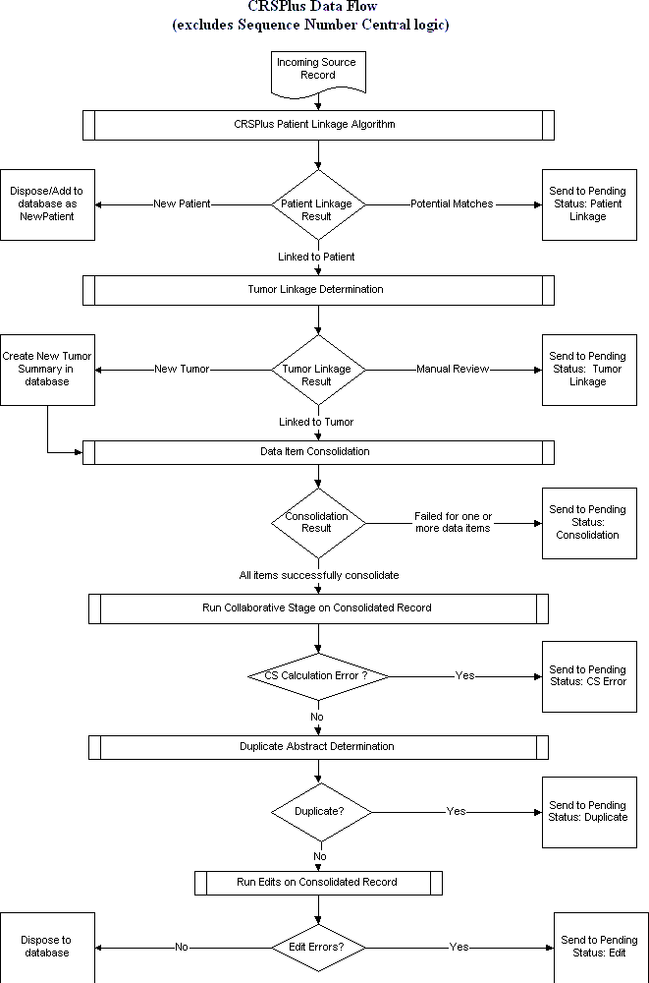

Patient Linkage
When a file is imported into CRS Plus each incoming record enters the patient linkage process to determine if the record should be linked to an existing patient in the database. The first step in the Patient Linkage process is known as 'blocking' which is performed to identify all consolidated records similar to the incoming record for (1) Soundex of last name, (2) birth date or (3) social security number. Blocking enables the system to complete patient linkage more efficiently. The second step of Patient Linkage involves the matching of specific data items from the incoming record against all consolidated records identified during blocking to assign a match score. The data items used to compute this score are:

- Date of Birth ▪ Social Security Number
- First Name ▪ Sex
- Middle Name ▪ Race1
- Last Name

The matching algorithm assigns different scores for matched or partially matched data items. For example a record with identical Social Security Number will receive a higher match score than a record matching only five of nine digits of the Social Security Number. Since blocking is performed on SSN, a transposition of one number will not significantly impact because the first three digits are reviewed, then the next two digits, then the final four digits.

CRS Plus uses two cut-off scores to identify potential matches. All records with a match score less than 80 are eliminated as non-matches. This low score can be determined by individual registries based on evaluation of registry data. All records with a match score of 155 or higher are considered definite matches. The highest possible match score is 170.

Potential dispositions of the patient linkage process are:

- New Patient – no records with match score 80 or greater. Record is sent for sequence number check after which a new Patient record and Tumor record are created in the CRS Plus database.

- Pending Patient Linkage - one or more records have a score within the 80 - 154 range; or one record with match score 155 or higher but another record matched with a score of 125 or greater points. Record is sent to pending for manual patient linkage.

- Linked to Patient - only one record with match score 155 or greater; or one record with match score 155 or higher and other record(s) matched with score(s) 124 points or lower. PatientID of the matching patient is assigned to the incoming record and the record proceeds to TLC Plus for tumor linkage.

Sequence Number Check

Records designated as a New Patient enter a sequence number check. If the Sequence Number--Hospital value is 00, 99 or blank, the record is assigned a Sequence Number-- Central of 00. If the Sequence Number--Hospital equals any other value the abstract is sent to pending for manual Sequence Number--Central assignment.

Tumor Linkage
Once an incoming abstract is linked to an existing patient record, the abstract enters the TLC Plus automated tumor linkage process to determine if the record should be linked to a tumor already in the database for the patient. As in patient linkage, tumor linkage involves the matching of specific data items from the incoming record against the linked consolidated records. Data items used to determine tumor linkage include:

- Primary Site ▪ Behavior (ICD-O-3)
- Laterality ▪ Diagnosis Date
- Histologic Type (ICD-O-3) ▪ Reporting Hospital

Abstracts proceed through a series of logic routines until a final outcome is determined or all routines are exhausted. Dispositions of the tumor linkage process are:

- New Tumor: Tumor is determined to be a new primary, not currently in the database for the patient. A new Tumor record is created in the CRS Plus database and the record proceeds to TLC Plus for automated consolidation (patient data items only).

- Pending Tumor Linkage: Automated tumor linkage cannot be determined; record is sent to pending for manual tumor linkage.

- Consolidate: Tumor is determined to be same primary as an existing tumor in the database for the patient. The MedRefID (unique identifier assigned to each individual tumor in the CRS Plus database) of the linked tumor is assigned to the incoming record and the record proceeds to TLC Plus for automated consolidation (patient and tumor data items).

Data Item Consolidation

To complete data item consolidation, TLC Plus applies consolidation rules for each field as defined by the user and entered in the TLC_DATA.mdb of CRS Plus. Consolidation rules define how data from two or more linked records are evaluated to select a final "best" value for each data item (field). Application of consolidation rules may be automated, manual, or a combination of automated and manual rules. In TLC Plus, consolidation rules are applied on a field-by-field basis whenever multiple values have been reported for the same field. For a field without defined consolidation rules, the field value from the first abstract received for the patient or tumor will be maintained in the consolidated record, unless manually updated.

Unlike the prior linkage processes the consolidated record value is not utilized. Consolidation compares values from the incoming record and all historical source records on file for the patient or tumor. All linked records undergo consolidation of patient- specific data items, however only records linked to an existing tumor undergo consolidation of tumor-specific data items. For each patient and tumor data item there are two potential dispositions from consolidation:

- Update: All automated consolidation rules were processed successfully, the consolidated record is updated and the incoming record disposed to the database.

- Manual Review: Consolidation rules did not complete successfully for all fields (although it will have completed all fields that it can). The record is sent to pending for manual data item consolidation of only those fields for which consolidation failed.

In TLC Plus consolidation rules are carried out via the application of Directives, or automated evaluation criterion used to select a final best value. There are many available directives that may be applied in any order determined by the user.

Collaborative Stage Algorithm - Introduction
The Collaborative Staging (CS) System schemas consist of several data input fields necessary to derive T, N, M, and Stage Group according to the sixth and seventh editions of the AJCC Cancer Staging Manual; SEER Summary Stage 1977; and SEER Summary Stage 2000. Collaborative Staging schemas apply to cases diagnosed from January 1, 2004 to the end of 2015 and should not be used for cases diagnosed prior to 2004. It is important for primary site to be coded correctly since most schemas are site-specific (although there are a few schemas such as melanoma and lymphoma that are based on histologic type).

Once the CS input data items are completed, the coded values are passed to a computer algorithm that generates the correct stage for the case in the four staging systems: AJCC TNM, 6th edition, AJCC TNM, 7th edition, SEER Summary Stage 1977, and SEER Summary Stage 2000 for cases diagnosed January 1, 2004 and 2015. The program returns a set of output values or numeric codes to be stored in the record.

How the Algorithm functions in CRS Plus
The incoming record runs through the Collaborative Stage algorithm. If it fails, the record will be sent to pending to correct the CS input data items and have CS derived fields re- derived. If the record runs through the CS algorithm successfully, it will proceed to the next step, Duplicate abstract determination.

In CRS Plus, the Collaborative Stage Algorithm can also calculate the derived stage fields upon Save and on demand (F5).

Duplicate Check
All incoming records linked to an existing patient and existing tumor (tumor linkage result was Consolidate) undergo comparison of the Reporting Hospital before final disposition in the CRS Plus database:

- If the Reporting Hospital numbers are different the record is disposed to the database.

- If the Reporting Hospital numbers are identical the record is sent to Pending for manual intervention.

Duplicate records may then be assigned one of three dispositions:

- ADD: Facility record is added to the database with appropriate patient and tumor linkages.

- VOID: Facility record is voided and does not become a structured record in the database. The voided records are retained but in a separate location. Voided records can be reassigned back to the database if voided accidentally since all data including text is retained.

- UPDATE: Facility record is added to the database with appropriate patient and tumor linkages and the user is immediately taken to the update case window. This option allows the user to update values on the original reporting facility source record from the duplicate record, and then VOID the duplicate from the update window.

Edits Check
The final step of record processing in CRS Plus is to run edits on the consolidated record. If there are no edit errors, the incoming record will be disposed to the database, and if there are edit errors, it will be sent to pending for error resolution.

Processing of Pending Records
NDSCR staff manually reviews and resolves all records sent to pending due to failure at some point during the automated processes described above. The below table describes the pending status options and the corresponding actions.

Pending  Status Code | Pending Status | Action
1 | Sequence New  Patient | Does not link to patient in database; Assign  Sequence Number > 00
2 | Patient Linkage | Potential Patient Match; Review Patient  demographics to determine a patient match
4 | Tumor Linkage | Potential Tumor Match; Review tumor-  specific fields to determine a tumor match
8 | Data Item Consolidation | One or more data items requires manual review; Review the specified data items and select the best value for the consolidated  record
9 | Duplicate Check | Based on Reporting Facility; Determine  whether information can be gleaned from the duplicate record prior to voiding
10 | Edit Error | Sent to Pending for Edits; Resolve edit  error(s)
11 | Collaborative Stage Calculation Error | Cannot derive Collaborative Stage – one or more CS items is invalid; Review/Recode CS input data items and re-derive CS derived data  items
12 | Sequence New  Tumor | Potential New Tumor; Review Sequence  Number

Independent De-duplication of the CRS Plus Database
On a twice annual basis, an extract of the CRS Plus database is generated and run through a de-duplication linkage using Link Plus probabilistic linkage software.
During de-duplication linkages in Link Plus records in the same file are blocked, compared, and scored against each other, and the result is a ranked list of record pairs, and high-scoring pairs are potential duplicates. The advanced probabilistic matching methods included in Link Plus find partial, approximate, or fuzzy matches, and generate values of match on a particular field that can be other than “yes” or “no”, 1 or 0.

These matching methods incorporate partial matching, value-specific matching, or both, are customized for the content of specific data items or types, and enable identification of duplicate records in the CRS Plus database that other methods would miss.

Training/Trainer
The NDSCR staff provides training at various times during the year for all facility and state registrars. Training may be provided at the annual cancer registrar’s association meeting.

All state staff participates in training provided by national organizations to increase their knowledge of cancer data collection and other registry procedures either through webinars, town hall meetings or conferences.

In addition to training presented by the state staff, the central registry staff trainer will provide in-depth training on new abstracting regulations and requirements.

Section 6
Death Clearance

Introduction

Procedures

Death Certificate Only Cases

Cause of Death

Introduction

The primary purpose of a cancer registry is to collect complete, timely and high-quality data for use in surveillance, decision-making, cancer control, research, and policy development. The use of mortality files to update death information and increase reporting completeness in the central registry is referred to as “death clearance”.

Death clearance is defined as the process of matching registered deaths in a population against reportable conditions in the registry database. Population-based cancer registries use death certificates for two purposes:
    - To update mortality and other information on cases in the registry database, and
    - As a case-finding source.

This linkage is performed annually. The central registry data files for a specific year and the death certificate file from the Division of Vital Records need to be complete before the death clearance process can begin. Abstracts produced during the resolution of death clearance cases are used to update the registry’s incidence database.

A computerized linkage program separates the death certificates into three categories:

    - Positive matches. Those patients already registered in the incidence database. If it is the same cancer, then the incidence database is updated with the death information. If the cancer death does not match the incidence record, then the case is followed back to a facility, physician, etc.

    - Inconclusive matches. Inconclusive matches must be manually reviewed. There are two possible outcomes to this review:
      - If it is a definite match, then the process continues with the path for a definite match.
      - If it is a possible match, then the case is followed back.

    - (3) Non-matches. These are patients who are not registered in the incidence database, but cancer information is present on the death certificate and is manually reviewed.
Non-match cancer deaths must be followed back to the facility, physician, nursing home, etc.

If it is determined that the cancer listed on the death certificate is a missed registry facility case, the registry is required to abstract and submit the case.

Procedures
The NDSCR follows NAACCR Procedure Guidelines for Cancer Registries, Death Clearance Manual January 1, 2015. Refer to this manual for complete death clearance guidelines at https://www.naaccr.org/wp-content/uploads/2016/11/The-New-Death- Clearance-Manual.pdf

Unknown values in the registry record are replaced with the death certificate values. This could include date of birth, Social Security number, middle name or initial, race, occupation/industry, birthplace, marital status and maiden name.

Death Certificate Only Cases

Information on a death certificate is entered as a Death Certificate Only (DCO) case when all attempts at securing correct date of diagnosis, diagnostic facility and treatment has failed.
Date of death is used as the date of diagnosis. Less than three percent DCO cases are permitted per year to achieve gold registry certification.

Cause of Death
Population-based cancer registries are required to use the ICD-10 Underlying Cause of Death code as recorded on the death certificate even when the central registry has more complete or detailed information.

SECTION 7 QUALITY CONTROL

  - Quality Control
  - EDITS, Visual Review,
Data Processing
  - Quality Assurance Activities

Quality Control/Continuous Quality Improvement
Quality control or continuous quality improvement is an ongoing series of functions designed to promote accuracy, timeliness and completeness of cancer reporting to NDSCR. These functions are necessary to measure and evaluate the completeness of cancer case reporting and to thoroughly assess data quality and are an integral part of NDSCR. They also are necessary to ensure complete, accurate and valid cancer surveillance.

Completeness is the extent to which all required cases have been reported to NDSCR. NDSCR file completeness is assessed using:

    - On-site case-finding audits of registry and non-registry facilities.
    - Management reports.
Accuracy is the extent to which the data submitted have been correctly coded and match the information contained in the text fields in the submitted data file. Accuracy encompasses correct interpretation and application of coding rules and guidelines, identifies data entry and data submission errors and evaluates case correctness. Accuracy is assessed using:
    - Field-item, inter-item and intra-item data edits.
    - Visual record view.
    - On-site case-finding audits.
    - Re-abstracting audits.

Timeliness involves how quickly each reporting facility submits cases to NDSCR once a patient enters the health-care system. Timeliness is assessed using:

    - Facility Data Submission Report.
    - Facility Record Counts by Diagnosis Year Report.

To ensure completeness and accuracy of the NDSCR cancer data, the NDSCR has established a formalized continuous quality improvement (CQI) program. This CQI program consists of routine (i.e., daily) data processing, as well as periodic auditing and monitoring activities. Routine data processing activities consist of duplicate report consolidation and electronic data editing. Electronic reports, pathology reports and partial abstracts received and imported into the NDSCR database undergo extensive data processing routines to ensure unduplicated and accurate data. Periodically, the NDSCR staff will perform various retrospective audits and monitors cancer reporting from all reporting facilities. The audits aid in monitoring case reporting completeness and accuracy. See Section 7.2.

NAACCR has established gold or silver standard certification awards for central cancer registries meeting various quality data requirements. Quality data elements reviewed by

NAACCR identify areas of strengths and weaknesses in completeness, accuracy and timeliness.

NAACCR Criteria for Certification
(https://20tqtx36s1la18rvn82wcmpn-wpengine.netdna-ssl.com/wp-content/uploads/2018/09/6-Data-Quality-Criteria.pdf)
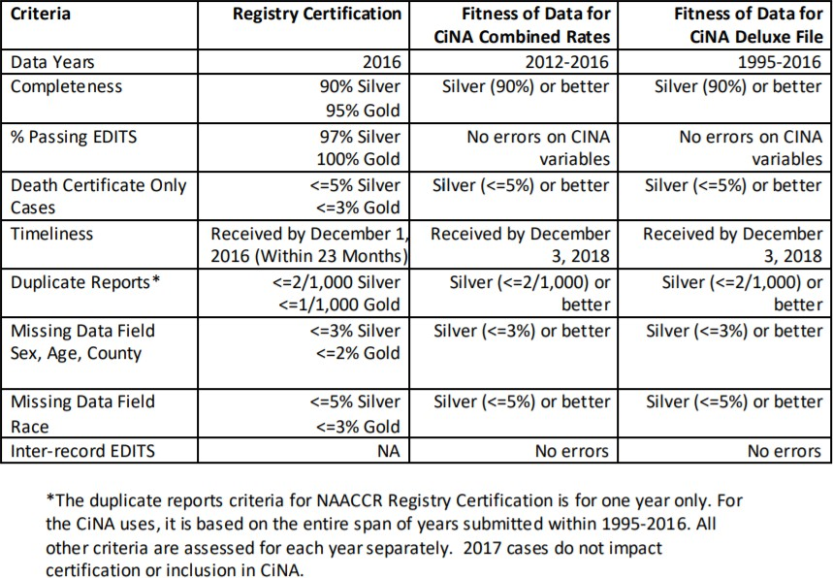

Section 7.1 describes the routine data processing activities performed by the NDSCR staff. Section 7.2 describes the quality assurance activities (i.e., periodic auditing and monitoring activities).

EDITS, Visual Review and Data Processing
To ensure completeness and accuracy and timeliness of the cancer data reporting, all cancer data received undergoes extensive visual and computerized edit checks for quality and completeness of data.

EDITS
Computerized edit checks are completed using the NAACCR, CDC and CoC WebEDITS and is only one small but very important component of the overall NDSCR quality control program. The Registry Plus suite of programs includes validation measures to ensure that only valid codes are submitted through data uploads or data entry by abstraction.

Empty fields are completed with correct information. Correct data is obtained for those items coded incorrectly or where there is a conflict of information. The electronic edits are applied to all (100%) of the data received by the NDSCR. Cancer reports not passing

the electronic edits are corrected and rechecked with the electronic edits. Electronic edits are performed before and after record consolidation. General edits and inter-record data edits are preformed on data transmissions compiled for the NAACCR and NPCR/CDC Calls-for-Data. Accredited hospital registries should be running an edit program against each data submission file and should fix any data discrepancies before completing the final data submission.

Completeness Check
The NDSCR database verifies completeness of each cancer report. This completeness check scans the reported cancer record and identifies missing required data elements (fields) as required by the NDSCR, NPCR and NAACCR. Eachcancer report can be incomplete with respect to patient, cancer and/or treatment data. Incomplete cancer reports are flagged to allow NDSCR staff to complete the incomplete data items. Completeness also refers to the extent to which all required cases have been reported to NDSCR.

Visual Review
Visual edit review is performed by reviewing the submitted data for correct cancer, treatment and demographic information to verify accurate abstracting/coding. NAACCR “Standards for Cancer Registries, Volume II” is utilized for data standards and allowable codes. Corrections are made to those records that show discrepancies. Data abstracted is checked against text to ensure accuracy of coding.

Data Processing
The NDSCR database is designed with a continuous data quality concept with respect to routine data processing. There are three areas within data processing where the NDSCR database performs and/or monitors data quality:

- Test Import QC Checking: Analyzes the submitted data file with electronic edits and performs completeness checks; accepts or rejects submitted data file for further data processing by the NDSCR database; incomplete or inaccurate files may be returned to the facilities for correction.

- Record Consolidation: Accepted submitted data files are checked to identify duplicate patients and cancers (primary cancers); utilizes a
probabilistic duplicate checking algorithm; consolidates duplicate patient and cancers into relational linkage to all original cancer report documentation (i.e., cancer abstracts, path reports); reports received from the same or multiple sources on the same patient are merged together to form one accurate cancer record. If necessary, the NDSCR
contacts all reporting sources for verification of data to ensure that patients and/or their primary cancer diagnoses are in the system only once to prevent duplicate reporting.

- QC Module: Allows NDSCR staff to continuously check "patient cancer profiles" with electronic edits and completeness; allows NDSCR staff to record data discrepancies and notate corrections.

The NDSCR database provides several quality control "feedback" reports to the reporting facilities submitting cancer data to the NDSCR. A "reporting summary" report is distributed to each reporting facility showing data on the facility's reporting timeliness, quality and completeness yearly.

Quality Assurance Activities

As part of the formalized CQI program, NDSCR staff performs various retrospective audits and monitors cancer reporting from all reporting facilities as part of the quality assurance activities. This auditing and monitoring benefits case reporting completeness and accuracy. The quality assurance activities consist of the following:

Visual Review of Text
Data is critiqued so that assigned codes meet the allowable code standards and submitted text documentation included with the cancer abstract. Examples of this visual review include:

    - Audit correct site and histology codes that match the descriptive text
    - Sites are coded correctly for male or female
    - Demographic codes match for city, county and state
    - Text supports stage
    - Earliest treatment date is recorded
    - Treatment is appropriate for type of cancer and is it recorded correctly

Visual review of text is not performed on all reported cancers. Visual review of text is performed on (1) all cases failing completeness checks and/or electronic edits and (2) selected cases passing completeness and/or electronic edits.

Re-abstracting Audits
These audits describe the process of independently re-abstracting cancer cases from the source patient records and then comparing the re-abstracted case with the original abstracted case in the registry. The objective of the re-abstracting audits is to ensure that the data in the cancer registry accurately reflects original medical record documents. The re-abstracting audits are performed periodically on selected cases. The methodology of case selection will vary with each audit (i.e., by site, reporting facility, geographic location, etc.). The NDSCR database will be used to perform re-abstracting audits through the QC module. A re-abstracting audit will take place every five years with a

different primary site being audited. Re-abstracting audits will be performed on a random sample of abstracted cases submitted by cancer registries in the state.

Case-finding Audits
The only way to document the true level of completeness of case ascertainment is through audits to identify and document deficiencies in the registry's data collection operations. These audits describe the process of independently locating unreported cancer cases from the source medical records. The objective of the case-finding audits is to ensure that cancer reporting covers the defined population of the cancer registry. NDSCR quality control staff will perform the case-finding audits. The methodology of each audit varies (i.e., by reporting facility, source document type, etc,). A case-finding audit will be scheduled at a different hospital registry each year, and two case-finding audits will be conducted at non-registry facilities each year.

Death Clearance
Death clearance is essential in achieving complete reporting. This process identifies those cancer deaths not reported to the NDSCR and recorded in the cancer registry, as well as updated vital status information for patients reported to the NDSCR. The NDSCR Database facilitates death clearance activities. Death clearance follow-up (updating death certificates matching reported cancer patients) is done continuously throughout the year. Death clearance follow-back (identifying and abstracting death certificate only cases) is done at least once a year.

Monitoring Reporting Completeness and Timeliness
Each reporting facility is monitored for accuracy, completeness and timeliness of reporting. The NDSCR Database provides several quality control "feedback" reports to the reporting facilities submitting cancer data to the NDSCR. A "reporting summary" report is distributed to each reporting facility showing data on the facility's reporting timeliness, accuracy and completeness. Timeliness of data submission is monitored to observe how many cases were submitted more than six months after diagnosis date.
Completeness is monitored by comparing the actual number of cases received to an expected number of cases per hospital.


Guidelines for Visual Editing
Demographic information
Patient Name: Check first name against sex; verify if suspect.
City/County/State: Is state consistent with city? Is county code consistent with city? Is
name of city spelled correctly?
Address: Is address abbreviated properly?
Zip Code: Check zip code/city against county code.
Race: Is race appropriate for name? Appropriate for place of birth? Occupation/Industry: Retired must not be entered.
Sex: Does sex match name and type of cancer?
Birth Date: Check birth date against age in record.
Date of Last Contact: Does date of last contact follow a logical sequence with
Dx/Admit/Rx dates?

Tumor Information
Sequence: Are other primary cancer diagnoses documented in text? Primary Site: Primary site requires text justification. Is it coded correctly? Histology: Is histology documented in text? Is it coded correctly?
Behavior: Supporting text is required for behavior code. If behavior is in- situ, stage must be in-situ.
Grade: Grade code requires supporting text. Is it coded correctly?
Laterality: Is laterality correct based on text? If primary site is unknown, laterality is “0.”
Summary Stage: Is there text to support assigned stage? In-situ must have
pathological confirmation. If site is unknown, stage must be unknown. Are distant metastases documented?
TNM Stage: Is tumor TNM stage completed?

Treatment Information
Surgery: All surgical treatment should be documented in text. Is surgical date recorded correctly?
CS Site Specific Factors Are CS site specific factors correct for primary site? CS Extension Is CS extension coded correctly? Verify per text.
Radiation: Is radiation appropriate for this tumor? Is date recorded?
Chemotherapy: Is chemotherapy treatment recorded? Ancillary drugs should not be
coded. Is date recorded?
Hormone: Is hormone treatment recorded? Is date recorded?
BRM: Is BRM treatment recorded? Is date recorded? Other treatment: Is other treatment recorded? Is data recorded?

Revised 1/17/17

SECTION 8
Audits: Case-finding and Re-abstracting

Introduction

Case-finding Audits
  - Re-abstracting Audits

Introduction
NDSCR will perform three case-finding audits per year by auditing case-finding sources within each facility. These audits will include cancer registry facilities and non-registry facilities.
Case-finding audits typically involve a statistically controlled study whereby case-finding sources are examined for possible missed cases. The audits provide the most direct estimate of completeness. Case-finding and quality control involves a carefully planned continuous loop of measurement, communication and action leading to continuous quality improvement.

NDSCR will also conduct one re-abstracting audit every five years. A re-abstracting audit is done to characterize the level of agreement between data already in NDSCR and data re- abstracted and recoded from source records (the hospital medical record in most cases). From each case, codes are compared to determine if data items reported to the state registry are accurate. Cases are identified for the re-abstracting audit through a process of the NDSCR computer program, which randomly selects a percentage of cases for re-abstracting.
Additional cases in an area of specific concern may be requested as needed.

Case-finding Audits

Case-finding Audits at Cancer Registry Facilities
Case-finding audits to access completeness of ascertainment will be performed at North Dakota hospitals to determine the level of completeness of reporting newly diagnosed cancer cases to the NDSCR. NDSCR case-finding audits are done on a rotating schedule with cancer registry and non-cancer registry facilities and are designed to locate records with cancer diagnosis that may not have been reported to the NDSCR. One case-finding audit will take place each year. The hospital to be audited will be randomly chosen by the NDSCR with consideration to the date of a previous case-finding audit, the size of the facility, location of the hospital and the number of days available to perform the audit. The months of the year chosen to be audited at each source will be based on the size of the hospital.

The quality control staff will review cases from the following departments of the hospital:
    - Pathology laboratory reports.
    - Autopsy reports.
    - Health Information indices of all reportable ICD-9/ICD-10 codes.

Quality control staff will review pathology reports for the diagnosis and comments for each specimen to determine reportability. When a reportable case is identified, information in the pathology report is compared to those cases already in the NDSCR database. When a reportable case or pathology report is not found in the NDSCR database, the pertinent cancer information is printed; the information brought back to the state office for further investigation by quality control staff. Once the determination is made regarding the reportability of the cancer case, if the case was missed by the registry, the hospital registrar is asked to abstract the case and submit it to the NDSCR.

Flow Chart for Case-Finding Audits at Registry Facilities
Eligible case identified at hospital in NDSCR: Yes = END
Eligible case identified at hospital in NDSCR: No = Missed Case Procedure:
    - Complete a listing of patients’ from a previously requested Medical Record Disease Index (MRDI) of reportable cancer cases not in NDSCR database.
    - After reviewing MRDI, mail a list of missing cancer cases to the hospital registrar of the facility being audited.
    - Hospital registrar locates patient record.
    - Quality control personnel review records for reportablity.
    - If cases are reportable, hospital registrar abstracts cancer case.
    - Case is submitted electronically to NDSCR.
    - A complete case finding audit report is written and mailed to the hospital cancer registry. This report includes findings and recommendations.

Case-finding Audits at NON-Registry Facilities
The quality control staff of the NDSCR will complete a case-finding audit of reporting facilities in the state without cancer registries. NDSCR case-finding audits are done on a rotating basis.
There will be two case-finding audits completed yearly by the NDSCR quality control staff. The hospitals chosen to be audited for completeness will be chosen on a rotating basis. Case- finding audits on non-registry facilities will be performed on a complete year’s data of reportable ICD-9/ICD-10 codes.

Flow Chart for Case-Finding Audits - Non-registry Facilities
Eligible case identified at hospital in NDSCR: Yes = END Eligible case identified at hospital in NDSCR: NO = Missed case Procedure:
    - Complete a listing of patients’ from a previously requested Medical Record Disease Index
(MRDI) of reportable cancer cases not in NDSCR database.
    - After reviewing MRDI, mail a list of missing cancer cases to the hospital Health Information Department Director.
    - Request copies of pertinent cancer information to be mailed to the quality control manager.
    - Quality control manager abstracts the missing cancer case into the NDSCR database.
    - A complete case-finding audit report including the findings and recommendations is written and mailed to the audited facility.

North Dakota Cancer Registry Case-finding Audit Guidelines For Hospitals to Resolve Unmatched Cases

Following comparison of the Medical Record Disease Index (MRDI) against the central cancer registry’s database, review of all highlighted cases are considered a non-match. Determination will then be made if the case should or should not have been abstracted and sent to the NDSCR. Indicate the outcome of each unmatched case on the list.

- Diagnosed prior to 1997
- Non-reportable (specify why not reportable)
- Other (specify reasons)
- Missed case
- Matched case (Patient registered under another name)

Note: If an unmatched case is matched in your system, re-send the case electronically to the NDSCR.

NDSCR Responsibilities

The NDSCR quality control staff will notify the facilities to be audited six weeks in advance of the planned audit date. Resolution of unmatched discrepancies will be completed within eight weeks or documentation of the reason the case was not abstracted or included in the NDSCR database of cancer cases made. Following the resolution of cases, the staff person performing the audit will write a final summary report containing the findings and recommendations. A copy of the report will be sent to the hospital cancer registry.

FACILITY Responsibilities

Compile and send the requested MRDI of reportable malignant and non-malignant reportable ICD-9/ICD-10 codes for the months requested. Once the MRDI has been reviewed, the facility will make available the required/requested records for the dates noted or will make copies of the requested records and mail them to the NDSCR. The registry facility will provide a work area with desk space and the records necessary to complete the audit.

(NDSCR / UND letterhead)

Date

Hospital Address
City, State, Zip Code Dear Registrar:
The North Dakota Statewide Cancer Registry (NDSCR) will be conducting case-finding
audits of North Dakota facilities who submit cancer cases to the state cancer registry. Facility case- finding audits are a requirement of CDC’s National Program of Cancer Registries. Three case- finding audits will be performed this year. Facilities with cancer registries and facilities without cancer registries are chosen randomly. Your registry has been chosen to participate. We will
be reviewing all (insert year) pathology laboratory reports, autopsy reports, medical record indices and radiation log books at your facility.
Quality control staff of the NDSCR will arrive at your facility at AM on . They will plan to meet with you upon their arrival to review procedures and learn where and when they will have access to records.

Thank you for your participation in our NDSCR case-finding audit.

Sincerely,

Mary Ann Sens, MD, PhD Xudong Zhou, MB, CTR
Chair, Department of Pathology Co-Program Director
UND School of Medicine & Health Sciences North Dakota Statewide Cancer Registry Encl.



Hospital Audited:
Date of Audit:
Audit Summary: Results Following Reconciliation of Data Number of Cases Identified:
Number of cases found in NDSCR database:
Number of identified unmatched cases at the hospital: Total cases identified:

Resolution of unmatched cases:
  - Missed cases
Cases missing from the NDSCR
  - Resolved case
Cases abstracted and in NDSCR database Case to be abstracted into NDSCR database
No abstract needed: Cases were diagnosed prior to NDSCR reference date 01/01/1997
Non-reportable diagnosis, recurrence Resident of another state at diagnosis

  - Unresolved cases

Total number of cases identified in the audit:
Number missed + number matched + number unresolved

Percent of cases missed: (not reported to NDSCR) 100 X (number missed + number unresolved)
Number identified

NORTH DAKOTA STATEWIDE CANCER REGISTRY GUIDELINES FOR CASE-FINDING REVIEW

Review all admissions within the dates requested and the following reports and logs for the audit.

Pathology Reports

Check numerical order for missing reports. Look for malignant disease diagnosis.
Look for reports with residual disease.
Watch for reports that mention “no residual disease”. Review all reports with orchiectomy as a surgical procedure.
Watch for reports with terminology such as “re-excision” or “wide re-excision”. Check “comments” area of report.

Autopsy Reports

Check numerical order for missing reports. Look for malignancy as cause of death.
Review summary/history for mention of malignant disease.

Radiation Logs
Report all patients with a malignancy noted in the log. Review all reports with a specific site recorded.
Investigate records of patients treated for “pain control”.

Re-abstracting Audits

A re-abstracting study is done to characterize the level of agreement between data already in the NDSCR and data re-abstracted and recoded from source records (the hospital medical record in most cases). For each case, codes are compared to determine if data items reported to the state registry are accurate.

NDSCR re-abstracting audits vary in size and content. Every five years different primary sites and data items are audited. The number of cases re-abstracted per registry also fluctuates depending on the focus of the study. Cases are identified from the re-abstracting audit through a process of the NDSCR computer program which randomly selects a percentage of cases for re-abstracting. Additional cases in an area of specific concern may be requested on an as needed basis.

Six weeks prior to the re-abstracting audit, a phone call plus a follow-up letter is sent to the head registrar of each registry facility. Instructions are given as to what procedures the hospital registry should follow. NDSCR will request that facilities make copies of records and that the copied records be mailed to the state central registry in one month’s time.

Quality control staff re-abstracts data from the source record supplied by the registry hospital. The recoded data is then compared to the previously submitted cancer case. Discrepancies are noted. The facility that submitted the case is phoned and reconciliation of the case ensues. Quality control staff will work with the hospital registrar to resolve data items in question. All unresolved discrepancies following reconciliation of a cancer case is tracked. A report is prepared for each hospital registry on data quality/discrepancies. A re-abstracting audit report is also written describing all North Dakota hospital cancer registry discrepancy totals following reconciliation. The hospital report is confidential to the affected facility, but the overall report is shared with all registries. The overall report can be used as an education tool to help registries see where they fit in with other registries, identify common areas of difficulty or interpretation of coding rules when abstracting a cancer case. The process of re-abstracting audits can serve to increase the quality of data being collected.

(NDSCR / UND letterhead)

Date

Hospital Address
City, State, Zip Code Dear Registrar:
The North Dakota Statewide Cancer Registry (NDSCR) will be conducting a re-abstracting and recoding audit. Re-abstracting audits are a requirement of CDC’s National Program of Cancer Registries.

A random sample of computer-selected cancer cases previously submitted to the NDSCR will be re- abstracted and recoded. The re-abstracting audit will focus on a random sample of site-specific cancer cases. Quality control staff will re-abstract specific predetermined data items.

A list of patient names will be mailed to your facility. NDSCR will request that facilities make copies of patient records and mail them to us at the NDSCR no later than one month from the date of this letter. Please provide a copy of the front face sheet, H&P, discharge summary, operative report, pathology report, laboratory reports and x-ray reports. Also include any other information in the chart that would seem necessary to accomplish re-abstracting and recoding of the patient record.

Once the audit is complete a report will be compiled and written with the results of the study. The NDSCR systems analyst also will prepare a statistical outcome report using data from findings of the re-abstracting audit. These reports will be mailed to you upon completion.

Thank you for your participation in the NDSCR re-abstracting and recoding audit. Sincerely,

Mary Ann Sens, MD, PhD Xudong Zhou, MB, CTR
Chair, Department of Pathology Co-Program Director
UND School of Medicine & Health Sciences North Dakota Statewide Cancer Registry

