What is a cancer cluster?
How does the Cancer Registry investigate reports of suspected cancer clusters?

ancer clusters may be suspected
C

when people report that several family members, friends, neighbors or coworkers have been diagnosed with cancer. A cancer cluster is the
occurrence of a greater than expected number of cases within a group of people, a geographic area or a period of time. Over the past years, a steadily rising number of suspected clusters of
many types of cancer has been reported by the public. Reported disease
clusters of any kind are investigated by epidemiologists (scientists who study the diseases in populations). Epidemiologists use their knowledge of diseases, environmental science,
lifestyle factors and biostatistics to try to determine whether a suspected cluster represents a true excess of cancer cases.

A true cluster is:
An aggregation of cases of a disease or other health condition (in this case
cancer) that are closely grouped in time and place. The number of cases may or may not exceed the number expected, and frequently the expected number is not known.
This aggregation of cases may indicate a common source or mechanism by which cancer develops. The occurrence of several different types of cancer in a group of people or a geographic area generally does not indicate a cancer cluster.

pidemiologists use various statistical methods to determine
whether the reported excess of cases is really a larger number than normally would be expected. They also try
E
to establish whether the suspected exposure has the potential to cause the reported cancer, based upon what is known about that cancer’s likely causes. Each type of cancer has certain known and/or probable risk factors.

ost reported cancer clusters are shown not to be true
M
clusters for a variety of reasons. Many reported cancer clusters do not include enough cases to allow epidemiologists to arrive at any conclusions. Sometimes there is a true excess for which no explanation can be found. It is possible that the suspected cause may be a low level
carcinogen that can cause cancer only under certain circumstances, making its impact difficult to detect. Also, people today move so often that it can be difficult to identify previous exposures, find old records, and follow
up on possible future cases. Finally, the majority of cancer clusters are simply the result of chance. A random excess of any disease, including cancer, can occur in any given population, but this does not always mean it can be linked to environmental or other factors.
hile investigating a reported cancer cluster, the North Dakota
Statewide Cancer Registry within the Dept. of Pathology at UND follows steps
recommended by the U.S. Centers for Disease Control and Prevention.
When a suspected cancer cluster is reported, the Cancer Registry gathers information about the suspected cluster and provides the caller with general information. This sometimes resolves the concern at this time because the caller realizes that what seemed like a cancer cluster is not a true cluster.
W

f a potential cancer cluster is indeed observed, it must be evaluated
I
carefully to see if it is “real.” The Cancer Registry begins by addressing the question: “Is the number of cancers that occurred in this population in this defined time period greater than normally would be expected?” To answer this question, the Registry compares the number of cancers observed in the community with the number expected for that population. Because cancer is so common, many clusters will be explained solely on the basis of chance. Statistical testing is used to determine if the community rates are significantly higher than the state rates.
I

f the rates are higher and statistically it is unlikely to be due to chance, a
cancer cluster may exist. In that event, investigators must evaluate whether it might be because of factors known to be
related to that type of cancer or unknown factors. To make this determination, the Cancer Registry reviews the most current cancer information and consults with
the environmental and risk assessment programs within the department.
I

f the rates are elevated and the initial evidence is compelling, the
Cancer Registry will look for common risk factors or exposures among those affected by the cancer. If no risk factors are common to the cancer patients, then a study is not possible. If there are one or more risk factors common to the cancer patients, we look to see if those factors are statistically more common among persons with the cancer than among other persons in the community
without the cancer. We then recommend a comprehensive epidemiological study of the possible relationship between
the disease and exposure. The main purpose of the study would be to pursue the epidemiologic and public health issues that the cluster raised. Most state health departments report that fewer than 5 percent of investigations reach the final stage of actually conducting the comprehensive study.
C

ancer cluster investigations take time and effort; they cannot
be completed in an hour or a day. As North Dakota cancer data become more complete, cancer researchers can
determine more quickly and accurately if a cancer cluster exists in a community.

What is Cancer?

Cancer Clusters
Cancer is a common disease. It strikes two of every five people and is the second-leading cause of death in this country. It is not unusual for several cases to occur within the same family or neighborhood. The following information can be helpful when
trying to understand suspected cancer clusters.
most cancers are not known.
♦
♦
The growth of cancer involves a series of changes within cells that usually occur over the course of many years. A decade or more can pass before the cancer is diagnosed, making it difficult to pinpoint the cause of the cancer. Cancer is most likely to occur in older people, and because people are living longer, even more cases of cancer can be expected in the future. This, coupled with the fact that cancer is already quite common, can create an impression of an abnormally high
number of cases.
♦
Cancer is the uncontrolled growth and spread of abnormal cells anywhere in the body.
Cancer is actually an umbrella term for at least 100 different but
related diseases, each of which may have its own set of causes. Cancer is not caused by injuries, nor is it contagious.
Cancer is almost always caused
by a combination of factors, including lifestyle, heredity and environment, which interact
in ways that are not yet fully
understood. The causes of most
Because most cancers are likely caused by a combination of factors related to heredity and environment (including behavior and lifestyle), studies of suspected cancer clusters usually focus
on these two issues.

Thank you!
This brochure was developed with information from the National Cancer Institute (http://cis.nci.nih.gov/fact/index.htm) and is adapted with
permission from the Texas Cancer Registry.

December 2020
Do you want to know more?

To find out more about cancer cluster investigations or the North Dakota Statewide Cancer Registry, call
701.777.0791 or 701.777.2868
or visit https://ndcancer.org/index.html

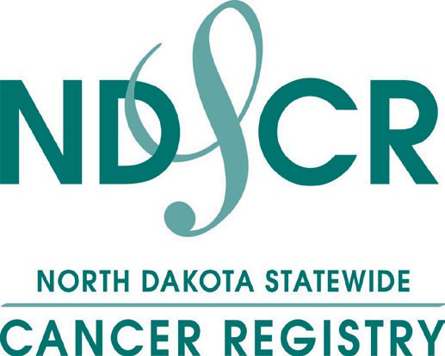
North Dakota Statewide Cancer Registry Department of Pathology
UND School of Medicine & Health Sciences
1301 N. Columbia Rd. Stop 9037 Grand Forks, ND 58202-9037

