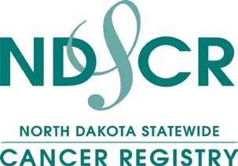

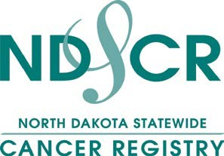
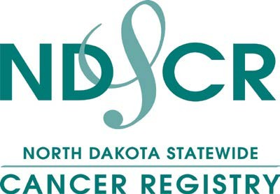
The North Dakota Statewide Cancer Registry (NDSCR) collects incidence and mortality data on all North Dakota residents who are diagnosed and treated for cancer either within or outside the state. The purpose of the state central cancer registry is to support cancer control by targeting, monitoring and evaluating programs that promote early detection, diagnosis and treatment of cancer. The NDSCR supports local health care agencies by providing summary statistics on the distribution of cancer cases, following cancer incidence and treatment trends, facilitating rapid reporting of cancer, and providing accurate cancer data
for cancer-related reports.

Revised December 2020

Source of Quality Cancer Incidence and Mortality Data

North Dakota Statewide Cancer Registry Department of Pathology
School of Medicine & Health Sciences University of North Dakota
1301 N. Columbia Road Stop 9037 Grand Forks, ND 58202-9037 Telephone: 701.777.2868, 701.777.0791
Fax: 701.777.3108

https://ndcancer.org/index.html

What Is a Cancer Registry?
The North Dakota Statewide Cancer Registry (NDSCR) – a statewide, population-based cancer registry that collects incidence and mortality data on residents of North Dakota – was established in 1994. Previously, cancer statistical information was available only through analysis of death certificates.
In 1996, the North Dakota Health Council amended the Administrative Rule, Chapter
33-06, to include cancer as a reportable disease. Data collection of newly diagnosed cancers that began in January 1997 enables the NDSCR to:
- Analyze the overall picture of cancer in North Dakota.
- Identify how many residents are diagnosed with cancer.
- Name the most common type of cancer.
- Recognize the deadliest cancers and if any area of North Dakota has lower or higher cancer rates.
- Study trends and improve cancer education, prevention and cancer screening.

Reportable Cancers

All in-situ or malignant cancers are reportable. This includes adenocarcinoma, carcinoma, leukemia, lymphoma, melanoma and sarcoma. All benign cancers of the central nervous system, pituitary gland, pineal gland and craniopharyngeal duct also are reportable.
Basal and squamous cell carcinoma of the skin or carcinoma in-situ of the cervix is not collected.

Data Collection
Each hospital, outpatient surgical center, clinic, pathology laboratory, radiation or oncology treatment center and physician office is required to submit data, including treatment on newly diagnosed cancers, to the state central cancer registry within six months of diagnosis. Other sources of data include death certificates and cancer registries from other states.

What Type of Information Is Collected?

The registry collects only cancer-related information. This information can be sorted into four categories. Demographic includes the cancer patient’s name, age, sex, race, ethnic background, marital status, birth- place, residence and occupation. Administrative includes the date the cancer was diagnosed and the source of the information. Diagnostic includes the type of cancer, the location of the cancer, the size of the cancer and the spread of the disease. First course of treatment includes all cancer treatment received.

Data Confidentiality
Federal and state laws protect confidential medical information. Only aggregate data are published. Cell sizes that contain fewer than five cases are suppressed to protect the confidentiality of the individual.

Why Collect Identifying Information?
Patient identifiers are necessary because some
cancer cases reported are diagnosed and/or treated at several facilities. This means that duplicate records are received at the state central registry. Patient identifiers assist the registry staff in determining whether a case has been submitted earlier and allows for the creation of a complete cancer record from all reporting sources.

Quality Control

To assure accurate, complete and reliable data, the NDSCR uses an EDITS metafile software program that checks the validity of the data in the various data fields against a set of acceptable codes. Data validity also is verified by visual review of submitted records, external audits conducted by the Centers for Disease Control and Prevention and internal case- finding and re-abstracting audits. Inaccurate information is reviewed and revised as necessary.

Health Insurance Portability and Accountability Act
The North Dakota Statewide Cancer Registry, within the Division of Cancer Prevention and Control of the North Dakota Department of Health, is authorized by law to collect cancer information for the purpose of preventing or controlling disease and to conduct public health surveillance, public health investigations and interventions. The Health Insurance Portability and Accountability Act (HIPAA) permits covered entities to disclose protected health information without individual authorization to public health authorities such as state health departments.

