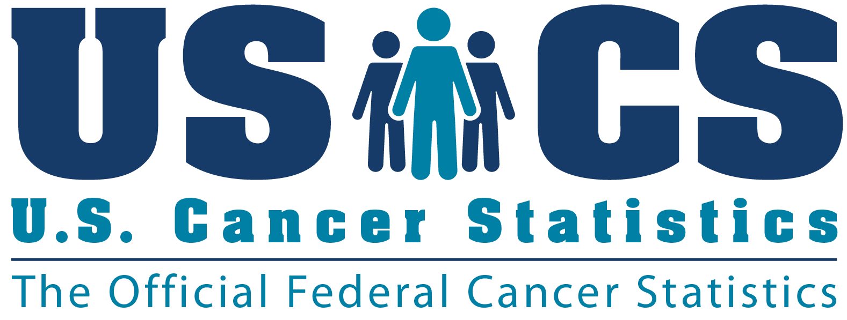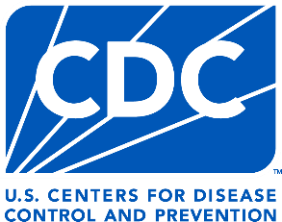
NATIONAL PROGRAM OF CANCER REGISTRIES

U.S. CANCER STATISTICS REGISTRY FOR SURVEILLANCE

NORTH DAKOTA STATEWIDE CANCER REGISTRY

Provides critical and high-quality data that are included in the
U.S. Cancer Statistics, the official federal cancer statistics.

Brandy Peaker, MD, MPH

Acting Chief, Cancer Surveillance Branch
Division of Cancer Prevention and Control

