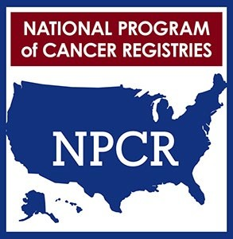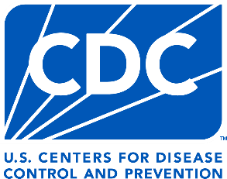

NATIONAL PROGRAM OF CANCER REGISTRIES
2024
REGISTRY OF DISTINCTION
NORTH DAKOTA STATEWIDE CANCER REGISTRY

In recognition of providing complete and timely
National Program of Cancer Registries data in 2024.

Brandy Peaker, MD, MPH

Acting Chief, Cancer Surveillance Branch
Division of Cancer Prevention and Control

