DEPARTMENT OF
MEDICAL LABORATORY SCIENCE

med.UND.edu/mls
Undergraduate Handbook
2026 - 2027

Published: 05-01-2026
TABLE OF CONTENTS

DESCRIPTION OF THE MEDICAL LABORATORY SCIENCE PROFESSION 4
DESCRIPTION OF ENTRY LEVEL COMPETENCIES OF THE MEDICAL LABORATORY SCIENTIST 5
UNIVERSITY OF NORTH DAKOTA DEPARTMENT OF MEDICAL LABORATORY SCIENCE 7
UND MEDICAL LABORATORY SCIENCE PROGRAM ESSENTIAL FUNCTIONS 8
DEPARTMENT OF MEDICAL LABORATORY SCIENCE FACULTY AND STAFF 9
MEDICAL LABORATORY SCIENCE CURRICULUM 10
CATEGORICAL CERTIFICATE CURRICULUM 12
MEDICAL LABORATORY SCIENCE ROUTES OF STUDY 13
POLICIES, PROCEDURES & PROCESSES 16
MLS PROGRAM POLICIES, PROCEDURES & PROCESSES 17
I. MLS Professional PROGRAM Application, Admission, Advancement & Standing 17
A. MLS Professional Program Application 17
B. MLS Professional Program Admission 17
C. Route-Specific MLS Professional Program (PP) Application & Advancement Processes 18
D. MLS Professional Program (PP) Advancement/Academic Standing 20
E. MLS Professional Program (PP) DISMISSAL 20
II. CRIMINAL Background Check 20
III. ESSENTIAL FUNCTIONS & TECHNICAL STANDARDS 21
IV. PARTICIPATION IN EDUCATION AS IT RELATES TO STUDENT HEALTH 21
V. Disability Access 21
VI. STUDENT/Graduate Records 21
VII. UNIVERSITY Refund Policy 22
VIII. UNEXPECTED University or Program Interruption/Closure 22
IX. LEAVE 22
X. Drug and Alcohol Screening 22
XI. EMAIL Communications 22
XII. SMHS ROOM USE & ETIQUETTE 23
XIII. PROMOTIONAL IMAGES 23
XIV. BIOHAZARD & Safety 23
XV. LEARNER MISTREATMENT 23
XVI. STUDENT Concerns & FEEDBACK 24
XVII. STUDENT Academic COMPLAINTS, GRIEVANCES, and APPEALS 24
XVIII. UNDERGRADUATE PROFESSIONAL & ACADEMIC STANDARDS COMMITTEE (UNDERGRADUATE PASC) 24
XIX. PROBATION STATUS 25
XX. STANDARDS of Professional Conduct 25
XXI. COURSE SECTIONS 26
XXII. PROCTOR INFORMATION 26
XXIII. COURSE POLICIES 27
XXIV. GRADING 27
XXV. HEALTH INSURANCE 28
XXVI. LIABILITY INSURANCE 28
XXVII. CLINICAL SITE PLACEMENT 28
XXVIII. CLINICAL PRACTICUM HOURS 29
XXIX. WELLNESS BENEFIT 29
XXX. EMPLOYMENT/SERVICE WORK 30
XXXI. UNEXPECTED DISCONTINUANCE OF A CLINICAL AFFILIATE 30
XXXII. REMOVAL from a clinical affiliate site 31
XXXIII. NATIONAL CERTIFICATION EXAM 31
ROUTE-SPECIFIC POLICIES, PROCEDURES & PROCESSES 32
I. TRADITIONAL / WCAMLS / BACHELOR’S + MLS 32
II. MLT to MLS 33
III. MLS COHORT PROGRAM 33
A. Proctor Policies 33
APPENDIX 1: Department of MLS Standards of Professional Conduct Evaluation Form 35
APPENDIX 2: Department of MLS Laboratory Safety Standard 36
APPENDIX 3: Department of MLS Pathogen Exposure Management Standard 46
APPENDIX 4: Technical & Academic Standards for Matriculation, Progression, and Graduation 51
STUDENT SIGNATURE PAGE 56

DESCRIPTION OF THE
MEDICAL LABORATORY SCIENCE PROFESSION

The medical laboratory scientist is qualified by academic and applied science education to provide service and research in medical laboratory science and related areas in rapidly changing and dynamic healthcare delivery systems. Medical laboratory scientists perform, develop, evaluate, correlate and assure accuracy and validity of laboratory information; direct and supervise clinical laboratory resources and operations; and collaborate in the diagnosis and treatment of patients. The medical laboratory scientist has diverse and multi‐level functions in the principles, methodologies and performance of assays; problem‐solving; troubleshooting techniques; interpretation and evaluation of clinical procedures and results; statistical approaches to data evaluation; principles and practices of quality assurance/quality improvement; and continuous assessment of laboratory services for all major areas practiced in the contemporary clinical laboratory.

Medical laboratory scientists possess the skills necessary for financial, operations, marketing, and human resource management of the clinical laboratory.

Medical laboratory scientists practice independently and collaboratively, being responsible for their own actions, as defined by the profession. They have the requisite knowledge and skills to educate laboratory professionals, other health care professionals, and others in laboratory practice as well as the public.

The ability to relate to people, a capacity for calm and reasoned judgment and a demonstration of commitment to the patient are essential qualities. Communications skills extend to consultative interactions with members of the healthcare team, external relations, customer service and patient education.

Medical laboratory scientists demonstrate ethical and moral attitudes and principles that are necessary for gaining and maintaining the confidence of patients, professional associates, and the community.

(NAACLS, 2024 Standards)

DESCRIPTION OF ENTRY LEVEL COMPETENCIES
OF THE MEDICAL LABORATORY SCIENTIST

At entry level, the medical laboratory scientist will possess the entry level competencies necessary to perform the full range of clinical laboratory tests in areas such as Clinical Chemistry, Hematology/Hemostasis, Immunology, Immunohematology/Transfusion medicine, Microbiology, Urine and Body Fluid Analysis and Laboratory Operations, and other emerging diagnostics, and will play a role in the development and evaluation of test systems and interpretive algorithms.

The medical laboratory scientist will have diverse responsibilities in areas of analysis and clinical decision‐making, regulatory compliance with applicable regulations, education, and quality assurance/performance improvement wherever laboratory testing is researched, developed or performed.

At career entry level, the medical laboratory scientist will have the following professional competencies:

A. Professional Behaviors and Communication
- Demonstrate professional and ethical behavior along with effective interpersonal communication skills when engaging with various stakeholders.
- Establish effective interprofessional working relationships with other health care professionals, demonstrating comprehension of and respect for their roles and patient welfare.
- Recognize and appreciate the importance of engaging with an inclusive workforce through collaboration.
- Value and advocate for a workplace environment that fosters inclusivity, diversity, equity, and accessibility.

B. Safety and Compliance
- Comply with government regulations and accreditation standards relevant to the respective discipline.
- Adhere to prescribed protocols for overall laboratory safety, biohazard containment, and waste disposal.
- Implement quality assurance principles to ensure the validity and accuracy of laboratory generated data.

C. Education and Research
- Acknowledge and respond to individual requirements for continuing education and development to foster growth and maintain professional competence.
- Provide instruction to users of laboratory services regarding appropriate procedures, test utilization and interpretation.
- Evaluate clinical research studies and data sets to assess applicability and validity.

D. Laboratory Operations
- Employ a logical and systematic problem-solving approach when identifying errors and/or technical issues with laboratory procedures and instrumentation.
- Apply principles of data security to safeguard laboratory and hospital information systems.
- Apply principles of quality assurance to ensure validity and accuracy of laboratory data.
- Recognize principles and practices of laboratory management as applied to clinical laboratory science.

E. Pre-Analytical Competencies
- Evaluate specimen collection, processing, and storage procedures in accordance with standard operating procedures.
- Ensure specimen integrity is maintained throughout the sample procurement process.

F. Analytical Competencies
- Adhere to written policies, processes, and procedures for analytical testing, analysis, and instrumentation maintenance.
- Evaluate and provide rationale for troubleshooting protocols in analytical testing when appropriate.
- Perform routine procedures in accordance with standard operating procedures.
- Apply quality control principles to analytical testing procedures, including instrument calibration, statistical analyses of control results, Westgard rules, and verification of reference ranges.
- Perform basic calculations, dilutions, and statistical analyses for procedures and analytical testing in the respective discipline.
- Apply theoretical principles of instrumentation to current methods of analysis.

G. Post-Analytical Competencies
- Perform all post-analytical procedures in accordance with quality assurance protocols and regulatory standards.
- Evaluate results for accuracy relative to quality control, patient history, specimen integrity, and overall clinical correlation.
- Report test results, including abnormal, STAT, and critical values, in accordance with the laboratory’s standard operating procedures.

(NAACLS 2024 Standards)

UNIVERSITY OF NORTH DAKOTA
DEPARTMENT OF MEDICAL LABORATORY SCIENCE

The Medical Laboratory Science (MLS) Program at the University of North Dakota (UND) is a university-based program that has been educating Medical Laboratory Scientists since 1949. The UND Department of MLS is located at the UND School of Medicine and Health Sciences (SMHS), 1301 N. Columbia Rd, Stop 9037 Grand Forks, ND 58202-9037. Program information can be found on the Department of MLS website: med.UND.edu/mls

ACCREDITATION

The UND MLS Program is accredited by the National Accrediting Agency for Clinical Laboratory Sciences (NAACLS) which is located at 5600 N. River Rd, Suite 720, Rosemont, IL 60018-5119.

MISSION

The mission of the Department of Medical Laboratory Science is to provide high-quality education that prepares students to positively impact healthcare through medical laboratory practice in the state and affiliated regions.

GOALS

- Develop and deliver a curriculum that: reflects current laboratory knowledge and best-practice; promotes critical thinking, scholarship, and life-long learning; is accessible; and aligns with University of North Dakota (UND), UND School of Medicine & Health Sciences, and National Accrediting Agency for Clinical Laboratory Sciences standards

- Provide a student-centered environment through individualized advising, responsive mentoring/instruction, and supportive faculty/staff

- Help address healthcare needs in the state and affiliated regions by graduating students that: meet entry-level competencies; are employable in various settings; and are positioned for leadership in medical laboratory practice

- Promote and advocate for medical laboratory professions

UND MEDICAL LABORATORY SCIENCE PROGRAM
ESSENTIAL FUNCTIONS

Essential Functions are the physical, behavioral and cognitive attributes of an individual that are necessary to be able to be successful in an academic or clinical laboratory setting. The following Essential Functions have been defined by the UND MLS Program:

1. Communication
- read, comprehend, and respond to English communications (including person-to person, telephone, electronic, and written forms) in an effective, respectful, and time-sensitive manner
- follow oral and written directions

2. Behavior and Professional Standards
- demonstrate ability to perform required skills and maintain professionalism (by continuing to meet Standards of Professional Conduct) under distracting, demanding, and/or stressful circumstances
- adapt to an environment that may change rapidly, without warning, and in unpredictable ways
- maintain consistent, positive work behaviors including initiative, preparedness, dependability, persistence, and follow-through
- project an image of professionalism through appearance, dress, hygiene, positive attitude, and body language
- demonstrate appropriate interpersonal behaviors while interacting with others during program-related occurrences, including but not limited to: courtesy and cooperation; receiving and responding to constructive feedback; respect and empathy; and non-threatening conduct
- abstain from use of illegal, prescription, over-the-counter, experimental, recreational, or other drugs that have a significant effect upon an individual’s judgment
- with minimal redirection, independently perform work and recognize appropriate next steps/actions

3. Critical Thinking and Application
- demonstrate time management skills by completing assigned tasks within time frames designated for professional competency
- correlate principles to practice
- complete work with precision and accuracy in accordance with established protocol

4. Sensory Functions
- differentiate colors (hue, shading or intensity) and clarity
- read fine print including information displayed on orders, printouts, monitors, and equipment
- visually analyze specimens and reagents
- hear and respond to sounds produced in the laboratory environment

5. Motor/Physical Functions
- sit/stand for prolonged periods of time
- safely operate laboratory instrumentation and equipment
- employ fine and gross motor skills to properly operate laboratory instrumentation and equipment
- be able to lift 10 lbs.

DEPARTMENT OF MEDICAL LABORATORY SCIENCE
FACULTY AND STAFF

Rebecca Bakke, PhD, MLS (ASCP)^{CM} rebecca.bakke@UND.edu
Assistant Professor, MLS Clinical Education Coordinator 701-777-5946, Rm E382 SMHS

Mary Coleman, MS, MLS(ASCP)^{CM}, SH (ASCP)^{CM}, CG(ASCP)^{CM} mary.coleman@UND.edu
Assistant Professor 701-777-2652, Rm E381 SMHS

Beth Ann DeMontigny, BS, HTL(ASCP)^{CM} elizabeth.demontigny@UND.edu
Instructor, HT Clinical Education Coordinator 701-777-5976, Rm E368 SMHS

Heather Langerud, MS, MLS(ASCP)^{CM} heather.langerud@UND.edu
Assistant Professor, WCAMLS Coordinator 701-777-5949 Rm E387 SMHS

Hannah Hove, MPH, MLS(ASCP)^{CM} hannah.hove@UND.edu
Assistant Professor, B+MLS Advisor 701-777-2651, Rm E383 SMHS

Shannon Jongeward, PhD, MLS(ASCP)^{CM} shannon.jongeward@UND.edu
Assistant Professor 701-777-4050, Rm E379 SMHS

Katie Kucera, MS, MLS(ASCP)^{CM}
katelyn.kucera@UND.edu
Education Specialist, MLS Advisor 701-777-6302, Rm E366 SMHS

Grace Matter, MLS(ASCP)^{CM} grace.matter@UND.edu
Education Laboratory Manager 701-777-6022, Rm E361-B SMHS

Karen Peterson, MS, MLS (ASCP)^{CM} karen.peterson@UND.edu
Assistant Professor, MLS Clinical Education Coordinator 701-777-2656, Rm E385 SMHS

Samantha Peterson, PhD, MLS(ASCP)^{CM} s.peterson@UND.edu
Associate Professor, Graduate Program Director 701-777-4468, Rm E365 SMHS

Robert Porter, MS, MLS(ASCP)^{CM} robert.porter@UND.edu
Assistant Professor, MLS Cohort Coordinator/Advisor 701-777-2647, Rm E378 SMHS

Linda Ray, MS, MLS(ASCP)^{CM} linda.ray@UND.edu
Assistant Professor, B+MLS Advisor 701-777-3687, Rm E384 SMHS

Brooke Solberg, PhD, MLS(ASCP)^{CM} brooke.solberg.1@UND.edu
Associate Professor, Chair and Program Director 701-777-2245, Rm E371 SMHS

Cherie Stoltman cherylyn.stoltman@UND.edu
Administrative Officer 701-777-2628, Rm E372 SMHS

Chris Triske, MS, MLS(ASCP)^{CM} chris.triske@UND.edu
Assistant Professor, Categorical Coordinator/Advisor 701-777-3575, Rm E380 SMHS
MLS Cohort Advisor

Allison Waswick, EdD, MLS(ASCP)^{CM} allison.waswick@UND.edu
Assistant Professor, MLT and MLS Advisor 701-777-6744, Rm E363 SMHS

September Woolever, MLS(ASCP) september.woolever@UND.edu
Education Specialist, HT Advisor 701-777-2632, Rm E361-C, SMHS

MEDICAL LABORATORY SCIENCE CURRICULUM

Individual course descriptions and specific degree/certificate requirements are listed in the UND Academic Catalog found on the UND website http://UND-public.courseleaf.com/ Students are required to meet regularly with UND MLS faculty/staff to develop and monitor a program of study that aligns with these established curriculum requirements, including determining transfer and/or route-specific equivalencies, where applicable.

MLS Pre-Professional Coursework

BIOL 150/150L General Biology I & Laboratory 4
BIOL 151 General Biology II 3
BIMD 220 Anatomy & Physiology I 3
BIMD 221 Anatomy & Physiology II 3
BIMD 301 Biochemistry 3
CHEM 121/121L General Chemistry I & Laboratory 4
CHEM 122/122L General Chemistry II & Chemistry Lab 4
COMM 110 Introduction to Public Speaking 3
ECON210/PSYC241/SOC326 Statistics 3
Elective Science Category* 3
Elective Science Category* 3
ENGL 110 College Composition I 3
ENGL 130 Composition II Writing for Public Audiences 3
Essential Studies Elective Analyzing Worldview Category 3
Essential Studies Elective Fine Arts Category 3
Essential Studies Elective Fine Arts or Humanities Category 3
Essential Studies Elective Humanities Category 3
Essential Studies Elective Social Science Category (Intro to Psychology Recommended) .3
Essential Studies Elective Social Science Category (Intro to Public Health Recommended)………...…3
Essential Studies Elective Social Science Category (Intro to Sociology Recommended) 3
MATH 103 College Algebra 3
MLS 110 Introduction to Medical Laboratory Science 2
MLS 220 Introduction to Clinical Laboratory Operations 2
MLS 226 Introduction to Clinical Immunology 3
MLS 332 Introduction to Clinical Hematology 3
MLS 334 Introduction to Clinical Microbiology 3
MLS 339 Introduction to Evidence Based Practice 3
MLS 340 Introduction to Molecular Diagnostics…………………………………………………..1

TOTAL MLS PRE-PROFESSIONAL CREDITS 83

*Microbiology, Organic Chemistry, Analytical Chemistry, Molecular Biology, Cell Biology, Genetics, or other advisor-approved basic science course; Note: if taking BIMD 301 from UND, one Science Elective must be CHEM 340 or 341

Note: courses shaded in gray (or equivalent) are required pre-professional courses for the Certificate in MLS route

MEDICAL LABORATORY SCIENCE CURRICULUM

MLS Professional Program (PP) Courses
Note: some pre-professional MLS courses may be considered as MLS PP courses depending on program route

Credits
MLS 411 Clinical Chemistry I 2
MLS 412 Clinical Hematology I 2
MLS 413 Clinical Immunohematology I 2
MLS 414 Clinical Microbiology I 3
MLS 415 Clinical Urinalysis & Body Fluids I 2
MLS 416 Clinical Immunology & Molecular Diagnostics …………………………….. 1
MLS 420 Clinical Laboratory Operations 2
MLS 421 Clinical Chemistry II 2
MLS 422 Clinical Hematology II 2
MLS 423 Clinical Immunohematology II 2
MLS 424 Clinical Microbiology II 3
MLS 425 Clinical Urinalysis & Body Fluids II 2
MLS 427 Clinical Hemostasis…………………………………………………………………………………………….2
MLS 431 Clinical Chemistry & Urinalysis III 2
MLS 432 Clinical Hematology & Hemostasis III 2
MLS 433 Clinical Immunohematology III 2
MLS 434 Clinical Microbiology III 2
MLS 449 Capstone in Medical Laboratory Science 3
MLS 450 Advanced Clinical Applications in Medical Laboratory Science 1

TOTAL MLS PP CREDITS 39

TOTAL MLS PROGRAM CREDITS 122

CATEGORICAL CERTIFICATE CURRICULUM
Individual course descriptions and specific degree/certificate requirements are listed in the UND Academic Catalog found on the UND website http://UND-public.courseleaf.com/. Students are required to meet regularly with UND MLS faculty/staff to develop and monitor a program of study that aligns with these established curriculum requirements, including determining transfer and/or route-specific equivalencies, where applicable. Note that each categorical certificate is considered as a MLS Professional Program for policy purposes.

CLINICAL CHEMISTRY CERTIFICATE
MLS 220 Introduction to Clinical Laboratory Operations 2
MLS 340 Introduction to Molecular Diagnostics………………………………………………………………….………..1
MLS 411 Clinical Chemistry I 2
MLS 415 Clinical Urinalysis & Body Fluids I 2
MLS 416 Clinical Immunology & Molecular Diagnostics…………………………….. .1
MLS 420 Clinical Laboratory Operations 2
MLS 421 Clinical Chemistry II 2
MLS 425 Clinical Urinalysis & Body Fluids II 2
MLS 431 Clinical Chemistry & Urinalysis III 2
MLS 449 Capstone in Medical Laboratory Science 3

CLINICAL HEMATOLOGY CERTIFICATE
MLS 220 Introduction to Clinical Laboratory Operations 2
MLS 332 Introduction to Clinical Hematology 3
MLS 340 Introduction to Molecular Diagnostics………………………………………………………………….………..1
MLS 412 Clinical Hematology I 2
MLS 415 Clinical Urinalysis & Body Fluids I 2
MLS 416 Clinical Immunology & Molecular Diagnostics…………………………….. .1
MLS 420 Clinical Laboratory Operations 2
MLS 422 Clinical Hematology II 2
MLS 427 Clinical Hemostasis 2
MLS 432 Clinical Hematology & Hemostasis III 2
MLS 449 Capstone in Medical Laboratory Science 3

CLINICAL IMMUNOHEMATOLOGY CERTIFICATE
MLS 220 Introduction to Clinical Laboratory Operations 2
MLS 226 Introduction to Clinical Immunology 3
MLS 340 Introduction to Molecular Diagnostics………………………………………………………………….………..1
MLS 413 Clinical Immunohematology I 2
MLS 416 Clinical Immunology & Molecular Diagnostics…………………………….. .1
MLS 420 Clinical Laboratory Operations 2
MLS 423 Clinical Immunohematology II 2
MLS 433 Clinical Immunohematology III 2
MLS 449 Capstone in Medical Laboratory Science 3

CLINICAL MICROBIOLOGY CERTIFICATE
MLS 220 Introduction to Clinical Laboratory Operations 2
MLS 334 Introduction to Clinical Microbiology 3
MLS 340 Introduction to Molecular Diagnostics…..…………………………………………………………….………..1
MLS 414 Clinical Microbiology I 3
MLS 416 Clinical Immunology & Molecular Diagnostics…………………………….. .1
MLS 420 Clinical Laboratory Operations 2
MLS 424 Clinical Microbiology II 3
MLS 434 Clinical Microbiology III 2
MLS 449 Capstone in Medical Laboratory Science 3

Note: MLS 450 - Advanced Clinical Applications in MLS (1 credit) is required for students completing all four categorical certificates

MEDICAL LABORATORY SCIENCE
ROUTES OF STUDY
TRADITIONAL BACHELOR OF SCIENCE IN MLS (BS-MLS)
The traditional BS-MLS degree curriculum includes 122 credits of Pre-Professional & Professional coursework. Pre-Professional coursework includes approximately 83 credits of basic science, liberal arts/essential studies, and introductory MLS courses. Introductory MLS courses must be completed on-campus at UND. Upon successful completion of pre-professional coursework, students apply to the MLS Professional Program (PP). MLS PP coursework spans 52 weeks and consists of 39 credits of advanced MLS coursework, including a clinical practicum for course credit that is completed at an assigned affiliated medical laboratory.

Upon successful completion of BS-MLS degree requirements, the student receives a Bachelor of Science in Medical Laboratory Science degree from the University of North Dakota and is eligible for national Board Certification and entry-level practice as a Medical Laboratory Scientist (MLS).

WESTERN COLLEGE ALLIANCE FOR MEDICAL LABORATORY SCIENCE (WCAMLS)
The Western College Alliance for Medical Laboratory Science (WCAMLS) is a collaboration between UND and the following affiliate colleges/universities, to facilitate delivery of MLS curricula:
- Bemidji State University (Bemidji, MN)
- Minot State University (Minot, ND)
- Montana State University-Billings
- University of Jamestown (Jamestown, ND)
- University of Mary (Bismarck, ND)
- University of Minnesota-Crookston (Crookston, MN)
- University of South Dakota (Vermillion, SD)
- University of Wisconsin-La Crosse (La Crosse, WI)
- St. Cloud State University (St. Cloud, MN)
- Winona State University (Winona, MN)
- Valley City State University (Valley City, ND)
Students complete three years of aligned preparatory coursework at the WCAMLS affiliate, and then apply to complete the final MLS Professional Program (PP) year at UND. The MLS PP coursework spans 52 weeks and consists of 39 credits of advanced MLS coursework, including a clinical practicum for course credit that is completed at an assigned affiliated medical laboratory.

Upon successful completion of WCAMLS degree requirements, the student receives a Bachelor of Science degree from the WCAMLS affiliate, a certificate from UND verifying completion of a NAACLS accredited MLS professional program, and is eligible for national Board Certification and entry-level practice as a Medical Laboratory Scientist (MLS).

MEDICAL LABORATORY TECHNOLOGY TO MEDICAL LABORATORY SCIENCE (MLT TO MLS)
The MLT to MLS professional program route enables students with an associate’s degree from a regionally accredited institution and completion of a NAACLS accredited MLT program to earn a Bachelor of Science degree in MLS (BS-MLS). Application is required for this program route. Students will work with an academic advisor in development of an individual program of study to meet Bachelor of Science in MLS degree requirements.

Upon successful completion of BS-MLS degree requirements, the student receives a Bachelor of Science in Medical Laboratory Science degree from UND and is eligible for national Board Certification and entry-level practice as a Medical Laboratory Scientist (MLS).

BACHELOR’S DEGREE PLUS MLS (B+MLS)
Students that have earned a Bachelor of Science (BS) or Bachelor of Arts (BA) degree from a regionally accredited college or university are eligible for the B+MLS program. The B+MLS curriculum includes specific pre-requisite (see UND Academic Catalog for required pre-requisite courses) and MLS Professional Program (PP) coursework. Students will work with an academic advisor to develop a program of study and determine appropriate application processes.

Upon successful completion of pre-requisite coursework and admission to the program, the student completes the MLS PP. MLS PP coursework spans 52 weeks and consists of 39 credits of advanced MLS coursework, including a clinical practicum for course credit that is completed at an assigned affiliated medical laboratory.

Upon successful completion of MLS curricular requirements without UND Essential Studies coursework, the student receives a Certificate in MLS from UND. Upon successful completion of MLS curricular requirements and UND Essential Studies coursework, the student receives a BS degree in MLS from UND. All graduates (certificate or BS degree) are all eligible for national Board Certification and entry-level practice as a Medical Laboratory Scientist (MLS).

UND MLS/MAYO CLINIC COHORT PROGRAM (MLS COHORT PROGRAM)
The UND MLS/Mayo Clinic Cohort Program (MLS Cohort Program) route is a collaborative program between the UND Department of Medical Laboratory Science and the Mayo Clinic in Rochester, MN. Only current employees of the Mayo Clinic Department of Laboratory Medicine & Pathology are eligible for this program route. Students in the MLS Cohort Program complete didactic coursework online and laboratory coursework at Mayo Clinic facilities, with no on-campus visits required.

Students will apply to the program and upon admittance work with an academic advisor in development of a program of study to meet pre-requisite and MLS Professional Program (PP) coursework requirements. Upon successful completion of pre-requisite coursework, the student completes the MLS PP. This coursework typically is divided into five semester blocks (including at least one summer semester) beginning in either a fall or spring semester, but can also be extended beyond five semesters. A clinical practicum for course credit is completed at the Mayo Clinic, which is an affiliated site.

Upon successful completion of MLS curricular requirements and UND Essential Studies coursework, the student receives a BS degree in MLS from UND. All BS degree graduates are eligible for national Board Certification and entry-level practice as a Medical Laboratory Scientist (MLS).

CATEGORICAL CERTIFICATES
The Categorical Certificate program route allows students to become eligible for certification and professional employment at the Medical Laboratory Science (MLS) level within a specific categorical area of the laboratory. Categorical certificates are available in the following areas: Clinical Chemistry; Hematology; Immunohematology (Blood Bank); and Microbiology. Student must have a baccalaureate degree from a regionally accredited college/university with a major in biological science or chemistry, OR a baccalaureate degree from a regionally accredited college/university with a combination of 30 semester hours (45 quarter hours) in biology and chemistry, which may be obtained within, or in addition to, the baccalaureate degree.

Students will apply to the program and upon admittance, work with an academic advisor in development of an individual program of study to meet certificate requirements. Students may choose to complete more than one categorical certificate. Coursework, including a clinical practicum for course credit, is completed online and/or at an affiliated categorical clinical site (typically the student is employed at this site), with no on-campus visits required.

Upon successful completion of Categorical Certificate requirements the student receives a certificate(s) from UND, and is eligible for entry-level practice and national Board Certification Examination(s) at the MLS level in specific certificate area(s), as follows:

Categorical Certificate | ASCP Board of Certification Exam Eligibility*
Clinical Chemistry | Chemistry (C) Exam
Clinical Hematology | Hematology (H) Exam
Clinical Immunohematology | Blood Bank (BB) Exam
Clinical Microbiology | Microbiology (M) Exam
All of the Above (with MLS 450) | Medical Laboratory Scientist (MLS) Exam
*All ASCP BOC Exams are at the MLS level (not specialist level)

POLICIES,
PROCEDURES & PROCESSES

Related Links:
UND Code of Student Life: https://und.edu/student-life/code-of-student-life.html
UND SMHS Student Policies: https://med.UND.edu/policies/students.html
UND MLS Student Resources: https://med.und.edu/medical-laboratory-science/forms-handbook.html

MODIFICATIONS to POLICIES, PROCEDURES and PROCESSES
- The Undergraduate Professional and Academic Standards Committee (PASC) will review and modify the UND MLS Undergraduate Handbook on an annual basis. The updated handbook will be available on the UND MLS website in May of each year.

- If necessary, additional modifications may be made by the Undergraduate PASC at any time. Modifications will be made available to students electronically and will take effect on the date of approval by the Undergraduate PASC.

- The most current policies, procedures and processes will be applicable to all students. It is the student’s responsibility to be aware of updates and/or modifications.

MLS PROGRAM POLICIES, PROCEDURES & PROCESSES

I. MLS Professional PROGRAM Application, Admission, Advancement & Standing

See UND and MLS websites, as well as in the UND Academic Catalog for additional applicable information.

A. MLS Professional Program Application

- Participation in the MLS Professional Program (PP) requires that students be matriculated to both UND and the MLS PP.
  - Application and acceptance to UND is different than application and acceptance to the MLS PP. A separate application is required for each, and admission into one does not guarantee admission to the other.
  - Processes, policies, and decisions related to UND application and admission are outside of MLS purview.
- Candidates interested in applying to the MLS PP should consult a MLS program advisor for specific application information and timelines.
- Candidates may submit a MLS PP application while in the process of taking required pre-requisite courses, but all pre-requisite requirements must be completed prior to beginning the MLS PP.
- MLS PP applications received after published deadlines will be subject to admission ranking deductions, and will only be considered if capacity allows and the timeline for review and/or potential admission is feasible.
- If information in the MLS PP application is falsified, the applicant will not be considered for MLS PP admission. If application falsification is discovered after the applicant has already been offered admission to the MLS PP, the offer will be immediately rescinded.
  - Utilizing Artificial Intelligence (AI) to develop certain application content is prohibited. Evidence of AI use in these sections will be considered as falsification of application material(s).

B. MLS Professional Program Admission

- MLS Professional Program (PP) admission requirements are as follows:
  - Timely completion of required pre-professional curriculum prior to the start of the MLS PP, including:
    - A final grade of C or higher in all required pre-professional MLS courses
    - No more than one letter grade of D for either a required pre-professional math or science course
  - Cumulative GPA of >2.8 on a scale of 4.0
  - Acknowledgement of program-specific Essential Functions (page 8) and School of Medicine & Health Sciences (SMHS) Technical Standards (Appendix 4)
  - Completion of a criminal background check in accordance with SMHS and/or Clinical Site policy
  - Be accepted/matriculated to UND as an undergraduate student
  - Additional route-specific requirements may apply

- Along with admission requirements, components evaluated and contributing to the admission ranking of candidates may also include:
  - Number of repeated pre-professional science and/or math courses
  - Number of repeated pre-professional MLS courses
  - Number of course credits completed at UND or affiliated institutions
  - Reference/advisor recommendations
  - Previous instance(s) of probation, disciplinary action, suspension, or dismissal from an academic or professional entity.
  - Proficiency in meeting Standards of Professional Conduct
  - Written statements
    - Include aspects related to critical thinking, writing skills, reflection, and/or professional goals; Blindly scored by multiple MLS faculty/staff using an established rubric.
    - Statements should be developed solely by the applicant; Assistance from other individuals, AI, or other outside resources is prohibited.
  - Adherence to directions and timelines in completion of the application.

- Admission to the MLS PP is competitive with the number of applicants selected based on competitiveness of the applicant pool and program capacity at the time of application. Applications are ranked based on the degree to which admission criteria are met. Unmet requirements and flagged components will impact the applicant’s overall ranking, and may result in conditional, probationary, or no admission.
  - Applicants whose rankings qualify them for an available MLS PP slot will be offered full admission.
  - Applicants that do not initially receive full admission but whose rankings suggest that forthcoming MLS PP placement is reasonable will be offered alternate admission status.
    - Alternates will be offered probationary full admission if additional MLS PP slots become available in a timeframe that is realistic for completion of outstanding program pre-requisites, clinical site placement, and/or required UND admission processes.
    - Alternates that are not moved to full admission status are eligible to re-apply to the MLS PP in the future. It is recommended that these candidates meet with a MLS PP advisor prior to re-application.
  - Applicants that do not meet application criteria and/or whose rankings make forthcoming MLS PP placement unlikely will be denied admission to the MLS PP.
    - Denial of admission to the MLS PP does not impact the applicant’s admission status at UND or any non-MLS PP courses the applicant is taking at UND.
    - Applicants denied admission to the MLS PP may be eligible to re-apply to the MLS PP in the future. It is recommended that these candidates meet with a MLS PP advisor prior to re-application.

C. Route-Specific MLS Professional Program (PP) Application & Advancement Processes

- Traditional / WCAMLS / Bachelor’s + MLS:
  - To be eligible for application to the MLS PP, a minimum of 59 credits (semester) or equivalent must be completed before application.
  - Admission into the MLS PP is competitive and a maximum of 75 students will be admitted. The MLS Admissions Committee will evaluate and rank applicants based on the following:
    - Pre-professional coursework criteria
    - Reference/advisor recommendations
    - Applicant-generated responses
  - Applicants will be notified via email of admission status (full admission, alternate admission, no admission). Applicants receiving alternate admission status will be placed on an alternate list in order of ranking, and moved to full admission status as/if openings become available and pre-requisite coursework requirements are met. Applicants receiving non-admission status may be eligible to reapply for a future application cycle.
  - Prior to advancement to the MLS PP, students must submit an unofficial transcript documenting coursework completed after MLS PP application to UND MLS for an audit (to verify pre-professional coursework requirements/criteria). The student will be notified if the audit reveals he/she is no longer eligible for MLS PP coursework.
  - Students transferring coursework to UND (including coursework completed after MLS PP application) must submit an official transcript to the UND Office of Admissions. Students may experience course registration issues or delays until all required transfer credits have been received.
  - Prior to advancement to MLS PP coursework, students must:
    - Complete all UND Essential Studies requirements (if applicable)
    - Complete all required pre-professional MLS courses
    - Complete all other required pre-professional coursework

- MLS Cohort Program:
  - Prior to any professional coursework, applicants must complete the program application form and submit to the MLS Cohort coordinator. To be eligible, the applicant must be an employee of the Mayo Clinic Department of Laboratory Medicine & Pathology at the time of application and throughout the duration of program coursework. If employment ends at any point during the application process or completion of coursework, applicants/students must immediately notify UND MLS personnel and they will not be permitted to pursue or complete further coursework/requirements within the MLS Cohort Program.
  - Prior to advancement to MLS PP coursework, students must:
    - Complete all UND Essential Studies requirements
    - Complete all required pre-professional MLS courses
    - Complete all other required pre-professional coursework
    - Submit a Clinical Competency Checklist completed by a clinical supervisor (for students requesting evaluation of previous clinical skills only)
  - Note: As it applies in Probation and Dismissal policies, the MLS PP will include all MLS coursework completed at UND

- MLT to MLS:
  - Prior to any MLS PP coursework, students must complete the program application and submit to the MLT to MLS coordinator. To be eligible, a student must have graduated from a NAACLS-accredited MLT program and have passed a national certification exam as an MLT.
  - Prior to advancement to MLS PP coursework, students must:
    - Complete all UND Essential Studies requirements
    - Complete all required pre-professional courses
    - Be employed by a laboratory willing to sponsor clinical rotations
      - Laboratory must meet minimum requirements as set by the Department of MLS
    - Submit a Clinical Competency Checklist completed by a clinical supervisor
- Categorical:
  - Prior to any certificate coursework, applicants must complete the program application form and submit to the UND Categorical coordinator. To be eligible, the applicant must be an employee at the affiliated clinical site and have a baccalaureate degree from a regionally accredited college/university with a major in biological science or chemistry, OR a baccalaureate degree from a regionally accredited college/university with a combination of 30 semester hours (45 quarter hours) in biology and chemistry, which may be obtained within, or in addition to, the baccalaureate degree.
  - Advancement throughout professional coursework is contingent upon successful academic progress.
  - Note: As it applies in Probation and Dismissal policies, the MLS PP will include all MLS coursework completed at UND

D. MLS Professional Program (PP) Advancement/Academic Standing

- Students in the MLS PP may be placed on program-level probation for academic and/or professional standard(s) issues. Specific policies and processes related to MLS PP probation are described throughout the MLS Undergraduate Handbook.
- Being placed on probation within the MLS PP does not impact academic standing at UND (i.e. the student is only on probation with the MLS PP and no other UND program).

E. MLS Professional Program (PP) DISMISSAL

- An instance of any of the following will be reviewed by the Department of MLS Professional and Academic Standards Committee and is grounds for immediate dismissal from the MLS Professional Program (PP) and may or may not be grounds for dismissal from UND, per UND policies:
  - Any proven evidence of academic dishonesty.
  - Violation of the Health Insurance Portability and Accountability Act (HIPAA) of 1996.
    - Disregard of the patient’s right to confidentiality and/or privacy
    - Accessing patient/healthcare information not needed to complete laboratory duties
  - Failure to comply with any institutional (University or clinical affiliate), department, program, or course policies/standards.
  - Any activity or behavior that is careless, disruptive, unsafe, or harmful to oneself or others.
  - Inability to meet UND MLS Essential Functions after reasonable accommodations pursued/attempted.
  - Dismissal as determined by UND MLS PP probation policies.
  - Dismissal as determined by the UND Code of Student Life.
- Students dismissed from the UND MLS PP will not meet the degree requirements to earn a bachelor’s degree or certificate in MLS, and will not be deemed eligible by UND MLS to take the board of certification exam.
- Students dismissed from the UND MLS PP will not be simultaneously dismissed from UND, unless the infraction is also a violation of UND-level policies.
  - Students that are not dismissed from UND are eligible to re-apply to the MLS PP at a later date.
  - Students that are dismissed from UND may not be eligible to re-apply to the MLS PP, per UND dismissal policies.

II. CRIMINAL Background Check

- The UND SMHS has a policy that requires criminal background checks of students in all health related programs, which can be found on the SMHS Student Policy Website.
- Per the SMHS policy, the criminal background checks must be completed through Verified Credentials, the approved agency. Students in the MLS Cohort, Categorical, and MLT to MLS program routes must check with UND MLS Faculty/Staff to determine if their employment background checks comply with the SMHS policy.
- An initial criminal background check must be completed at the time of application. Some program routes may need to complete another background check at the beginning of MLS PP coursework (consult route advisor to determine if a second background check is needed).
  - If criminal activity or an allegation of criminal activity occurs at any point after the initial criminal background check (which occurs at the time of program application), the student must inform UND MLS faculty/staff immediately so that potential impact to academic progress can be assessed.
- The student is responsible for all fees associated with the Verified Credentials criminal background check, and must be able to pay the fees electronically at the time of background check submission.
- Discrepancies identified through the criminal background check will be reviewed by MLS faculty/staff and forwarded as appropriate to the SMHS Criminal Background Check Review Committee. Certain discrepancies may result in the student not being accepted into or not being allowed to continue/advance in the MLS PP.

III. ESSENTIAL FUNCTIONS & TECHNICAL STANDARDS

- The UND Department of MLS has defined Essential Functions (see page 8) and the UND School of Medicine & Health Sciences (SMHS) has defined Technical and Academic Standards (see Appendix 4) that are applicable to MLS program students. All MLS program students, with or without accommodations, must meet the defined MLS program Essential Functions and SMHS Technical and Academic Standards to matriculate, progress through the program’s curriculum, and complete MLS program graduation requirements.

IV. PARTICIPATION IN EDUCATION AS IT RELATES TO STUDENT HEALTH

- Students who are known to have a condition (injury, illness, infection, environmental disease) that may negatively impact themselves, fellow students, staff, faculty or patients have a professional obligation to inform and work with UND MLS faculty/staff to develop a plan to balance their own health, educational needs and confidentiality as well as the health of others with whom they may come in contact. See the UND SMHS Policy 3.7 – Participation in Education as it Relates to Student Health, found on the SMHS Student Policy website, for complete details (note: this policy was previously titled as “Health Conditions Impacting Student Participation”).

V. Disability Access

- The University of North Dakota is committed to providing equal access to students with documented disabilities. To ensure access to this class and your program, please contact Student Disability Resources to engage in a confidential discussion about accommodations for the classroom and clinical settings. Accommodations are not provided retroactively. Students are encouraged to register with Student Disability Resources at the start of their program. More information can be obtained by email UND.sdr@UND.edu or by phone at 701.777.2100.

VI. STUDENT/Graduate Records

- All files concerning students are subject to the Family Education Rights and Privacy Act of 1974. Specific information concerning student records is published in the UND Code of Student Life.
- The Office of Admissions and Records (Registrar) maintains official documents for students enrolled in courses at the University of North Dakota, such as the application to the University, official transcripts from other institutions, UND transcripts and other such official documents. These records are maintained permanently.
- The Department of MLS maintains an academic file for each student officially enrolled in an MLS program of study. These files are maintained for the duration of established records/retention timeframes.

VII. UNIVERSITY Refund Policy

- A student who drops or withdraws from the university after the beginning of instruction will be granted a refund of tuition in accordance with Undergraduate Academic Calendar published by the UND registrar (UND.edu/academics/registrar/).
- Current students wishing to dispute a charge must follow UND One Stop Student Services processes (https://und.edu/one-stop/tuition-fees/payment.html). Note that students dismissed from a MLS program route for failure to comply with UND MLS policies likely will not be eligible for a refund.

VIII. UNEXPECTED University or Program Interruption/Closure

- In the event of an emergent situation that could impact University functions, a phone alert system at UND will notify all students, staff, and faculty of the immediate situation. Further information will be disseminated as the situation evolves. In addition, each department at UND has an established Continuity of Operations Plan (COOP) that will go into effect if the situation warrants, which includes direct notification of multiple departmental personnel (including the Program Director). The UND Department of MLS will work in cooperation with the UND Office of Emergency Management as appropriate. Course instructors will alert students to any potential course/schedule changes via Blackboard and/or email.
- In the event of an emergent or unforeseen circumstance arising that forces temporary or long-term closure of the program or University, within 30 days a teach-out plan will be implemented. In the teach-out plan, every effort will be made to provide students with options for the continuation of their program of study with the shortest interruption possible. Any refunds of tuition and fees would be determined by the UND Office of the Registrar.

IX. LEAVE

- Family leave, funeral leave, military leave, or sports participant leave will be given following the UND Code of Student Life Policies. A leave of absence may require a delay in completion of the program.

X. Drug and Alcohol Screening

- Any student may be subject to drug and/or alcohol screening as outlined in the SMHS Drug and Alcohol Screening and Education Program Policy. A positive drug/alcohol drug screen will be subject to disciplinary action up to and including immediate dismissal from the program. The complete Drug and Alcohol Screening and Education Program Policy can be found on the SMHS student policy website.

XI. EMAIL Communications

- All students admitted to the MLS Professional Program and/or taking MLS courses will be assigned a UND email account. It is the student’s responsibility to monitor this account regularly as all communication initiated from UND MLS faculty/staff will be made using this e-mail account.
- MLS faculty/staff will make every effort to respond to emails within 1-2 business days of receipt, unless otherwise indicated (ex. an out-of-office reply).

XII. SMHS ROOM USE & ETIQUETTE

- As students in UND School of Medicine & Health Sciences (SMHS) courses and programs, it is expected that you will be respectful during interactions in and around the SMHS building to ensure that it remains a professional, high-quality, and positive learning space. Specifically,
- Clean-up before leaving SMHS rooms. This includes but is not limited to: picking-up garbage and throwing it away, erasing marker boards, shutting down computers/cameras, turning off lights.
- Be aware of room schedules. If someone else has reserved a room that you are in, it is expected that you: Clean-up and leave the room a few minutes before the next person’s reservation. If you are unaware of the reservation, quickly and politely clean-up and exit the room once you are informed. Be sure to take all personal belonging with you, as typically it is not appropriate to re-enter the room after the next scheduled group has begun.
- Be cognizant of your conversations in and around the building, which should be kept in a professional tone and avoid disrespectful and/or vulgar comments.
- Follow UND policies regarding children/minors being brought to class: https://und.policystat.com/policy/12389550/latest/#autoid-2z9x9

XIII. PROMOTIONAL IMAGES

- Photos and/or videos taken during MLS coursework and activities may be utilized for educational and/or promotional purposes. Students not wanting their image to be utilized for these purposes must communicate the request in writing to the UND MLS Laboratory Manager, or to their designated route advisor.

XIV. BIOHAZARD & Safety

- Students are expected to be aware of and comply with the following safety standards and/or policies:
  - Department of MLS Safety Standard (Appendix 2)
  - UND Bloodborne Pathogens Exposure Control Plan (Appendix 3)
  - SMHS Bloodborne Pathogen Exposure: Immediate Steps
    - In the event of a needle stick, sharps injury, or exposure to blood or other potentially infectious material, follow the steps outlined in this link and any clinical site requirements: https://med.und.edu/policies/bloodborne-pathogen-immediate-steps.html
  - Safety/Biohazard policies and procedures at the clinical affiliate site

XV. LEARNER MISTREATMENT

- The Department of MLS recognizes its obligation to maintain a safe and healthy learning environment. Any learner who feels that they may have been subjected to non-protected class mistreatment of any kind by UND faculty or staff has options for addressing the mistreatment. See the UND SMHS Policy on Learner Mistreatment, found on the SMHS policy website, for complete details.

XVI. STUDENT Concerns & FEEDBACK

- If students have concerns related to the safety of themselves or others, and/or the learning environment, they should communicate that concern to the MLS Program Director or another UND MLS faculty/staff immediately.
- At any point, students wishing to share ideas and/or feedback about the program may do so by contacting the MLS Program Director, Brooke Solberg (brooke.solberg.1@UND.edu; 701-777-2245).

XVII. STUDENT Academic COMPLAINTS, GRIEVANCES, and APPEALS

- Any MLS student shall be provided the opportunity to seek redress where they believe SMHS and/or MLS program policy has not been followed with respect to academic matters. This includes but is not limited to issues related to course grades, outcomes, or other academic or professional behaviors. To initiate a grievance or appeal, students must follow the UND SMHS Student Academic Grievance and Appeal Policy 3.9, which can be found on the UND SMHS website. Note that aspects of this policy are time sensitive, typically within a 30-day window.
  - For complaints not related to a Professional & Academic Standards Committee (Undergraduate PASC) decision:
    - Informal Process: Student brings their complaint to the attention of the appropriate faculty member
    - Student Grievance Process: If complaint is not resolved during Informal Process, student brings their complaint to the attention of the Department of MLS Chair
    - Student Appeal Process: If complaint is not resolved during Student Grievance, student follows Student Appeal process as defined in SMHS Policy 3.9 to bring their complaint to the attention of the SMHS Committee on Student Appeals
  - For complaints related to an Undergraduate PASC decision:
    - Student Appeal Process: Student follows Student Appeal process as defined in SMHS Policy 3.9 to bring their complaint to the attention of the SMHS Committee on Student Appeals

XVIII. UNDERGRADUATE PROFESSIONAL & ACADEMIC STANDARDS COMMITTEE (UNDERGRADUATE PASC)

- The Department of MLS Undergraduate Professional & Academic Standards Committee (Undergraduate PASC) reviews instances where undergraduate students have not met professional and/or academic standards, as outlined in the MLS Undergraduate Handbook.
- All full-time faculty and staff with undergraduate instructional and/or advising roles within the Department of MLS are voting members of the Undergraduate PASC. If a member is a student in the same program route as student/issue under review, they will not be eligible to participate in the correlating Undergraduate PASC meeting(s).
- The Department of MLS Chair serves as a non-voting advisory member and communicates all Undergraduate PASC decisions to students.
- Students involved in Undergraduate PASC review will be notified in advance and given the opportunity to provide feedback.
  - Exception: Grading infractions follow Student Academic Complaints, Grievances, and Appeals policy

XIX. PROBATION STATUS

- A student may be placed on probation within the Department of MLS Professional Program (PP) for failure to meet admissions criteria, upon being moved from alternate to full admission status during program admissions, or for failure to comply with academic and/or standards of professional conduct policies.
  - Any instance of a student being placed on probation will be reviewed by the MLS Professional & Academic Standards Committee and/or Admissions Committee prior to student notification.
  - A student being placed on probation will be notified in writing. For students being placed on probation outside of the admissions process, the written notification will explain the reason/policy infraction warranting probation, remediation requirements for continuance in the MLS PP, and duration of the probation status.
    - The written notification will include a request for the student to acknowledge receipt; The student will remain on probation whether or not receipt is acknowledged
    - Failure to comply with requirements for MLS PP continuance outlined in the written notification will result in MLS PP dismissal (and may or may not be grounds for dismissal from UND, per UND policies).
    - Students who meet the requirements established in the written notification will be allowed to continue in the MLS PP, but will be required to comply with academic and standards of professional conduct policies designated for students on probation.
- Students placed on probation will remain on probation for the duration of the MLS PP, unless otherwise noted in the initial written notification.

XX. STANDARDS of Professional Conduct

- The student must meet Department of MLS Standards of Professional Conduct during all program coursework and activities. If a student does not meet one of more of the standards, they will receive a Professional Conduct Evaluation Form (see Appendix 1) that outlines the unmet standard(s) and provides correlating suggestions for improvement. All instances of unmet Standards of Professional Conduct are reviewed by the Department of MLS Professional and Academic Standards Committee.
  - If a student does not meet the Department of MLS Standards of Professional Conduct:
    - For the student not already admitted to the MLS PP: Documentation related to the unmet standard or any future failure to meet a standard will be considered if the student chooses to apply to the MLS PP, and may impact admission status and/or program advancement.
    - For the student already admitted to the MLS PP but not currently on probation: The student will be placed on probation (see Probation Status policy).
    - For the student already admitted to the MLS PP and currently on probation: The student is dismissed from the MLS PP.
  - If a student does not meet the Department of MLS Standards of Professional Conduct and the unmet standard warrants immediate dismissal per the dismissal policies outlined in this handbook:
    - The student is dismissed from the MLS PP, regardless of probation status.
- The Department of MLS Standards of Professional Conduct is as follows:
The student is expected to:
  - demonstrate time management skills by completing assigned tasks within time frames designated for professional competency
  - follow oral and written directions
  - demonstrate ability to perform required skills and maintain professionalism (by continuing to meet Standards of Professional Conduct) under distracting, demanding, and/or stressful circumstances
  - adapt to an environment that may change rapidly, without warning, and in unpredictable ways
  - correlate principles to practice
  - demonstrate neatness by making the work area and submitted documents presentable
  - attend, be punctual, and be present for the duration of all scheduled program coursework
  - maintain consistent, positive work behaviors including initiative, preparedness, dependability, persistence, and follow-through
  - complete quality work with precision and accuracy in accordance with established protocol
  - with minimal redirection, independently perform work and recognize appropriate next steps/actions
  - take ownership of and be accountable for your actions
  - project an image of professionalism through appearance, dress, hygiene, positive attitude, value of coursework and body language
  - read, comprehend, and respond to English communications (including person-to-person, telephone, electronic, and written forms) in an effective, respectful, and time-sensitive manner
  - demonstrate appropriate interpersonal behaviors while interacting with others during program-related occurrences, including but not limited to: courtesy and cooperation; receiving and responding to constructive feedback; respect and empathy; and non-threatening conduct
  - develop organizational, prioritization, and multi-tasking skills throughout all program coursework
  - abstain from use of illegal, prescription, over-the-counter, experimental, recreational, or other drugs that have a significant effect upon an individual’s judgement
  - comply with all institutional (University and clinical affiliate), department, program, course, and laboratory policies and procedures, including HIPAA and safety standards/policies
  - demonstrate academic and professional integrity as outlined in departmental policies/procedures/standards
  - demonstrate responsible and appropriate use of electronic resources and communication systems (including but not limited to: cell phones, computers, tablets, email, instant messaging, social media, blogs, and websites) that is not disruptive or harmful to oneself or others

XXI. COURSE SECTIONS

- For all MLS courses, MLS advisors will assign students to the appropriate course section for their designated route/program of study. Students will receive registration information for these courses during required advisement sessions.

XXII. PROCTOR INFORMATION

- For certain MLS courses where a face-to-face/physical proctor is required (as opposed to proctor software), it is the student’s responsibility to find an acceptable proctor for verification. Falsification of proctor information will be grounds for dismissal from the program.
  - A proctor MUST be a supervisor, librarian, high school principal or someone of authority. A proctor CANNOT be a friend, roommate, or family member. The proctor must have and use a professional email address. Proctors forfeit eligibility to enroll in any future undergraduate MLS course.
  - Proctors and their supervisory role will be verified for authenticity by MLS faculty/staff. The MLS program reserves the right to approve/disapprove all proctors; students who proctors have been disapproved must find an alternate proctor.

- All closed-book exams and quizzes must be proctored unless specified by course instructor, and must be proctored in the format designated by the instructor.
- If a student chooses to utilize a proctor or proctoring service that requires a fee for use, the student will be responsible for those fees.

XXIII. COURSE POLICIES

- Students must comply with all course policies listed in MLS course syllabi. Student compliance or non-compliance with these course policies will be reflected in the MLS Standards of Professional Conduct evaluations and addressed according to the MLS Standards of Professional Conduct Policy.

XXIV. GRADING

- Grades will be determined based on performance across all learning domains. Examples of graded course components from each domain include:
Domains | Examples
Cognitive | Quizzes, assignments, exams, case studies
Psychomotor | Performance evaluations, laboratory cases and activities (including simulated, digital, etc.), practical exams
Affective | Performance evaluations, assignments, case studies
- Courses may contain critical objectives. Failure of any single critical objective is equivalent to failure of the overall course.
- A final grade of “C” or higher must be earned in all Medical Laboratory Science (MLS) courses.
- If a student receives a “D” or “F” grade in 110, 220, 226, 332, 334, 339, 340:
  - The student will meet with his/her academic advisor to evaluate and adjust the program of study to facilitate re-taking of the failed course(s). Repeated courses may impact program admission status and/or program advancement.
- If a student receives a grade of “F” in any MLS Professional Program (PP) course (MLS 411, 412, 413, 414, 415, 416, 420, 421, 422, 423, 424, 425, 431, 432, 433, 434, 449, 450), the student is dismissed from the MLS PP.
- If a student receives a single, initial grade of “D”, or does not successfully complete one or more critical objectives in any MLS Professional Program (PP) course (MLS 411, 412, 413, 414, 415, 416, 420, 421, 422, 423, 424, 425, 430, 431, 432, 433, 434, 439, 440, 449, 450), the following rules apply:
  - For the student not on probation:
    - The student is placed on probation for the remainder of the MLS PP and must successfully complete course remediation, as defined in the probation notice.
  - For the student already on probation, or for the student earning multiple “D” grades simultaneously and/or in a single semester:
    - The student is dismissed from the MLS PP and continuance in the program.

XXV. HEALTH INSURANCE

- Students are responsible for having a health insurance policy throughout the duration of coursework completed at a clinical affiliate site. UND program officials will complete verification of this policy.
- Students are responsible for payment of health-related bills that occur, including needle sticks or bloodborne/airborne pathogen exposure.

XXVI. LIABILITY INSURANCE

- The University will provide professional liability insurance for University students and faculty/staff liaisons with maximum limits of $1,000,000 per occurrence and $5,000,000 annual aggregate.

XXVII. CLINICAL SITE PLACEMENT

General Information/Procedures:

- All clinical sites affiliated with the UND MLS program have met equivalency requirements which ensure that the site can provide an experience that meets defined UND MLS learning objectives.
- All students admitted/advanced into the MLS Professional Program and compliant with clinical site policies such as health and vaccination requirements will receive clinical placement at an affiliated site.
- Clinical site placements will be made in accordance with defined procedures established for each program route.
- The program does not guarantee that the assigned clinical placement will be at one of the students’ selected preferences or desired locations.
- If a student declines the clinical site placement assigned to them, they will not be allowed to continue in the program.

Route-Specific Clinical Site Placement Procedures:

- MLS Cohort Students:
  - Clinical site placement will be at the Mayo Clinic, or other Mayo Clinic affiliate. Students will work with the program route coordinator to determine specific dates and/or locations for clinical practicum experiences.
- Categorical Certificate Program Students:
  - Prior to application, students will work with the route coordinator to determine the clinical site assignment, including specific dates and/or locations for clinical practicum experiences.
- MLT to MLS Students:
  - Students will work with the program route coordinator to determine a clinical site assignment, including specific dates and/or locations for clinical practicum experiences.
- All Other Program Students (Traditional, WCAMLS, Bachelor’s+MLS):
- A list of clinical sites affiliated with the UND MLS program can be found on the UND MLS webpage (note: a clinical site’s ability to take a student is variable and subject to change based on their current resources; UND MLS personnel will provide students with the most current clinical site list at the beginning of the clinical site placement process).
  - Students who have been awarded full admission will be contacted by UND clinical education coordinators via email with a link to the online clinical site request survey and a list of current clinical site options. The student must complete the survey by date indicated in the email; surveys received after this date will not be considered in the first round of clinical site placement. This survey will ask for students’ top three preferred clinical site locations (from the provided list). Additionally, certain clinical sites may implement one or more of the following, which will be communicated to students:
    - Interviews. Some clinical sites require that the student interview for a placement position. In these situations, student selection is determined by the clinical site; UND MLS does not participate in the interviews or student selection process.
    - Microbiology rotation. Students assigned to clinical sites that are unable to meet UND MLS defined learning objectives in the area of microbiology will be required to complete a Clinical Intensive Rotation in microbiology on-campus at UND, or be assigned a separate clinical site for the microbiology portion of the rotation.
    - Unique requirements. Certain clinical sites may have other unique requirements including but not limited to: drug/alcohol testing, onboarding processes, vaccination requirements, additional caregiver’s background check, etc. Note that there may a fee associated with these requirements for which the student is responsible.
  - To complete clinical site placements, the Department of MLS Clinical Site Placement Committee (CSPC) will utilize clinical site preference survey responses and faculty/staff feedback related to which type of learning environment best supports individual student learning. When possible, students will be assigned a clinical site that was one of their indicated preferences. Each year, clinical sites will communicate to UND MLS the maximum number of student rotations they can accommodate. When the number of students requesting a site exceeds the communicated maximum capacity, a lottery will be utilized to determine placement. UND MLS will provide contact information to clinical sites for all students indicating preference (first, second, or third) of a site that requires an interview. Students will be contacted by the clinical site to set-up the interview. Students not selected by lottery or by an interviewing site will be contacted by the MLS CSPC for their next three preferences of remaining available clinical sites. A lottery will again be utilized to determine placement when demand exceeds capacity.
  - Students with alternate admission status will be entered into the clinical placement process upon advancement to full admission status.
  - Students should not begin communication with the assigned clinical site until authorization to do so has been given by UND MLS faculty/staff.

XXVIII. CLINICAL PRACTICUM HOURS

- The scheduling of required clinical practicum rotations is influenced by workflow at the assigned clinical affiliate and the desire to expose students to various skillsets. As such, clinical practicum experiences may occur during any shift, in accordance with when a site can best facilitate learning/skillset exposure.

XXIX. WELLNESS BENEFIT

- A wellness benefit is available through the UND School of Medicine & Health Sciences (SMHS) for students that are:
Actively enrolled in one or more course(s) with a clinical component (HT 367, HT 368, MLS 431, MLS 432, MLS 433, MLS 434, MLS 439) in the Spring or Fall Semester
and
Completing the course’s clinical component at an affiliated site that is outside the area of the Grand Forks, North Dakota
- The wellness benefit for Department of MLS students offers up to $40 of reimbursement per eligible month (January-May in Spring Semester; August-December in Fall Semester), for wellness-related activities such as a gym membership, fitness class, etc.
- Receipts documenting payment for service must be provided for all activities; invoices showing billed cost only will not be accepted (they must show evidence of payment). Reimbursement will not occur until after the services have concluded for the requested timeframe.
- Students are responsible for submitting all required documentation per the following guidelines:
- Complete the electronic Reimbursement Request Form (RRF) in full, providing all required information and receipts, to initiate your request.
  - Contact cherylyn.stoltman@UND.edu if you have issues accessing the form.
- Only one RRF will be processed by the department per eligible semester; It is recommended that students wait until the end of the semester, or the end of the services being incurred (whichever comes first) to submit the RRF each semester.
- The RRF must be submitted no later than January 1st for Fall Semester, and no later than June 1st for the Spring Semester.
- The RRF will not be processed or approved by the department if: information is missing/incomplete; a previous submission for the same semester has already been made and approved; submission was after the deadline for a given semester; or an activity is deemed ineligible.

XXX. EMPLOYMENT/SERVICE WORK

- Service Work is defined as performance of duties expected of a paid employee by an unpaid student. Upon demonstration of proficiency in the learning environment, students may perform clinical tests under the direct supervision of a qualified laboratorian employed by the clinical affiliate. However, at no time is the unpaid student expected or allowed to perform service work and/or replace paid employees.
- A student can seek out optional employment at his/her own discretion. However, employment is not a required program component and does not fall under any academic jurisdiction.
- Student employment at the clinical affiliate site is non-compulsory, and must be outside of assigned clinical hours.

XXXI. UNEXPECTED DISCONTINUANCE OF A CLINICAL AFFILIATE

- When circumstances outside of a clinical affiliate’s control lead to an unexpected discontinuation of the clinical site affiliation that a student has been or is assigned to, the Department of MLS will secure an alternate clinical site to allow the student to finish his/her program of study.
- Placement at alternate clinical site will depend on site availability and may not be at the student’s preferred site or location, or offer the student’s preferred scheduling. When an alternate site is secured, UND MLS will provide the student with an individualized program completion plan, which may include a delayed program completion date.

XXXII. REMOVAL from a clinical affiliate site

- In the event that a clinical affiliate chooses to remove a student from the clinical placement at their facility, and the removal does not warrant dismissal per existing dismissal policies, the situation will be reviewed by the Department of MLS Professional & Academic Standards Committee (Undergraduate PASC) to determine if the removal circumstances would inhibit/impede placement at another clinical affiliate or future ability to meet entry-level and employment competencies.
  - If the Undergraduate PASC determines that placement at an alternate site is reasonable/feasible, the Department of MLS will attempt to secure an alternate clinical site to allow the student to finish their program of study. Placement at alternate clinical site will depend on site availability and may not be at the student’s preferred site or location, or offer the student’s preferred scheduling. If an alternate site is secured, UND MLS will provide the student with an individualized program completion plan, which may include a delayed program completion date.
    - If the alternate clinical site also chooses to remove the student from their clinical placement, the student will be dismissed from the program.
  - If placement at an alternate site is determined to be unreasonable/not feasible, the student will be dismissed from the program.

XXXIII. NATIONAL CERTIFICATION EXAM

- Upon successful completion of UND MLS certificate or baccalaureate degree requirements, a student becomes eligible for American Society for Clinical Pathology Board of Certification (ASCP BOC) and American Medical Technologists (AMT) national certification exams as outlined in the following table. The length of eligibility is established and enforced by the individual certification agency.
Certificate or Degree Earned from UND | ASCP BOC Exam Eligibility | AMT Exam Eligibility
Certificate in Clinical Chemistry | Chemistry (C) | NA
Certificate in Clinical Hematology | Hematology (H) | NA
Certificate in Clinical Immunohematology | Blood Bank (BB) | NA
Certificate in Clinical Microbiology | Microbiology (M) | NA
Certificate in MLS (or, all of the above) | Medical Laboratory Scientist (MLS) | Medical Laboratory Scientist (MLS)
Baccalaureate Degree in MLS | Medical Laboratory Scientist (MLS) | Medical Laboratory Scientist (MLS)

- Issuing of a MLS certificate or baccalaureate degree from UND is not contingent upon the student attempting or passing any type of national/external board certification examination.
- Attempting certification within two months from graduation is recommended, as performance may be negatively impacted by longer passages of time. If barriers to this timeframe exist, students are encouraged to contact the Program Director to explore options.

ROUTE-SPECIFIC POLICIES, PROCEDURES & PROCESSES

I. TRADITIONAL / WCAMLS / BACHELOR’S + MLS

A. Clinical Practicum Attendance Expectations
1. Daily Schedule:
a. Students are expected to report to their clinical affiliate on time, as scheduled.
b. Students are expected to stay at the clinical affiliate until dismissed by the bench instructor for the day.
c. Asking to leave early is not appropriate.
d. Student compliance or non-compliance with attendance expectations will be reflected in the MLS Standards of Professional Conduct evaluations
2. Personal/Illness Leave Time
a. A maximum of three personal/illness leave days are granted. Personal/illness leave is only meant to be used when absolutely necessary. No more than one day of personal leave can be utilized during the final week of a clinical rotation.
b. For each day of an illness related absence, the student MUST call the department/area they are currently rotating in at least ½ hour before the scheduled arrival time, AND email a UND MLS Faculty/Staff.
c. Personal/illness time must be taken in a minimum of a four-hour block.
d. The student may request personal leave time only with the consent of the clinical affiliate site liaison. Notification must be made at least five days in advance.
3. Make-Up Time:
a. If the student exceeds more than the total number of personal/illness days allowed, each day in excess must be made up in full, which may delay graduation and/or certification exam eligibility.
b. The clinical affiliate may decline the opportunity for make-up time to be completed at their institution and an alternative site placement may occur.
i. Placement at alternate clinical site will depend on site availability and may not be at the student’s preferred site or location, or offer the student’s preferred scheduling. When an alternate site is secured, UND MLS will provide the student with an individualized program completion plan, which may include a delayed program completion date and certification exam eligibility.
4. Extended Time Off:
a. If the student needs an extended period of time off, the clinical affiliate site liaison, the student, and UND MLS faculty/staff will assess the situation and make appropriate adjustments if possible, and in accordance with established policies.
b. An alternate clinical affiliate site may need to be assigned. Conditions of alternate clinical site placement are outlined in section I.A.3.b.i.
5. Inclement Weather:
a. Notification of university/college closure due to inclement weather does not mean the student is excused from attending clinical practicum for that day.
b. For each day of inclement weather, the student MUST call the department/area they are currently rotating in at least ½ hour before the scheduled arrival time to determine whether attendance is appropriate.
B. Other Clinical Practicum Expectations
- Students must coordinate their own transportations to and from clinical sites.
- Students are responsible for securing their own housing for the duration of the clinical rotation.
- Students must complete the entirety of the scheduled clinical rotation to be eligible for program completion.

II. MLT to MLS

- Clinical Practicum Didactic Coursework
  - For individuals meeting the following criteria, clinical practicum coursework is competency based.
    - Graduated from a NAACLS accredited MLT program
    - Passed an MLT national board exam
    - Currently working as an MLT or have worked as an MLT in the past 5 years.
- Clinical Practicum Attendance Expectations
  - The student will work with the UND MLT to MLS coordinator and/or the clinical liaison at his/her assigned clinical affiliate to establish attendance expectations for each rotation area.

III. MLS COHORT PROGRAM

- Proctor Policies:
  - In addition to the proctor information in the general policies, Mayo Clinic proctors forfeit eligibility to enroll in either the UND MLS Cohort Program at Mayo Clinic or UND MLS Categorical program.
  - A proctor MUST be a supervisor, education specialist or someone of authority within the Mayo Clinic System.
  - All closed book exams/quizzes must have proctor supervision unless specified by the course instructor. Proctor verification (electronic or handwritten) will be required for all proctored exams/quizzes.
- Competency Checklist:
  - Completion of this checklist is required prior to starting their senior semesters for any student requesting evaluation of previous clinical skills. If a student does not complete the competency checklist they will be required to enroll in all courses as scheduled.
  - The checklist is used to indicate the level of performance a cohort student has already achieved for each of the following major areas of the laboratory: Microbiology, Chemistry, Immunohematology, Hematology, Coagulation, Body Fluids, Urinalysis, Phlebotomy, and Immunology.
  - A Clinical supervisor must complete this from by checking the appropriate column (highest level attained) following an assessment of the cohort student’s past work history.
- Intensive Laboratory Sessions:
  - There are mandatory senior intensive laboratory sessions which all students must attend. These intensive laboratory sessions take place over a one to two week period and are only offered at designated dates and starting times. Intensive labs are taught by UND instructors in Stabile-350.
  - Students are required to attend all sessions as there are no makeup labs. Students must make their own arrangements with department supervisors so that they can attend.
- Clinical Intensive Rotations (CIR’s):
  - There are four mandatory core clinical rotations (MLS 431, 432, 433, 434). These clinical rotations are taught by Mayo Clinic education specialists. All CIR’s are only offered on designated dates and starting times.
  - Special coagulation is taught by Mayo Clinic education specialists on designated dates and starting times.

- MLS Cohort Signature Page:
  - The Signature Page for MLS Cohort students will include the traditional acknowledgement items found on the last page of this handbook, as well as additional items specific to the program route. UND MLS faculty/staff will provide students with this Signature Page.

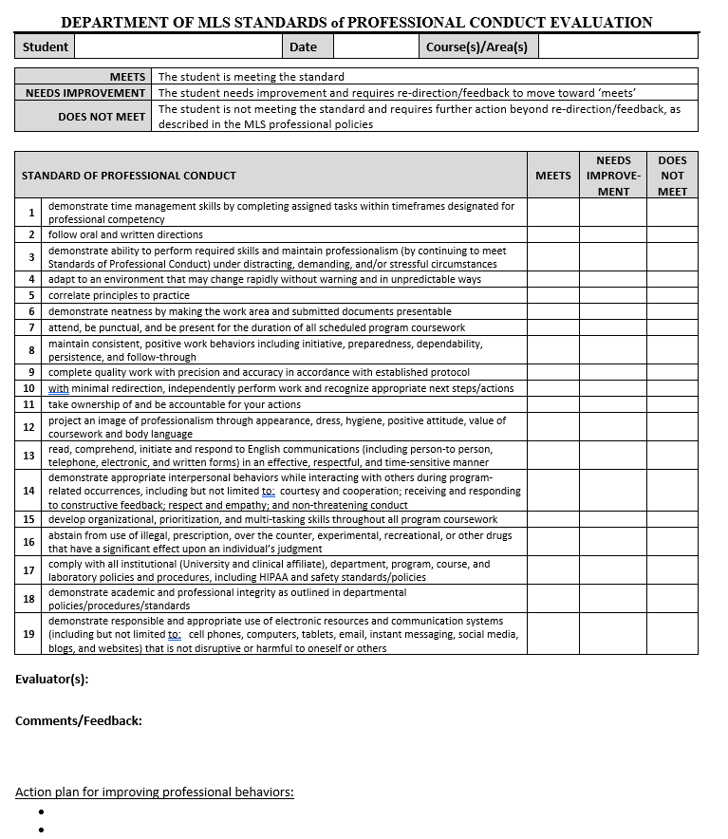
APPENDIX 1: Department of MLS Standards of Professional Conduct Evaluation Form

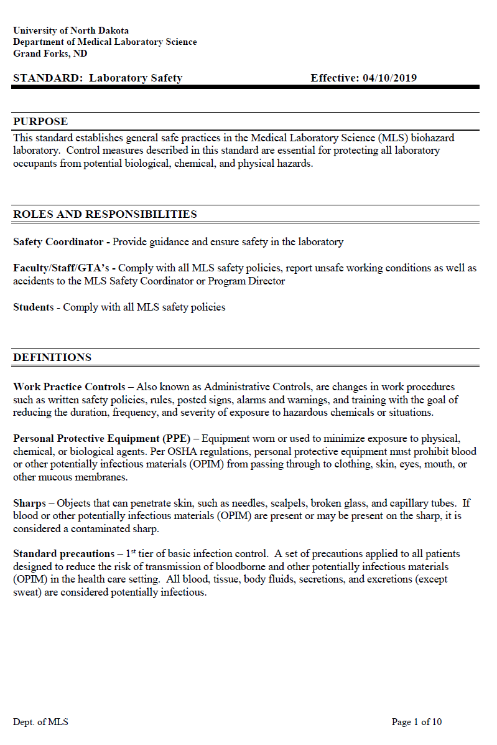
APPENDIX 2: Department of MLS Laboratory Safety Standard
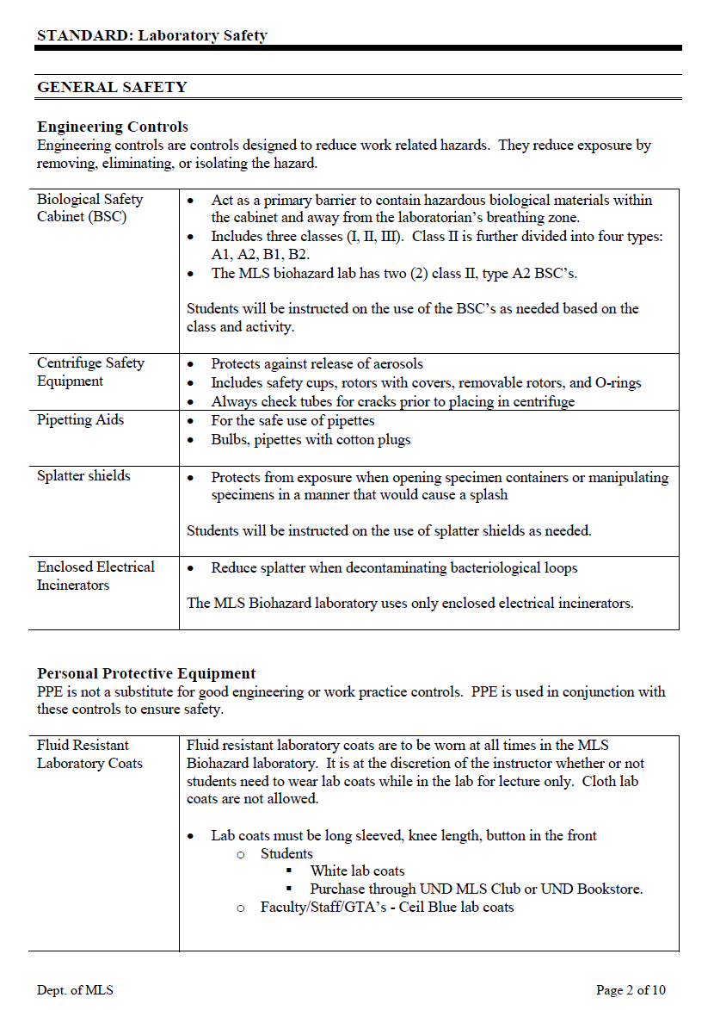

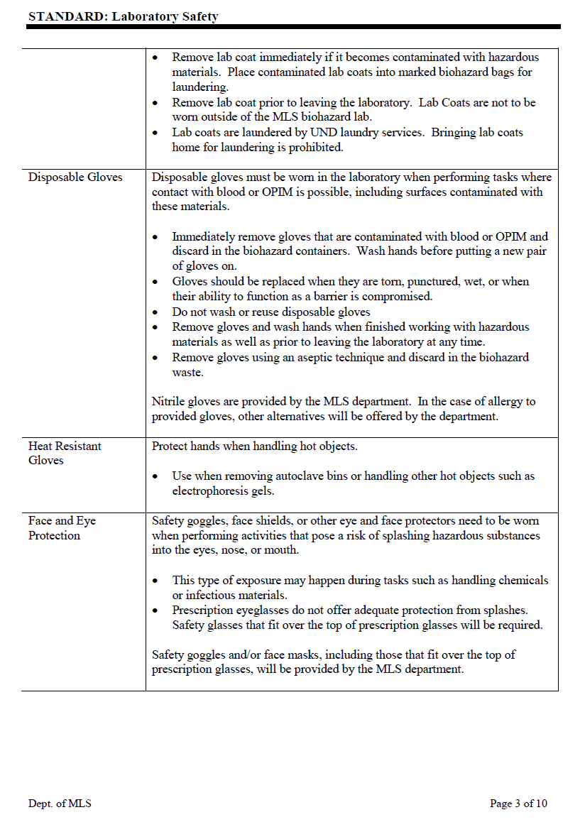

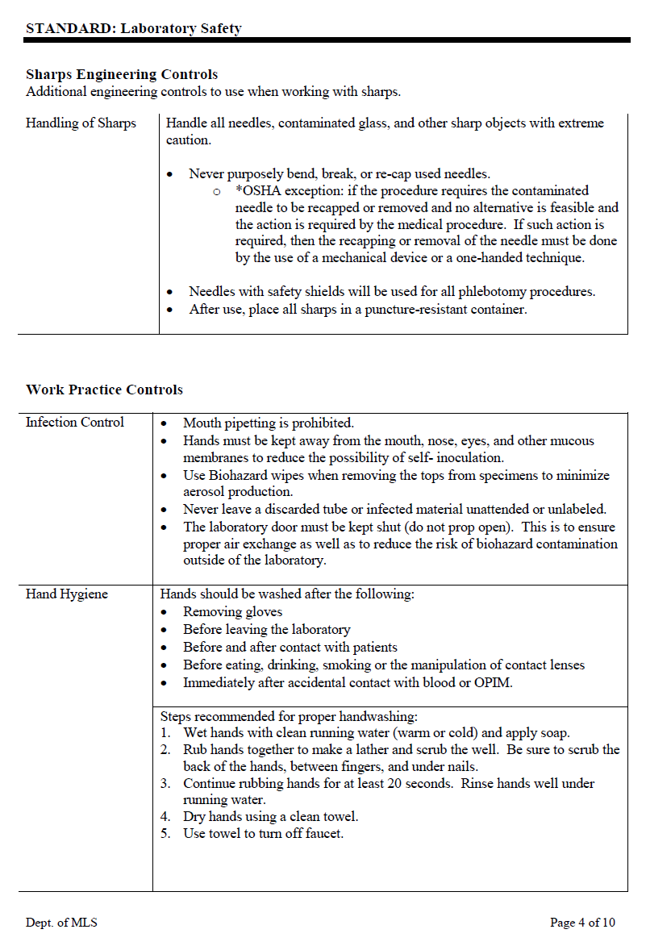

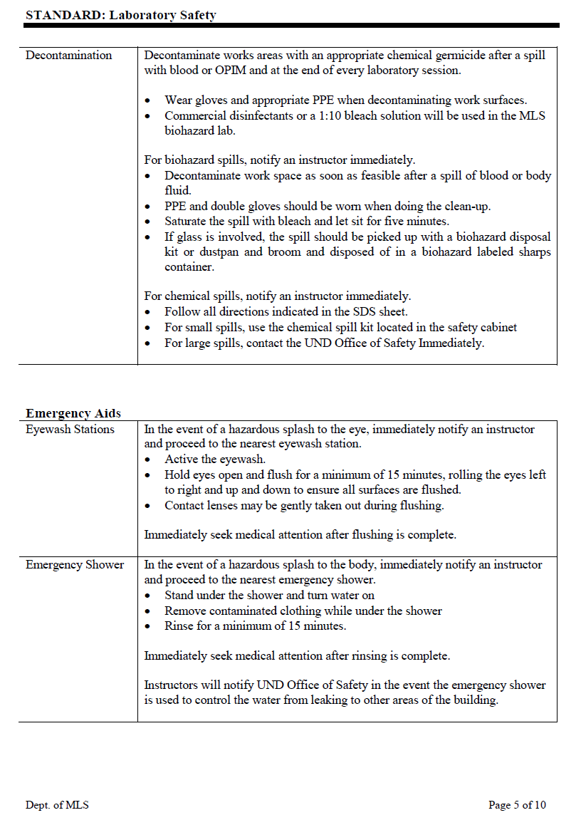

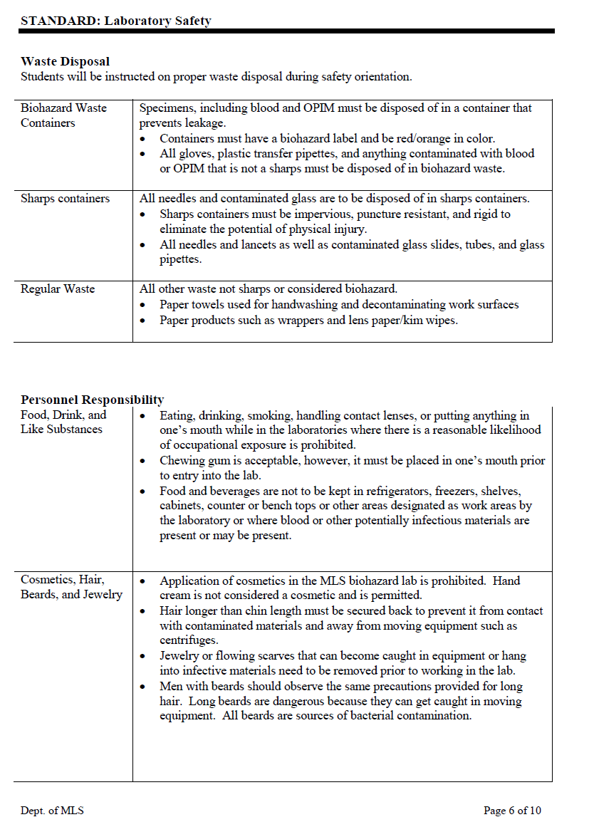

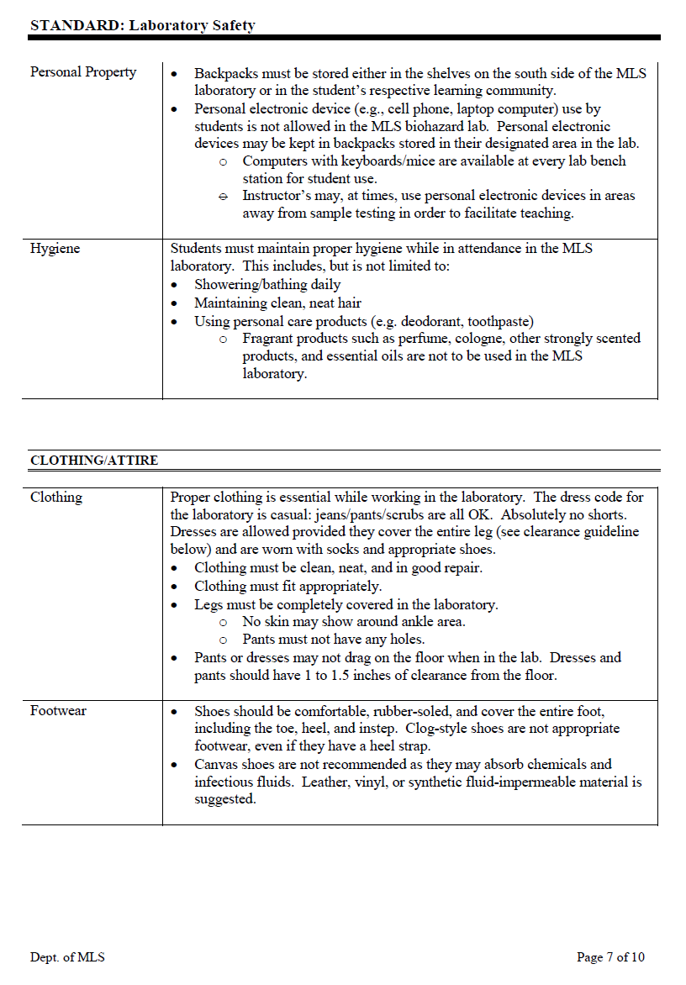

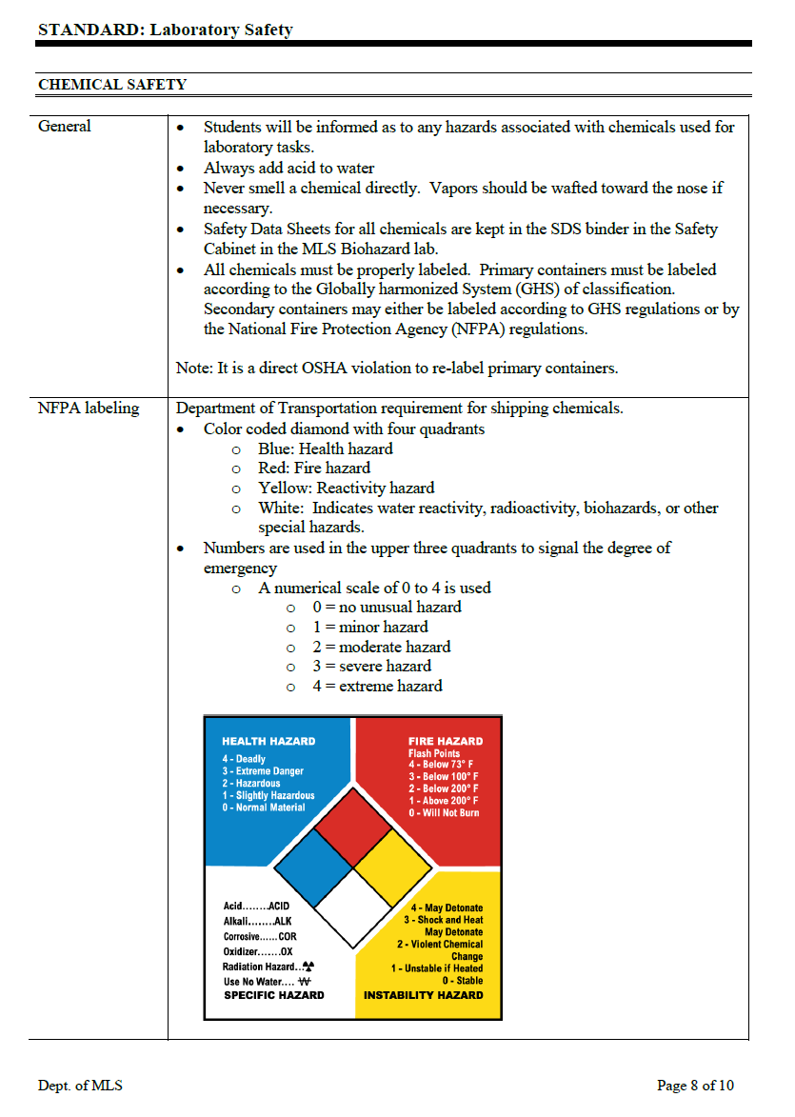

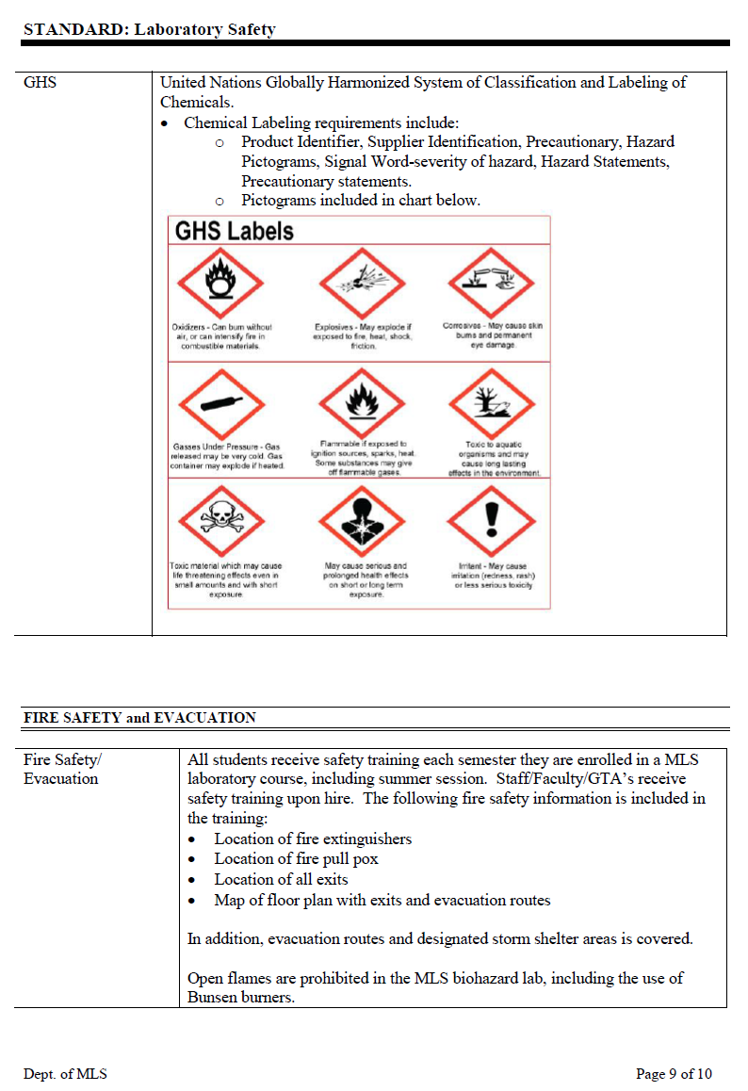

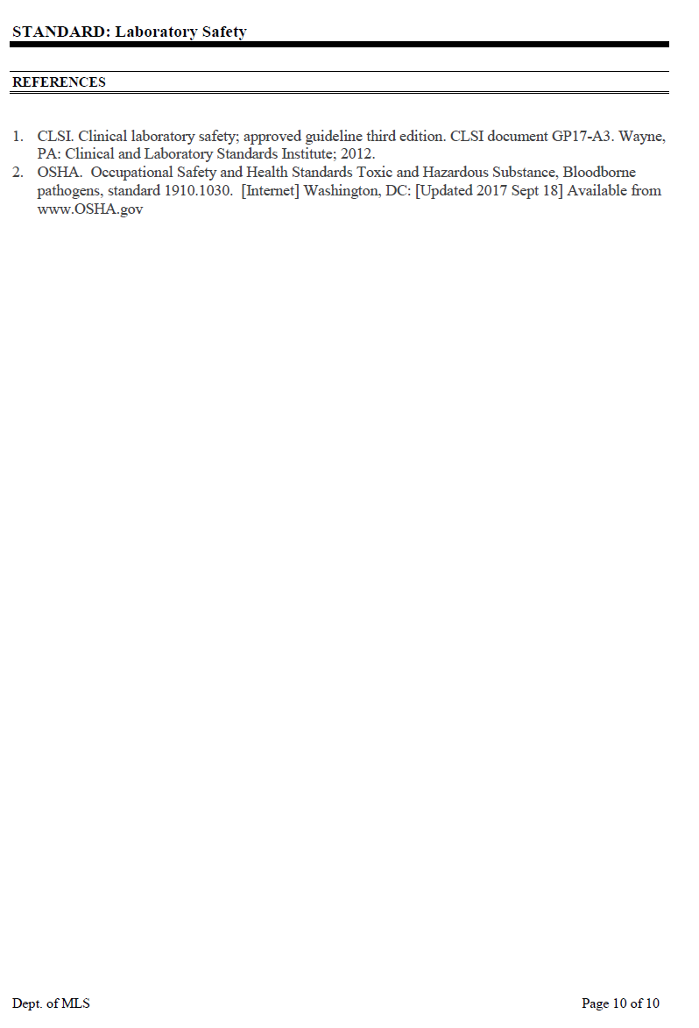

APPENDIX 3: Department of MLS Pathogen Exposure Management Standard
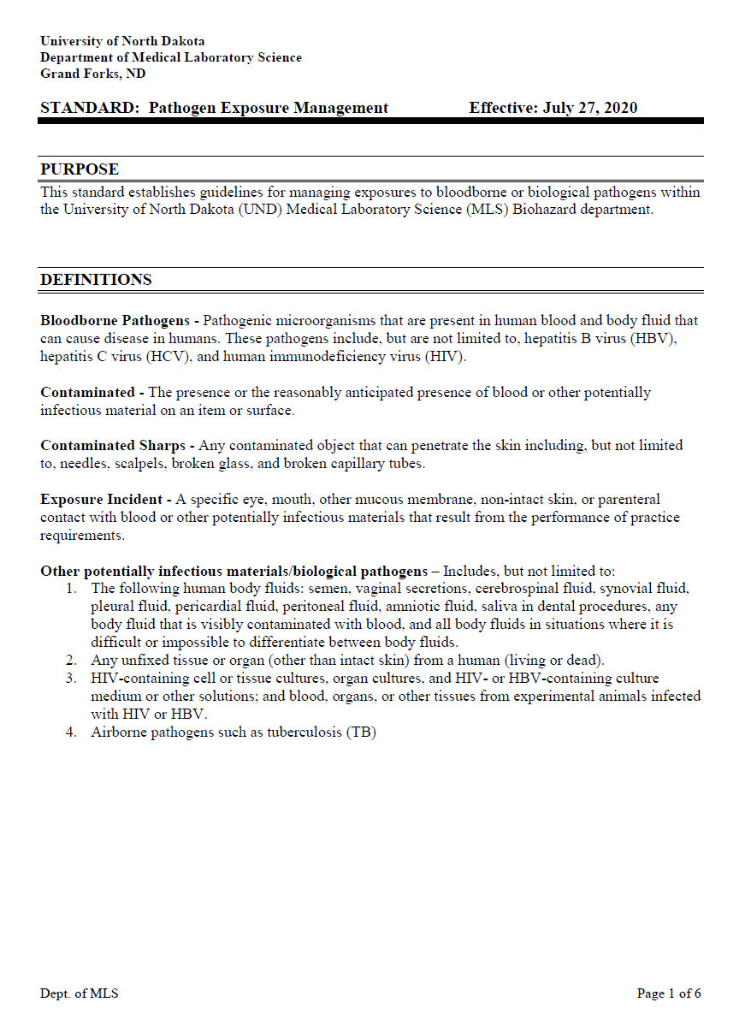

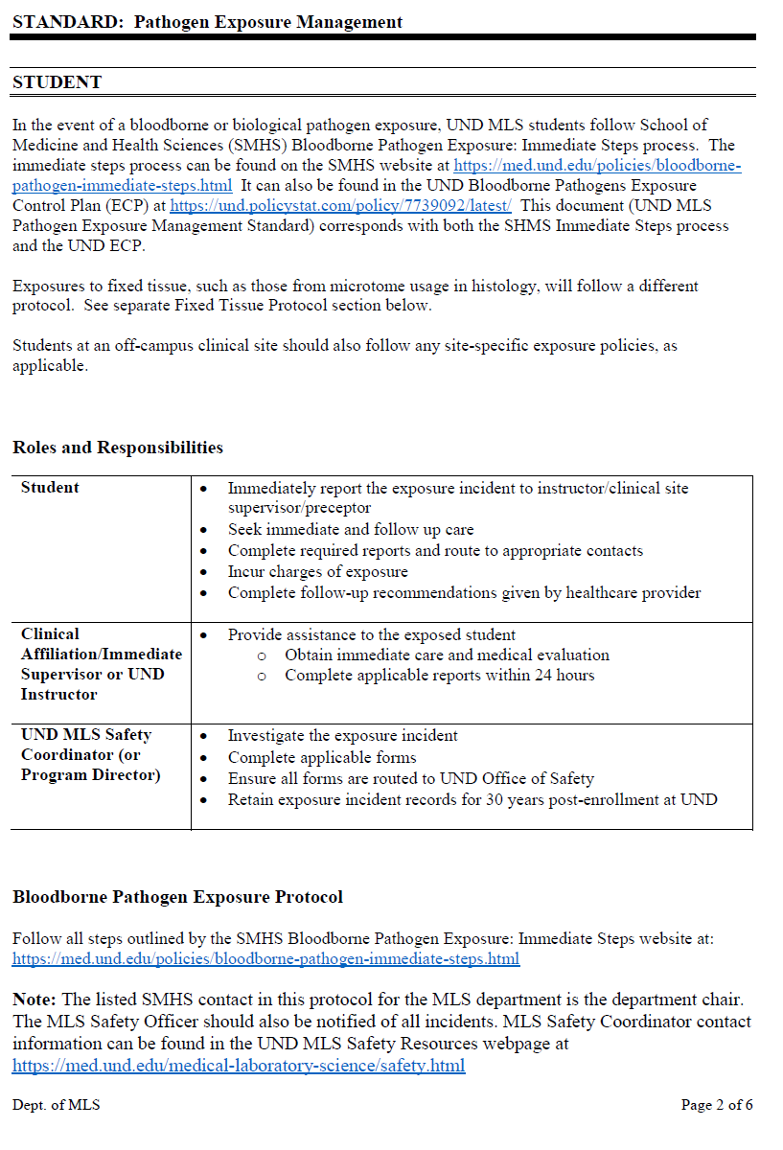
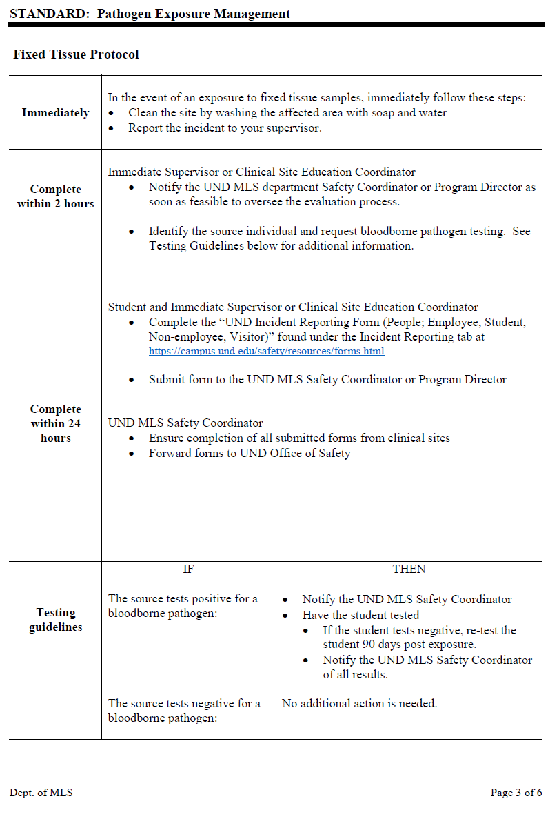
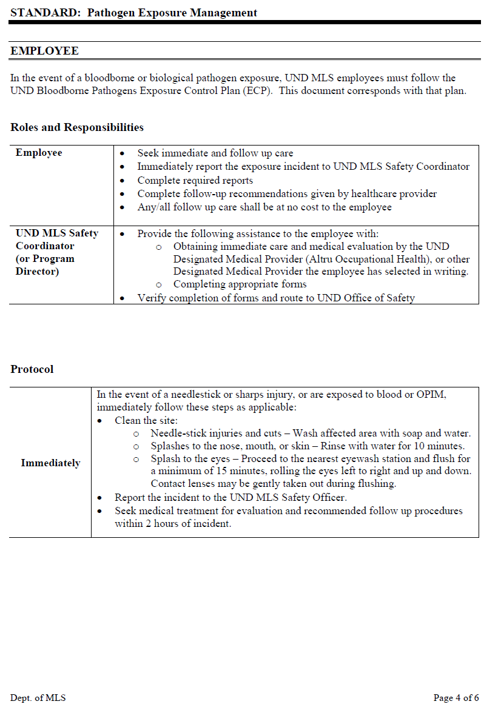
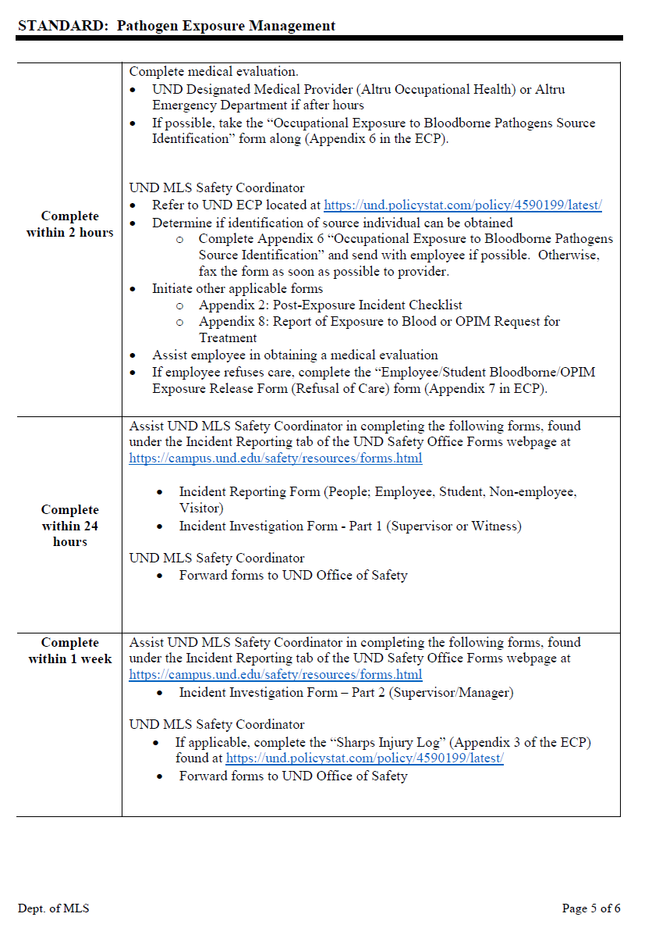
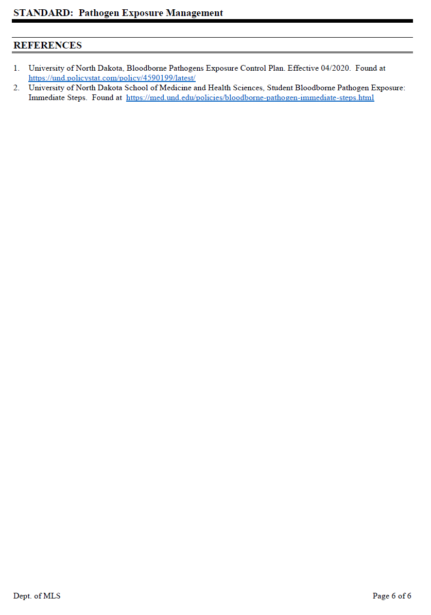

APPENDIX 4: Technical & Academic Standards for Matriculation, Progression, and Graduation

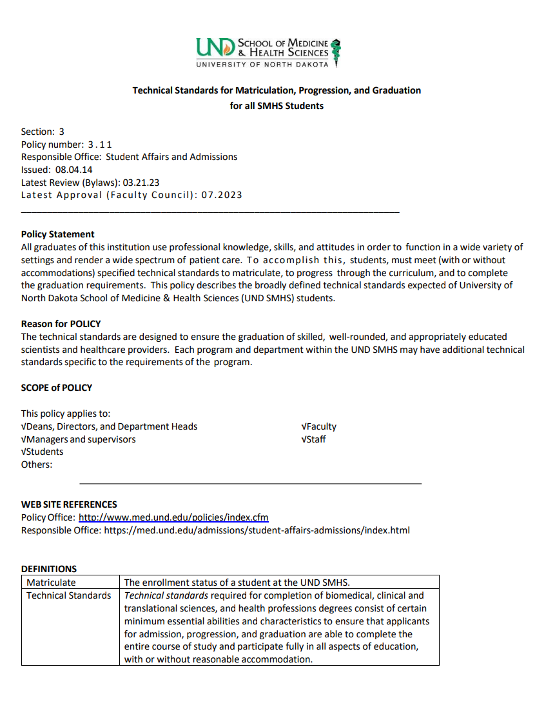

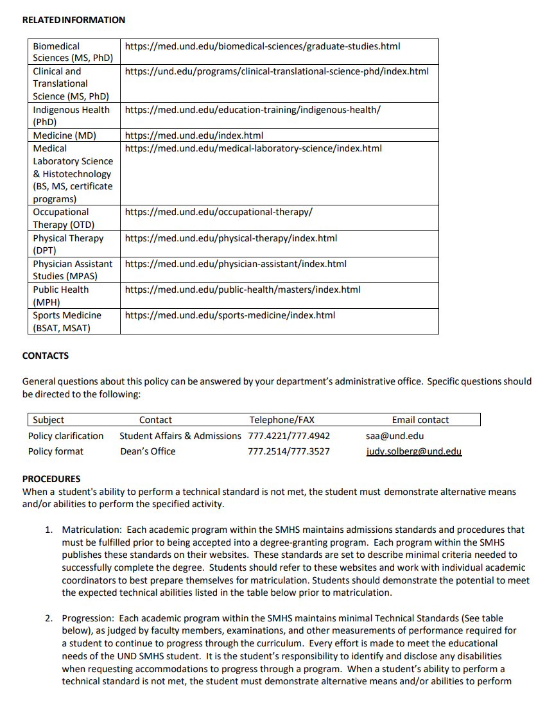

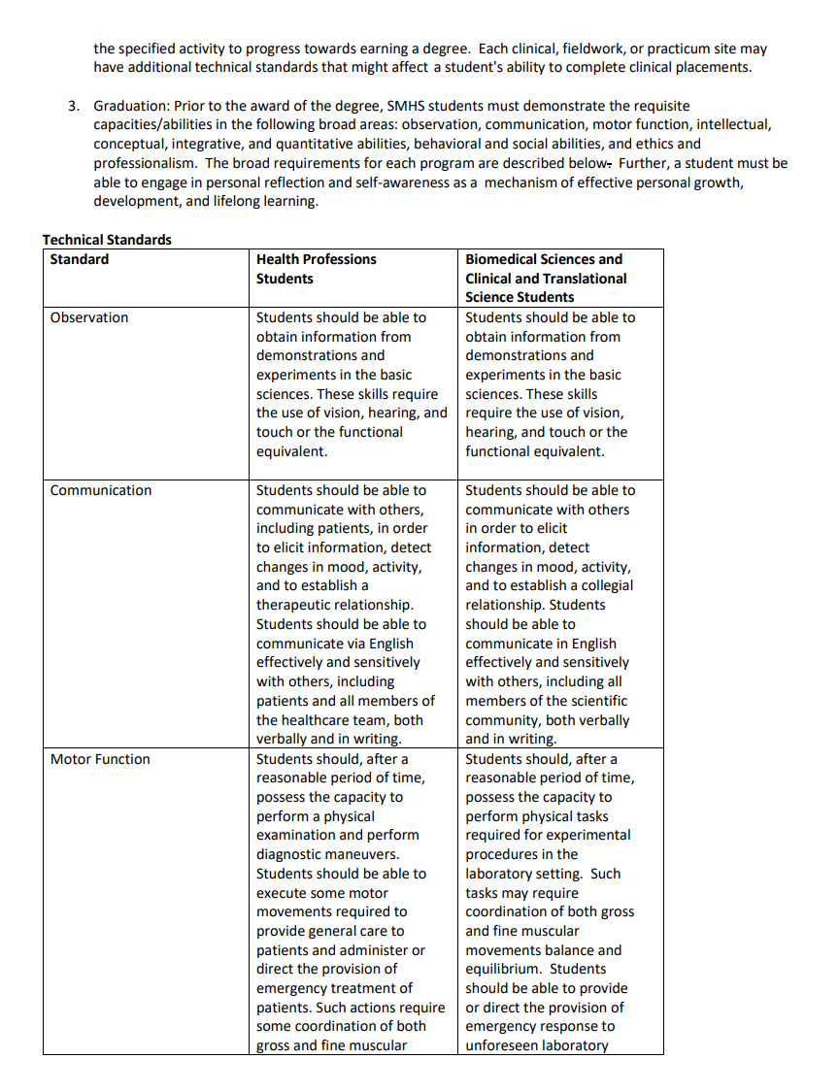

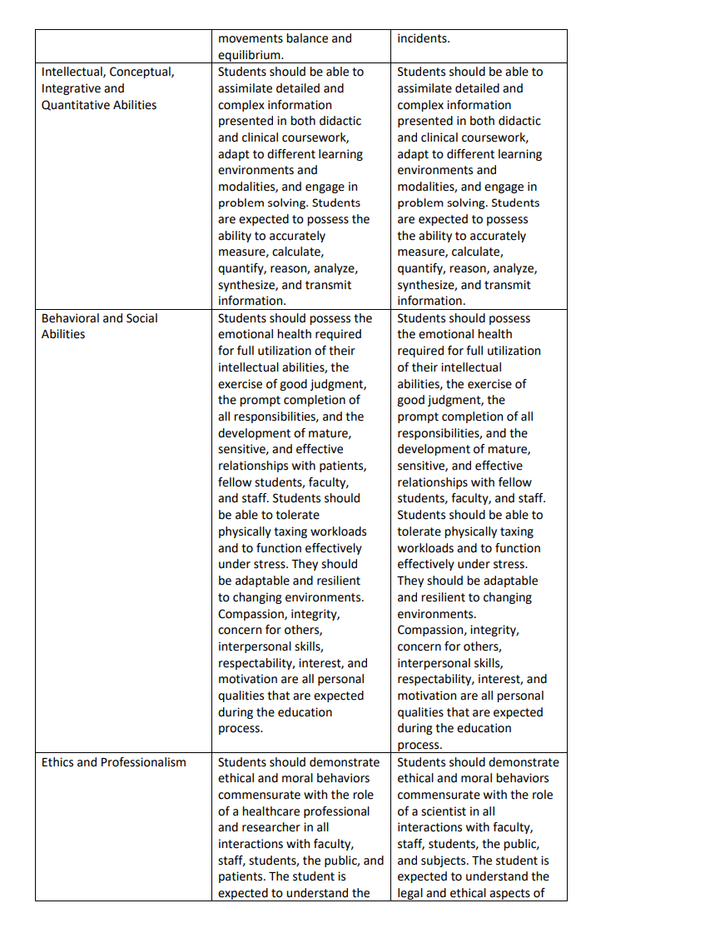

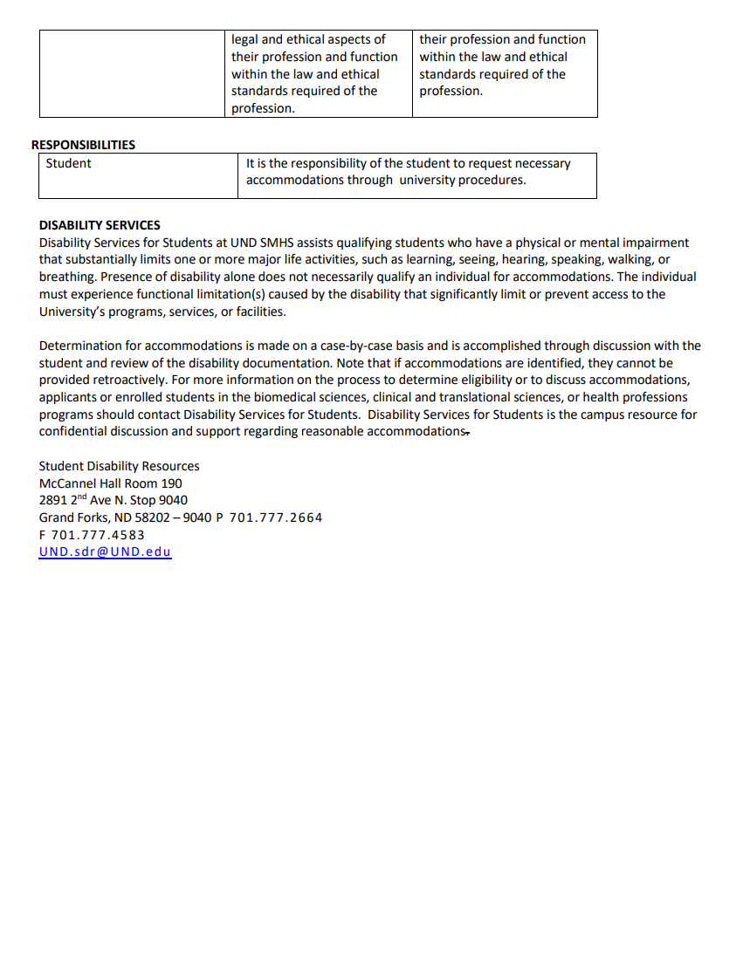

STUDENT SIGNATURE PAGE
The UND MLS Undergraduate Handbook contains policies, procedures and processes that MLS students must comply with in order to be successful academically and professionally. It is the responsibility of the UND MLS program to ensure that students are aware of these policies, procedures and processes, which is accomplished through completion of this signature page. Note that students in the MLS Cohort Program route will complete a separate signature page that contains additional route-specific acknowledgement items.

Initial each item as acknowledgement:
Initials | Signature Page Item
 | - I have read, understand, and agree to comply with the policies, procedures and processes as defined in the UND MLS Undergraduate Handbook. I understand that the policies, procedures and processes in the handbook are subject to modification and that I am responsible for updates as they occur.
 | - I have read and understand that I must be able to meet the UND MLS Essential Functions (pg. 8) and SMHS Technical and Academic Standards for Matriculation, Progression, and Graduation (Appendix 4) in order to be successful in the academic and clinical laboratory. I understand that if I am unable to meet any of these essential functions or standards, I must inform UND MLS faculty/staff to determine if accommodation options are available that would allow for continuation in the program.
 | - I am aware of the UND SMHS Participation in Education as it Relates to Student Health Policy 3.7 and understand that if I have a condition (injury, illness, infection, environmental disease) that may negatively impact myself, fellow students, staff, faculty or patients, I have a professional obligation to inform and work with UND MLS faculty/staff immediately.
 | - I give permission to the UND Department of MLS to release information from my student files for purposes of job or educational opportunities and/or advancement.
 | - I have read the MLS safety and biohazard standards and have been informed about the blood borne pathogens exposure control plan regulations and policies. I understand that I am responsible for compliance with these policies and standards.
 | - I understand that photos and/or videos taken during MLS program coursework and activities may be utilized for educational and/or promotional purposes and give consent for my image to be utilized in them. If I do not want my image to be utilized in such photos and/or videos, I must communicate that request in writing to the UND MLS Laboratory Manager or program route coordinator.
 | - I understand that in order to learn phlebotomy skills, students and instructors in the MLS program may be performing venipunctures and fingersticks on each other. I give permission for these phlebotomy procedures to occur.
 | - I understand that my criminal background check information and my immunization records may need to be shared with my clinical affiliate.

_______________________________________________________ _____________________
Clearly Print Your Full Name Clearly Print Your 3 Initials

______________________________________________________________ _____________
Signature

