Do It Now, Share It Later
Most communication platforms have time-based release functionality. Prepare announcements, emails, and content when convenient. Schedule for publication when timely.

Have you ever…

- provided several weeks’ worth of assignments to students all at once, resulting in confusion or homework completed out of order?
- interrupted your conference or vacation to post time-based lessons, announcements, or information to students?
- forgotten to remind advisees or collaborators about upcoming deadlines?
- needed to reach out to someone after they returned from vacation, but subsequently forgotten to do it?

These situations are preventable through the use of scheduling tools that are built into many software platforms. Here’s how it works within a few of the most common tools.

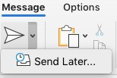  Microsoft Outlook | “Send Later…” is found next to the “Send” icon on new email messages. Complete the message, then schedule a date and time.  The message appears in your drafts and is sent at the time you specified. It is saved to the cloud, so your computer does not need to be on or connected to the Internet at the  specified “Send” time.
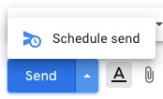  Gmail | “Schedule Send” is found next to the “Send” button on new email messages. This tool functions like the Outlook tool described above.
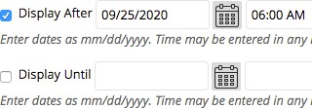  Blackboard | Almost every content item can be scheduled using “Display after…/Display until…” settings within the item.  Blackboard has additional Adaptive Release settings  to specify content access based on rules or groups.  Many people set up the entire semester’s content—including announcements, discussions, and tests—before the semester begins.

