5 Great CATS for Higher Education

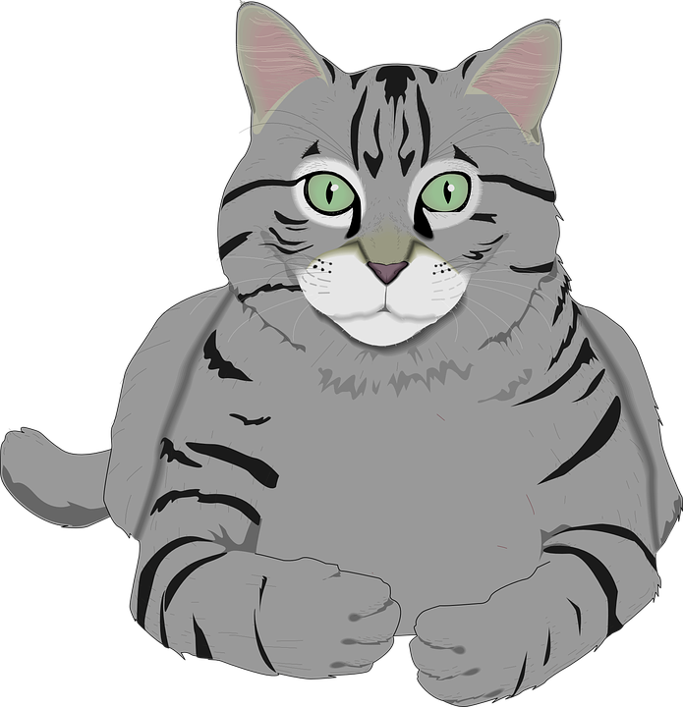
Classroom Assessment Techniques (CATS) are quick, formative in-class activities. Their purpose is twofold. Students reflect on what they do and don’t know. Instructors receive valuable, just-in-time feedback about student understanding. CATS are usually completed anonymously. Here are a few favorites.*

- Use the last 2 minutes of class for any of these.
- Pass out note paper or index cards to students.
- Collect them and use the information to direct your next class session’s focus, consider what to review, or provide more resources based on the results.

Minute Paper
Students write a paragraph answering the question: “What is the most important thing you learned class today?”

Focused Listing
Give students a topic you plan to discuss at the next class. Have them create a list of 10 things related to or subsumed by the topic.

One-Sentence Summary
Students must answer the question: “Who does what to whom, when, where, how, and why?” Consider assigning a disease, illness, symptom, or drug as the initial “who.”

Muddiest Point
Students write down the most confusing or unclear thing from the session or provide questions they have about the topic.
Pros and Cons
Write a prompt asking students to briefly list advantages and disadvantages of a treatment or medicine or the main arguments for each side of a controversial topic.

Empty Outline
Create a simple outline of your lecture topics (limit this to 10 items or less). Leave space: students will fill in subtopics or main ideas.

You can implement most of these with very little preparation. After completion, review of student responses can usually be completed within 15 minutes for a class of 30.

*For 40+ more CATS and examples of their use, see: Classroom Assessment Techniques: A Handbook for College Teachers, 2nd edition, by Thomas A. Angelo and K. Patricia Cross (Jossey-Bass, 1993).

If you are already using CATS in your classes, we would like to know how it’s going!

