_____________________________________________________________________________________

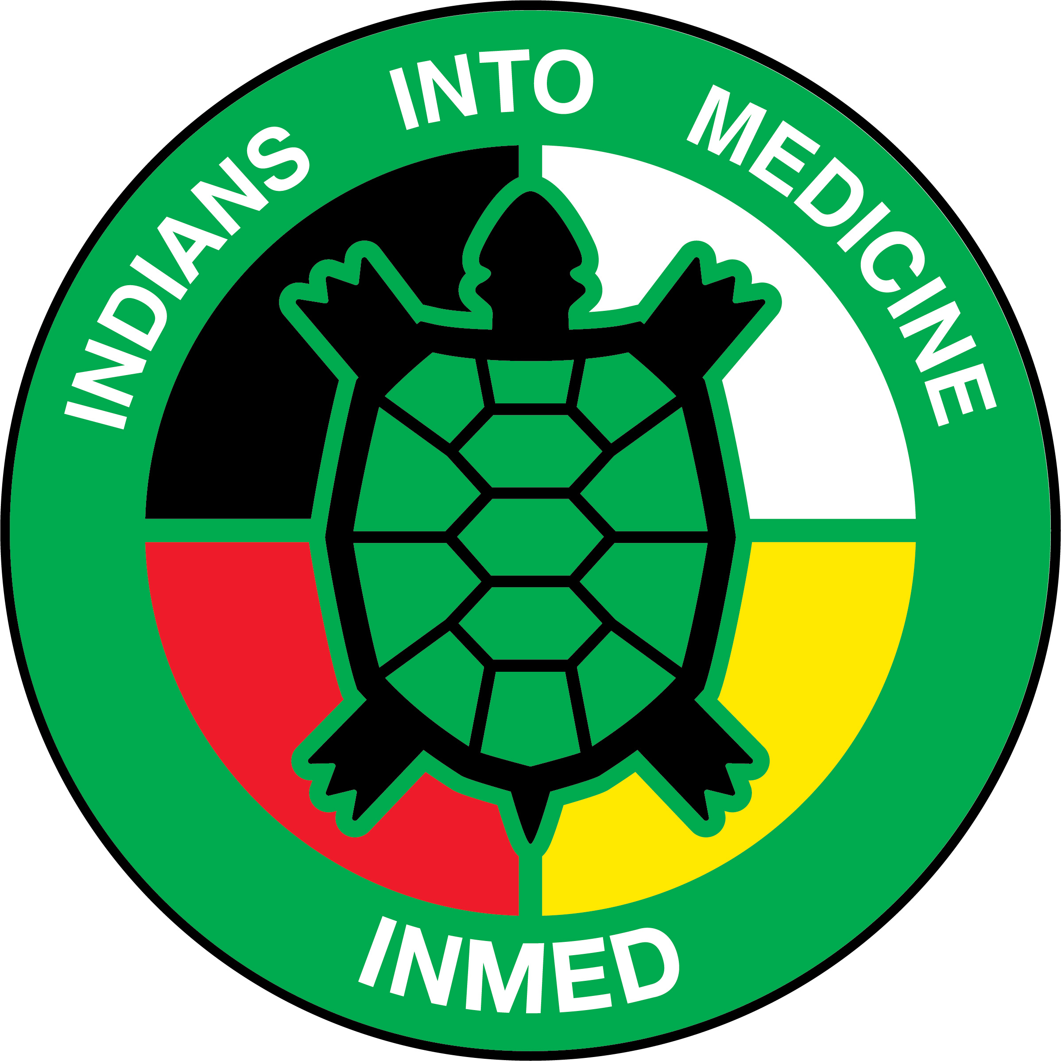 | INMED PROGRAM  UNDSMHS Suite E263  1301 North Columbia Road – Stop 9037  Grand Forks, ND 58202-9037  Phone: (701) 777-3037  Fax: (701) 777-3277

January 15, 2020

Director Report and Brief Updates

- INMED Cohort
- 13 students interviewed for MD Program on Saturday January 11
  - MHA Nation (2)
  - TMBCI/SRST
  - Blackfeet
  - Northern Arapaho
  - Navajo (2)
  - Alaska Native (Inupiag)
  - Cherokee
  - Chickasaw
  - Kiowa
  - Rappahannock
  - Sault St. Marie

- Other medical schools
- UM Duluth https://cbs3duluth.com/news/2019/08/16/native-american-students-increased-in-medical-schools/
- UNM https://www.kunm.org/post/unm-dean-will-push-free-medical-school-state-health-officials-urge-flu-vaccines
- U of A https://news.azpm.org/p/news-articles/2019/6/12/153201-2019-sees-highest-number-of-indigenous-medical-school-grads-at-ua-to-date/
- UW http://cedi-web01.s.uw.edu/pathways-electives/indian-health-pathway/
- WSU https://news.wsu.edu/2019/03/04/naomi-bender-creating-climate-place-space-success/
- OHSU https://www.ohsu.edu/school-of-medicine/nnacoe
- OSU https://news.okstate.edu/articles/health-sciences/2018/first-tribally-affiliated-college-of-medicine-established.html

- COBRE—Indigenous Trauma & Resilience Research Center
- Chokeberry—Redvers
- Boarding Schools—Running Bear
- Stress during pregnancy—Williams
- Request: INMED TAB serve as the CAB for the Community Engagement & Outreach Core?
  - Standing Agenda Item on TAB meetings
  - Earliest start date January 2021
  - Research opportunities (and funding) for INMED, PhD, and MPH students

- Endowed Scholarships
- John Shore Endowment--$150K! ($10K/year for 15 years)
  - Tribal match??
- Pending Opportunities
  - MHA Nation Endowed Scholarship (Thank you Gerilyn Yellow Bird!)
  - MN Dakota Tribes Endowed Scholarship
  - Phil Jackson “Sacred Hoops Scholar”
  - INMED Alumni Endowed Scholarship
  - Others?

- Follow up on New Programming
- Indigenous MPH
- Indigenous Health PhD—approved by AAC/NDUS. SBHE meeting Jan 21
- Indigenous STEM
- INMED Pre-Med
- Indian Health Teaching Hospital / Reservation-based medical student & residency opportunities

5. Other
- Valley News Live: https://www.valleynewslive.com/content/misc/NDT---History-of-Indians-into-Medicine-565977381.html?fbclid=IwAR102NP0-5AEALsZPPphO9JXPf6wYnusPr9X48iYoEURFznaiD3PagUCGsE
- Grand Forks Herald: https://www.grandforksherald.com/news/education/4833705-New-study-shows-more-women-than-men-entering-medical-school-UNDs-numbers-about-even?fbclid=IwAR2dGx5ESc1xDpFztO9bx5tLB7cUIbUPB5LqS5pruF_hKG3NRdPzM2rwCCE
- Journal of Graduate Medical Education: Developing Graduate Medical Education Partnerships in AI/AN Communities https://www.jgme.org/doi/pdf/10.4300/JGME-D-19-00078.1

6. Program & Staff Updates
- Brittany Belgarde
- Kathleen Fredericks
- Erica Gunville
- Susan Holden

