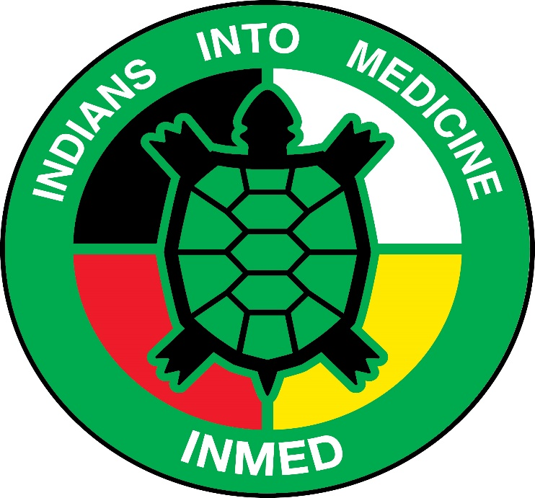
INMED Tribal Advisory Board Meeting Agenda
January 15 2020 @ 10AM central time
UND SMHS RM: E153

10:00AM Roll Call
10:05AM Director & INMED Staff Update
10:30AM Community Advisory Board – Dr. Warne
10:45AM Charter Members – James Ironshell
11:00AM Adjourn

