_____________________________________________________________________________________

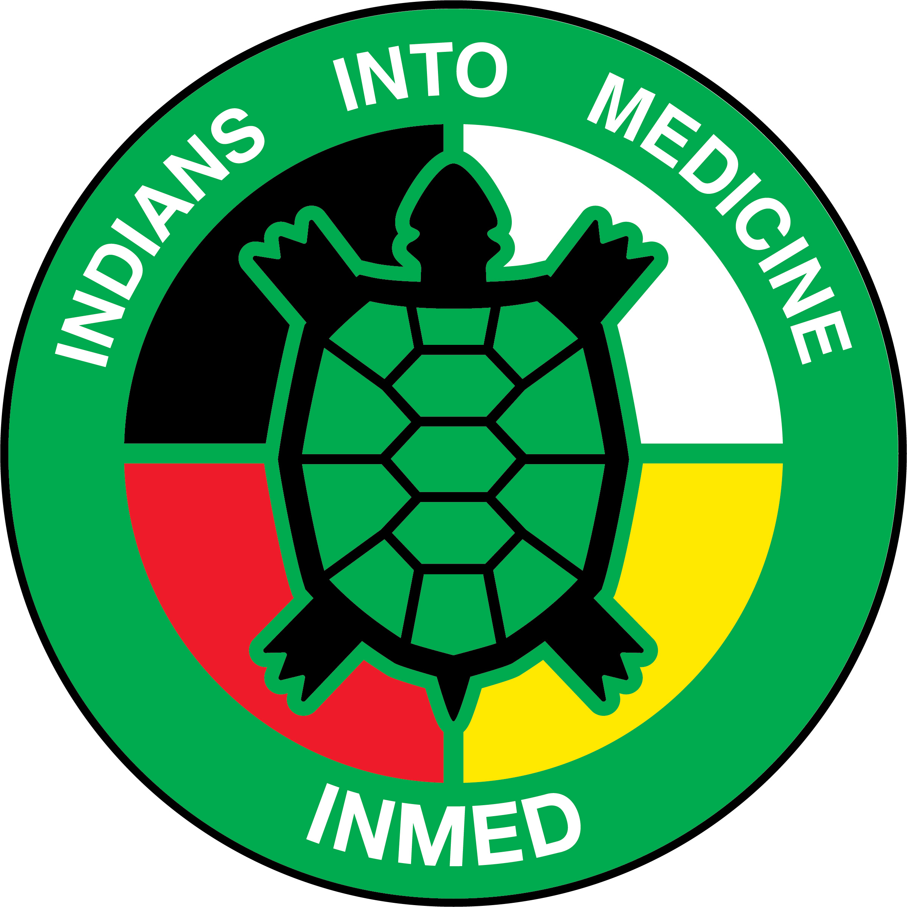 | INMED PROGRAM  UNDSMHS Suite E263  1301 North Columbia Road – Stop 9037  Grand Forks, ND 58202-9037  Phone: (701) 777-3037  Fax: (701) 777-3277

October 23, 2019

Director Report and Brief Updates

- Tribal Outreach & Engagement
- Standing Rock (October 30)
- Turtle Mountain (Nov 7?)
- MHA Nation (Nov 8?)
- Spirit Lake (Nov 12?)

- Tribal Advisory Board representation
- ND
  - Spirit Lake - Iris Walking Eagle
  - Turtle Mountain—Courtney Souvannasacd
  - Standing Rock—Brandon Maui / Ira Taken Alive
  - MHA Nation - Lisa Lone Fight
- MT
  - Blackfeet - Harold DustyBull
  - Crow - LeeAnn Bruised Head
  - Northern Cheyenne - Janelle and Sterling
  - Flathead—LeeAnna Musquiz, MD
  - Rocky Boy - Jessica Windyboy
  - Ft. Belknap - Jennifer Show
  - Ft. Peck - Haven Gourneau
- SD
  - Pine Ridge—Tally Plume
  - Rosebud - James Ironshell
  - Cheyenne River - Ryman LeBeau
  - Lower Brule -
  - Crow Creek -
  - Sisseton Wahpeton Oyate - Danny Seaboy/Audrey German
  - Flandreau -
  - Yankton -
- NE
  - Ponca—Larry Voegele
  - Omaha - Ashleen Blackbird
  - Winnebago - Linae Big Fire
  - Santee - Diane LaPointe
- WY
  - Wind River –
- Charter
  - Twila Martin-Kekahbah
  - David Gipp

- INMED Cohort
- Six students in MD Program

- Other medical schools
- UM Duluth https://cbs3duluth.com/news/2019/08/16/native-american-students-increased-in-medical-schools/
- UNM https://www.kunm.org/post/unm-dean-will-push-free-medical-school-state-health-officials-urge-flu-vaccines
- U of A https://news.azpm.org/p/news-articles/2019/6/12/153201-2019-sees-highest-number-of-indigenous-medical-school-grads-at-ua-to-date/
- UW http://cedi-web01.s.uw.edu/pathways-electives/indian-health-pathway/
- WSU https://news.wsu.edu/2019/03/04/naomi-bender-creating-climate-place-space-success/
- OHSU https://www.ohsu.edu/school-of-medicine/nnacoe
- OSU https://news.okstate.edu/articles/health-sciences/2018/first-tribally-affiliated-college-of-medicine-established.html

- Endowed Scholarships
- John Shore Endowment--$150K! ($10K/year for 15 years)
  - Tribal match??
- Pending Opportunities
  - MHA Nation Endowed Scholarship
  - MN Dakota Tribes Endowed Scholarship
  - Phil Jackson “Sacred Hoops Scholar”
  - Others?

- Follow up on New Programming
- INMED Pre-Med
- Indigenous MPH
- Indigenous Health PhD
- Indigenous STEM
- New Hires!! (Wescott, Redvers, Nadeau, Running Bear)

7. Program & Staff Updates
- Brittany Belgarde
- Kathleen Fredericks
- Erica Gunville
- Susan Holden

