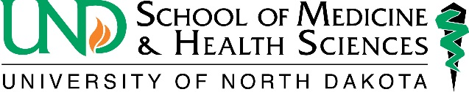
Office of Alumni and Community Relations
1301 N. Columbia Rd., Stop 9037
Grand Forks, ND 58202
701.777.4305

Photograph Permission/Release Form

I hereby grant to the University of North Dakota (“University”) the perpetual right to use, reproduce, exhibit, display, broadcast, distribute and create derivative works of University-related photographic or video-recorded images of me for use in connection with activities of the University. This grant includes, without limitation, the right to publish such images in the University’s student newspaper, alumni magazines, on the University’s websites, social media sites, and on public relations/
promotional materials, such as marketing and admissions publications. These images may appear in a wide variety of formats and media now available to the University and that may be available in the future, including but not limited to print, video, and electronic/online media.

I understand that some photographs of enrolled students may be considered educational records under the Family Educational Rights and Privacy Act of 1974 (FERPA), and that by granting this Release I hereby give University my consent to use such educational records for the purposes set forth above.

I hereby waive any right to royalties or other compensation arising from or related to the use by the University of the images, and I waive any claim of ownership over any image or copyright therein.

I hereby acknowledge that I am 18 years of age or older and have read and understand the terms of this Release.

Name (printed): _______________________________________

Signature: ____________________________________________

Relation to subject (if subject is a minor): ___________________

Address: _____________________________________________

Event/Location: ___ ____________________________________

Date: _____________

