_____________________________________________________________________________________

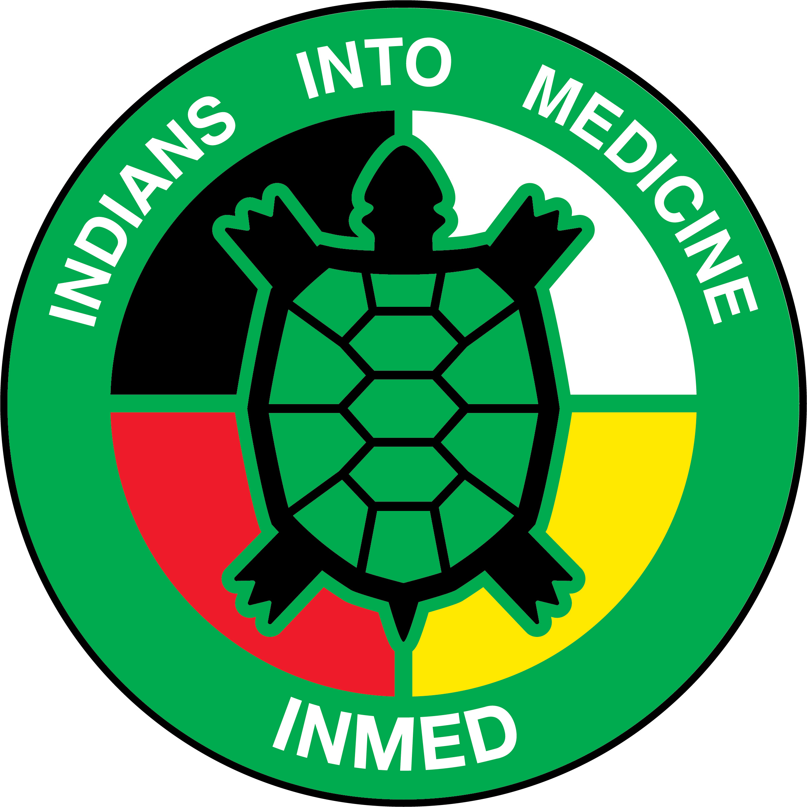 | INMED PROGRAM  UNDSMHS Suite E263  1301 North Columbia Road – Stop 9037  Grand Forks, ND 58202-9037  Phone: (701) 777-3037  Fax: (701) 777-3277

October 14, 2020

Director Report and Brief Updates

Dr. David Gipp acknowledgement

Proposed “Dr. David Gipp Endowed Scholarship”

- INMED Cohort
- 8 First-Year students started the MD Program this July
  - Hannah Balderas, MHA Nation
  - Tristan Bullshoe, Blackfeet
  - Megan Corn, Choctaw
  - Waylon Decoteau, TMBCI
  - Andrea Kelsch, MHA Nation
  - Judge Muskrat, Cherokee
  - Kendra Roland (Christensen), MHA Nation
  - Tarlyn Tonepahote, Kiowa

- Impact of COVID-19
- Distance learning for incoming class
- Minimizing in-person sessions to clinical training
- Questions/Comments?

- COBRE—Indigenous Trauma & Resilience Research Center
- Impact score 24!
- Chokeberry—Redvers
- Boarding Schools—Running Bear
- Stress during pregnancy—Williams
- Final funding decision this fall
- INMED TAB will serve as the CAB for the Community Engagement & Outreach Core
  - Proposal will be reviewed this summer
  - Standing Agenda Item on TAB meetings
  - Earliest start date January 2021
  - Research opportunities (and funding) for INMED, PhD, and MPH students

- Follow up on New Programming
- Indigenous Health MPH—nine enrolled for fall 2020 (21 total in MPH)
- Indigenous Health PhD—19 admitted! (over 50 applications), 17 American Indian
- INMED Pre-Med—met with President Wynne and incoming President Armacost
  - Serving on new University-wide Diversity & Inclusion Taskforce
- Dual degree programs—MD/MPH, MD/PhD, JD/MPH
- Indian Health Teaching Hospital / Reservation-based medical student & residency opportunities

6. Other
- INMED acknowledged as the top medical school for AI/AN student numbers

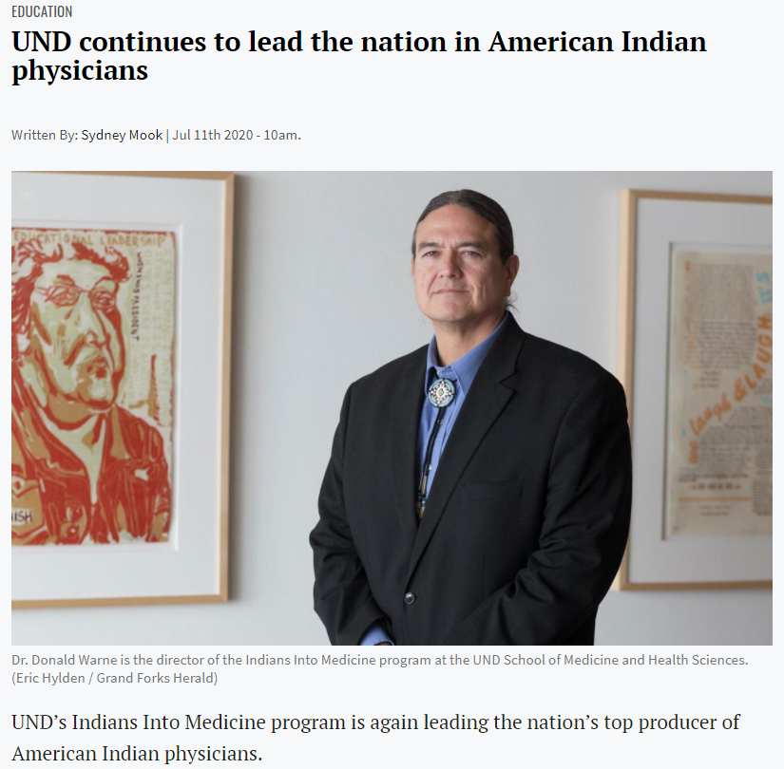

- Dr. Warne will be receiving a Heroes in Health award from NIHB today.

7. Program & Staff Updates
- Dr. Siobhan Wescott
- Dr. Yvette LaPierre
- Kathleen Fredericks
- Erica Gunville
- Susan Holden

