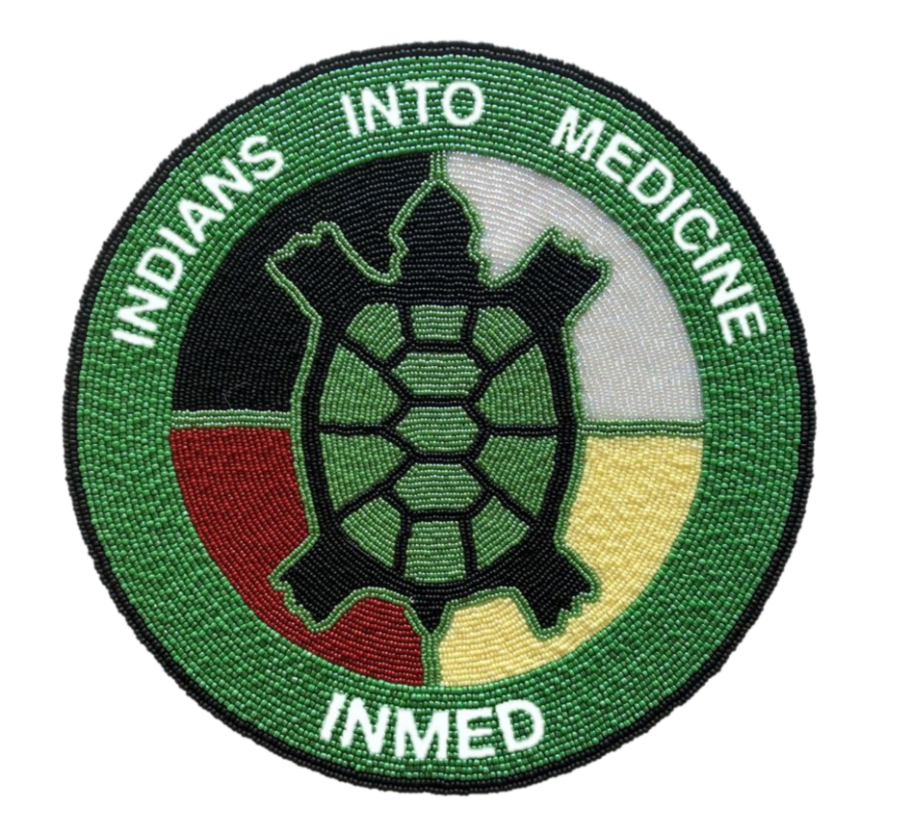
INMED Tribal Advisory Board (TAB) Meeting VIA Zoom
August 6, 2020 – 10AM central time

Roll Call - Erica

Opening Blessing

Staffing Updates:
  - Welcome to Dr. Yvette La Pierre (fulltime) – Dr. Warne
  - Erica transition to new role(s) – Dr. Warne

Director Report – Dr. Warne

Program Updates:
  - SI – Dr. Wescott
  - MCAT prep - Kathleen
  - CLIMB – Dr. La Pierre

TAB Updates:
- Welcome Packets (TAB input) - Erica
- Monthly Check-ins (pics & bio) - Erica
- Next In-person meeting (professional pictures) - Erica

Question(s) & Comments – TAB Charter Members

Next (call) meeting -TBD

