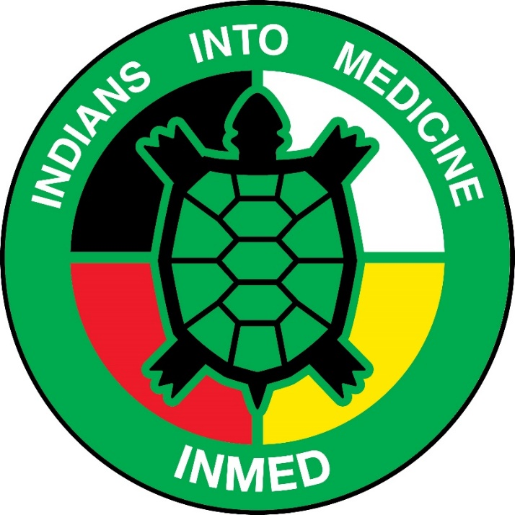
INMED Tribal Advisory Board (TAB) Meeting VIA Zoom
April 17, 2020 – 10AM central time
Opening Blessing

Welcome & Introductions

Staffing Updates:
  - Brittany leaving to TMCC - Brittany
  - Welcome to Yvette – Dr. Warne

COVID Update—Dr. Warne
Director Update—Dr. Warne

Program Updates:
  - INMED Students—Wescott & Warne
  - SI (No banquet) —Wescott & Warne
  - MCAT—Kathleen
  - CLIMB—Kathleen
  - NEURO—Erica

Honoring of Graduates:
  - Considering FB Live
  - Star Quilts

Funding/IHS Grant—Warne
- Indigenous Health PhD—Warne
- COBRE Update—Warne
- Open Discussion with TAB

*In person meeting in July-TBD

