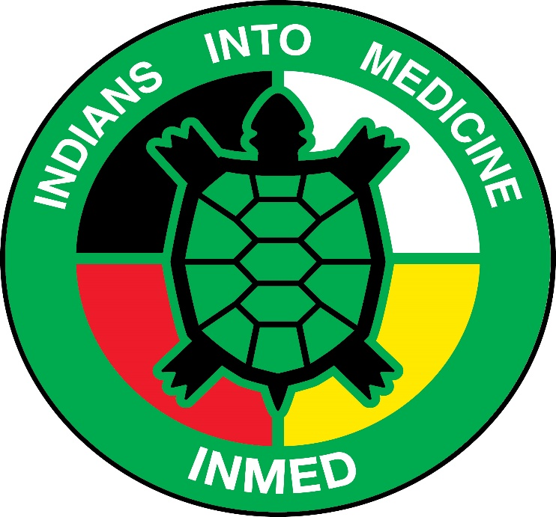
INMED Tribal Advisory Board Meeting Agenda
Wednesday October 23rd at 1PM
UND SMHS RM:

1:00PM Roll Call
1:05PM Director’s Update & INMED Staff Update
2:00PM Board Discussion
3:00PM Adjourn

