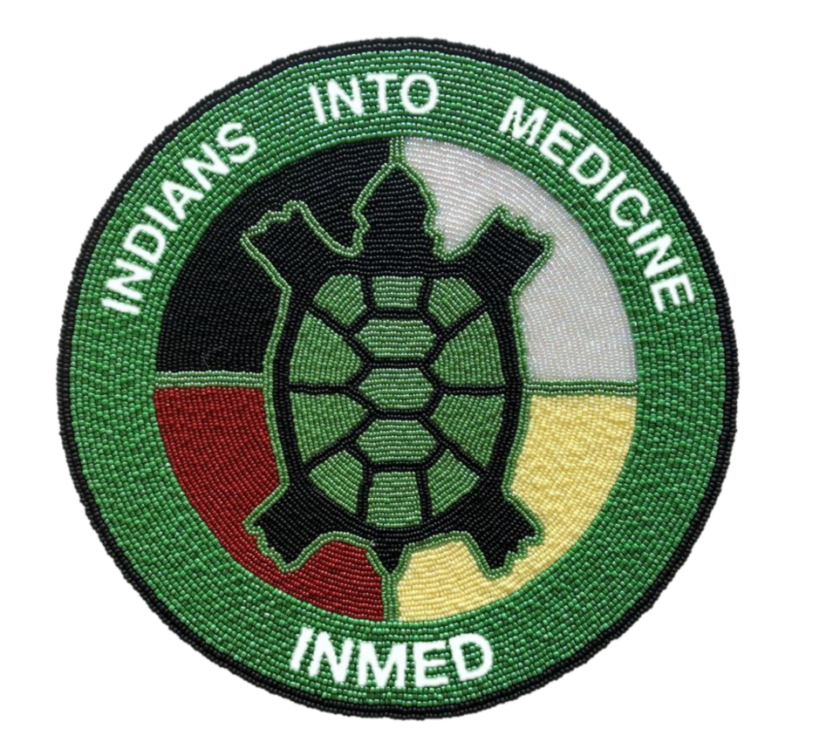
INMED TAB Meeting: Conference call via Zoom
Wednesday, October 14th, 2020
10am CT

Roll Call - Erica

Opening Blessing

Director Report – Dr. Warne

UND Program Updates:
- Dr. Wescott
- Kathleen
- Dr. La Pierre
- Erica

USD Program Updates:
- DenYelle
- Donis

Charter Membership – James Iron Shell (Vice Chair)

Re-election (July-2019) - TAB

Next meeting (Jan 2021) -TBD

