Revised 11/2025
DEPARTMENT OF MEDICAL LABORATORY SCIENCE
HISTOTECHNICIAN PROGRAM

2025-2026
TABLE OF CONTENTS
DESCRIPTION OF THE HISTOTECHNOLOGY PROFESSION 4
DESCRIPTION OF ENTRY LEVEL COMPETENCIES OF THE HISTOTECHNICIAN 5
UNIVERSITY OF NORTH DAKOTA 6
DEPARTMENT OF MEDICAL LABORATORY SCIENCE 6
Accreditation 6
Mission 6
Goals 6
UND HISTOTECHNICIAN PROGRAM ESSENTIAL FUNCTIONS 7
DEPARTMENT OF MEDICAL LABORATORY SCIENCE 8
HT PROGRAM FACULTY AND STAFF 8
HISTOTECHNICIAN PROGRAM & CURRICULUM 9
HT Program Curriculum 9
Modifications to Polices, Procedures & Processes 10
HT PROGRAM POLICIES, PROCEDURES & PROCESSES 10
I. HISTOTECHNICIAN PROGRAM APPLICATION, ADVANCEMENT & STANDING 10
A. HT Program Admission Criteria 10
B. HT Program Application/Admission Processes & Polices 10
C. HT Program Advancement/Academic Standin 11
D. HT Program Dismissal 11
III. ESSENTIAL FUNCTIONS & TECHNICAL STANDARDS 12
IV. PARTICIPATION IN EDUCATION AS IT RELATES TO STUDENT HEALTH 12
V. DISABILITY ACCESS 12
VI. STUDENT/GRADUATE RECORDS 13
VII. UNIVERSITY REFUND POLICY 13
VIII. UNXPECTED UNIVERSITY OR PROGRAM INTERRUPTION/CLOSURE 13
IX. LEAVE 13
X. DRUG & aLCOHOL SCREENING 13
XI. EMAIL COMMUNICATIONS 14
XII. PROMOTIONAL IMAGES 14
XIII. BIOHAZARD & SAFETY 14
XIV. LEARNER MISTREATMENT 14
XV. STUDENT CONCERNS & FEEDBACK 14
XVI. STUDENT ACADEMIC GRIEVANCES & APPEALS 14
XVII. UNDERGRADUATE PROFESSIONAL & ACADEMIC STANDARDS COMMITTEE (UNDERGRADUATE PASC) 15
XVIII. PROBATION STATUS 15
XIX. STANDARDS OF PROFESSIONAL CONDUCT 15
XX. COURSE SECTIONS 16
XXI. PROCTOR INFORMATION 17
XXII. COURSE POLICIES 17
XXIII. GRADING 17
XXIV. HEALTH INSURANCE 18
XXV. LIABILITY INSURANCE 18
XXVI. CLINICAL SITE PLACEMENT 18
XXVII. CLINICAL PRACTICUM HOURS 18
XXVIII. CLINICAL PRACTICUM SCHEDULE & ATTENDANCE EXPECTATIONS 18
XXIX. EMPLOYMENT/SERVICE WORK 19
XXX. UNEXPECTED DISCONTINUANCE OF A CLINICAL AFFILIATE 19
XXXI. REMOVAL FROM A CLINICAL AFFILIATE SITE 20
XXXII. NATIONAL CERTIFICATION EXAM ELIGIBILITY 20
XXXIII. WELLNESS BENEFIT 20
APPENDIX 1: Department of MLS Standards of Professional Conduct Evaluation Form 21
APPENDIX 2: Department of MLS Laboratory Safety Standard 22
APPENDIX 3: Technical and Academic Standards for matriculation, Progression, and Graduation 32
STUDENT SIGNATURE PAGE 37

DESCRIPTION OF THE HISTOTECHNOLOGY PROFESSION

Histotechnician professionals are qualified by academic and applied science education to provide service and research in histotechnology and related areas in rapidly changing and dynamic healthcare delivery systems. They have diverse and multi‐level functions in the areas of analysis and clinical decision‐making, information management, regulatory compliance, education, and quality assurance/performance improvement wherever anatomic pathology testing is researched, marketed, developed or performed.

Histotechnician professionals perform, develop, evaluate, correlate and assure accuracy and validity of laboratory testing and procedures; direct and supervise anatomic pathology laboratory resources and operations; and collaborate in the diagnosis and treatment of patients. They possess skills for financial, operations, marketing, and human resource management of the histopathology laboratory.

Histotechnician professionals work independently and collaboratively, being responsible for their own actions, as defined by the profession. They have the requisite knowledge and skills to educate laboratory professionals, health care professionals, and others in laboratory practice, as well as the public.

The ability to relate to people, a capacity for calm and reasoned judgment, and a demonstration of commitment to the patient are essential qualities. Communication skills extend to consultative interactions with members of the healthcare team, external relations, customer service and patient education. Histotechnician professionals demonstrate ethical and moral attitudes and principles that are necessary for gaining and maintaining the confidence of patients, professional associates, and the community.

(NAACLS, 2024 Standards)

DESCRIPTION OF ENTRY LEVEL COMPETENCIES OF THE HISTOTECHNICIAN

At career entry-level, the histotechnician will have the following professional competencies. They will have the ability to:
- Professional Behaviors and Communication
  - Demonstrate professional and ethical behavior along with effective interpersonal communication skills when engaging with various stakeholders.
  - Establish effective interprofessional working relationships with other health care professionals, demonstrating comprehension of and respect for their roles and patient welfare.
  - Recognize and appreciate the importance of engaging with an inclusive workforce through collaboration.
  - Value and advocate for a workplace environment that fosters inclusivity, diversity, equity, and accessibility.
- Safety and Compliance
  - Comply with government regulations and accreditation standards relevant to the respective discipline.
  - Adhere to prescribed protocols for overall laboratory safety, biohazard containment, and waste disposal.
  - Implement quality assurance principles to ensure the validity and accuracy of laboratory generated data.
- Education and Research
  - Acknowledge and respond to individual requirements for continuing education and development to foster growth and maintain professional competence.
  - Provide instruction to users of laboratory services regarding appropriate procedures, test utilization and interpretation.
- Laboratory Operations
  - Employ a logical and systematic problem-solving approach when identifying errors and/or technical issues with laboratory procedures and instrumentation.
  - Apply principles of data security to safeguard laboratory and hospital information systems.
  - Apply principles of quality assurance to ensure validity and accuracy of laboratory data.
- Pre-Analytical Competencies
  - Evaluate specimen collection, processing, and storage procedures in accordance with standard operating procedures.
  - Ensure specimen integrity is maintained throughout the sample procurement process.
- Analytical Competencies
  - Adhere to written policies, processes, and procedures for analytical testing, analysis, and instrumentation maintenance.
  - Evaluate and provide rationale for troubleshooting protocols in analytical testing when appropriate.
  - Perform routine procedures in accordance with standard operating procedures.
  - Apply quality control principles to analytical testing procedures, including instrument calibration, statistical analyses of control results, Westgard rules, and verification of reference ranges.
  - Perform basic calculations, dilutions, and statistical analyses for procedures and analytical testing in the respective discipline.
  - Apply theoretical principles of instrumentation to current methods of analysis.

(NAACLS, 2024 Standards)

UNIVERSITY OF NORTH DAKOTA

DEPARTMENT OF MEDICAL LABORATORY SCIENCE

The Histotechnician (HT) program at the University of North Dakota (UND) is a university-based certificate program. The HT program is part of the Department of MLS, which is located at the UND School of Medicine and Health Sciences (SMHS), 1301 N. Columbia Rd, Stop 9037 Grand Forks, ND 58202-9037. Program information can be found on the Histotechnology website

Accreditation

The UND HT Program is accredited by the National Accrediting Agency for Clinical Laboratory Sciences (NAACLS) which is located at 5600 N. River Rd, Suite 720, Rosemont, IL 60018-5119.

Mission

The mission of the Department of Medical Laboratory Science is to provide high-quality education that prepares students to positively impact healthcare through medical laboratory practice in the state and affiliated regions.

Goals

- Develop and deliver a curriculum that: reflects current laboratory knowledge and best-practice; promotes critical thinking, scholarship, and life-long learning; and aligns with University of North Dakota (UND), UND School of Medicine & Health Sciences, and National Accrediting Agency for Clinical Laboratory Sciences standards

- Provide a student-centered environment through individualized advising, responsive mentoring/instruction for all students, and supportive faculty/staff

- Help address healthcare needs in the state and affiliated regions by graduating students that: meet entry-level competencies; are employable in various settings; and are positioned for leadership in medical laboratory practice

- Promote and advocate for medical laboratory professions

UND HISTOTECHNICIAN PROGRAM ESSENTIAL FUNCTIONS

Essential Functions are the physical, behavioral and cognitive attributes of an individual that are necessary to be able to be successful in an academic or clinical laboratory setting. The following Essential Functions have been defined by the UND HT Program:
- Communication
  - read, comprehend, and respond to English communications (including person-to person, telephone, electronic, and written forms) in an effective, respectful, and time-sensitive manner
  - follow oral and written directions

- Behavior and Professional Standards
  - demonstrate ability to perform required skills and maintain professionalism (by continuing to meet Standards of Professional Conduct) under distracting, demanding, and/or stressful circumstances
  - adapt to an environment that may change rapidly, without warning, and in unpredictable ways
  - maintain consistent, positive work behaviors including initiative, preparedness, dependability, persistence, and follow-through
  - project an image of professionalism through appearance, dress, hygiene, positive attitude, and body language
  - demonstrate appropriate interpersonal behaviors while interacting with others during program-related occurrences, including but not limited to: courtesy and cooperation; receiving and responding to constructive feedback; respect and empathy; and non-threatening conduct
  - abstain from use of illegal, prescription, over-the-counter, experimental, recreational, or other drugs that have a significant effect upon an individual’s judgment
  - with minimal redirection, independently perform work and recognize appropriate next steps/actions

- Critical Thinking and Application
  - demonstrate time management skills by completing assigned tasks within timeframes designated for professional competency
  - correlate principles to practice
  - complete work with precision and accuracy in accordance with established protocol

- Sensory Functions
  - differentiate colors (hue, shading or intensity) and clarity
  - read fine print including information displayed on orders, printouts, monitors, and equipment
  - visually analyze specimens and reagents
  - hear and respond to sounds produced in the laboratory environment

- Motor/Physical Functions
  - sit/stand for prolonged periods of time
  - safely and accurately manipulate laboratory instrumentation and equipment
  - employ fine and gross motor skills to properly operate laboratory instrumentation and equipment
  - be able to lift 10 lbs.

DEPARTMENT OF MEDICAL LABORATORY SCIENCE

HT PROGRAM FACULTY AND STAFF

Brooke Solberg, PhD, MLS(ASCP)^{CM} brooke.solberg.1@UND.edu
Associate Professor, Chair and Program Director 701-777-2245, Rm E371 SMHS

Beth Ann DeMontigny, BS, HTL(ASCP)^{CM} elizabeth.demontigny@UND.edu
Instructor, HT Clinical Education Coordinator 701-777-5976, Rm E368 SMHS

Amanda Steier, HT(ASCP)^{CM} amanda.steier@UND.edu
Instructor 701-777-4654

September Woolever, MLS(ASCP)^{CM} september.woolever@und.edu
Education Specialist 701-777-2632, RM E361 SMSH

Katie Kucera, MS, MLS(ASCP)^{CM}
katelyn.kucera@UND.edu
Education Specialist 701-777-6302, Rm E366 SMHS

Cherie Stoltman cherylyn.stoltman@UND.edu
Administrative Officer 701-777-2628, Rm E372 SMHS

HISTOTECHNICIAN PROGRAM & CURRICULUM

The Histotechnician (HT) certificate curriculum includes the following pre-requisites:
- Associate degree (minimum)
- Introduction to Chemistry (at least 4 credits)
- Concepts of Biology (at least 4 credits)
- A College-Level Math Course
- Commitment from an approved clinical site
Upon successful completion of the established prerequisites, the student will apply for entrance into the HT certificate program. The HT program curriculum consists of 19 credits of asynchronous online courses and synchronous on-site clinical practicum courses, as outlined below. Upon successful completion of all HT program requirements the student receives a certificate from the University of North Dakota and is eligible for national board certification and entry-level practice as a Histotechnician. Note: Students with a bachelor’s degree or higher and at least 30 credits of chemistry/biology coursework may also be eligible for national board certification and entry-level practice as a Histotechnologist (HTL).

HT Program Curriculum
- HT 360 Histopathology Laboratory Theory** (3 credits): This course presents an overview of topics related to histology laboratory operations and an introduction to histology laboratory management.
- HT 362 Histotechniques I** (3 credits): This course is the introduction to the fundamental techniques including fixation, processing, instrumentation, solution preparation and staining.
- HT 363 Histotechniques II** (3 credits): This course is the continuation of the fundamental techniques of histology including: muscle and connective tissue, nerves, microorganisms, pigment, minerals, cytoplasmic granules, immunohistochemistry, and enzyme histochemistry.
- HT 367 Histology Clinical Practicum I* (5 credits): This course is a supervised work experience in an accredited Histology Laboratory. Students will learn procedures in preparation and sectioning of tissue for staining.
- HT 368 Histology Clinical Practicum II* (5 credits): Individual assignments in an accredited histology lab. The emphasis of this course is on refining skills learned in Practicum I, special staining procedures and tissue identification.

* Taught as a clinical practicum at assigned clinical affiliate. Modes of Instruction include observations, demonstrations, discussions, performance, and practical examination.
** Taught as an online, asynchronous course. Modes of instruction include lecture, email, discussion, handouts, readings, study guides, other assignments, and/or exams.

Typical Schedule for Fall or Spring Start Dates:

FIRST SEMESTER | SECOND SEMESTER
HT 360  HT 362  HT 367 | HT 363  HT 368

Typical Schedule for Summer Start Dates:
FIRST SEMESTER | SECOND SEMESTER
HT 362  HT 367 | HT 360  HT 363  HT 368

POLICIES, PROCEDURES & PROCESSES
Related Links:
UND Code of Student Life: https://und.edu/student-life/code-of-student-life.html
UND SMHS Student Policies: https://med.und.edu/about/policies/students.html
UND HT Student Resources: https://med.und.edu/education-training/histotechnology/forms-handbook.html

Modifications to Polices, Procedures & Processes
- The Department Medical Laboratory Science Professional and Academic Standards Committee (PASC) will review and modify the UND HT Program Student Orientation Handbook on an annual basis. The updated handbook will be available on the UND Histotechnology website.

- If necessary, additional modifications may be made by the Department of MLS PASC at any time. Modifications will be made available to students electronically and will take effect on the date of approval by the PASC.

- The most current policies, procedures and processes will be applicable to all students. It is the student’s responsibility to be aware of updates and/or modifications.

HT PROGRAM POLICIES, PROCEDURES & PROCESSES

I. HISTOTECHNICIAN PROGRAM APPLICATION, ADVANCEMENT & STANDING

Application and acceptance to the University of North Dakota (UND) is different than the application process of the Histotechnician (HT) professional program. Acceptance (admission) to UND does not guarantee acceptance into the HT professional program, nor does acceptance to the UND HT professional program guarantee acceptance to UND. A separate application is required for each. UND admission and advanced placement policies are found on the UND website at https://und.edu/

HT Program Admission Criteria

Completion of an associate degree (or higher) from a regionally accredited institution
  - Cumulative GPA of >2.8 on a scale of 4.0
  - Successful and timely completion of the following pre-requisite coursework with a letter grade of C or better, prior to the start of HT Program coursework:
    - Introduction to Chemistry (at least 4 credits)
    - Concepts of Biology (at least 4 credits)
    - College Level Math
  - Confirmation of placement at an approved clinical site for practicum coursework
    - The clinical site must be approved by the UND HT program as meeting curricular requirements, and an affiliation agreement must be in place between UND HT and the site.
  - Acknowledgement of program-specific Essential Functions and SMHS Technical Standards
  - Completion of a criminal background check in adherence with the SMHS Background Check policy
  - Admission to UND

HT Program Application/Admission Processes & Polices

  - HT program applications are accepted for each of the three semester start dates at UND, with the following deadlines:
Semester | Semester Start Date | Application Deadline
Fall Semester | August | June 1
Spring Semester | January | November 1
Summer Semester | May | March 1

  - Applications are reviewed by departmental personnel and/or the Department of MLS Non-Traditional Routes Admissions Committee, and ranked based on the following:
    - Meeting of HT Program Admission Criteria (see I.A)
    - Reference recommendations
      - Two recommendations from current or former work supervisors or instructors; recommendations from coworkers or family members will not be accepted
    - Timely completion of the application
    - Accurate completion of the application
      - If information on the application is falsified, the application will not be considered for admission. If application falsification is discovered after the applicant has been offered admission, the offer will be rescinded.
    - Display of skills and behaviors in accordance with Department of MLS Standards of Professional Conduct throughout the application and application process
    - Previous instance(s) of probation, disciplinary action, suspension, or dismissal from an academic or professional entity
    - Number of repeated pre-requisite courses
  - Admission to the HT program is competitive and based on meeting admission requirements, ranking, and program capacity at the time of application. Program capacity is variable each semester and determined by available resources, course enrollments, and/or clinical site availability.
    - Unmet, partially met, or low-ranking criteria impact the applicant’s overall ranking and may result in no admission offer, a conditional admission offer, and/or the applicant being placed on HT Program probation if admitted.
    - Applicants that are otherwise qualified but with clinical site placement that is not yet secured may defer their HT Program application for one semester. A new application would need to submitted if clinical placement is after the one semester deferral.

- HT Program Advancement/Academic Standing

  - Students in the HT Program may be placed on program-level probation for academic and/or professional standard(s) issues. Specific policies and processes related to HT Program probation are described throughout the HT Program Student Handbook.
  - Being placed on probation within the HT Program does not impact academic standing at UND (i.e., the student is only on probation with the HT Program and no other UND program).

- HT Program Dismissal

  - An instance of any of the following will be reviewed by the Department of MLS Professional and Academic Standards Committee and is grounds for immediate dismissal from the HT Program and may or may not be grounds for dismissal from UND, per UND policies:
    - Any proven evidence of academic dishonesty.
    - Violation of the Health Insurance Portability and Accountability Act (HIPAA) of 1996.
      - Disregard of the patient’s right to confidentiality and/or privacy
      - Accessing patient/healthcare information not needed to complete laboratory duties.
    - Failure to comply with any institutional (University or clinical affiliate), department, program, or course policies/standards.
    - Any activity or behavior that is careless, disruptive, unsafe, or harmful to oneself or others.
    - Inability to meet UND HT Essential Functions.
    - Dismissal as determined by UND HT Program probation policies.
    - Dismissal as determined by the UND Code of Student Life.
  - Students dismissed from the UND HT Program will not meet the requirements to earn a certificate in HT and will not be deemed eligible by UND HT to take the board of certification exam.
  - Students dismissed from the UND HT Program will not be simultaneously dismissed from UND, unless the infraction is also a violation of UND-level policies.
    - Students that are not dismissed from UND are eligible to re-apply to the HT Program at a later date.
    - Students that are dismissed from UND may not be eligible to re-apply to the HT Program, per UND dismissal policies.

II. CRIMINAL BACKGROUND CHECK

- The SMHS Background Check policy, found on the SMHS Student Policy Website, requires criminal background checks of students in all health-related programs.
- Per the SMHS policy, the criminal background checks must be completed through Verified Credentials, the approved agency. Students in the HT Program route must check with UND HT Faculty/Staff to determine if their employment background checks comply with the SMHS policy.
- An initial criminal background check must be completed at the time of application. Some program routes may need to complete another background check at the beginning of HT program coursework (consult route advisor to determine if a second background check is needed).
  - If criminal activity or an allegation of criminal activity occurs at any point after the initial criminal background check (which occurs at the time of program application), the student must inform UND HT faculty/staff immediately so that potential impact to academic progress can be assessed.
- The student is responsible for all fees associated with the Verified Credentials criminal background check and must be able to pay the fees electronically at the time of background check submission.
- Discrepancies identified through the criminal background check will be reviewed in accordance with the SMHS Background Check policy. Background check results that restrict clinical site placement may be disqualifying for applicants and/or progression in the program.

III. ESSENTIAL FUNCTIONS & TECHNICAL STANDARDS

- The UND Department of MLS has defined Essential Functions (page 7) and the UND School of Medicine & Health Sciences (SMHS) has defined Technical and Academic Standards (Appendix 3) that are applicable to HT program students. All HT program students, with or without accommodations, must meet the defined HT program Essential Functions and SMHS Technical and Academic Standards to matriculate, progress through the program’s curriculum, and complete HT program graduation requirements.

IV. PARTICIPATION IN EDUCATION AS IT RELATES TO STUDENT HEALTH

- Students who are known to have a condition (injury, illness, infection, environmental disease) that may negatively impact themselves, fellow students, staff, faculty or patients have a professional obligation to inform and work with UND MLS faculty/staff to develop a plan to balance their own health, educational needs and confidentiality as well as the health of others with whom they may come in contact. See the UND SMHS Policy 3.7 – Participation in Education as it Relates to Student Health, found on the SMHS Student Policy website, for complete details (note: this policy was previously titled as “Health Conditions Impacting Student Participation”).

V. DISABILITY ACCESS

- The University of North Dakota is committed to providing equal access to students with documented disabilities. To ensure access to this class and your program, please contact Student Disability Resources to engage in a confidential discussion about accommodations for the classroom and clinical settings. Accommodations are not provided retroactively. Students are encouraged to register with Student Disability Resources at the start of their program. More information can be obtained by email UND.sdr@UND.edu or by phone at 701.777.2100.

VI. STUDENT/GRADUATE RECORDS

- All files concerning students are subject to the Family Education Rights and Privacy Act of 1974. Specific information concerning student records is published in the UND Code of Student Life.
- The Office of Admissions and Records (Registrar) maintains official documents for students enrolled in courses at the University of North Dakota, such as the application to the University, official transcripts from other institutions, UND transcripts and other such official documents. These records are maintained permanently.
- The Department of MLS maintains an academic file for each student officially enrolled in the HT program of study. These files are maintained for the duration of established records/retention timeframes, in accordance with SMHS Records Retention and Disposition Policy 1.4.

VII. UNIVERSITY REFUND POLICY

- A student who drops or withdraws from the university after the beginning of instruction will be granted a refund of tuition in accordance with Undergraduate Academic Calendar published by the UND registrar (https://und.edu/academics/registrar/index.html).
- Current students wishing to dispute a charge must follow UND One Stop Student Services processes (https://und.edu/one-stop/tuition-fees/payment.html ). Note that students dismissed from a HT program route for failure to comply with UND HT policies likely will not be eligible for a refund.

VIII. UNXPECTED UNIVERSITY OR PROGRAM INTERRUPTION/CLOSURE

- In the event of an emergent situation that could impact University functions, a phone alert system at UND will notify all students, staff, and faculty of the immediate situation. Further information will be disseminated as the situation evolves. In addition, each department at UND has an established Continuity of Operations Plan (COOP) that will go into effect if the situation warrants, which includes direct notification of multiple departmental personnel (including the Program Director). The UND Department of MLS will work in cooperation with the UND Office of Emergency Management as appropriate. Course instructors will alert students to any potential course/schedule changes via Blackboard and/or email.
- In the event of an emergent or unforeseen circumstance arising that forces temporary or long-term closure of the program or University, within 30 days a teach-out plan will be implemented. In the teach-out plan, every effort will be made to provide students with options for the continuation of their program of study with the shortest interruption possible. Any refunds of tuition and fees would be determined by the UND Office of the Registrar.

IX. LEAVE

- Family leave, funeral leave, military leave, or sports participant leave will be given following the UND Code of Student Life Policies. A leave of absence may require a delay in completion of the program.

X. DRUG & aLCOHOL SCREENING

- Any student may be subject to drug and/or alcohol screening as outlined in the SMHS Drug and Alcohol Screening and Education Program Policy. A positive drug/alcohol drug screen will be subject to disciplinary action up to and including immediate dismissal from the program. The complete Drug and Alcohol Screening and Education Program Policy can be found on the SMHS student policy website.

XI. EMAIL COMMUNICATIONS

- All students admitted to the HT Certificate Program and/or taking HT courses will be assigned a UND email account. It is the student’s responsibility to monitor this account regularly as all communication initiated from UND HT faculty/staff will be made using this e-mail account.
- HT faculty/staff will make every effort to respond to emails within 1-2 business days of receipt, unless otherwise indicated (ex. an out-of-office reply).

XII. PROMOTIONAL IMAGES

- Photos and/or videos taken during HT coursework and activities may be utilized for educational and/or promotional purposes. Students not wanting their image to be utilized for these purposes must communicate the request in writing to the UND HT Education Coordinator.

XIII. BIOHAZARD & SAFETY

- Students are expected to be aware of and comply with the following safety standards and/or policies:
  - UND Bloodborne Pathogens Exposure Control Plan: https://und.policystat.com/policy/7739092/latest/
  - SMHS Bloodborne Pathogen Exposure: Immediate Steps
    - In the event of a needle stick, sharps injury, or exposure to blood or other potentially infectious material, follow the steps outlined in this link and any clinical site requirements: https://med.und.edu/about/policies/bloodborne-pathogen-immediate-steps.html
  - Department of MLS Safety Standard (Appendix 2)
  - Safety/Biohazard policies and procedures at the clinical affiliate site

XIV. LEARNER MISTREATMENT

- The Department of MLS recognizes its obligation to maintain a safe and healthy learning environment. Any learner who feels that they may have been subjected to non-protected class mistreatment of any kind by UND faculty or staff has options for addressing the mistreatment. See the UND SMHS Policy on Learner Mistreatment, found on the SMHS policy website, for complete details.

XV. STUDENT CONCERNS & FEEDBACK

- If students have concerns related to the safety of themselves or others, and/or the learning environment, they should communicate that concern to the HT Program Director or another UND HT faculty/staff immediately.
- At any point, students wishing to share ideas and/or feedback about the program may do so by contacting the HT Program Director, Brooke Solberg (brooke.solberg.1@UND.edu; 701-777-2245).

XVI. STUDENT ACADEMIC GRIEVANCES & APPEALS

- Any HT student shall be provided the opportunity to seek redress where they believe SMHS and/or HT program policy has not been followed with respect to academic matters. This includes but is not limited to issues related to course grades, outcomes, or other academic or professional behaviors. To initiate a grievance or appeal, students must follow the UND SMHS Student Academic Grievance and Appeal Policy 3.9, which can be found on the UND SMHS website. Note that aspects of this policy are time sensitive, typically within a 30-day window.
  - For complaints not related to a Professional & Academic Standards Committee (PASC) decision:
    - Informal Process: Student brings their complaint to the attention of the appropriate faculty member
    - Student Grievance Process: If complaint is not resolved during Informal Process, student brings their complaint to the attention of the Department of MLS Chair
    - Student Appeal Process: If complaint is not resolved during Student Grievance, student follows Student Appeal process as defined in SMHS Policy 3.9 to bring their complaint to the attention of the SMHS Committee on Student Appeals
  - For complaints related to a PASC decision:
    - Student Appeal Process: Student follows Student Appeal process as defined in SMHS Policy 3.9 to bring their complaint to the attention of the SMHS Committee on Student Appeals

XVII. UNDERGRADUATE PROFESSIONAL & ACADEMIC STANDARDS COMMITTEE (UNDERGRADUATE PASC)

- The Department of MLS Undergraduate Professional & Academic Standards Committee (Undergraduate PASC) reviews instances where undergraduate students have not met professional and/or academic standards, as outlined in the MLS Undergraduate Handbook.
- All full-time faculty and staff with undergraduate instructional and/or advising roles within the Department of MLS are voting members of the Undergraduate PASC. If a member is a student in the same program route as student/issue under review, they will not be eligible to participate in the correlating Undergraduate PASC meeting(s).
- The Department of MLS Chair serves as a non-voting advisory member and communicates all Undergraduate PASC decisions to students.
- Students involved in Undergraduate PASC review will be notified in advance and given the opportunity to provide feedback

XVIII. PROBATION STATUS

- A student may be placed on probation within the Department of MLS Histotechnician Program for failure to meet admissions criteria or failure to comply with academic and/or standards of professional conduct policies.
  - Any instance of a student being placed on probation will be reviewed by the Professional & Academic Standards Committee and/or Admissions Committee prior to student notification.
  - A student being placed on probation will be notified in writing. For students being placed on probation outside of the admissions process, the written notification will explain the reason/policy infraction warranting probation, remediation requirements for continuance in the HT Program, and duration of the probation status.
    - The written notification will include a request for the student to acknowledge receipt; The student will remain on probation whether or not receipt is acknowledged
    - Failure to comply with requirements for HT Program continuance outlined in the written notification will result in HT Program dismissal (and may or may not be grounds for dismissal from UND, per UND policies).
    - Students who meet the requirements established in the written notification will be allowed to continue in the HT Program but will be required to comply with academic and standards of professional conduct policies designated for students on probation.
- Students placed on probation will remain on probation for the duration of the HT Program, unless otherwise noted in the initial probation letter.

XIX. STANDARDS OF PROFESSIONAL CONDUCT

- The student must meet Department of MLS Standards of Professional Conduct during all program
coursework and activities. If a student does not meet one of more of the standards, they will receive a Professional Conduct Evaluation Form ( see Appendix 1) that outlines the unmet standard(s) and provides correlating suggestions for improvement. All instances of unmet Standards of Professional Conduct are reviewed by the Department of MLS Professional and Academic Standards Committee.
  - If a student does not meet the Department of MLS Standards of Professional Conduct:
    - For the student not already admitted to the HT Program: Documentation related to the unmet standard or any future failure to meet a standard will be considered if the student chooses to apply to the HT Program, and may impact admission status and/or program advancement.
    - For the student already admitted to the HT Program but not currently on probation: The student will be placed on probation (see Probation Status policy).
    - For the student already admitted to the HT Program and currently on probation: The student is dismissed from the HT Program.
  - If a student does not meet the Department of MLS Standards of Professional Conduct and the unmet standard warrants immediate dismissal per the dismissal policies outlined in this handbook:
    - The student is dismissed from the HT Program, regardless of probation status.

- The Department of MLS Standards of Professional Conduct is as follows:
The student is expected to:
  - demonstrate time management skills by completing assigned tasks within timeframes designated for professional competency
  - follow oral and written directions
  - demonstrate ability to perform required skills and maintain professionalism (by continuing to meet Standards of Professional Conduct) under distracting, demanding, and/or stressful circumstances
  - adapt to an environment that may change rapidly, without warning, and in unpredictable ways
  - correlate principles to practice
  - demonstrate neatness by making the work area and submitted documents presentable
  - attend, be punctual, and be present for the duration of all scheduled program coursework
  - maintain consistent, positive work behaviors including initiative, preparedness, dependability, persistence, and follow-through
  - complete quality work with precision and accuracy in accordance with established protocol
  - with minimal redirection, independently perform work and recognize appropriate next steps/actions
  - take ownership of and be accountable for your actions
  - project an image of professionalism through appearance, dress, hygiene, positive attitude, value of coursework and body language
  - read, comprehend, and respond to English communications (including person-to-person, telephone, electronic, and written forms) in an effective, respectful, and time-sensitive manner
  - demonstrate appropriate interpersonal behaviors while interacting with others during program-related occurrences, including but not limited to: courtesy and cooperation; receiving and responding to constructive feedback; respect and empathy; and non-threatening conduct
  - develop organizational, prioritization, and multi-tasking skills throughout all program coursework
  - abstain from use of illegal, prescription, over-the-counter, experimental, recreational, or other drugs that have a significant effect upon an individual’s judgement
  - comply with all institutional (University and clinical affiliate), department, program, course, and laboratory policies and procedures, including HIPAA and safety standards/policies
  - demonstrate academic and professional integrity as outlined in departmental policies/procedures/standards
  - demonstrate responsible and appropriate use of electronic resources and communication systems (including but not limited to: cell phones, computers, tablets, email, instant messaging, social media, blogs, and websites) that is not disruptive or harmful to oneself or others

XX. COURSE SECTIONS

- For all HT courses, HT advisors will assign students to the appropriate course section for their designated route/program of study. Students will receive registration information for these courses during required advisement sessions.

XXI. PROCTOR INFORMATION

- All closed-book exams and quizzes must be proctored unless specified by course instructor, and must be proctored in the format designated by the instructor.
- If a face-to-face/physical proctor is required (as opposed to proctor software), it is the student’s responsibility to find an acceptable proctor for verification. Falsification of proctor information will be grounds for dismissal from the program.
  - A proctor MUST be a supervisor, librarian, high school principal or someone of authority. A proctor CANNOT be a friend, roommate, or family member. The proctor must have and use a professional email address. Proctors forfeit eligibility to enroll in any future undergraduate HT course.
  - Proctors and their supervisory role will be verified for authenticity by HT faculty/staff. The program reserves the right to approve/disapprove all proctors; students who proctors have been disapproved must find an alternate proctor.
  - If a student chooses to utilize a proctor or proctoring service that requires a fee for use, the student will be responsible for those fees.

XXII. COURSE POLICIES

- Students must comply with all course policies listed in HT course syllabi. Student compliance or non-compliance with these course policies will be reflected in the Department of MLS Standards of Professional Conduct evaluations and addressed according to the Standards of Professional Conduct Policy.

XXIII. GRADING

- Grades for HT courses may be determined using the following learning domains:
Domains | Examples
Cognitive | Quizzes, assignments, exams
Psychomotor | Performance in the laboratory and/or at the clinical site
Affective | Standards of Professional Conduct evaluation

- In addition to the three domains of learning, courses may contain critical objectives. Failure of any single critical objective is equivalent to failure of the overall course.
- A final grade of C or higher must be earned in all HT courses.
- If a student receives a grade of “F” in any HT Program course (HT 360, 362, 363, 367, 368), the student is dismissed for the HT Program.
- If a student receives a single, initial grade of “D”, or does not successfully complete one or more critical objectives in any HT Program course (HT 360, 362, 363, 367, 368), the following rules apply:
  - For the student not on probation:
    - The student is placed on probation for the remainder of the HT Program.
    - The student will receive a written course remediation plan developed by UND faculty/staff that will establish requirements for continuance in the HT Program.
      - Successful compliance with the written remediation plan will result in the student earning a letter grade of “C” for the course, and HT Program continuance.
      - Failure to comply with the written remediation plan will result in the student earning a grade of “D” in the course and being dismissed from the HT Program.
  - For the student already on probation, or for the student earning multiple “D” grades simultaneously and/or in a single semester:
    - The student is dismissed from the HT Program and continuance in the program.

XXIV. HEALTH INSURANCE

- Students are responsible for having a health insurance policy throughout the duration of coursework completed at a clinical affiliate site. UND program officials will complete verification of this policy.
- Students are responsible for payment of health-related bills that occur, including needle sticks or bloodborne/airborne pathogen exposure.

XXV. LIABILITY INSURANCE

- The University will provide professional liability insurance for University students and faculty/staff liaisons with maximum limits of $1,000,000 per occurrence and $5,000,000 annual aggregate.

XXVI. CLINICAL SITE PLACEMENT

- All clinical sites affiliated with the UND HT program have met equivalency requirements which ensure that the site can provide an experience that meets defined UND HT learning objectives.
- At the time of application, the student will provide contact information for their identified clinical site. UND HT personnel will contact the site and begin the evaluation process to determine if the site meets requirements for providing required learning objectives. If the site meets requirements, UND HT personnel will work with them to establish an affiliation agreement. The student cannot begin clinical practicum coursework until the affiliation agreement is in place; if an affiliation agreement cannot be agreed upon by both the program and the clinical site, a new site will need to be secured in order for the student to participate in the program.
- Students must comply with clinical affiliate policies required for placement at the site such as health and vaccination requirements.
  - If a student is unwilling to comply and the site does not approve an exception, UND HT will attempt to find an alternate clinical site placement but does not guarantee that the alternate placement will be at one of the students’ preferred locations. If a student declines the alternate placement offered, they will not be eligible to continue in the program.

XXVII. CLINICAL PRACTICUM HOURS

- The scheduling of required clinical practicum rotations is influenced by workflow at the assigned clinical affiliate and the desire to expose students to various skillsets. As such, clinical practicum experiences may occur during any shift, in accordance with when a site can best facilitate learning/skillset exposure.
- Each clinical affiliate has its own workflow and department organization. The length of time that a student spends in a particular subject area or experience may differ because of the variety of testing and procedures that are incorporated into that department. Taking those aspects into consideration, student clinical schedules through the departments will be created by the clinical affiliate liaison with consultation from the UND HT education coordinator and will include an established minimum time requirement.
- Students may be permitted to complete their clinical practicum rotation prior to the semester end date, provided all required competencies and clinical practicum coursework have been satisfactorily completed and submitted to UND HT faculty, and prior approval has been obtained from both the assigned clinical liaison and the UND HT Education Coordinator.
  - HT 367 (Fall and Spring Semesters): Up to 1 week before semester end date
  - HT 368 (All Semesters): Up to 2 weeks before semester end date

XXVIII. CLINICAL PRACTICUM SCHEDULE & ATTENDANCE EXPECTATIONS

- Daily Schedule:
  - Students are expected to report to their clinical affiliate on time and as scheduled to complete HT program coursework. Failure to adhere to the established schedule will be reflected in Standards of Professional Conduct evaluations.
  - Students are expected to stay at the clinical affiliate until dismissed by the bench instructor for the day. Asking to leave early is not appropriate.
  - The student is not allowed to perform service work at any point during the daily clinical practicum schedule.
- Personal/Illness Leave Time/Student Holiday
- A maximum of three personal/illness leave days are granted each semester. Personal/illness leave is only meant to be used when absolutely necessary. Personal leave cannot be utilized during the final week of a clinical practicum course.
- The student may request personal leave time only with the consent of the clinical affiliate site liaison. Notification must be made at least five days in advance.
- For each day of an illness related absence, the student MUST call the department/area they are currently rotating in at least ½ hour before the scheduled arrival time. If an illness related absence becomes prolonged, notify UND HT Faculty/Staff.
- UND has established holiday/breaks during each semester. At the discretion of the clinical affiliate, these holidays/breaks may or may not be implemented into the student’s scheduled coursework.
- Make-Up Time:
- If the student exceeds more than the total number of personal/illness days allowed, additional time may need to be added to the student’s schedule.
- If an excess of personal leave time has occurred, the clinical affiliate may decline the opportunity for make-up time to be completed at their institution and an alternative site placement may occur.
- Make-up time may delay graduation and/or certification exam eligibility.
- Extended Time Off:
  - If the student needs an extended period of time off, the clinical affiliate site liaison, the student, and UND HT faculty/staff will assess the situation and make appropriate adjustments if possible, and in accordance with established policies.
  - An alternate clinical affiliate site may need to be assigned.
- Inclement Weather:
- Notification of university/college closure due to inclement weather does not mean the student is excused from online or clinical practicum coursework. If the student is not in the weather-impacted area, they should proceed with coursework as normal. If the student is in the weather-impacted area, they must communicate with the clinical affiliate site to determine whether attendance is appropriate.
- Other Clinical Practicum Expectations
- Students must coordinate their own transportation to and from clinical sites.
- Students are responsible for securing their own housing for the duration of program coursework.

XXIX. EMPLOYMENT/SERVICE WORK

- Service Work is defined as performance of duties expected of a paid employee by an unpaid student. Upon demonstration of proficiency in the learning environment, students may perform clinical tests under the direct supervision of a qualified laboratorian employed by the clinical affiliate. However, at no time is the unpaid student expected or allowed to perform service work and/or replace paid employees.
- A student can seek out optional employment at his/her own discretion. However, employment is not a required program component and does not fall under any academic jurisdiction.

XXX. UNEXPECTED DISCONTINUANCE OF A CLINICAL AFFILIATE

- When circumstances outside of a clinical affiliate’s control lead to an unexpected discontinuation of the clinical site affiliation that a student has been or is assigned to, the Department of MLS will secure an alternate clinical site to allow the student to finish his/her program of study.
- Placement at alternate clinical site will depend on site availability and may not be at the student’s preferred site or location, or offer the student’s preferred scheduling. When an alternate site is secured, UND MLS will provide the student with an individualized program completion plan, which may include a delayed program completion date.

XXXI. REMOVAL FROM A CLINICAL AFFILIATE SITE

- In the event that a clinical affiliate chooses to remove a student from the clinical placement at their facility, and the removal does not warrant dismissal per existing dismissal policies, the situation will be reviewed by the Department of MLS Professional & Academic Standards Committee (PASC) to determine if the removal circumstances would inhibit/impede placement at another clinical affiliate or future ability to meet entry-level and employment competencies.
  - If the PASC determines that placement at an alternate site is reasonable/feasible, the Department of MLS will attempt to secure an alternate clinical site to allow the student to finish their program of study. Placement at alternate clinical site will depend on site availability and may not be at the student’s preferred site or location, or offer the student’s preferred scheduling. If an alternate site is secured, UND HT will provide the student with an individualized program completion plan, which may include a delayed program completion date.
    - If the alternate clinical site also chooses to remove the student from their clinical placement, the student will be dismissed from the program.
  - If placement at an alternate site is determined to be unreasonable/not feasible, the student will be dismissed from the program.

XXXII. NATIONAL CERTIFICATION EXAM ELIGIBILITY

- The issuing of a certificate in HT from the University of North Dakota is NOT contingent upon the student passing any type of national/external certification examination.

XXXIII. WELLNESS BENEFIT

- A wellness benefit is available through the UND School of Medicine & Health Sciences (SMHS) for students that are:
Actively enrolled in one or more course(s) with a clinical component (HT 367, HT 368, MLS 431, MLS 432, MLS 433, MLS 434, MLS 439) in the Spring or Fall Semester
and
Completing the course’s clinical component at an affiliated site that is outside the area of the Grand Forks, North Dakota
- The wellness benefit for Department of MLS students offers up to $40 of reimbursement per eligible month (January-May in Spring Semester; August-December in Fall Semester), for wellness-related activities such as a gym membership, fitness class, etc.
- Receipts documenting payment for service must be provided for all activities; invoices showing billed cost only will not be accepted (they must show evidence of payment). Reimbursement will not occur until after the services have concluded for the requested timeframe.
- Students are responsible for submitting all required documentation per the following guidelines:
- Complete the electronic Reimbursement Request Form (RRF) in full, providing all required information and receipts, to initiate your request.
  - Contact cherylyn.stoltman@UND.edu if you have issues accessing the form.
- Only one RRF will be processed by the department per eligible semester; It is recommended that students wait until the end of the semester, or the end of the services being incurred (whichever comes first) to submit the RRF each semester.
- The RRF must be submitted no later than January 1st for Fall Semester, and no later than June 1st for the Spring Semester.
- The RRF will not be processed or approved by the department if: information is missing/incomplete; a previous submission for the same semester has already been made and approved; submission was after the deadline for a given semester; or an activity is deemed ineligible.

APPENDIX 1: Department of MLS Standards of Professional Conduct Evaluation Form
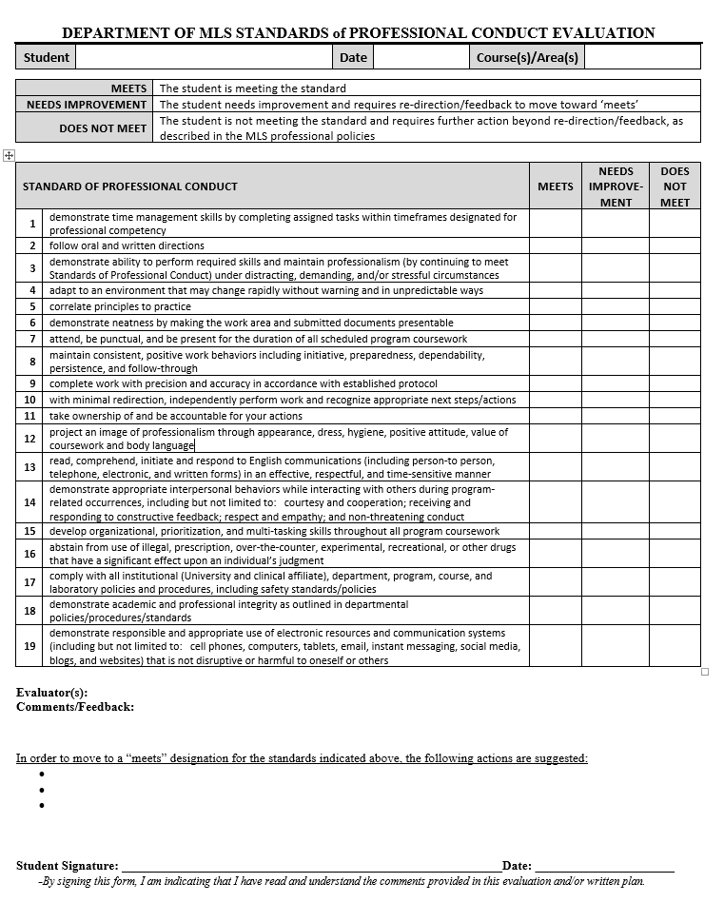

APPENDIX 2: Department of MLS Laboratory Safety Standard
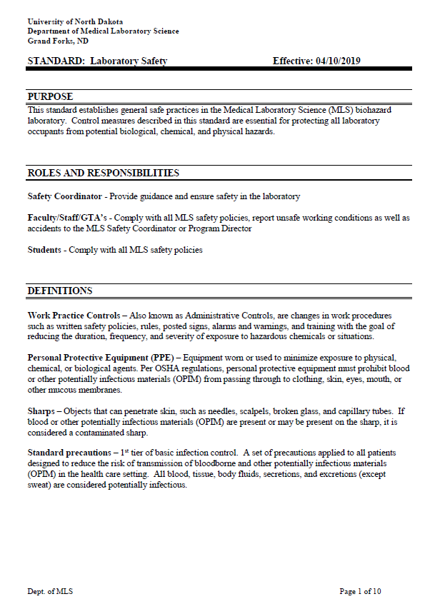
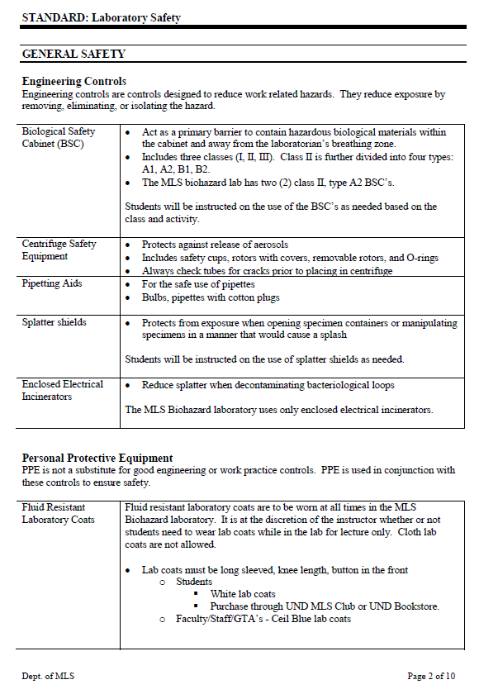

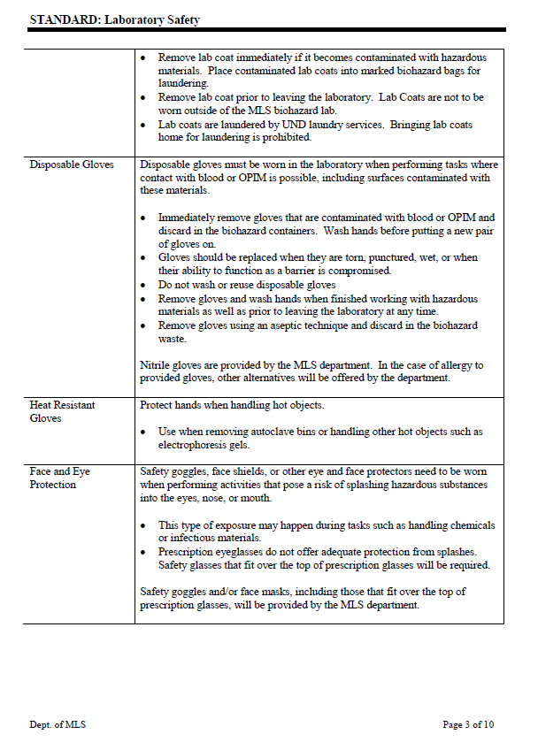

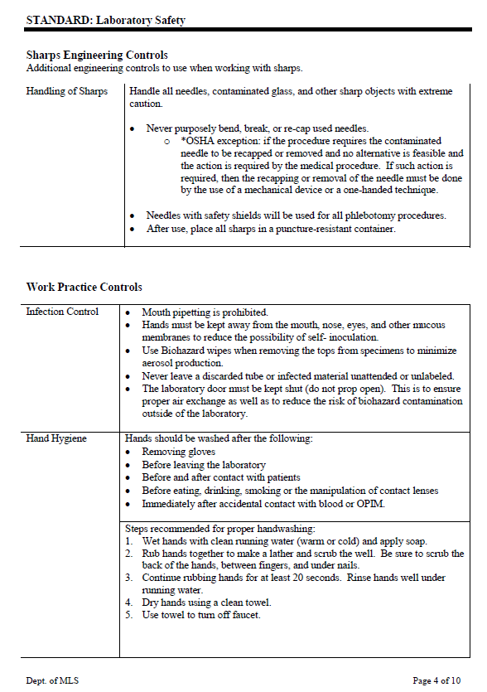

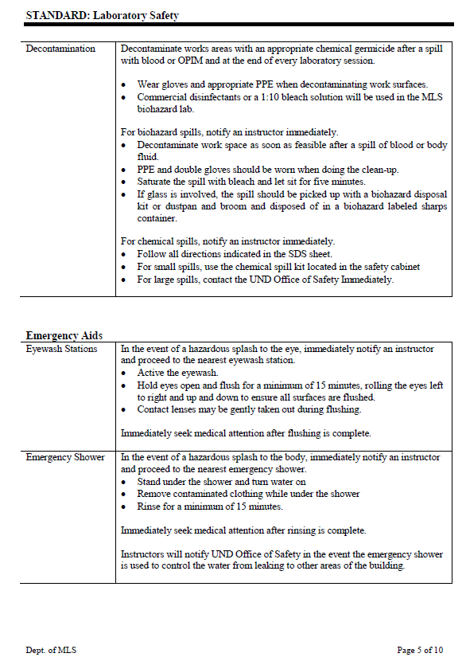

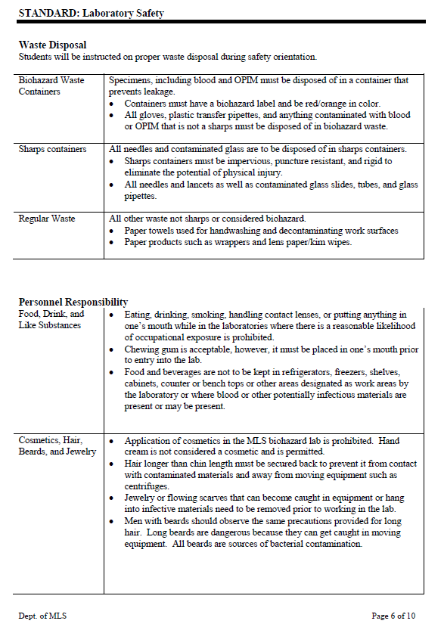
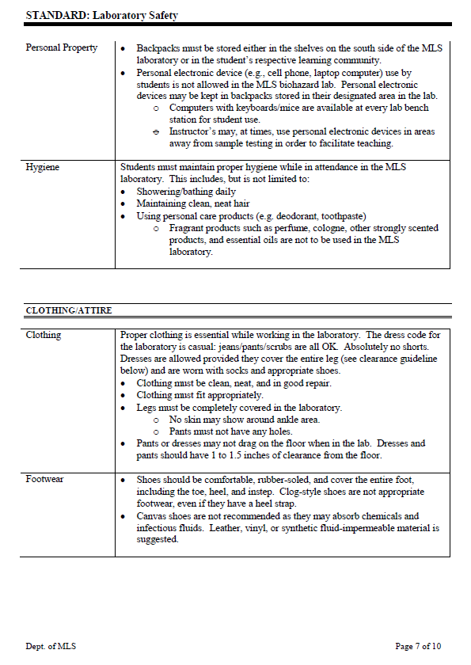

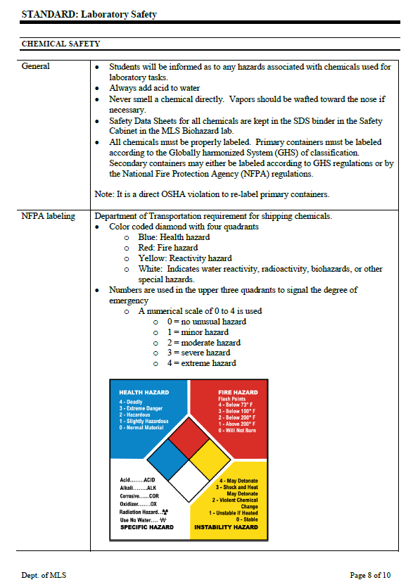

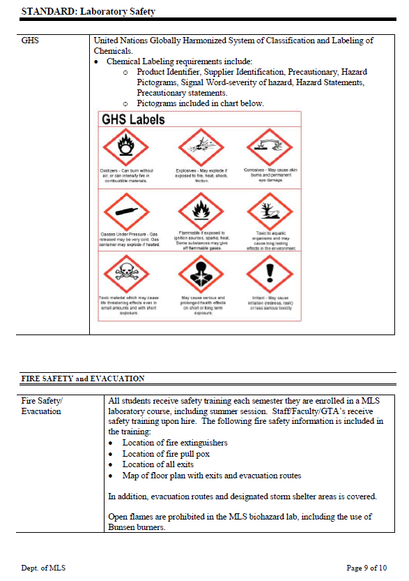

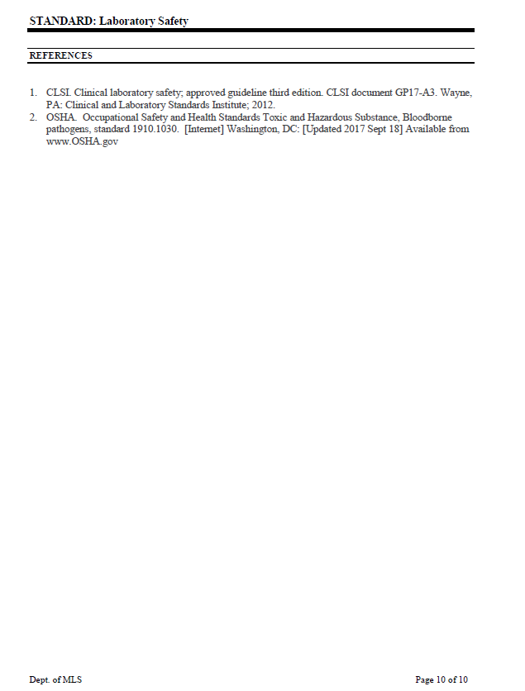

APPENDIX 3: Technical and Academic Standards for matriculation, Progression, and Graduation

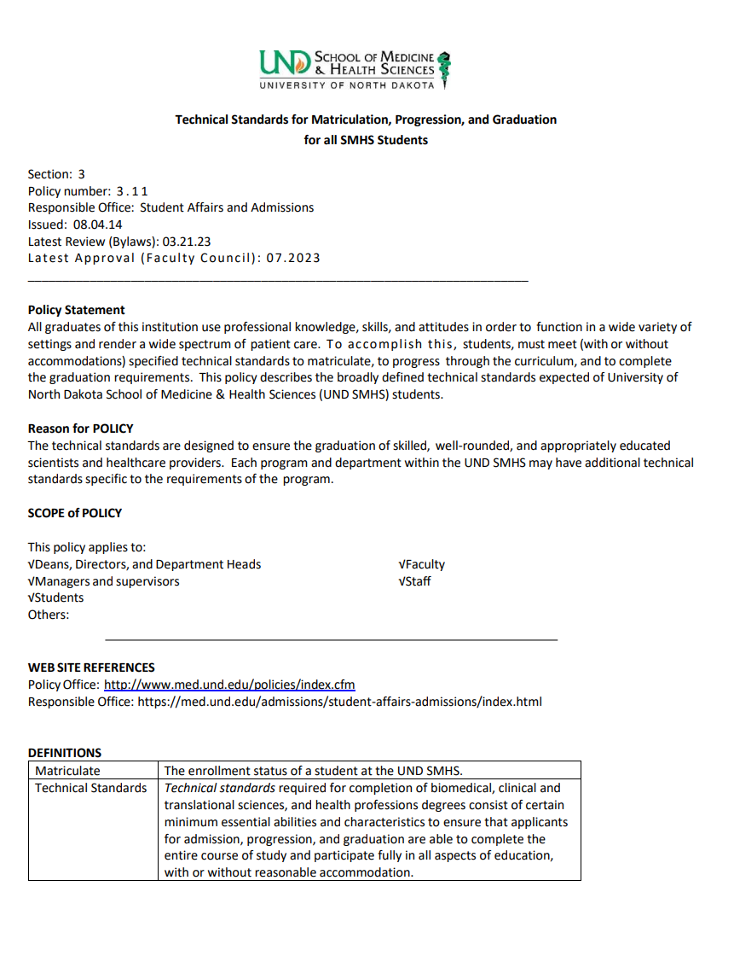
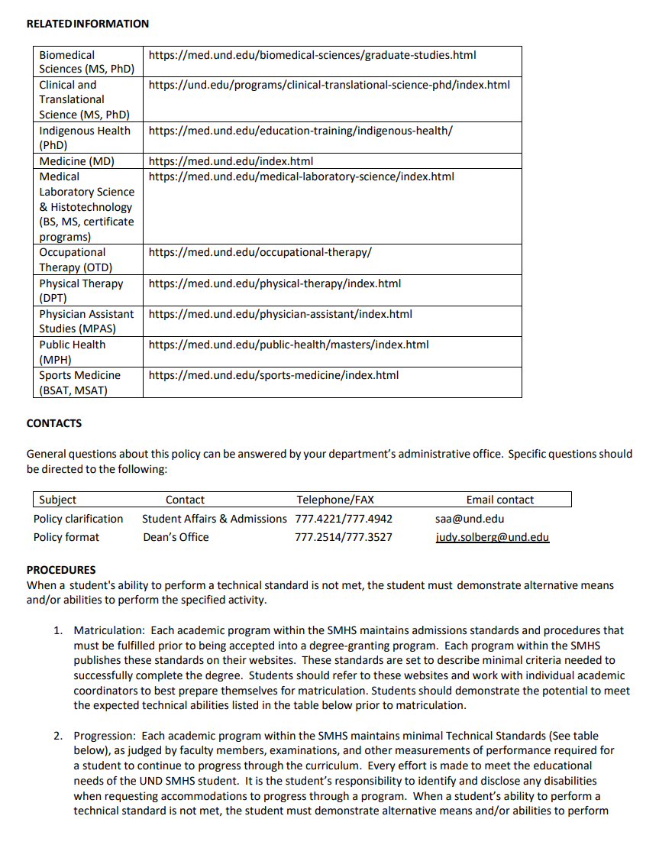

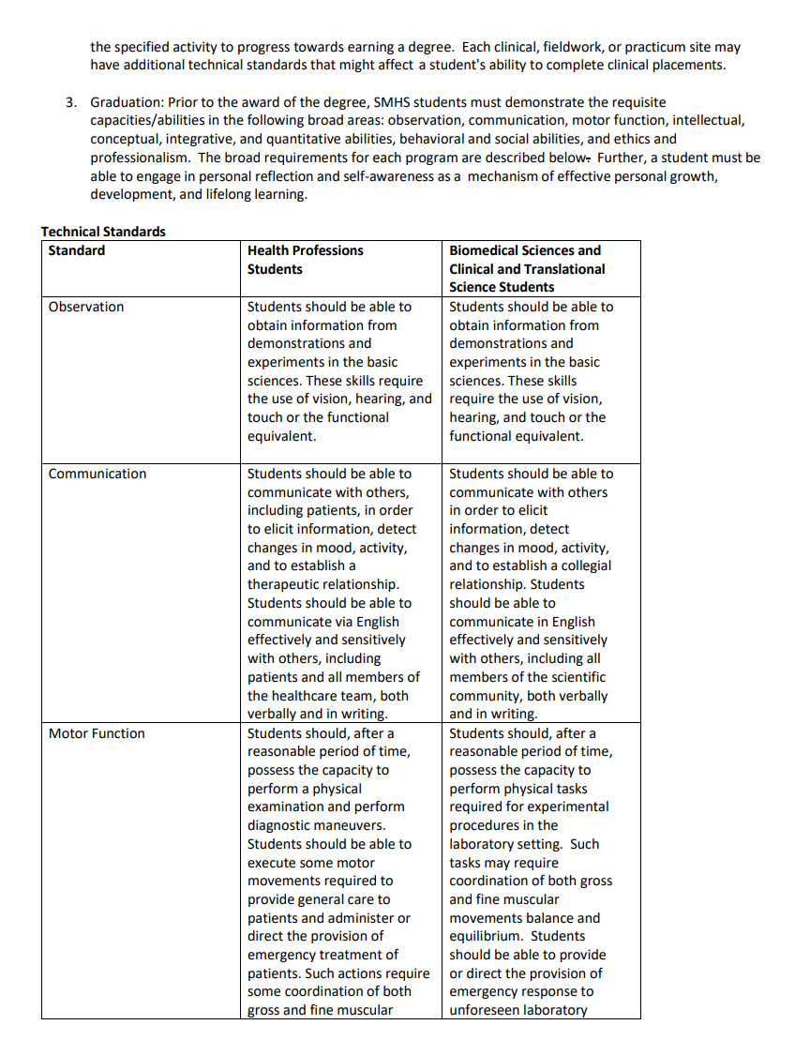

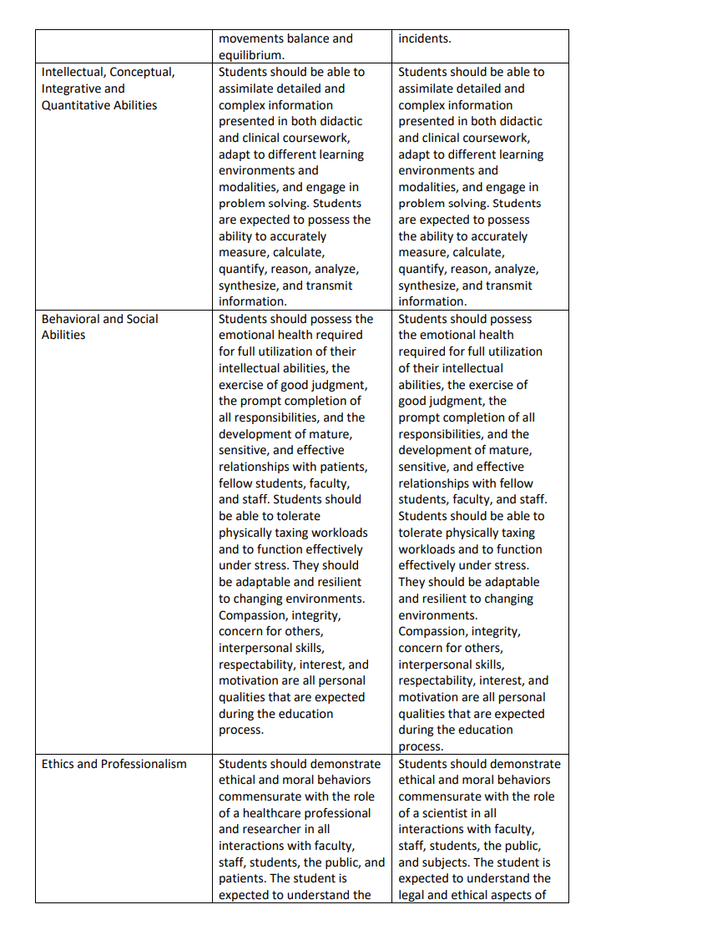
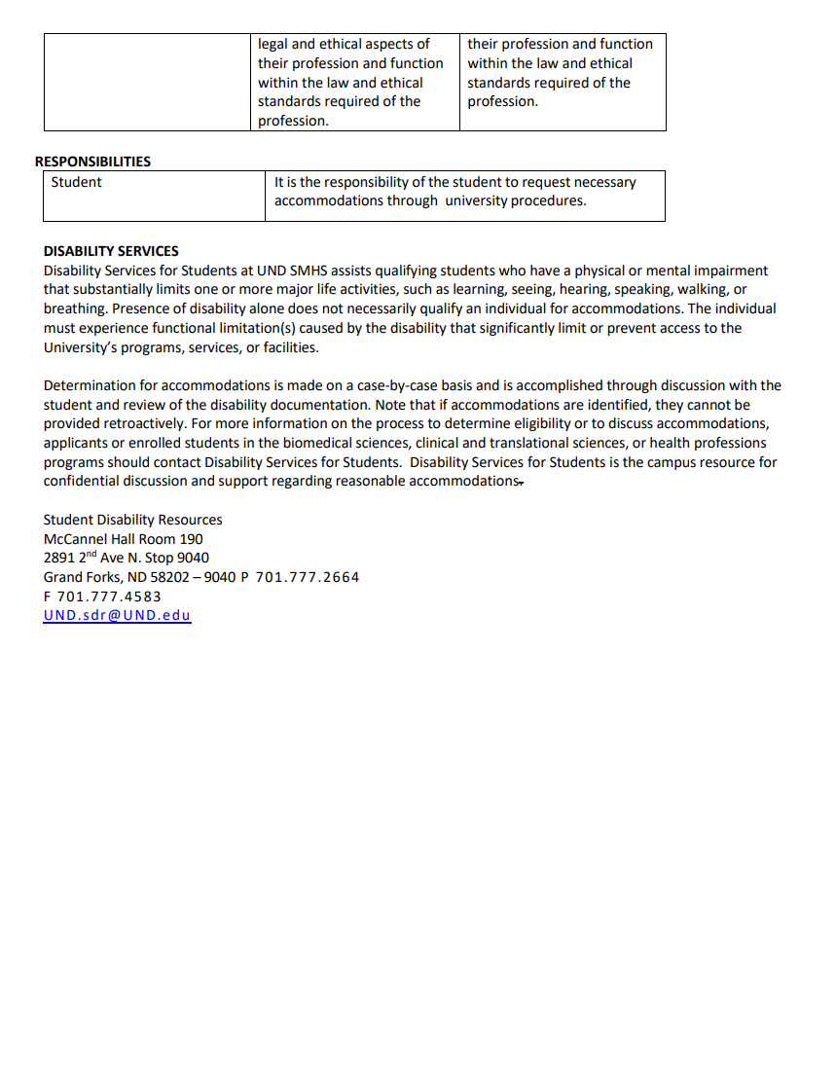

STUDENT SIGNATURE PAGE

The UND HT Program Student Orientation Handbook contains policies, procedures and processes that HT students must comply with in order to be successful academically and professionally. It is the responsibility of the UND HT program to ensure that students are aware of these policies, procedures and processes, which is accomplished through completion of this signature page.

Initial each item as acknowledgement:
Initials | Signature Page Item
 | - I have read, understand, am aware of, and agree to comply with the policies, procedures and processes as defined in the UND HT Program Student Orientation Handbook. I understand that the policies, procedures, and processes in the handbook are subject to modification and that I am responsible for updates as they occur.
 | - I have read and understand that I must be able to meet the UND HT Program Essential Functions and SMHS Technical & Academic Standards in order to be successful in the academic and clinical laboratory. I understand that if I am unable to meet the UND HT Program Essential Functions or SMHS Standards, I must inform UND HT Program faculty/staff in order to determine if accommodation options are available that would allow for continuation in the program.
 | - I am aware of the UND SMHS ‘Participation in Education as it Relates to Student Health’ policy and understand that if I have a condition (injury, infection, immunocompromised status, environmental disease) that may negatively impact myself, fellow students, staff, faculty or patients, I have a professional obligation to inform and work with UND HT Program faculty/staff immediately.
 | - I give permission to the UND Department of MLS to release information from my student files for purposes of job or educational opportunities and/or advancement.
 | - I have read the Dept. of MLS safety and biohazard standards and have been informed about the blood borne pathogens exposure control plan regulations and policies. I understand that I am responsible for compliance with these policies and standards.
 | - I understand that photos and/or videos taken during HT program coursework and activities may be utilized for educational and/or promotional purposes and give consent for my image to be utilized in them. If I do not want my image to be utilized in such photos and/or videos, I must communicate that request in writing to the UND HT Education Coordinator.
 | - I understand that my criminal background check information and my immunization records may need to be shared with my clinical affiliate.

_______________________________________________________ _____________________
Clearly Print Your Full Name Clearly Print Your 3 Initials

______________________________________________________________ _____________
Signature Date

