Medical Curriculum Telehealth Badging Proposal
Approved by UMEC on June 28, 2023
Overview
This proposal outlines a proposed Telehealth Badge for the Undergraduate Medical Education program at the University of North Dakota School of Medicine and Health Sciences (UNDSMHS):
In 2020, UMEC approved the addition of medical curriculum badging as a formal part of the curriculum as outlined in the proposal. The purpose of this new approach to documenting competency in the Undergraduate Medical Education (UME) program is to account for the delivery of curriculum that is competency-based, longitudinal in nature, demonstrated through a combination of direct instruction and vetted student-selected activities, and to allow students to pursue and document individualized courses of study beyond the minimum expected competencies for the curriculum.
This proposal is for Telehealth Badge earned through participation in a combination of mandatory and optional curriculum across all three phases of the UME program. All activities will be tracked and documented by the Associate Dean for Teaching and Learning (ADTL), the “Badge Champion” and reported to the appropriate personnel in the UME program. All students will reach Level 1, “Competency.”
In future years, it is hoped that additional levels comprising more mandatory and optional activities will be added as Level 2, “Expertise,” and Level 3, “Mastery.” However, because of logistical concerns regarding capacity and access to telehealth clinical experiences, the current proposal is for Level 1 only. The balance of the document provides the details and processes by which this will occur.
Processes Used to Design the Telehealth Badge
The following text from the approved Curriculum Badging document describes the required design parameters for proposed badges:

The first step is to identify what the demonstration of mastery looks like, [using] competencies... Next, “levels” of performance with rigorous, explicit criteria for each level would be determined. The existing medical curriculum would be “mined” for activities that would satisfy beginning or intermediate “levels” of related badges. Additional assessments, activities, and opportunities would be designed and developed to fill in the gaps and populate the highest levels. In some cases, these activities may be student-directed (e.g., design a small group learning event around a competency and facilitate it for peers).

Accordingly, the Telehealth Badge begins with a set of competencies, in this case defined by the Association of American Medical Colleges (AAMC), entitled “Telehealth Competencies Across the Learning Continuum.” These competencies are organized into 6 domains with between 3 and 4 competencies per domain for a total of 20 competencies. Those domains and competencies are further broken out by level of performance for Entering Residency (Recent Medical School Graduates), Entering Practice (Recent Residency Graduates), and Experienced Faculty Physician (2-5 Years Post-Residency).

For the purposes of UME, this proposal adopts the competencies listed under Entering Residency.

The existing UME MD Program curriculum was then analyzed across all three phases to identify existing mandatory events that address one or more of the telehealth competencies. This resulted in 5 mandatory curriculum events:
- Phase 1
  - ROBOTS Simulations 1–3
- Phase 2
  - SHaPE
- Phase 2/Phase 3 Transition
  - CSPR
These events together cover 10 of the 20 competencies (coverage defined as at least one event covering the competency):
- Domain 1: 4 of 4 competencies covered 10 times
- Domain 2: 0 of 3 competencies
- Domain 3: 3 of 3 competencies covered 8 times
- Domain 4: 3 of 3 competencies covered 7 times
- Domain 5: 0 of 3 competencies
- Domain 6: 0 of 4 competencies

To address potential gaps in coverage three additional strategies were adopted:
- Identify optional (non-mandatory) current events or activities that cover one or more potential gaps in coverage and have sufficient capacity to allow a full class of students to experience were identified.
- Propose minor modifications to existing mandatory curriculum events (e.g., an extra task or reflection or debrief added to the event) to address gaps
- Propose new events that would cover one or more gaps.

There are currently 5 optional curriculum resources or events that cover telehealth, three of which have capacity to allow an entire class of students to participate:
- Asynchronous (any phase)
  - Aquifer clinical education modules on telehealth (all students can access)
  - Telehealth Curriculum Modules from the Society for Teachers of Family Medicine (STFM)—(free membership for students—all students could access)
  - AMA Telehealth Implementation Playbook and CCHP Policies by State
- Phase 2/Phase 3
  - HATS Geriatric IP Optional Experience (limited capacity)
- Phase 3
  - VA Phase 3 Elective (limited capacity)

Only the asynchronous activities were retained for this proposal (Level 1), as the others lack sufficient capacity for all students in a given class. The asynchronous activities can take place at any time of the student’s choosing or can be prescribed by Phase Directors if desired. These activities provide additional depth of coverage to Domains 1, 3, and 4, and provide initial coverage for Domain 2 (3 of 3 competencies covered), Domain 5 (3 of 3 competencies), and Domain 6 (3 of 4 competencies).

Next, minor modifications to existing mandatory events are proposed that provide additional depth of coverage to multiple competencies and to address remaining gaps in competencies. These revisions include adding one or two assessment feedback measures to the CSPR evaluation at the end of Phase 2, and modifying the final debrief session for the Psychology SHaPE simulation in Phase 2.

Finally, one new event is proposed to fill in final gaps in coverage. This event would be a one-hour lecture or a 30 minute lecture plus 30 minute discussion, and could be live or pre-recorded (asynchronous). This lecture will be developed and taught by Dr. Eric Johnson.

Asynchronous events can be accessed and completed by students at any time of their choosing, notwithstanding and completion deadlines established for them by the Phase Directors or Assistant Dean for Medical Curriculum. Most of the other events are already scheduled in Phase 1 and Phase 2 (or the transition to Phase 2) so do not add any curriculum time aside for the minor modifications to existing events (ROBOTS, CSPR, SHaPE). The only exception is the one-hour lecture on telehealth to be scheduled in Phase 1 (see above).

The end result is a set of curriculum events that are or would become mandatory which all students in a given class could access and which together ensure coverage of all of the competencies:
- Domain 1: 4 of 4 competencies covered by 5 or 6 events
- Domain 2: 3 of 3 competencies covered by 3 or 4 events
- Domain 3: 3 of 3 competencies covered by 4, 6, and 7 events
- Domain 4: 3 of 3 competencies covered by 3, 4, and 6 events
- Domain 5: 3 of 3 competencies covered by 3 or 4 events
- Domain 6: 4 of 4 competencies covered 2 or 3 events

Table 1: Curriculum Coverage of the AAMC Telehealth Competencies.
Competencies | Events
Domain 1 | Events
Explains to patients and caregivers the uses, limitations, and benefits of telehealth — that is, the use of electronic communications technology to provide care at a distance | 5
Works with diverse patients and caregivers to determine patient and caregiver access to technology to incorporate telehealth into patient care during real or simulated encounters | 6
Explains to patients and caregivers the roles and responsibilities of team members in telehealth encounters regardless of modality | 5
Describes when patient safety is at risk, including when and how to escalate care during a telehealth encounter (e.g., converts to in-person visit or emergency response) | 5
Domain 2
Describes one’s own implicit and explicit biases and their implications when considering telehealth | 3
Defines how telehealth can affect health equity and mitigate or amplify gaps in access to care | 3
When considering telehealth, assesses the patient’s needs, preferences, access to, and potential cultural, social, physical, cognitive, and linguistic and other communication barriers to technology use | 4
Domain 3
Develops an effective rapport with patients via real or simulated video visits, attending to eye contact, tone, body language, and nonverbal cues | 7
Assesses the environment during real or simulated video visits, such as attending to disruptions related to privacy, lighting, sound, and attire | 5
3a. Explains how remote patients’ social supports and health care providers can be incorporated into telehealth interactions and the care plan (e.g., asynchronous communication and the storage and forwarding of data) | 4
Domain 4
Obtains history (from patient, family, and/or caregiver) during a real or simulated telehealth encounter | 6
Conducts appropriate physical examination or collects relevant data on clinical status during a real or simulated telehealth encounter, including guiding the patient and/or tele-presenter | 4
Explains the importance of patient-generated data in the clinical assessment and treatment plan during a telehealth encounter | 3
Domain 5
Explains equipment required for conducting care via telehealth at both originating and distant sites | 4
Explains limitations of and minimum requirements for local equipment, including common patient-owned devices | 3
Explains the risk of technology failures and the need to respond to them | 3
Domain 6
Describes locally relevant legal and privacy regulations for telehealth | 3
Defines components of informed consent for the telehealth encounter | 2
Demonstrates knowledge of ethical challenges and professional requirements in telehealth | 2
Describes potential conflicts of interests that may arise in the use of telehealth such as interest in commercial products or services | 2
How Performance and Compliance Will Be Tracked and Reported
Because only Level 1 is proposed and will comprise only mandatory curriculum, there is little additional tracking and reporting that will be required.
Mandatory Synchronous Telehealth Curriculum Events
Completion of the 3 ROBOTS simulations, the CSPR, and SHaPE are already tracked by curriculum personnel. The additional one-hour lecture will be tracked and reported using the same procedures. The Office of Student Affairs and Admissions (OSAA) will report any absences (excused or unexcused), remediations, or leaves of absence for these required events to the ADTL.
Mandatory Asynchronous Telehealth Curriculum
Completion of the proposed asynchronous telehealth curriculum will be tracked by the ADTL through the MD Program’s badging platform, Anthology Milestones. Students will be required to document their review/participation/completion of asynchronous activities via an attestation, completion certificate, or question completion.
For the Aquifer Foundations of Telehealth modules, students will be required to download their completion status for each module via Aquifer and upload that document to the Telehealth Badge. Currently, students will not be able to begin these modules until Phase 2 but they do not take more than an hour or two to complete so there will be sufficient time to do so during Phase 2.
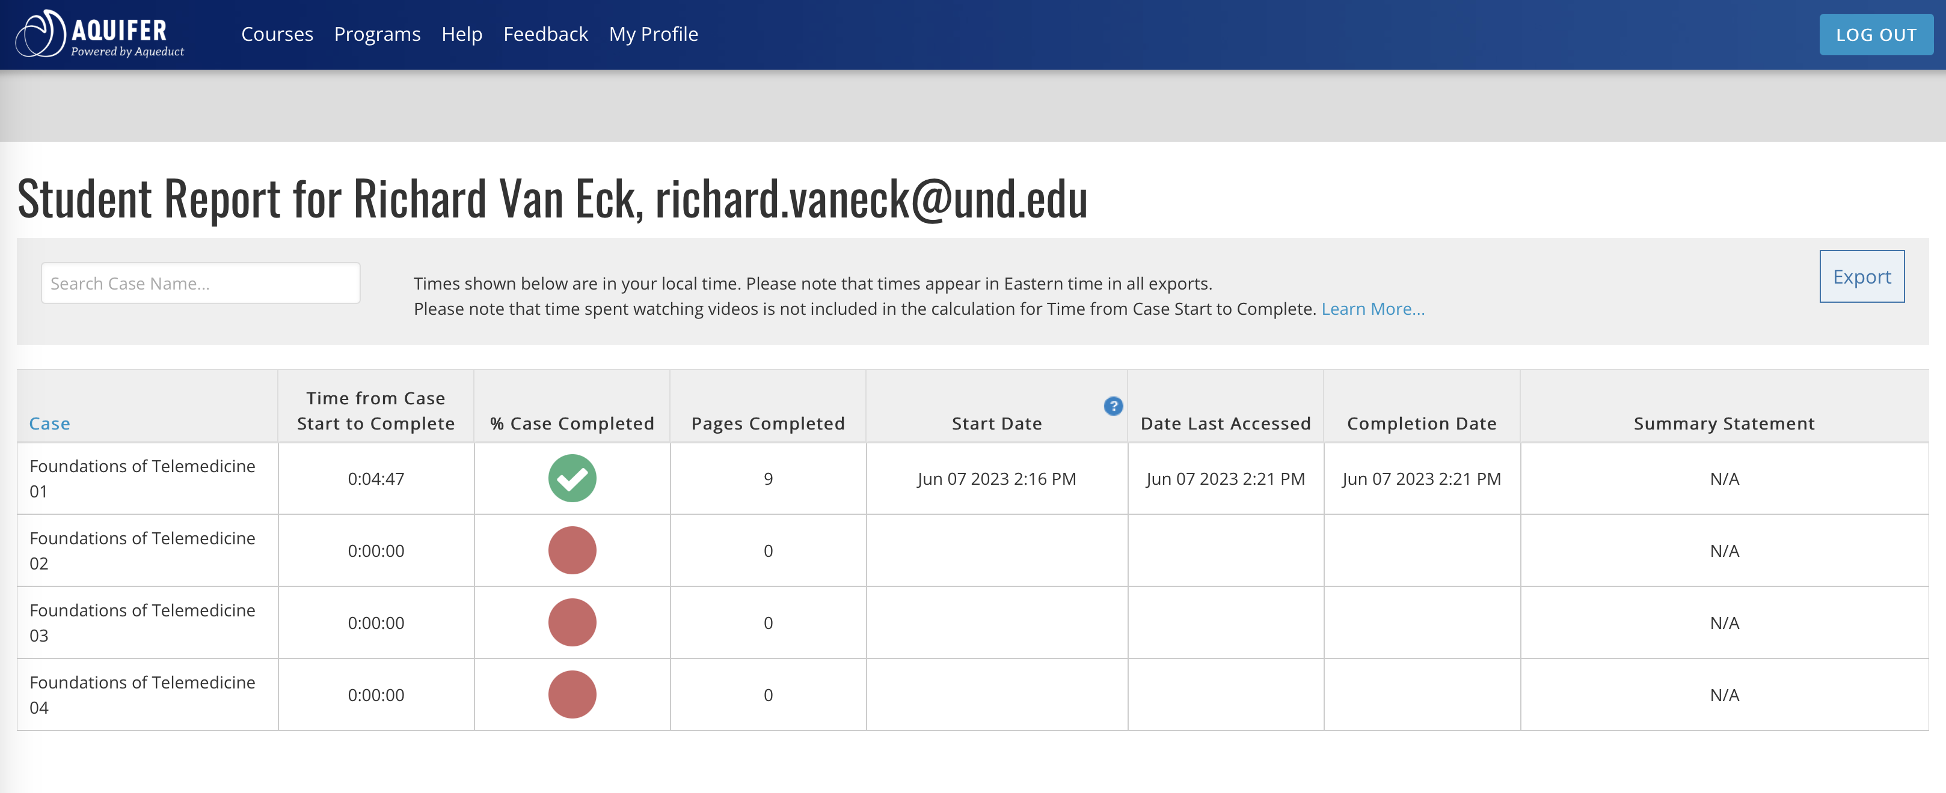
For the STFM Telemedicine Curriculum Modules, students will submit the certificate of completion for each of assigned modules to the Telehealth Badge as evidence of completion. Students may enroll in the STMF at no charge at any time in the curriculum and may begin the work at any time. In doing so, they will further attest that they have taken sufficient time to review all the modules and complete the knowledge checks along the way.
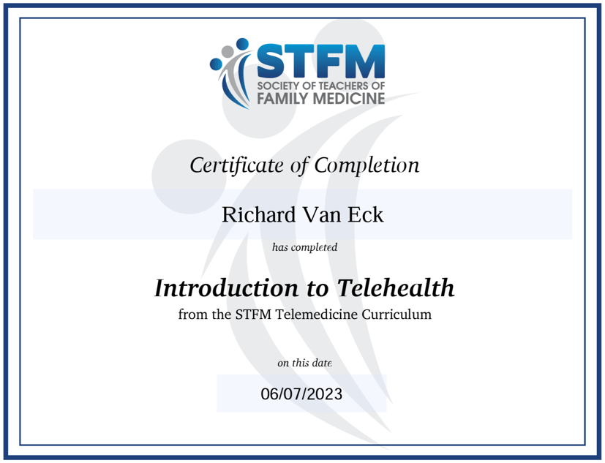
For the AMA Telehealth Implementation Playbook, students will upload a one-page maximum summary of how implicit and explicit bias can impact telehealth; how issues of equity and access apply to telehealth; how cultural, social, physical, cognitive, and linguistic factors can create barriers to telehealth; the equipment needed for telehealth, the limitations of patient-owned devices, and the risk of technology failure and need to respond.

For the CCHP Policies by State, students will upload a document attesting to having reviewed the policies for North Dakota and Minnesota listed on the Website they are provided along with the a screenshot of the Medicaid Overview policy statement for North Dakota or Minnesota.
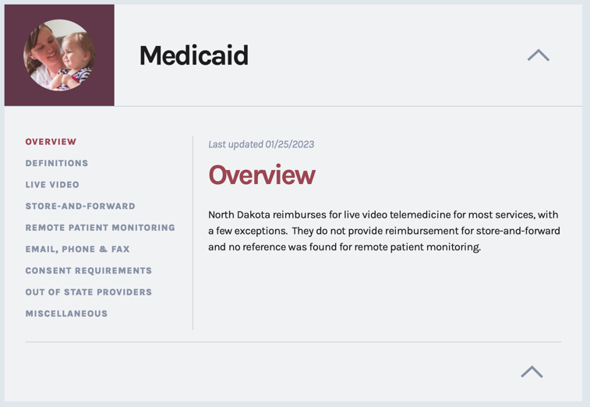
For all of these events, the ADTL will review each students’ evidence and approve it if it meets the criteria or reject it and provide written feedback about what needs to be done to meet the criteria.
Timeline and Process for Completion and Reporting of the Telehealth Badge
The following is the timeline for completion of required activities for the Telehealth Badge as well as the means of communication regarding progress toward this badge:
Phase 1
- Launch Week: Orientation to the Telehealth Badge
- July: Students sign up for STFM membership
- ~September: ROBOTS 1 Simulation
- ~October: ROBOTS 2 Simulation
- ~November: ROBOTS 3 Simulation
- Ongoing work on STFM modules if and as desired
Phase 2
- Start of Phase 2: Reminder to complete STFM modules, Aquifer modules, Telehealth Playbook, and CCHP policies by the end of Phase 2.
- One month before the end of Phase 2: Reminder to complete required work by the end of the phase.
- End of Phase 2: Non-compliant students referred to OSAA and Assistant Dean for Medical Curriculum
Phase 3
- Badge appears on MSPE August 1
Issues regarding non-completers in the context of promotion and graduation
What happens if a student does not meet the minimum requirement?
If a student has not submitted evidence of a completed activity/assessment/attestation as described above by the required time, the ADTL will contact those students explaining the requirement and will refer the student names to the Associate Dean for Student Affairs and Admissions and the Assistant Dean for Medical Curriculum.
Documentation Regarding the Telehealth Badge
The ADTL will work with the Assistant Dean for Medical Curriculum and the Assistant Dean for Phase 2 and Phase 3 to ensure that the telehealth badge as a program component will be fully described in our required curriculum documentation on the Medical Curriculum Website so that anyone can read about it in the same place they read about existing courses and requirements.
Summary
A telehealth badge is proposed as a required element for graduation from the MD program. The badge comprises 1 level which all students will complete via a mix of existing mandatory curriculum (with minor modifications to the assessment and debriefs for CSPR and SHaPE), new asynchronous curriculum (Aquifer and STFM modules; AMA Telehealth Implementation Playbook and CCHP Policies by State) and the addition of 60 minutes of synchronous, asynchronous, or hybrid lecture on telehealth. Completion of synchronous mandatory curriculum is already monitored and tracked by program personnel, who will notify the ADTL of any student who does NOT complete the mandatory synchronous curriculum. Completion of asynchronous curriculum will be documented by students, tracked and evaluated by the ADTL, and reported to MSAPC as part of normal promotion decisions by that committee. The Anthology Milestone badging platform will be used to document completion and to award badge credit.

