Office of Interprofessional Education (OIPE)
Medical Curriculum Interprofessional Education Point system “Badging”
Executive Summary
This proposal outlines a system for ensuring complete curriculum coverage of competencies within Domain 7 of the Undergraduate Medical Education program at the University of North Dakota School of Medicine and Health Sciences (UNDSMHS):
Domain 7: Interprofessional Collaboration (IPC)
“Develop skills in functioning both as a team member and as a team leader, and demonstrate the ability to engage in an interprofessional team in a manner that optimizes safe, effective patient-centered and population-focused care.”
There are five competencies in this domain that inform the design of our curriculum. Although medical students have routinely engaged in Interprofessional Education and Collaboration (IPE/C) for many years, the Curriculum as a Whole Report in 2019 indicated a gap in in Domain 7 by virtue of having no official course objectives for those competencies. At the behest of UMEC, the Office of Interprofessional Education (OIPE) created 24 course objectives, which were presented to UMEC and approved in 2020.
In communication with the Curriculum Evaluation and Management Committee (CEMC), the OIPE has since conducted an inventory of mandatory IPE activities in each of the phases of the medical curriculum to better understand if and how well the course and clerkship objectives linked to Domain 7 are being met by students. While there are mandatory IPE activities in Phase 1 and multiple IPE/C opportunities in Phases 2 and 3, there are opportunities to strengthen the IPC curriculum across the phases to ensure complete coverage of the Domain 7 IPC.
Also in 2020, UMEC approved the addition of medical curriculum badging as a formal part of the curriculum as outlined in the proposal. The purpose of this new approach to documenting competency in the Undergraduate Medical Education (UME) program is to account for the delivery of curriculum that is competency-based, longitudinal in nature, demonstrated through a combination of direct instruction and vetted student-selected activities, and to allow students to pursue and document individualized courses of study beyond the minimum expected competencies for the curriculum.
This proposal is for an IPC Badge earned through participation in a combination of mandatory and optional curriculum across all three phases of the UME program. Students will earn “points” for the current mandatory curriculum linked to Domain 7 and will earn additional points for participation in additional optional IPE/C curriculum. All activities and resulting points will be tracked and documented by the OIPE and reported to the appropriate personnel in the UME program. All students will reach Level 1, “Competency,” documenting the achievement of Domain 7 competencies by all students in the UME program. Students who choose to pursue deeper expertise in IPC will have the option to achieve Level 2, “Expertise,” and Level 3, “Mastery,” as mandated by the medical curriculum badging document approved in 2020. The balance of the document provides the details and processes by which this will occur.
Background and Rationale:
The following excerpts from the Medical Curriculum Badging document are relevant to this proposal:
Where participation in mandatory existing Curriculum Events is NOT sufficient to meet Level 1 (competency), students will be required to participate in a specified number of optional or self-directed activities by a specified point in time (e.g., end of Phase 3) that meet the criteria for Level 1. Students who choose to optionally pursue Level 2 (expert) or Level 3 (mastery) will be required to meet the established criteria through evidence of achievement via a specified number of optional and/or self-directed activities that meet the criteria for those levels.
For example, UMEC approved twenty-four new Course Objectives for Domain 7 (Interprofessional Collaboration)in 2020 in response to the CEMC Gaps and Redundancy report. Many of these objectives are met by existing IPE activities in the medical curriculum (e.g., the Interprofessional Healthcare Course, ROBOTS IPE simulations, nursing and PharmD simulations,the PharmD match required activities). However, minimal competency level may not be fully achieved by these activities alone as many require the ongoing demonstration of attitudes and behaviors that are self-selected by students (e.g., choosing to reach out to another profession in the furtherance of their learning). Thus, students might be required to select/create and document a certain number of activities from a menu of options that meet criteria for Competency Level (e.g., document activities such as using the PharmD match for a consult, participating in ISCLE and others).
Performance levels and expectations of timeline would be established and communicated to students regarding which badges and which levels they must attain within or by a given period of time.
Current UME Program IPE Activities

Phase 1
Formal Interprofessional Education was launched in 2006 at the University of North Dakota with the Interprofessional Health Care Course, based on the Interprofessional Education Collaborative (IPEC) Core Competencies for Interprofessional Collaborative Practice 2016. Currently 8 professions across 3 schools/colleges participate in this course; it is a required course for 7 of the 8 professions, including medical students. This is offered in Phase 1. Although this is a powerful and unique experience (classroom courses with multiple professions are not common at most schools), the IPHC is not sufficient on its own to meet all of the competencies in Domain 7, and was never intended to be the totality of Interprofessional learning.
Since 2013, a number of required Interprofessional Education activities have been added, including the ROBOTS rural interprofessional telehealth simulations (3), the PharmD student match, and a various other simulations with nursing students). The existing, mandatory IPC curriculum in Phase 1 appears to be sufficient for the path to achieve Level 1 (Competency) within the phase, and that no additional required IPC curriculum is needed for Phase 1.
Phase 2 and Phase 3
While there appear to be sufficient opportunities for IPE/C in Phase 2 and Phase 3 (see Table 1), none of these activities are mandatory.
Table 1
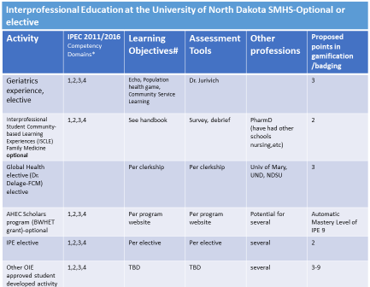
Accordingly, an IPC activity would need to be completed for each Phase in order to meet the “competency” level for an IPC badge. Rather than making a specific activity mandatory as is done with IPHC in Phase 1, it is more feasible to require students to select and complete one of these activities at some point during each phase.
However, there are not enough seats at the right time for every UME student to select and participate in one of these activities during the phase. What is needed is to identify additional, equivalent opportunities for IPE/C so that every student could experience a quality IPE/C activity aligned with Domain 7 during the phase.
Clerkships currently have interprofessional objectives which are considered during the course of a student’s path through that clerkship and there are likely multiple interprofessional interactions in typical clinical learning settings in a normal student workflow that are currently not “captured” or credited directly as distinct IPE. If these interactions could be captured, it would become possible to require students to complete a specific number of these interactions and/or the other available IPE/C activities during their time in Phase 2 and Phase 3.

A Point System to Capture and Document IPE/C for Badging
Competency (Level 1)
We propose to use a point-system to classify interprofessional activities across all phases and to align those points to the three different levels for an IPC Badge. A documented single interaction with 1 other profession would earn 1 point. A documented single interaction with at least 2 other professions would earn 2 points. A documented ongoing immersive interaction with at least 1 other profession would earn 3 points.
Applying this point system to our current, mandatory curriculum would result in 8 points for activities during Phase 1:
- 3 points Interprofessional Health Care Course
- 2 points ROBOTS telehealth simulation
- 1 point nursing simulation (drug allergy)
- 1 point PharmD simulation (drug overdose)
- 1 point PharmD/MD “match day” activity
As stated previously, the activities in Phase 1 are sufficient to warrant “competency” for the phase and each is already fully documented and evaluated as part of the curriculum. Accordingly, all students would earn 8 points automatically by the end of Phase 1 and would not be required to do anything else to meet “competency” level (see Figure).
Figure 1.
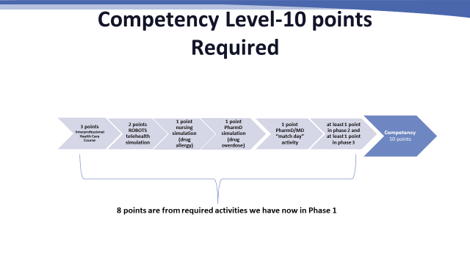
In order to meet competency for Phase 2 and Phase 3 under this proposal, students in these phases would be required to document a 1-point activity in Phase 2 and a 1-point activity in Phase 3, in order to achieve “Competency” (Level 1) in the IPC Badge. They could do this by selecting from the existing, optional IPE/C activities listed in Table 1, previously, OR by documenting one of the many IPE/C interactions that occur formally or informally during clinical education. These interactions are likely frequent during the normal student workflow. These activities could easily be “mined and captured” for credit toward achieving competency in Domain 7 with the completion of a simple self-evaluation write-up of the interaction. Because clerkships have IPE/C learning objectives, these student interactions serve as evidence for these objectives and the documentation would thus allow us to track IPE learning effectively across all 3 phases, consistent with our accreditation needs.
Regardless of which avenue a Phase 2 or Phase 3 student chose to meet these requirements, OIPE would evaluate and verify the work of the student and would track and report on the achievement of this requirement to the appropriate medical curriculum personnel (Education Resources and UMEC and its committees).
Expert (Level 2): Optional
Students who choose to pursue deeper expertise in IPE/C could optionally select and document additional IPE/C activities in order to earn Expert Level. To achieve the Expert (Level 2) designation, students must first meet all the requirements for the Competency (Level 1) designation (the 10 points earned as described above) and then earn an additional 5 points over the course of Phase 2 and Phase 3. These could be achieved via any combination of activities that achieves a total of 5 points. IPE/C interactions in “real world” clinical environments are more advanced and richer in IPE/C than classroom or simulation activities in Phase 1, which is why the additional points are to be earned in Phase 2 and Phase 3 (see Figure 2).

Students who earn this level receive a brief specific mention in the MSP/Dean’s Letter, including an image of the badge earned.

Figure 2.
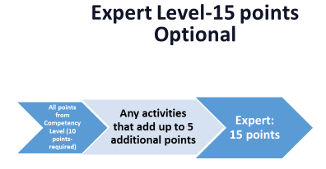

Mastery (Level 3): Optional
Students seeking Mastery Level for this badge would be required to complete Level 1 (10 points) and Level 2 (15 points) and then complete an additional 9 points under the IPE/C point system. This could be accomplished by completing and documenting an additional 3, 3-point activities over the course of the MD curriculum, completing the AHEC Scholars program (see attached flyer), a very rich set of IPE experiences that already exists, or proposing (and getting prior approval for) an equivalent IPE/C experience which they would then complete.

We anticipate that the AHEC program is the most likely path for this level and AHEC have sought out UND as a “feeder” university for their program and has the capacity to take as many students as would apply. AHEC has agreed to track, document, and report back to us on students completing the program for tracking. Not all students will be interested, willing, or able to complete the AHEC program, however, which is why the other two paths are available for this level.

Figure 3.
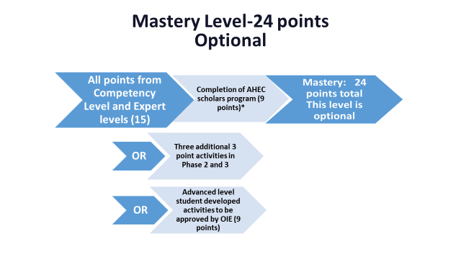
Students who achieve this level receive a 1-3 sentence mention in the MSP/Dean’s Letter, along with an image of the badge earned.
Tracking for all three levels of this badge would be the responsibility of the OIPE, who would report student progress to the Directors of Phase 1, 2, and 3 for grade reporting purposes. OIPE would be responsible for assisting students with tracking the points needed for the competency level (and any additional levels the student chooses to pursue) as well as approving student-proposed IP activities that they feel meet the requirements for 1-, 2-, or 3-point activities.

Issues regarding non-completers in the context of promotion and graduation
What happens if a student does not meet the minimum requirement?
- Michelle and I will meet in person or virtually with any student who hasn’t reported at least 1 point in phase 2 or phase 3 at the midpoint of a phase for a remediation discussion. We will also avoid this by sending frequent periodic reminders to students throughout the phase. We have a plan like this for PharmD/MD match program, so a precedent exists.

- Discuss possible promotion/graduation issues in Phase 2/3: This should not be an issue with the proposed remediation plan. We will make sure everyone who does not complete by the above timeline will be remediated. If a student has not completed by 2 weeks after mid-phase meeting, that would result in a warning letter. Further non-completion would result in a letter of unprofessionalism submitted to MSAPC. Potential outcomes for non-completers are non-promotion or recommendation for graduation as determined by MSAPC.

In summary, we propose the previously articulated point system for earning the IPC Badge based on a mix of existing required and optional IPE/C activities, which would be documented, evaluated, tracked, and reported to the appropriate medical curriculum personnel and committees. This point system and badge will allow the MD curriculum to effectively integrate and track IPE/C across all 3 phases in a variety of settings and “touch points” consistent with nationally-accepted best practices, aligning with our competencies and learning objectives, nationally-accepted competencies, and accreditation needs. We anticipate that as IPE/C interactions increase, this point system may need adjustment.

References:
Interprofessional Education Collaborative. Core Competencies for Interprofessional Collaborative Practice 2016. https://www.ipecollaborative.org/resources.html
Koehn M, Charles SC. A Delphi Study to Determine Leveling of the Interprofessional Core Competencies for Four Levels of Interprofessional Practice. Medical Science Educator (2019) 29:389–398
Shrader S, et al. Evaluating the impact of an interprofessional education program on workforce: Recruitment, collaborative practice, and culture. Journal of Interprofessional Education & Practice. Available online 13 January 2022.

These objectives were in addition to clerkship objectives relating to Domain 7 already in place.

