SMHS Medical Student Assessment System
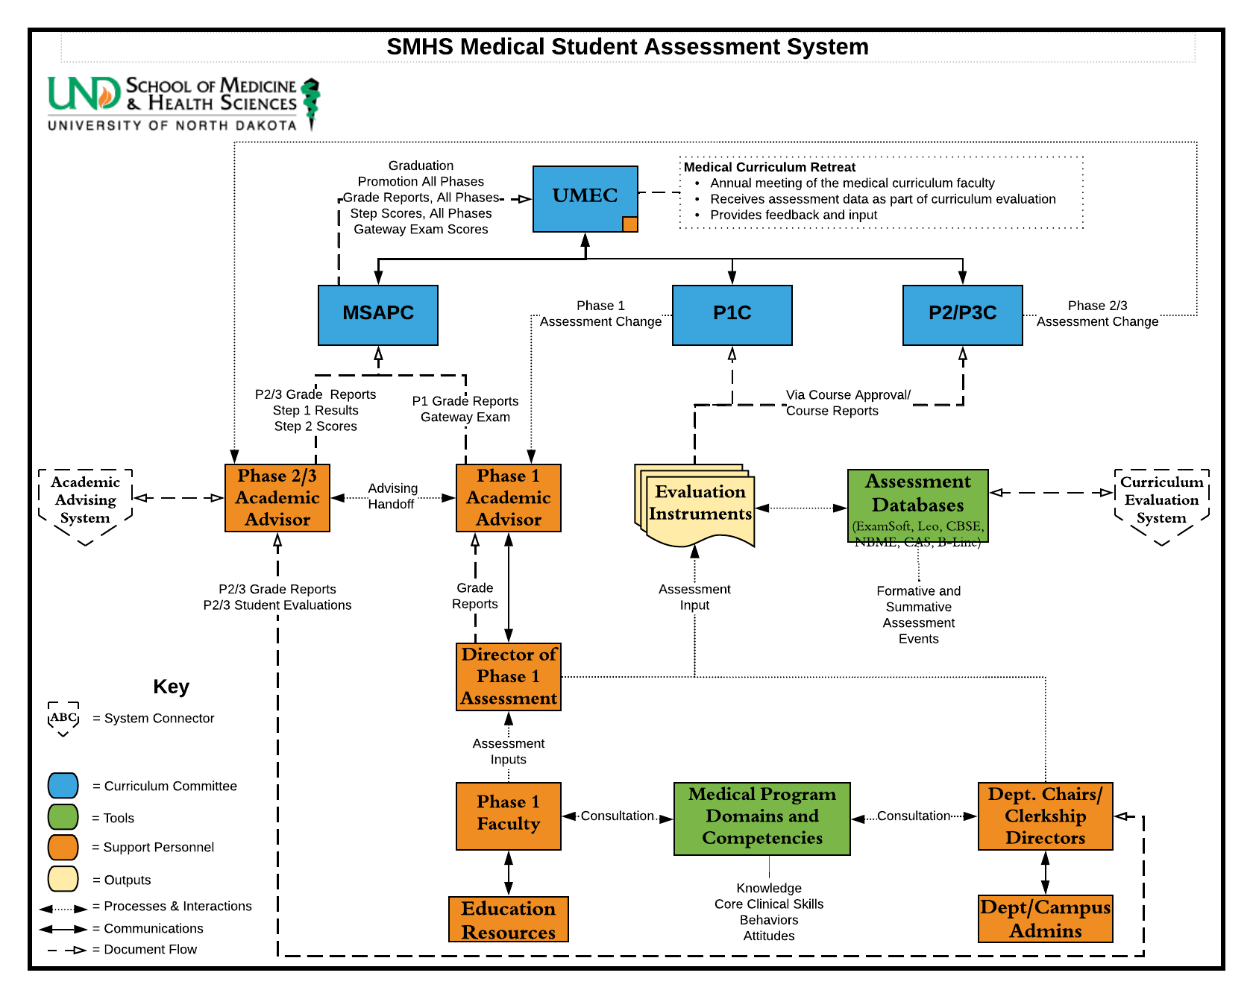
A full-text whitepaper explaining the above system is available on request.

