INFINITY
Idea Elan
2020
Comprehensive Online Solution for Lab and Core Facility Management
User Guide for UND
13800 Coppermine Rd,
Herndon, VA 20171
Phone: 1-800-506-5905
Email: support@IdeaElan.com

Contents
Logging In: 3
New User Registration Process: 4
To Access Facilities 8
To Access Instruments 9
The User: 11
User Functions: 11
My Home Page: 12
Publications: 12
Instruments 13
How to make a reservation: 13
Reservation as a user: 13
How to make a wait-list appointment: 15
How a user deletes a reservation: 15
Request Services 16
Supplies 19

Quick Startup Guide

Logging In:
Users with University of UND login ID can use their credentials to log into the Infinity Start page.
Users will login using https://secure7.ideaelan.com/UND_Test/Public/AppLogin.aspx
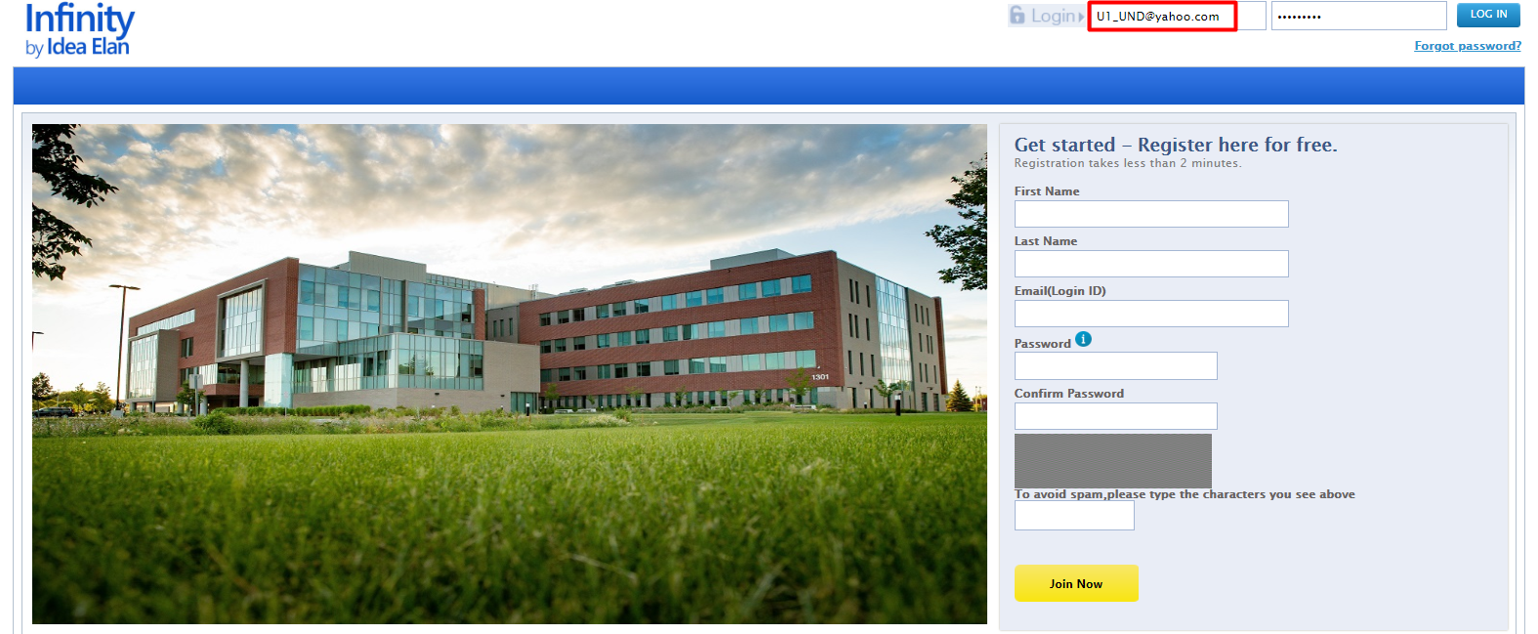

New User Registration Process:
- Users can register on the login page of the INFINITY link.
- Enter First Name, Last Name, Email ID, Password and click on Join Now Button.

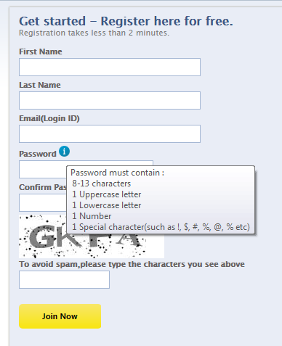
Click on Join Now Button
Enter the user ID here
Enter the password here
- After registering, a confirmation message will appear on the screen. Click the verification link sent to the email provided.

- Once the email is verified, the page will be redirected to a registration wizard.
- Click on the start button to go through the registration process.
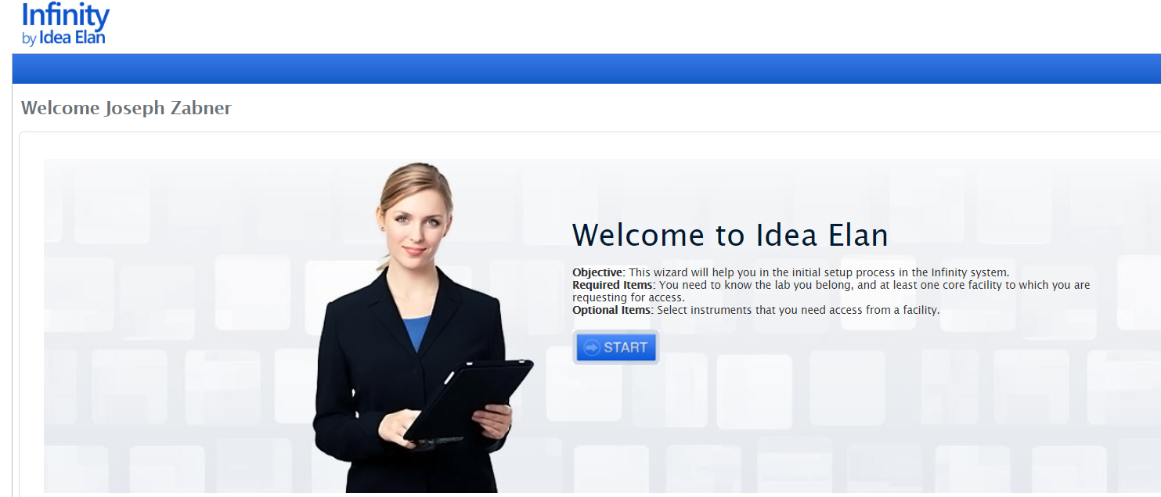

- In the next page, select access to labs by clicking on “Request Access.”

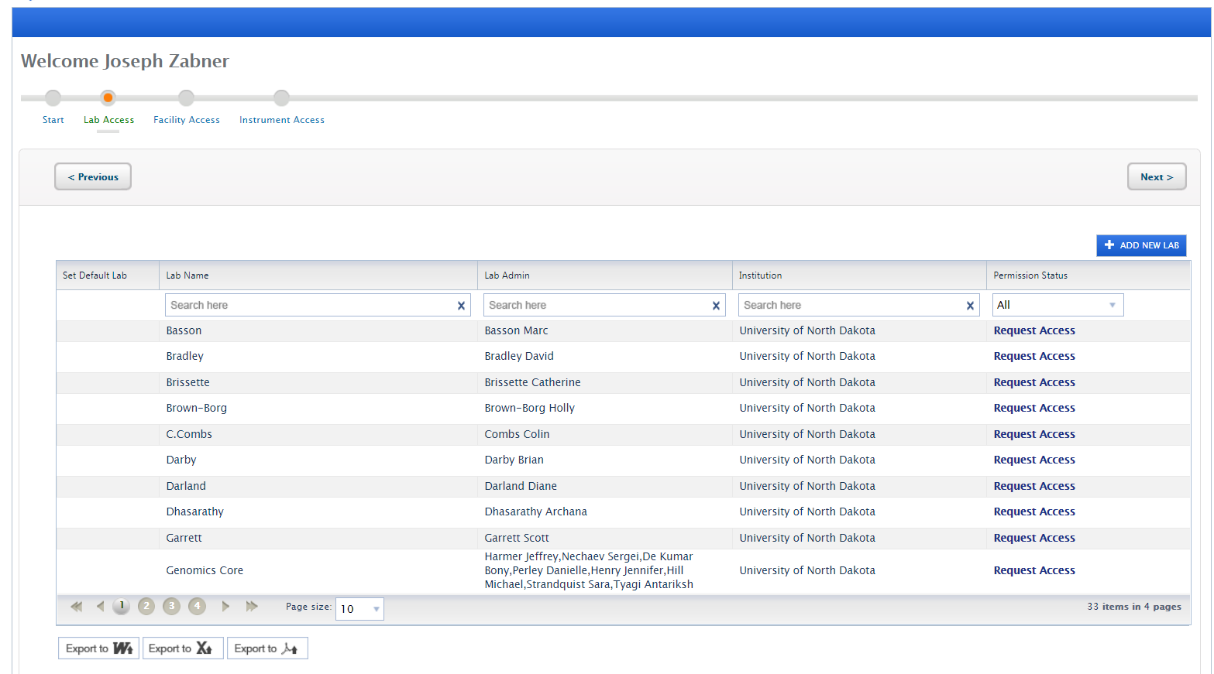

- Now, select a default lab and click on “Next”.
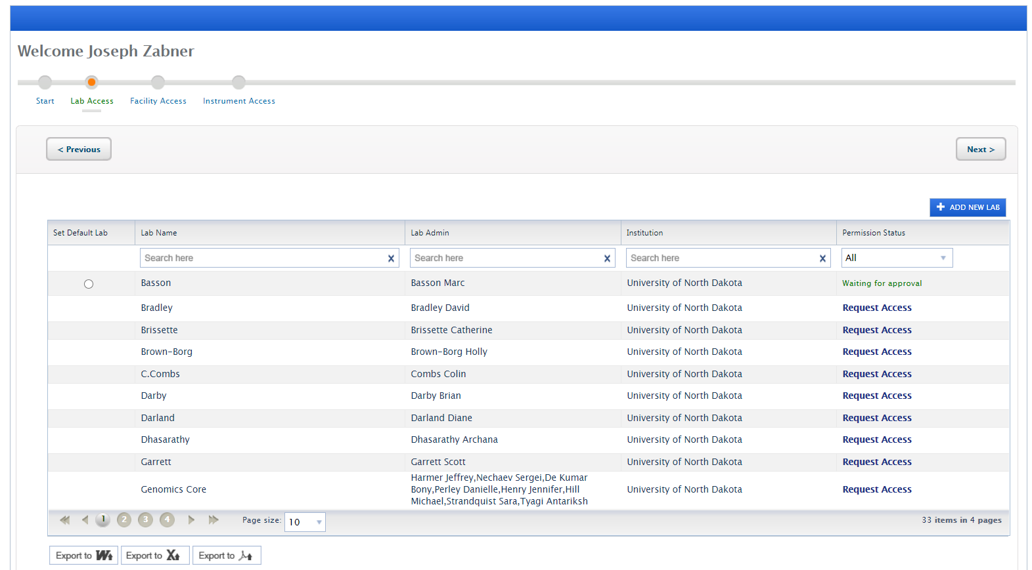

- In the next page, select access to facilities. Note: The facility admin can decide whether to automatically approve or manually approve, depending on their facility settings. In some cases, facilities require facility access forms to be filled out.

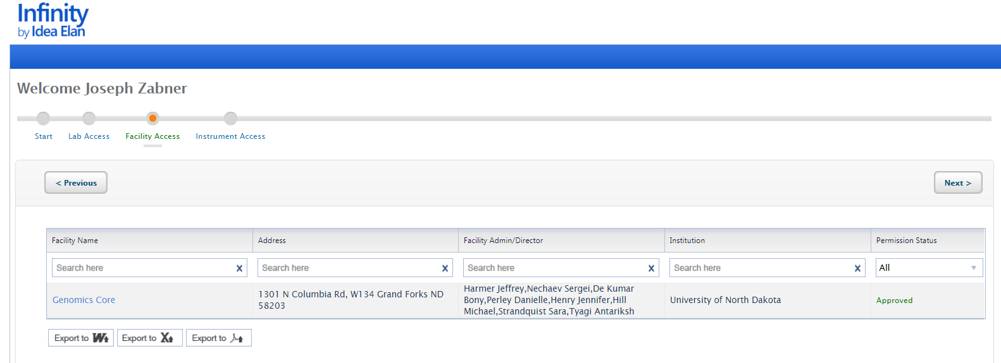

- Next request access to applicable instruments within a facility. This can be done by clicking on “Request Access” on the right of each instrument. Instrument access request forms may also be applicable.

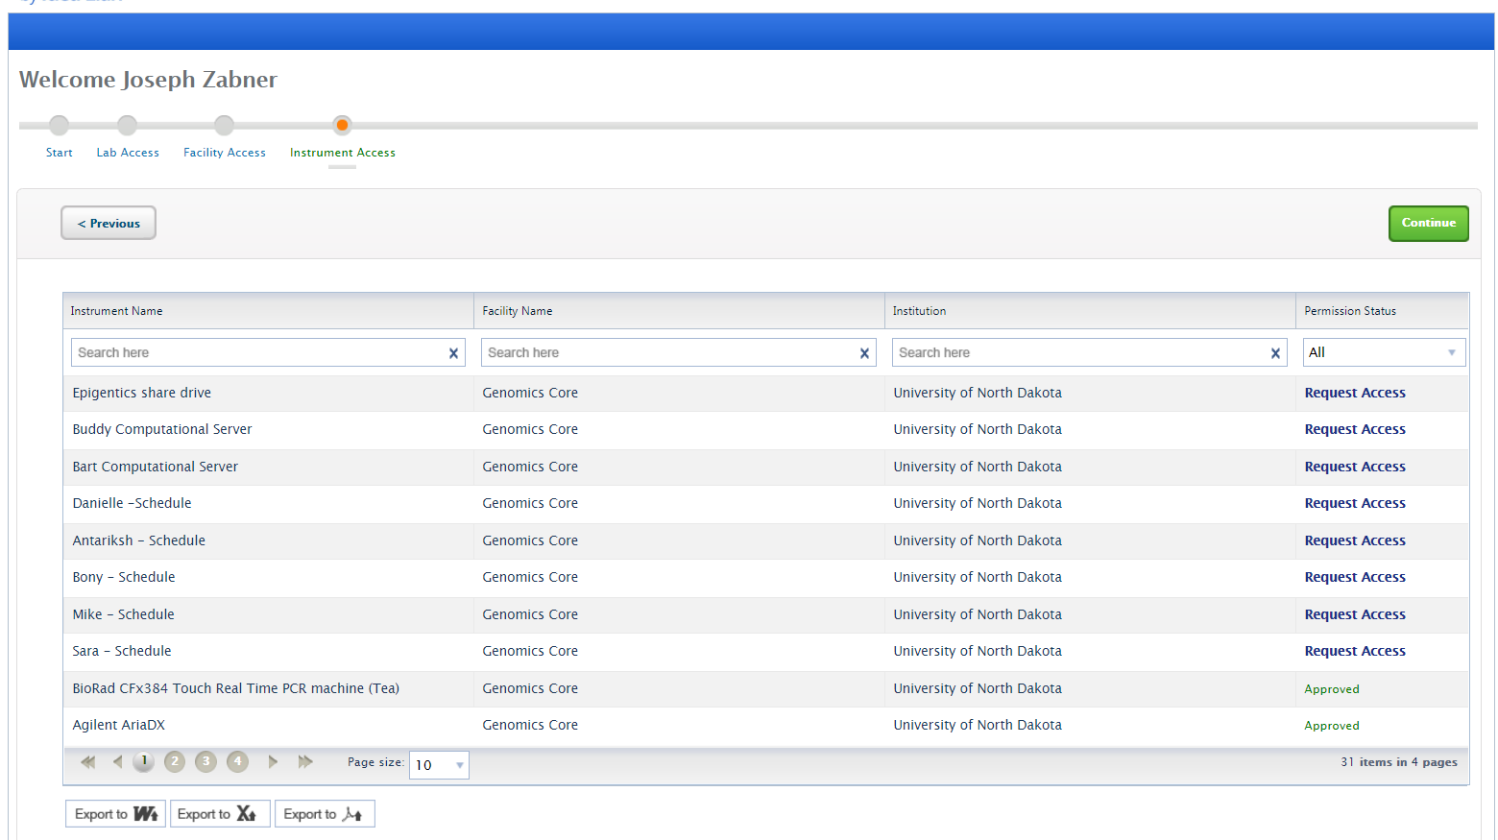

- Click on Continue to exit the wizard.
- The last part of the user registration process gives quick links to edit the user profile, reserve instruments, and/or submit a sample form. A search bar is also provided to search through the software.

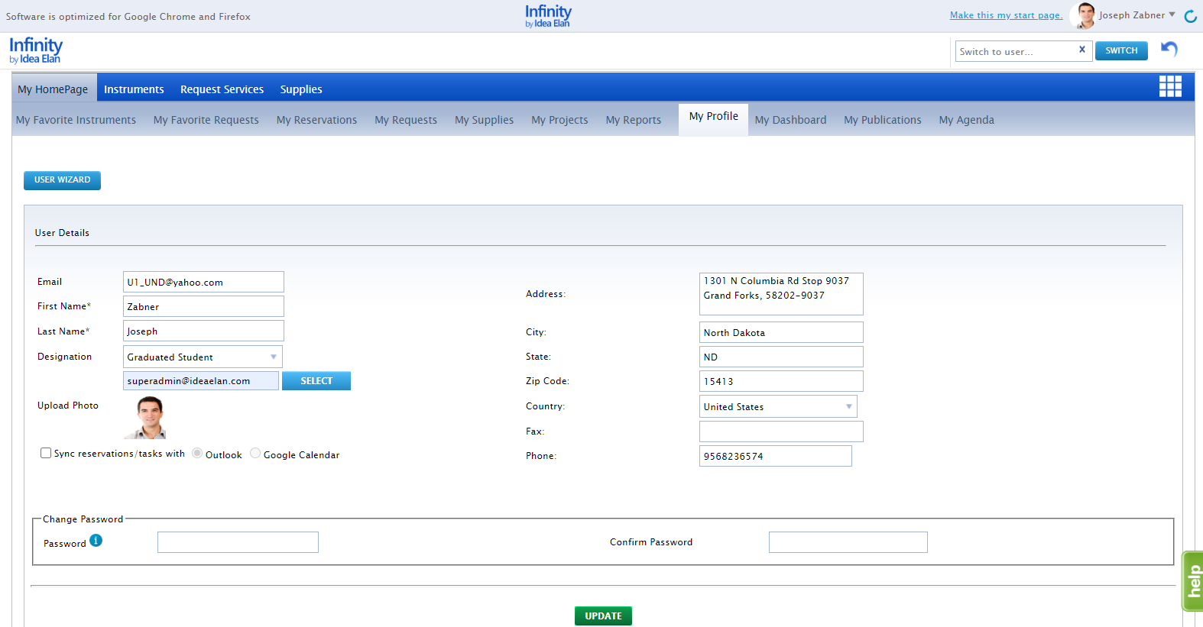
- The new user registration process is now complete.

To Access Facilities
- To request access to other facilities, hover over the 9 square box and click on the blue DNA icon on the far right.
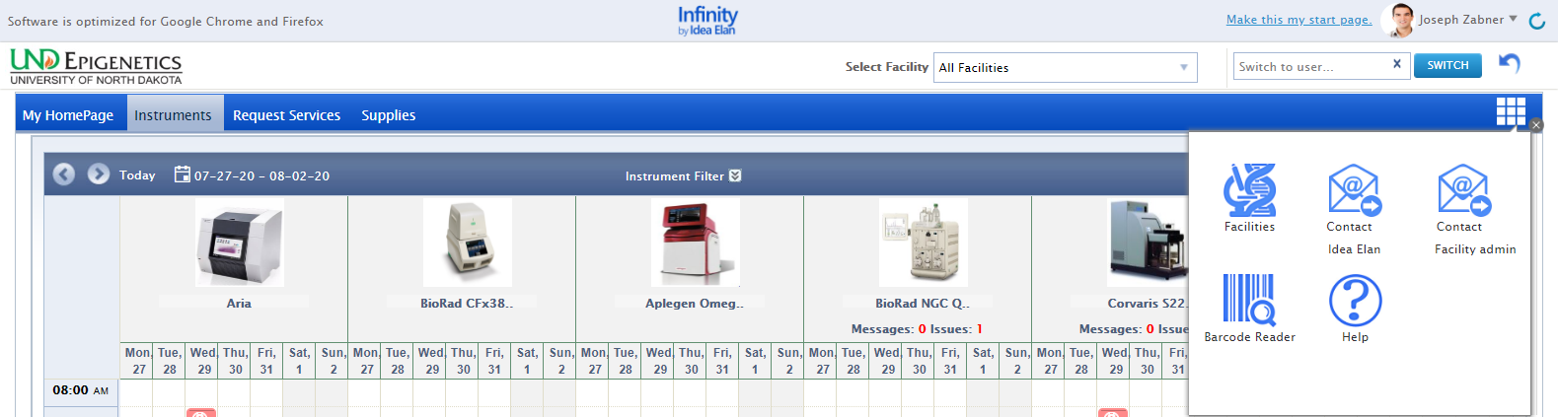

- All facilities within the institution will be listed.
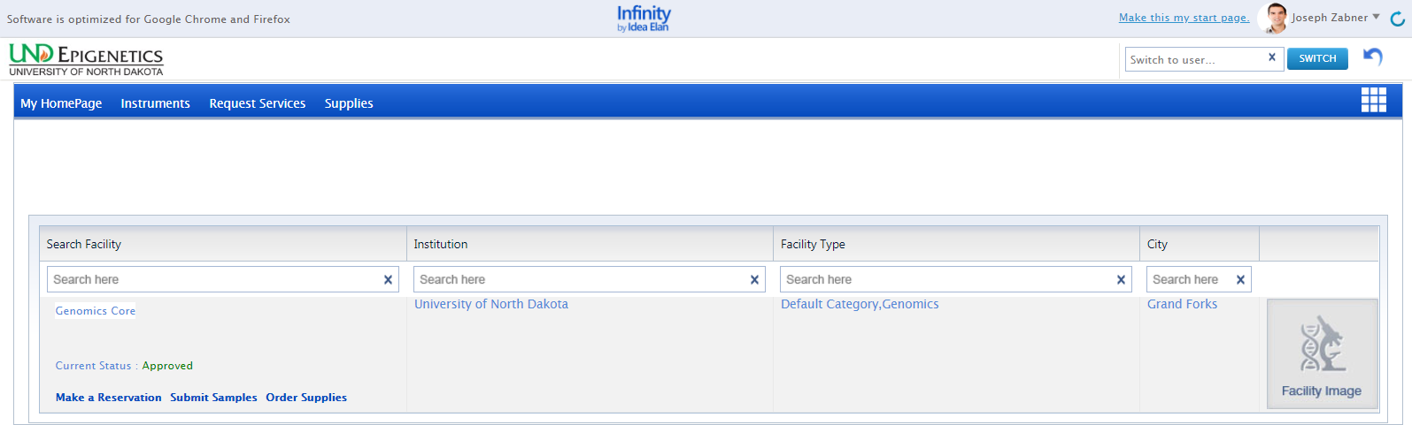

- Click on “Request Access” to request access to the facility you want to use. Depending on the facility settings, a manual approval may be necessary.

- If the facility settings are set as auto-approve, then the request will be automatically approved.

To Access Instruments
- To request access to instruments, hover over the instrument on the calendar, click on Request Access.
- All Instruments within the facility will be listed.

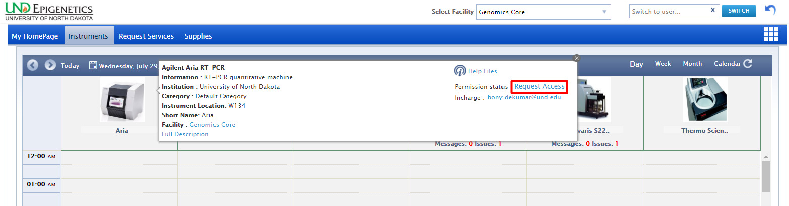
- The user will need to complete the instrument access request form. Once completed, approval will be given by the facility admin.
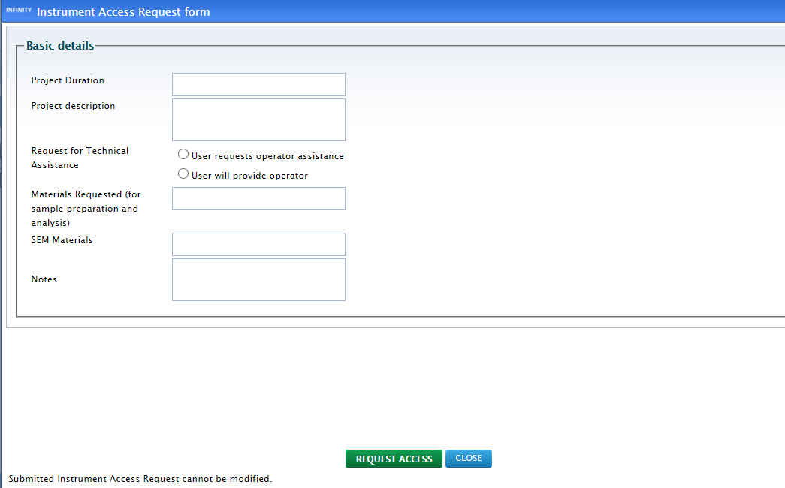

- Depending on the facility settings, a manual approval may be necessary.

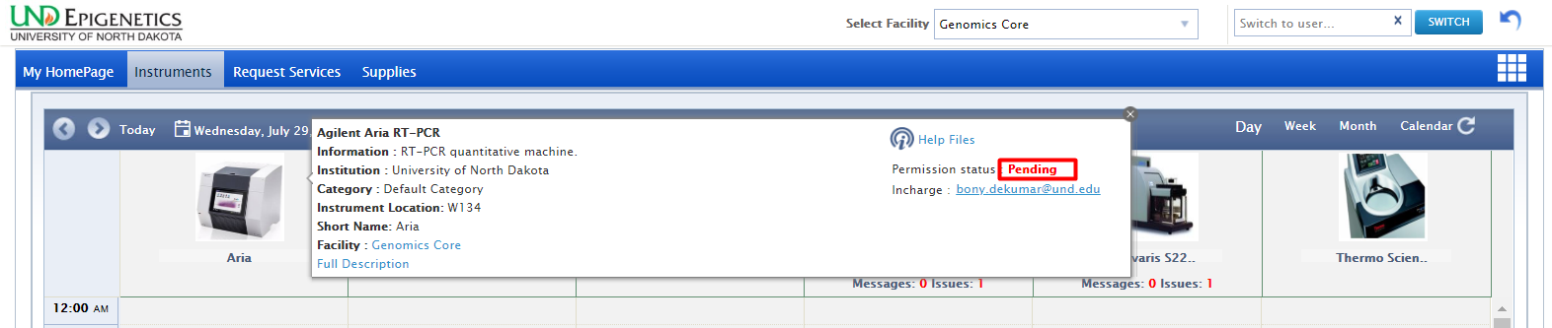
- If the settings are set as auto-approve by the admin, then the request will be automatically approved. The user will then be able to make reservations.

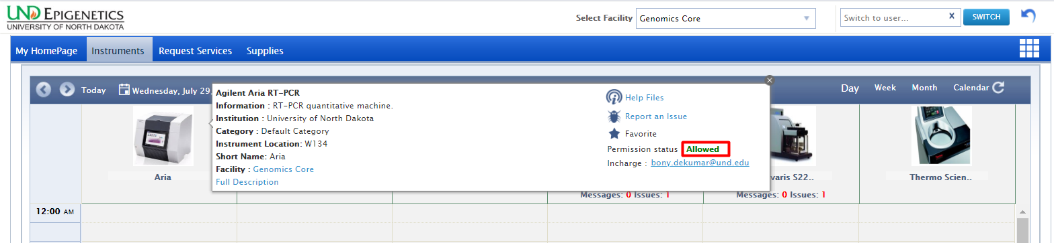

The User:
- Once logged into INFINITY as a user, a toolbar with tabs will appear that are specific to your role.
- The “9 square box” tool provides the quick links to access facilities, contact Idea Elan, Facility admins, Help files etc.

User Functions:
1 2 3 4 5 6 7
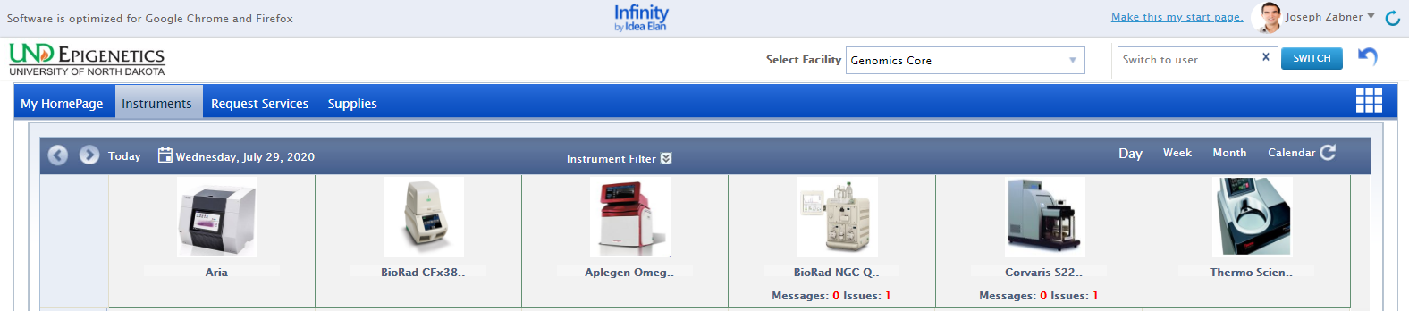

- View a home page that has specified favorite instruments and sample submissions, reservations, submitted samples, issues, service requests, and user profile.
- Request instruments in a facility and make reservations under the instrument tab.
- Submit sample forms/ service requests for processing in Request Services tab.
- Place supply orders for new supplies from facilities under the supplies tab.
- Select the facility from dropdown box for which you want to access the details, such as instruments, sample submission etc.
- Start page: Click here you can make your current page as the start page.
- My Items List: with quick links to homepage icons, my favorite instruments, favorite requests, etc.

My Home Page:

1 2 3 4 5 6 7 8 9 10 11

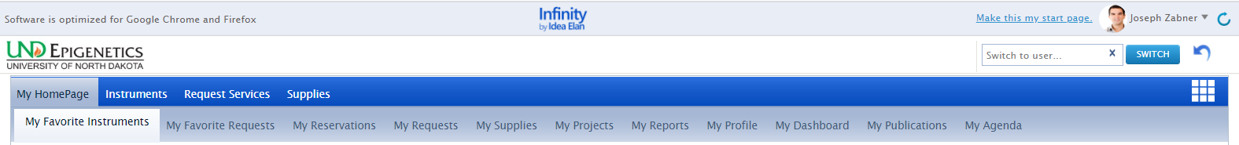

- My Favorite Instruments: Displays Instruments set as favorite with a calendar to aid in making quick reservations.
- My Favorite Requests: Displays all sample submission forms and service requests set as favorite by the user.
- My Reservations: To view the instrument reservations made by the user.
- My Requests: To view sample submissions or service requests made by the user.
- My Supplies: To view submitted supply orders.
- My Projects: To create and view all the projects assigned.
- My Reports: Generate reports based on usage across various facilities, instruments, and sample submissions.
- My Profile: Displays the profile of the user; labs and facilities affiliations of the user.
- My Dashboard: Displays the number of samples submitted, and the number of instruments
reservations made (graphical representation).
- My Publications: For reviewing and accepting publications made by the user.
- My Agenda: User can save the tasks to be performed in a day, week, or month with priority.

Publications:
Users can keep track of their publications using Idea Elan. The feature allows for users to sort through and view their previous works. Also, facility admins have the ability to request that users’ publications be present under their facility to accreditate the core. Users have the option to select yes or no.

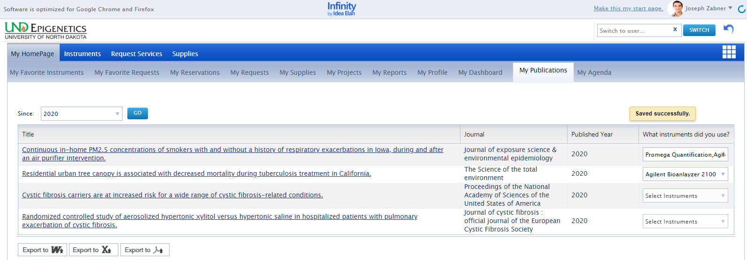

Instruments

How to make a reservation:
- Click on Instruments tab to view the calendar for instrument reservation.
- The User can filter instruments using filter options.
- Calendar can be seen in day/week/month view based on the selection.
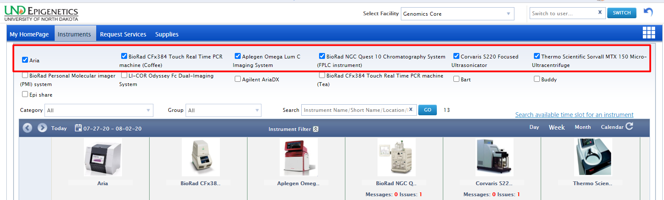

Reservation as a user:
- Select an instrument, drag on the calendar to create a reservation.
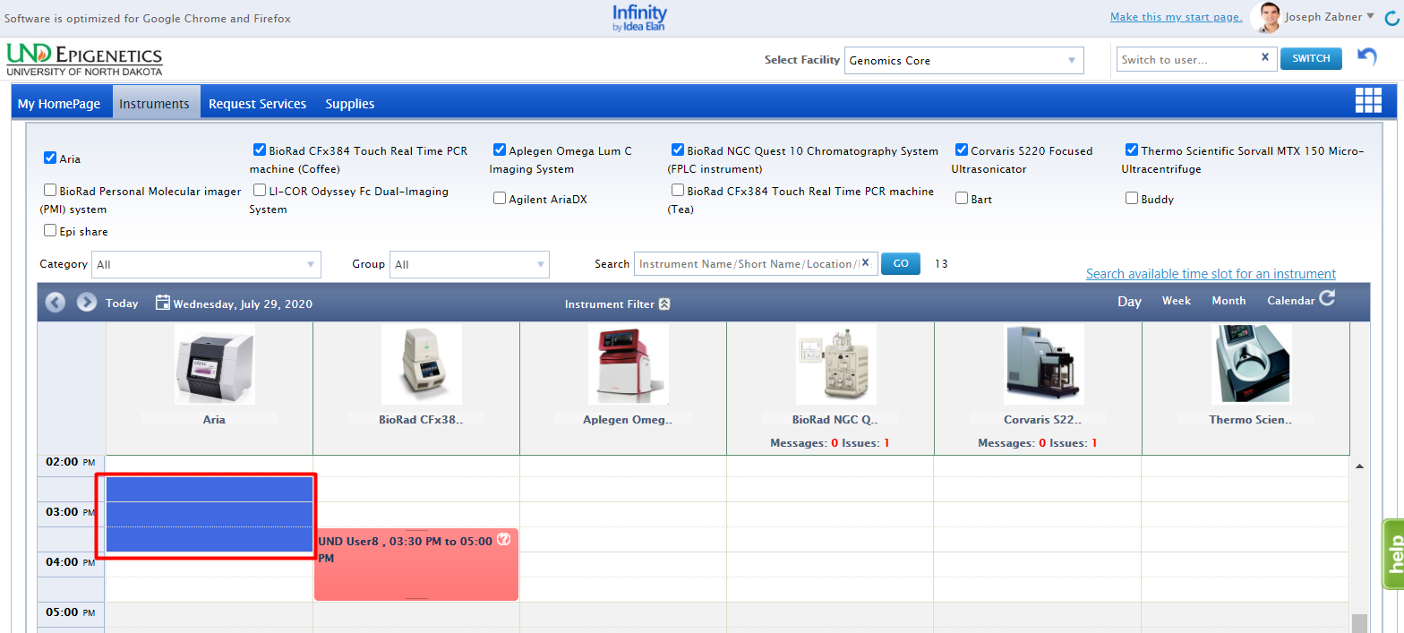
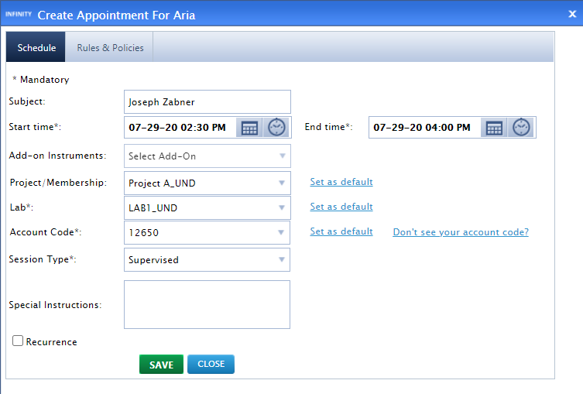
- Confirm the usage fee and click on OK.
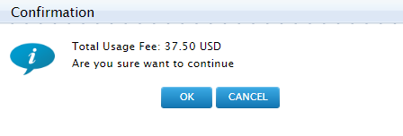
- A reservation will be created.

How to make a wait-list appointment:
- When User A has created an appointment and User B wants to have the same slot for the same instrument, then User B creates a wait list appointment by clicking on the appointment created by User A. Then click on SAVE.
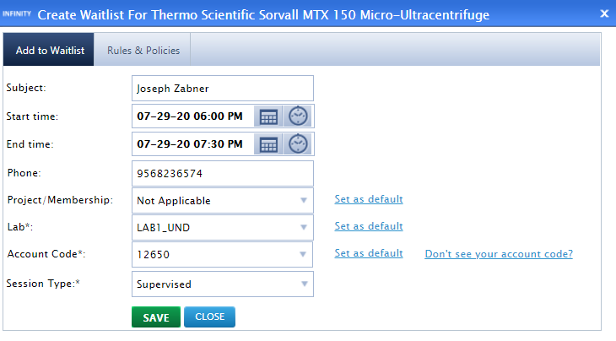
- A wait list appointment will be created.

How a user deletes a reservation:
- When the User hovers over the appointment to be deleted, an X symbol appears. Click on X to delete the appointment.
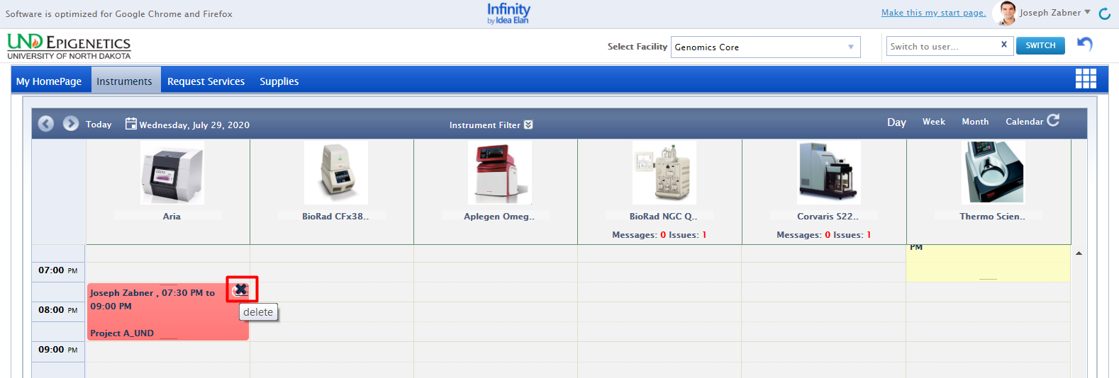

Request Services
- Sample submission forms are provided for each facility under the “Request Services” tab. Forms can be favorited for quicker access.
- All the Help files uploaded by the admin while creating the sample submission form can be seen beside the favorite icon.
- If the User faces any issue while using the sample submission form, he/she can directly report using the Report Issue icon beside the Help icon.

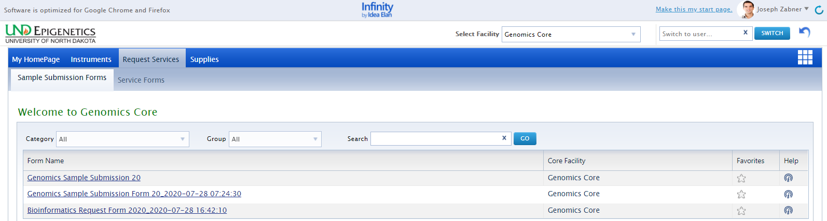

- To submit a sample form, click on the form name. Fill in the necessary details pertaining to the samples.
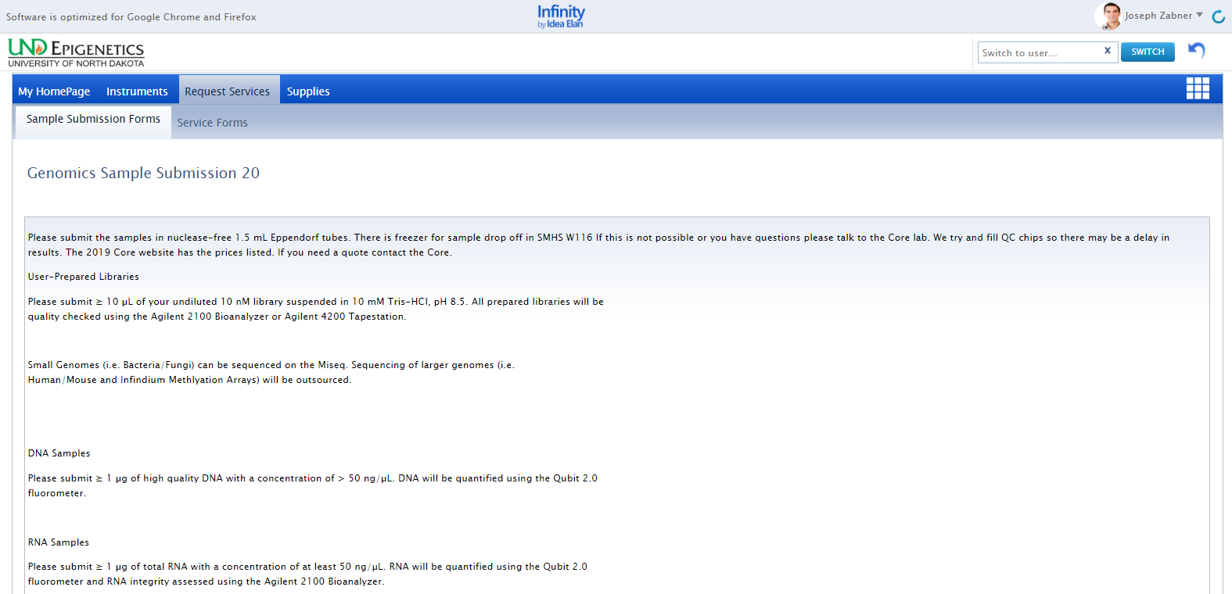
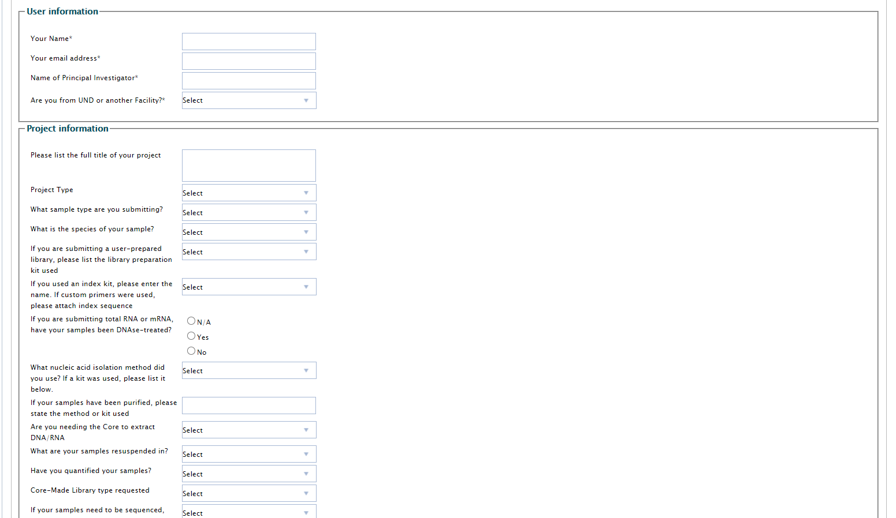
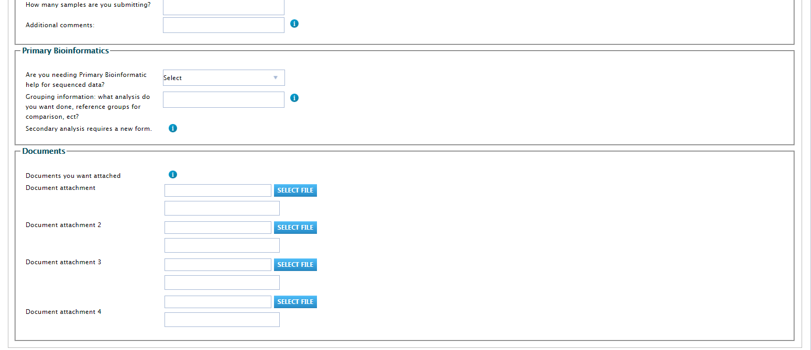
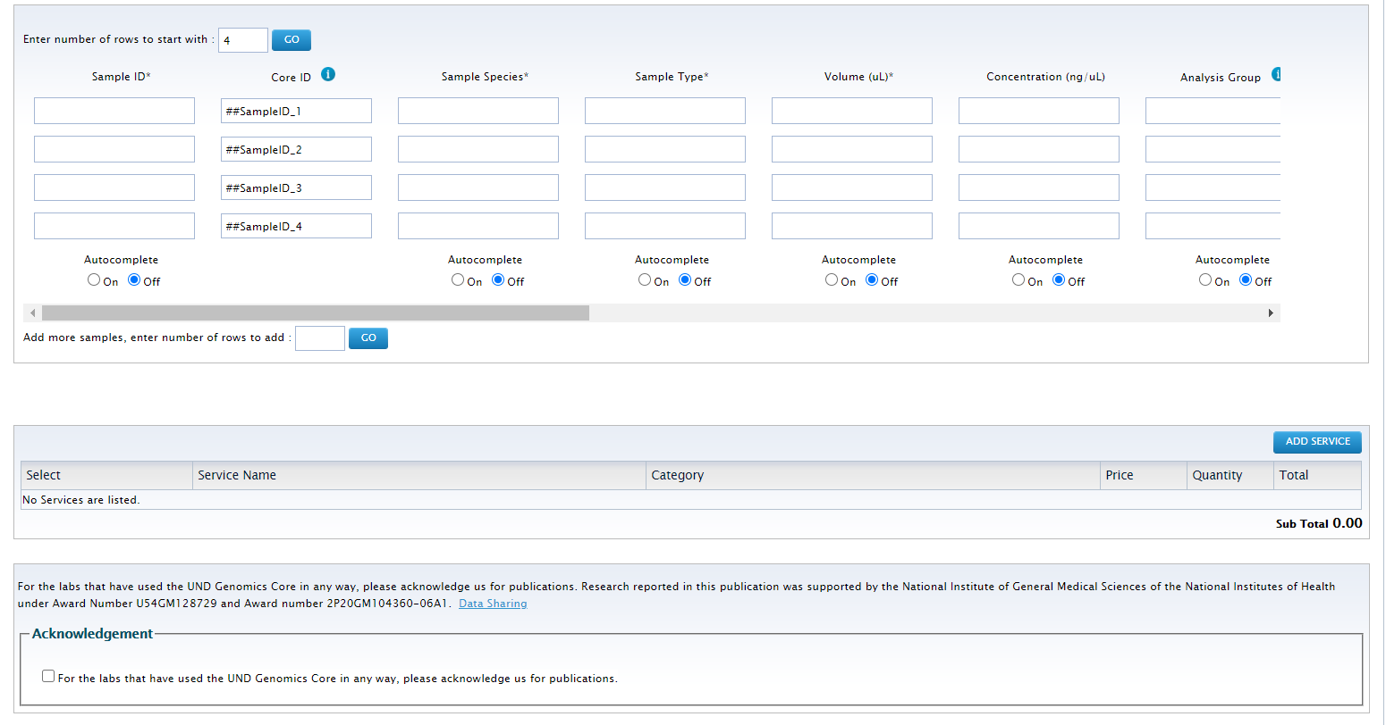
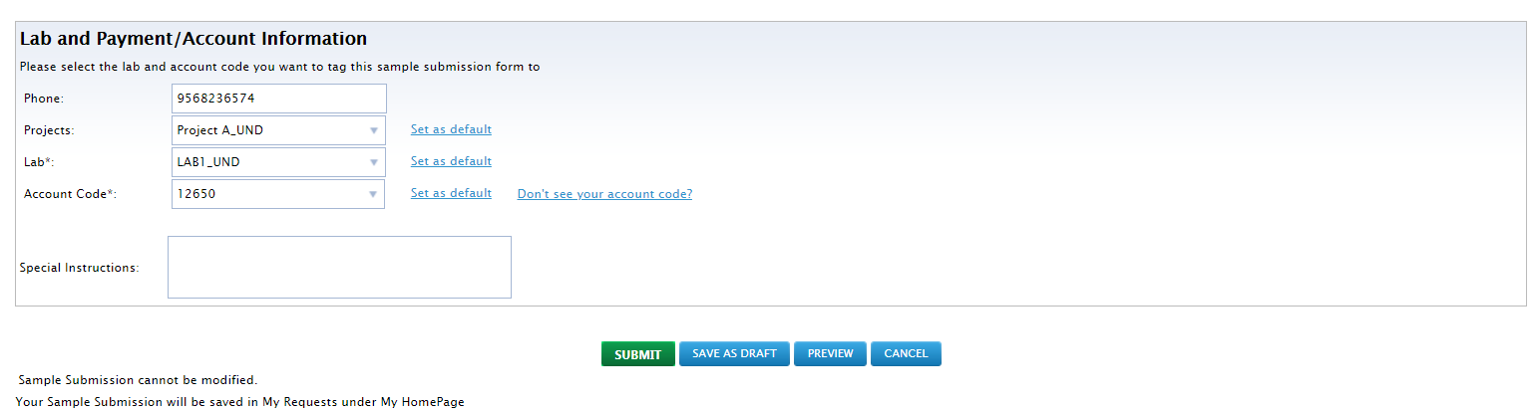

- After filling out the sample submission form, select the lab. This can be set to default for the most often used lab.
- Select the Account code you wish to use. The number can also be split for multiple charges as well as defaulted for quicker access.
- Once the form is ready, click on “Submit”. The form cannot be modified once submitted.

Supplies
- Some facilities provide supplies that are essential for the instrument or analysis.
- Clicking on the “Supplies” tab on the user toolbar redirects to the page that displays the facility and the products available. Click on “Order Supplies” to order the supplies.
- Select the specific products by clicking on the check box near the item name. Then specify the quantity and click on “Create an Order”.
- The lab name and code need to be added while ordering supplies, or a default lab and Account Code can be set for a user.

